Descriptive Statistics and Visualization with R
Boro, Binya Benson Abe
- Dataset: school_spending.dta
The dataset is “school_spending.dta.” It consists of observations on school expenditure and pupil’s performance.
- Data cleaning
The variable attributes/labels are in German. They were translated into English.
- Descriptive statistics
- There are 420 observations and 11 variables.
- The pupil’s average test score is 654.16 points, with the maximum and minimum points being 706.75 and 605.55 respectfully.
- A district spends on average 5312 US dollars per pupil.
- The average share of pupils with food voucher is 45 percent
- The ratio of pupils per teacher is about 20 percent.
- The average income of a district is about 15,000 US dollars.
- The mean share of non-native English speakers is about 16 percent.
Table 1: Summary Statistics
 | Mean | SD | Min | Max | N
Average Test Scores | 654.16 | 19.05 | 605.55 | 706.75 | 420
Expenditure Per Pupil | 5312.41 | 633.94 | 3926.07 | 7711.51 | 420
Pupil-Teacher Ratio (in %) | 19.64 | 1.89 | 14.00 | 25.80 | 420
Food Voucher (in %) | 44.71 | 27.12 | 0.00 | 100.00 | 420
No. Computer per pupil | 0.14 | 0.06 | 0.00 | 0.42 | 420
Average Income (1000US$) | 15.32 | 7.23 | 5.34 | 55.33 | 420
Share non-Native English Speakers | 15.77 | 18.29 | 0.00 | 85.54 | 420
- Data visualization with ggplot2
First, I used histograms to analyse the key variables of interest, average test score - testscr and expenditure per pupil - expn_stu. Then, I used graphical methods to analyse the relationship between average test scores and income, food vouchers, pupil-teacher ratio, non-native English speakers, among others. I applied esquisser from the esquisse package to build the ggplot2 graphs and code.
- The distribution of Pupil’s Average Test Scores
The distribution of pupil’s average test scores is approximately symmetric around the mean. Most pupil’s test scores cluster around 660 points, suggesting an even distribution of pupil’s performance across all districts.
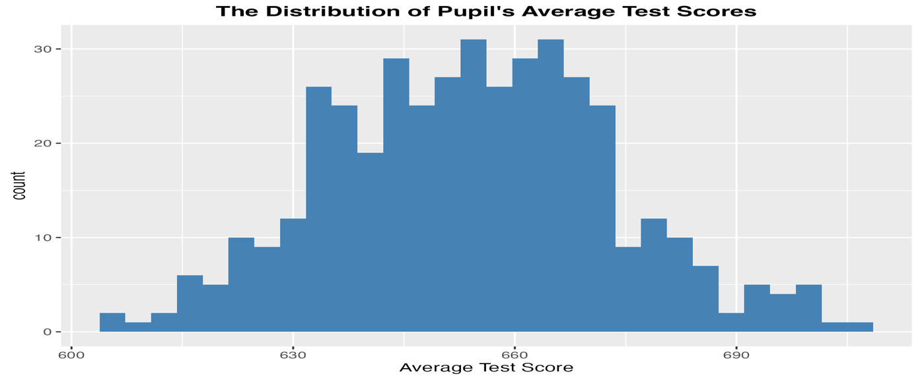
- The distribution of Expenditure Per Pupil
The distribution of expenditure per pupil is approximately symmetric around the mean. Most districts spend around 5000 US dollars on pupils. However, the histogram reveals some few extreme observations, which may represent higher expenditure per pupil in some districts. Furthermore, the distribution is slightly right skewed, suggesting fewer districts with very high income and expenditure per pupil.
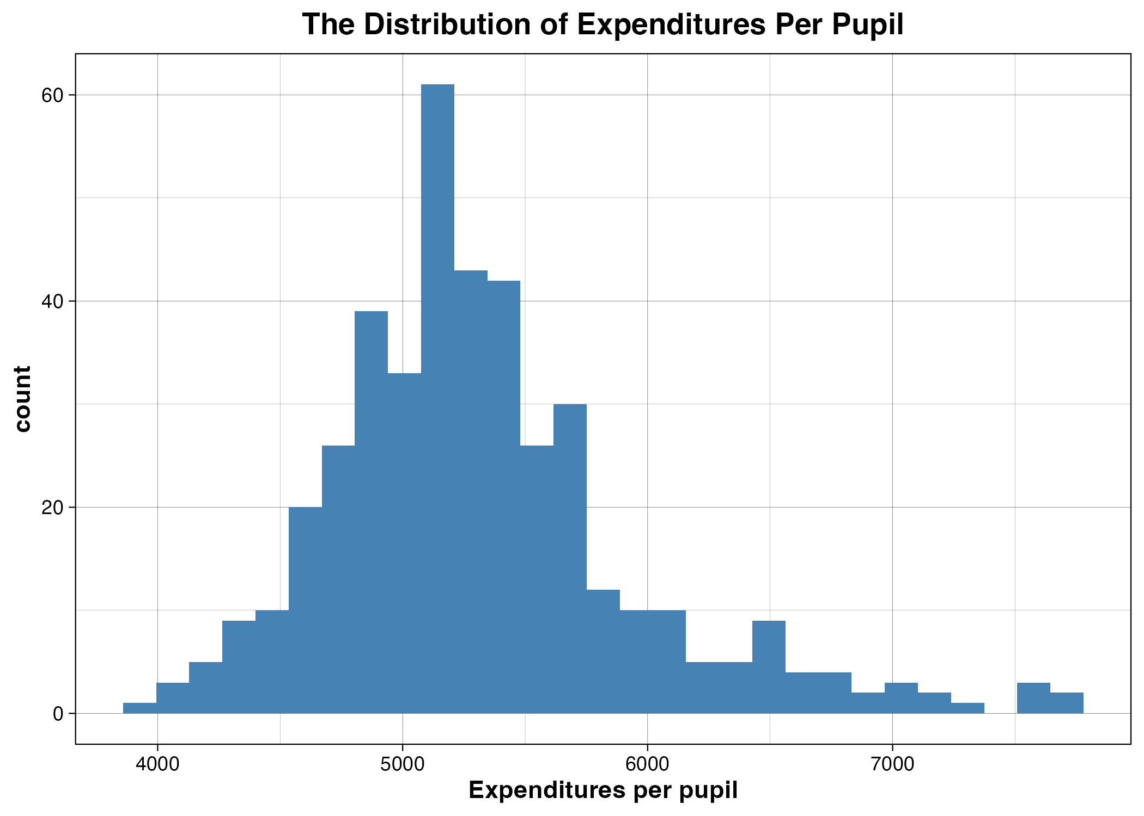
- Relationship Between Income and Pupil’s Performance
The relationship between average income and pupil’s average test score is positive. In addition, the regression line is upward sloping, implying that districts with higher average incomes tend to have higher pupil’s test scores.
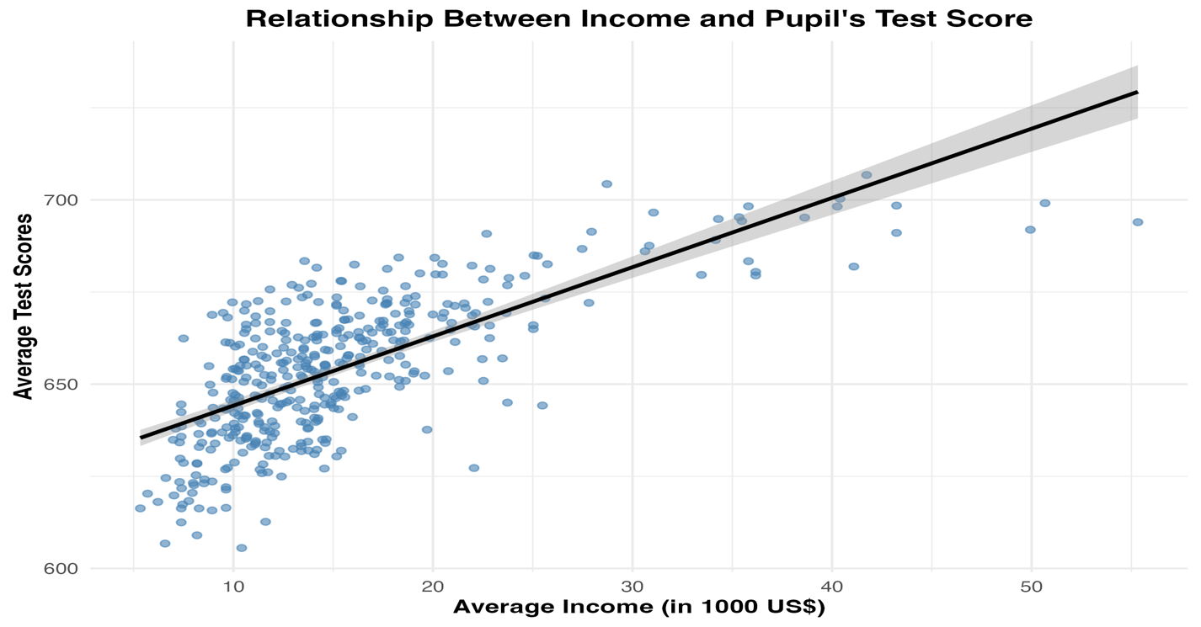

- Relationship Between Meal Vouchers and Pupil’s Performance
There is a negative association between the share of pupils with meal vouchers and pupil’s average test scores. The regression line is downward sloping, suggesting that schools with a high percentage of pupils with food vouchers tend to record poor average test scores.
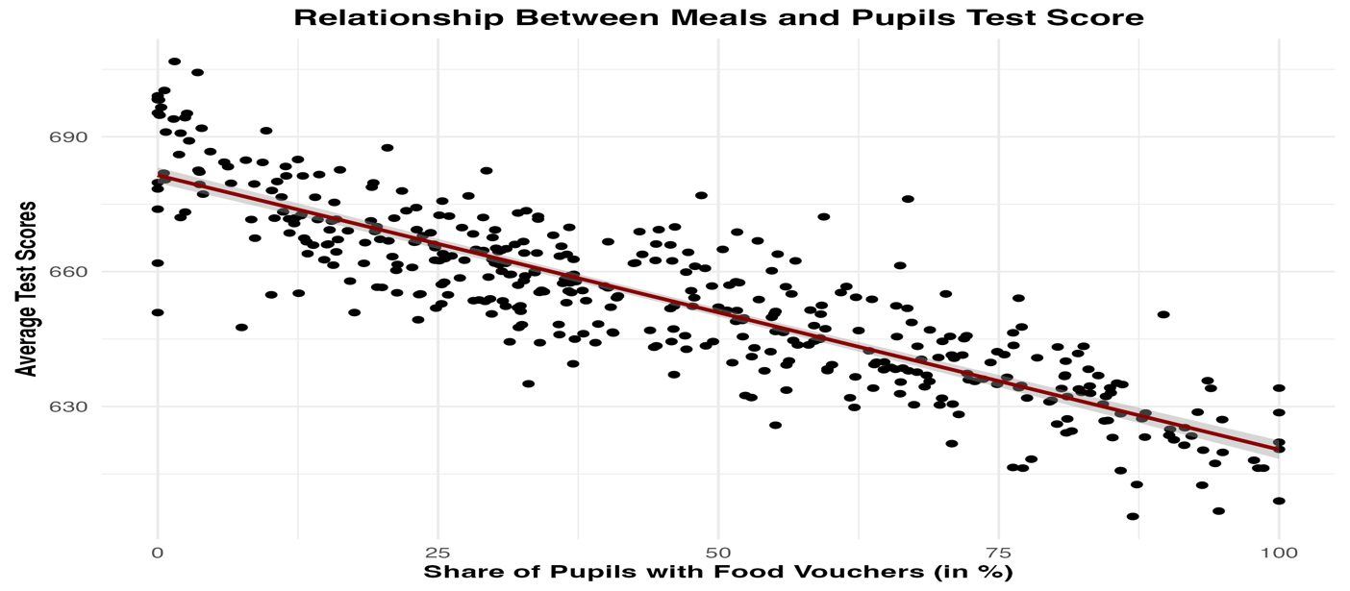
- Relationship between Expenditure and Pupil’s Test Scores
There is a positive relationship, the regression line slopes upward. This means that high expenditure per pupil improves pupil’s performance in tests.
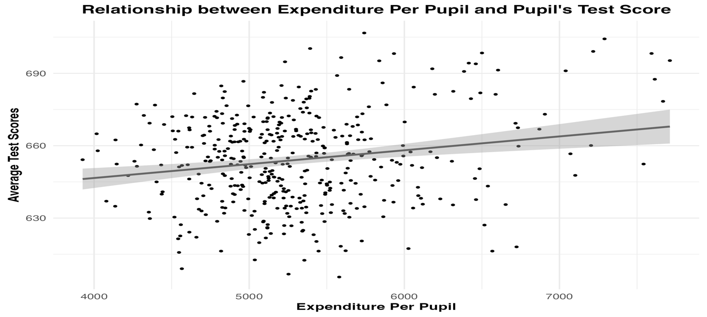
- Relationship between Non-native English Speakers and Pupil’s Performance
There is a negative association between the share of non-native English speakers and pupil’s average test scores: The regression line is downward sloping, implying that having non-native English speakers tend to worsen pupil’s test scores.
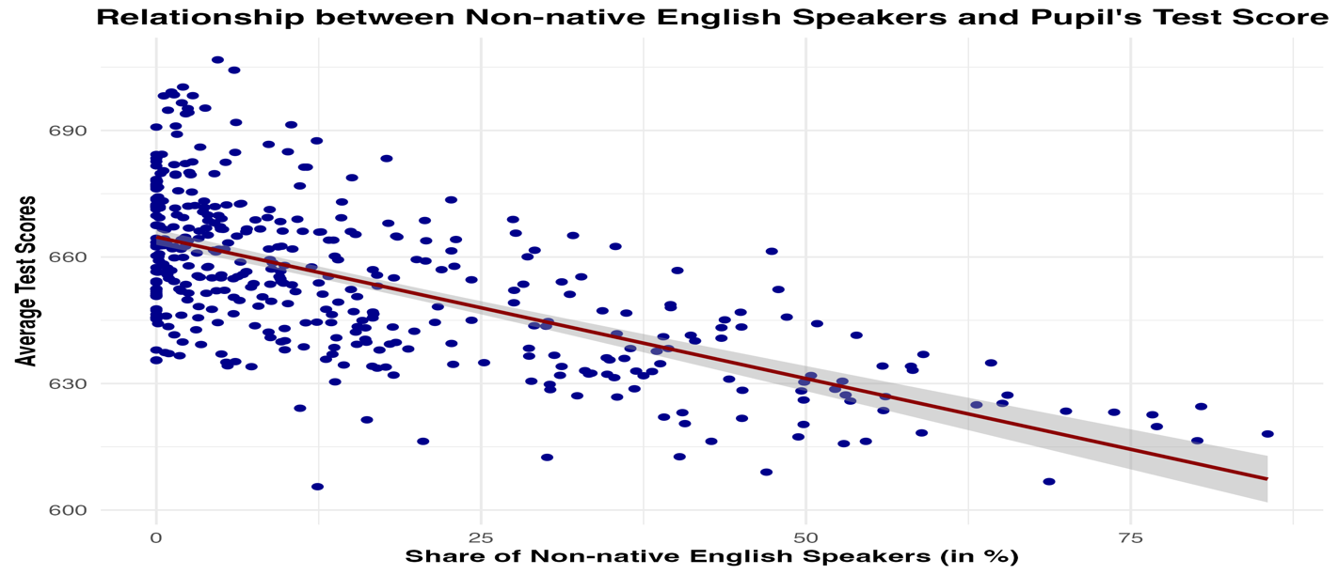
- Relationship between Computer and Pupil’s Performance
The number of computers per pupil has a positive association with pupil’s average test scores. The regression line slopes upward, suggesting that having a computer improves pupil’s performance.
