Binya Benson Abe Boro
M.A. Development Economics and International Studies, FAU Erlangen-Nürnberg, Germany
- Introduction
Is public expenditure on education an economic priority? Globally, improving education quality ranks high on the 2030 Agenda for Sustainable Development (United Nations, 2015). In 2022, governments and households spent about US$55 per school child in low-income countries, while donor countries contributed a record US$16.6 billion to education in developing nations (World Bank, 2024). This analysis examines whether spending on education improves pupils’ performance.
Economists have long studied this relationship, establishing the field of the economics of education. Human capital theory, a core framework, views education as an investment in human capital (Becker, 1962). It posits that investing in education develops the skills, knowledge, and competencies that boost individual and national productivity and earnings. Empirical evidence supports this view. Baron (2022) found that rising school spending by US$1000 per student increased test scores by 8 percent and lowered dropout rates by 9 percent in poor districts of Wisconsin. Hyman (2017) showed that students in Michigan who benefited from a 10 percent increase in school funding were 7 percent more likely to go to college and 11 percent more likely to earn a degree. Krueger and Lindahl (2001) showed a strong positive and statistically significant effect of investing in education on individual wages and economic growth.
The rest of the paper include sections on descriptive statistics, data analysis and interpretation, further statistical and graphical tests, and a conclusion.
- Descriptive Statistics
Table I below shows that the average test score of a pupil is 654 points, with the best pupil scoring 707 points and worst 606 points. The average expenditure per pupil per year in each district is US$5,312. The maximum expenditure per pupil is US$7,711 and the minimum is US$3,926. The average district has an annual income of US$15,317, with the poorest district having an income of US$5,335 per year while the richest US$55,328 per year. Some districts have 100 percent of their pupils receiving food vouchers while others have none. On average, each pupil has at least one computer. However, some pupils have no access to computers even though some schools have at least four computers per pupil. The average class has about 16 percent share of non-native English speakers but some schools zero number of non-native English speakers.
Table 1: Summary Statistics
Figure I shows a histogram of the distribution of the average test scores. The shape is approximately symmetric, indicating that pupil’s test scores are evenly distributed around the mean.
Figure I: The distribution of average test scores
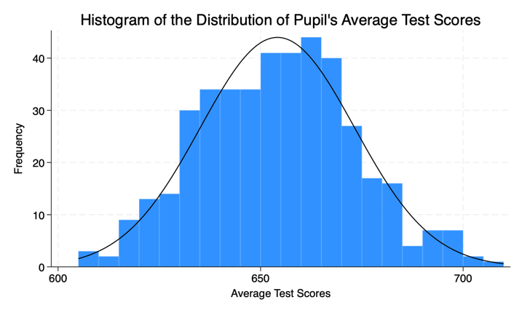
Figure II below shows a histogram of the distribution of expenditure per pupil. Th distribution is right-skewed, implying even distribution around the mean.
Figure II: The distribution of school spending
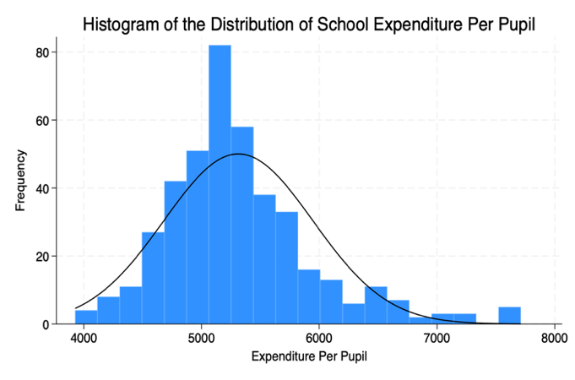
Figure III below shows a scatter plot of the relationship between school expenditure and pupil’s test scores. The correlation coefficient of 0.191 indicates a weak positive correlation, meaning that expenditure can indeed influence test scores.
Figure III: Relationship between school spending and pupils performance
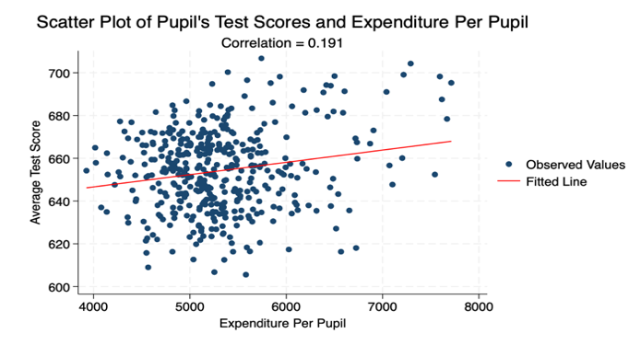
- Data Analysis and Interpretation
In this section, I applied OLS to estimate the effect of school spending on pupil’s performance. I first defined a baseline model to guide the analysis below:
  - Baseline economic model
Average Test Scores = f (Expenditure Per Pupil, Covariates)
Performance in test scores, measured by the average test scores, is a function of public-school expenditure, measured by expenditure per pupil, plus other covariates, such as, school meals, access to a computer, income, and non-native English speakers in a class.
  - Econometric Model
y_{i =} β₀+ β₁×+ γX + ε_{i}
Where: y_{i} is the dependent variable (average test scores); × is the independent variable (expenditure per pupil); X is a vector of covariates; and ε_{i} is the disturbance term, capturing unobserved factors. The coefficient of interest is β₁ because it captures the effect of public-school expenditure on pupil’s performance. average test scores. Since governments and households, including donors, primarily invest in education to improve educational outcomes of pupils, the sign of β₁ is expected to be positive.
  - OLS Results
Table II presents the OLS estimates. Column (1) is a bivariate regression of pupil’s average test scores on expenditure per pupil. The coefficient (29.465) indicates a positive and statistically significant effect. However, this analysis focuses on the interpretation of the multivariate results in column (2), which is in fact the baseline model. The main coefficient of interest, β₁, is 8.906. It implies that a one percent increase in expenditure per pupil is associated with 0.089 points (8.906/100) increase in pupil’s average test scores, holding other factors constant. This is statistically significant at the 5% level (p-value <0.05). On average, one percentage point increase in the share of non-native English speakers is associated with 0.187 points decrease in pupil’s average test scores, ceteris paribus. This is significant at the 1% level. Increasing the number of computers per pupil by one computer on average increases pupil’s average test scores by 13.9 points, ceteris paribus. Increasing annual income of the district by one dollar on average increases pupil’s average test scores by 0.624 points, holding other factors constant. This is also significant at the 1% level. Finally, one percentage point increase in the share of pupils with food vouchers is associated with a decrease of 0.406 points in pupil’s average test scores, other factors constant. This is significant at the 1% level. The model explains about 81 percent of the variation in pupil’s average test scores (R_Squared = 0.808) and is jointly significant (F-statistic p-value < 0.001). This result implies that public school expenditure does improve pupil’s performance.
Table II: OLS results of average test scores on expenditure per pupil
- Functional Form and Model Testing
In this part, the analysis compares the baseline model with a log-linear model to ascertain which model specification is ideal for estimating the relationship between school spending and pupil performance. Table III presents the OLS estimates. Column (1) shows the baseline model and column (2) shows a log-linear model. The baseline model has a larger adjusted R-squared (0.806) than the log-linear model (0.798). In addition, it has a lower AIC (2985) and BIC (3009) as compared to the log-linear model. This means that the baseline model explains the relationship better than the log-linear model.

Table III: Comparing model specifications
- Analysis of Heteroskedasticity.
This section presents a test for heteroskedasticity in the baseline model using white test and graphical approach.
  - White Test
Table IV presents the OLS estimates of the baseline model with and without robust standard errors and the p-value of the white test (0.734). Heteroskedasticity is rejected at the 5% level (white test p-value > 0.05). In column (2), estimating the baseline model with robust standard errors did change the coefficients but did slightly change the standard errors. Thus, the baseline model is homoscedastic. That is, the explanatory variables are uncorrelated with the error term.
Table IV: OLS estimates with Robust SEs
  - Graphical Analysis of heteroskedasticity
Figure IV below presents a scatter plot of residuals against fitted values. The plot shows no distinct patterns, implying no evidence of heteroskedasticity. In addition, the lowess smooth line is approximately flat and centered around zero, which further suggests no evidence of heteroskedasticity.
Figure IV: Scatter plot of residuals and fitted values
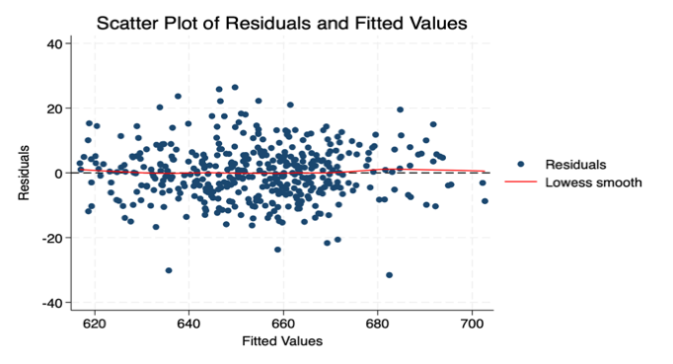
- Endogeneity
The above analysis reveals that school spending per child improves educational performance. Further tests of the baseline model reveals that it explains this relationship better. In addition, it is homoscedastic and has no omitted variables.
However, the estimated effect of school expenditure per pupil on performance could possibly contain the effect of other unobserved factors. Parents level of education, for example, can have significant effect on their children’s educational outcomes. Educated parents are more likely to provide an ample environment for their children to study and pass examinations. Household income can also positively affect performance and determine public spending per child. Pupils from rich households are more likely to perform better than those from poor households. Finally, Pupil’s test scores might also determine initial public funding and funding continuity. Schools or pupils that keep underperforming might has their funding cut or reduced. These factors rise a possibility of omitted variable bias and endogeneity problems in the baseline model.
- Conclusion
This analysis examined whether public-school expenditure improves pupil performance. The main OLS estimate reveals that increasing expenditure per pupil per year by one percent improves, on average, pupils’ average test scores by 0.089 points, other factors constant. This effect is statistically significant. Further tests reveals that the estimated model is well specified and homoscedastic. However, there is a possibility that estimated effect contains the effect of unobserved factors such as parents’ educational level and household income, among others.
References
Baron, E. Jason. 2022. “School Spending and Student Outcomes: Evidence from Revenue Limit Elections in Wisconsin.” American Economic Journal: Economic Policy 14 (1): 1-39.
Becker, Gary S. 1962. “Investment in Human Capital: A Theoretical Analysis.” Journal of Political Economy, no. 5, Part 2: 9-49.
Hyman, Joshua. 2017. “Does Money Matter in the Long Run? Effects of School Spending on Educational Attainment.” American Economic Journal: Economic Policy 9(4): 256-80
Krueger, Alan B., and Mikael Lindahl. 2001. “Education for Growth: Why and For Whom?” Journal of Economic Literature 39, no. 4: 1101–36.
United Nations. 2015. “Transforming Our World: The 2030 Agenda for Sustainable Development.” Resolution adopted by the General Assemble.
World Bank. 2024. “Education Finance.” Education Finance Watch Report.

