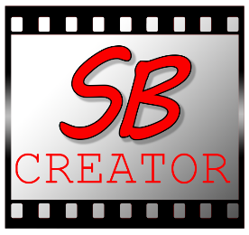

Story Board Creator

Story Board Creator is a basic application to get your ideas for storyboard out quickly

The software has basic features like drawing and saving into a sequence for use in your video editor

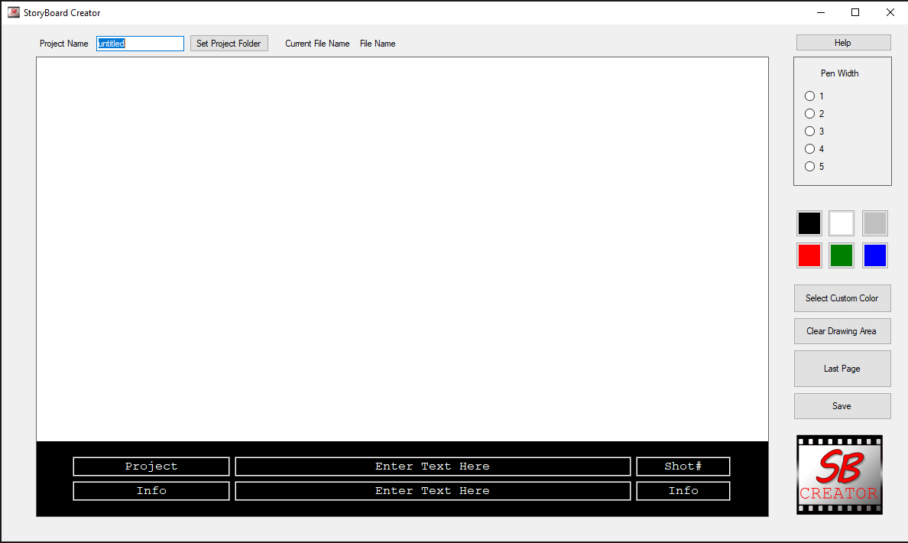

Here you have the Main Layout

Project Name: Here you set your project name, its recommended you do this before beginning any drawings.

Then Click the Set Project Folder Button

You will see to the right the name of the folder and file. The Full path

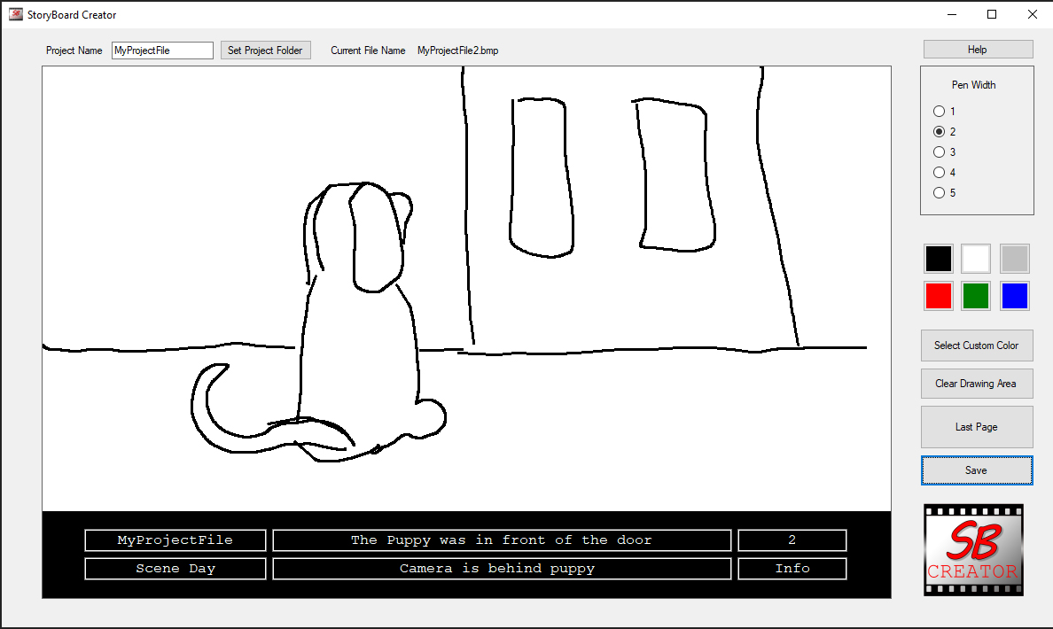

Next Fill out the Text boxes at the bottom with your scene descriptions and all the info you want to see and have as reference .

As you can see on the right Top you have the Help File.

* You then have your Pen Width for quick change of pen size
* Quick color selector: Use these preselected Colors to get you Ideas Quickly Down
* Custom Color selector: This allows a wider range of colors
* Next is the Clear Drawing area which only clears the image. But does not clear the text.
* Last Page feature just brings back the Last Drawing in case you Cleared the Page
* Click save to save the files, anytime you hit save it will make a New File.  
  This style is meant to get your ideas quickly out and saved as if you were using index cards.  
  Later you can delete unwanted files.