By Harry Pearce,

18136044 Computer Science student

Portfolio

CS2S567 Professional Practice and Employability: Team Based Software Development Workshop

|  |  |
| --- | --- |
| Team Number | **2** |
| Team Task | Create a PIM system |
| Own role(s) and tasks in Team | Role:   * Documentation * Programmer   Tasks:   * Create a Flowchart for mock-up GUI design. * Writing a Document on LESPI * Researching a Python and Tkinter framework |

Contents

Weekly Activity Report 4

Weeks 1 & 2 4

Weeks 3 4

Weeks 4 5

Weeks 5 5

Personal QA and Issue Tracking Activity Log 6

Appendix Evidence 8

Appendix 1 - Mock-up Flowchart 8

Appendix 2 – MyProgrammingLab Progression 9

Appendix 3 – MyProgrammingLab Progression 9

Appendix 4 – Text Document code 10

Appendix 5 – Text Document GUI 11

Appendix 6 – QA of Application design and Installation 12

Appendix 7 – three slide that I make for this seminar slideshow 13

# Weekly Activity Report

|  |  |
| --- | --- |
| Weeks 1 & 2 | **Project Setup** |
| Author: Harry | **Own** |
| **Activities undertaken** | Understanding the idea from team discussed and convert it into flowchart mock-up. The flowchart mock-up give team an expectation of what the prototype and final design looks like.  I am using Lucidchart for making flowchart since it had all the shape, I need to make a mock-up design.  I planned on research of how to use GitHub because team need a cloud storage that we can share each other works for references.  One of team member Ben creating Trello that allow to track the progress.  Discord was undergoing creating the channel to communicate. |
| **Outcome of QA activities** | After creating flowchart, team gain the ideas about GUI design and the system behind it. So, this allows some of member to create realistic mock-up GUI and QA. I gained learning what Git is and what GitHub do.  Trello will help team to manage task that need to be complete and by who.  Discord quickly become our main communication that allow show their work in live, talk by voice and text and quickly share the file across. We will attend to meet every Monday at 1pm in discord to use Voice chat. |
| **Activities resulting from QA process** | Mock-up flowchart completed.  Completed chapter one of MyProgrammingLab.  Learned how to Clone GitHub repository into computer. Began to use GitHub Desktop because it makes easy to manage. |
| **Personal QA development** | After researching, I began knowing how git work and send some command to submit something. |
| **Evidence of own activities** | Appendix 1 - Mock-up Flowchart  Appendix 2 – MyProgrammingLab progression |

|  |  |
| --- | --- |
| Weeks 3 | **Project Setup** |
| Author: Harry | **Own** |
| **Activities undertaken** | I planned to learn Tkinter and MyProgrammingLab because I can gain the expectation from python of what degree that need to learn. I quickly began to set a new mini project by making a text document. This allows to create load, save, edit, and exit function. Button and the layout as well. Their final product will use this function. |
| **Outcome of QA activities** | I gained to understanding of what I expecting to learn about python and framework. This allows me to narrow the new goal of research without ending up faces hard to understanding.  I faces a few issues on setting up the framework into my computer, I resolve it by learning how to install python’s framework using computer’s terminal.  I have completed the chapter 2 of MyProgrammingLab, and 2 projects complete. |
| **Activities resulting from QA process** | Tkinter framework knowledge completed.  More python knowledge completed.  Completed Mini project Text document software. |
| **Personal QA development** | I faces a few issues on setting up the framework into my computer, I resolve it by learning how to install python’s framework using computer’s terminal.  I gain to learn how to create python that read, write, edit the file, and exit the program that which I think our final design will need. I able to understand what tkinter allow and how it renders. This would help me to track down the errors that involve with tkinter framework.  I am feeling more confident using command for install further framework and my IDLE getting easier to handle libraries. |
| **Evidence of own activities** | Appendix 3 – MyProgrammingLab  Appendix 4 - Text Document code  Appendix 5 – Text Document GUI  GitHub Link for text Document –  <https://github.com/BenB33/ProfessionalismTeam2/tree/main/Harry/python%20research%20practice/Simple%20Text%20Editor> |

|  |  |
| --- | --- |
| Weeks 4 | **Project Setup** |
| Author: Harry | **Own** |
| **Activities undertaken** | My team leader Jess assign me to create an information for QA and three slides for seminar slideshow for our phase one. The topic for document is Application design and installation. I plan to research of what to include this format of information. There one of slide which will be covering the main tools of organisation that the team manages together. In two other slides, once which I will cover the QA and other will cover the text Document that I made. Each slide has voice record to talk about the progression we had gone so far. |
| **Outcome of QA activities** | The QA of Application design and installation have created the information about the application design and installation. |
| **Activities resulting from QA process** | I do not experience any difficulty with QA, but after receiving the review from my team suggest making record my voice instead of voice generate. |
| **Personal QA development** | I discovered that to share the slides to teammate in blank will make it easier for them to format, so I make sure that the slides will make it easier to adapt the format in main presentation |
| **Evidence of own activities** | Appendix 6 – QA of Application design and Installation.  Appendix 7 – three slide that I make for this seminar slideshow. |

|  |  |
| --- | --- |
| Weeks 5 | **Project Setup** |
| Author: Harry | **Own** |
| **Activities undertaken** | This week was when the seminar slideshow is due, team and I finishing the slides and post forward to Ben who Organise this seminar slideshow. |
| **Outcome of QA activities** | Ben and Jess like my information and audio on slides that I share. As all slides were complete. |
| **Activities resulting from QA process** | seminar slideshow completed. |
| **Personal QA development** | I find that I do not have any problem with this seminar slideshow. |
| **Evidence of own activities** | [ProfessionalismTeam2/PIM – Phase 1.odp at main · BenB33/ProfessionalismTeam2 (github.com)](https://github.com/BenB33/ProfessionalismTeam2/blob/main/PIM%20%E2%80%93%20Phase%201.odp) |

# Personal QA and Issue Tracking Activity Log

|  |  |  |  |  |  |
| --- | --- | --- | --- | --- | --- |
| Issue | Week Date | Activities undertaken | Outcome of QA Activities | Activities Resulting from QA Process | Personal QA development |
| 1 | 1 | Creating mock-up flowchart | All the team looking into the flowchart. | Team then working on what they assigned to do, and my flowchart give them an idea of what to do. | Creating Flowchart, understanding the shape use in flowchart |
| 2 | 1 | Learning how to use GitHub | Team using GitHub to store the progression | Team members creating folder themselves to store information in | Learning what git and GitHub is and how to command them through terminal . |
| 3 | 2 | Began to use MyProgrammingLab | Completed the first chapter. | Planning when to use MyProgrammingLab | Gain understanding of Python. |
| 4 | 3 | Learning Python and Tkinter framework. | Learned how Python communicate tkinter to renders and display something. | Planning to create a mini project as text Document Software | Gain understanding of Python and Tkinter. |
| 5 | 3 | Installing framework into my computer | Able to understand how to install Framework into my computer and how IDLE detect this framework. | Better support to keep IDLE running properly. | Learned to terminal that pick up the internet and downloading into default python folder where it stores all framework into library. |

|  |  |  |  |  |  |
| --- | --- | --- | --- | --- | --- |
| 6 | 3 | Create mini project of Text document that make in tkinter.  Appendix 4 & 5 | Text Document allow me to understand of what tkinter is capable of. | This allows me to set the expectation and set the narrow goal of what need to learns. | Understand better about the file management |
| 7 | 4 | Create a QA of Application Design and Installation | Team Leader assign me to make an information of Application Design and Installation a part of QA | This allows team to able to fill the QA | Learned what to write about Application Design and Installation |
| 6 | 4 | Created slides for seminar slideshow | Team leaders assign each member to create slide for seminar slideshow. Jess ask me to make three slides which one for what tool we using and two for what I have done. | Jess and Ben discussing what formats and layout to match which change of how much should I show my work. | Earlier time would make a different on how long we spend make a script. |
| 7 | 5 | Completed seminar slideshow | Begin to finish my three seminar slides | Team able to complete the Seminar Slideshow. | In the feedback, we discuss to use voice recording and not to read script which give speech more naturally |

# Appendix Evidence

## Appendix 1 - Mock-up Flowchart

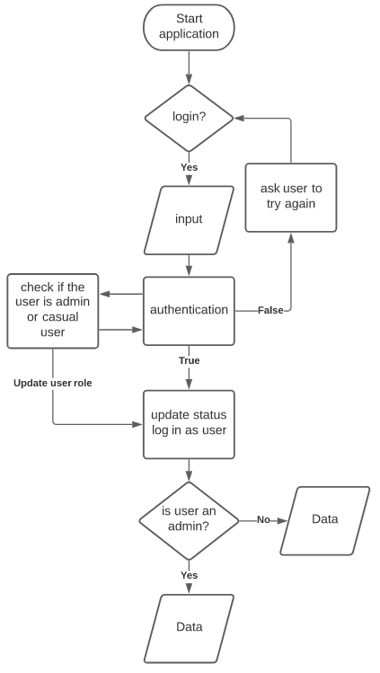

## Appendix 2 – MyProgrammingLab Progression

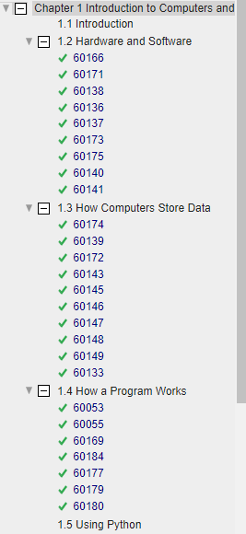

## Appendix 3 – MyProgrammingLab Progression

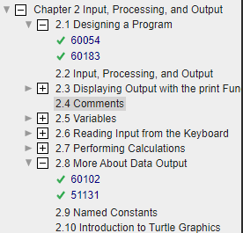

## Appendix 4 – Text Document code

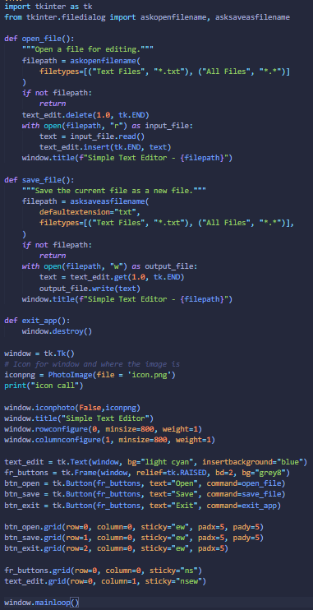

## Appendix 5 – Text Document GUI

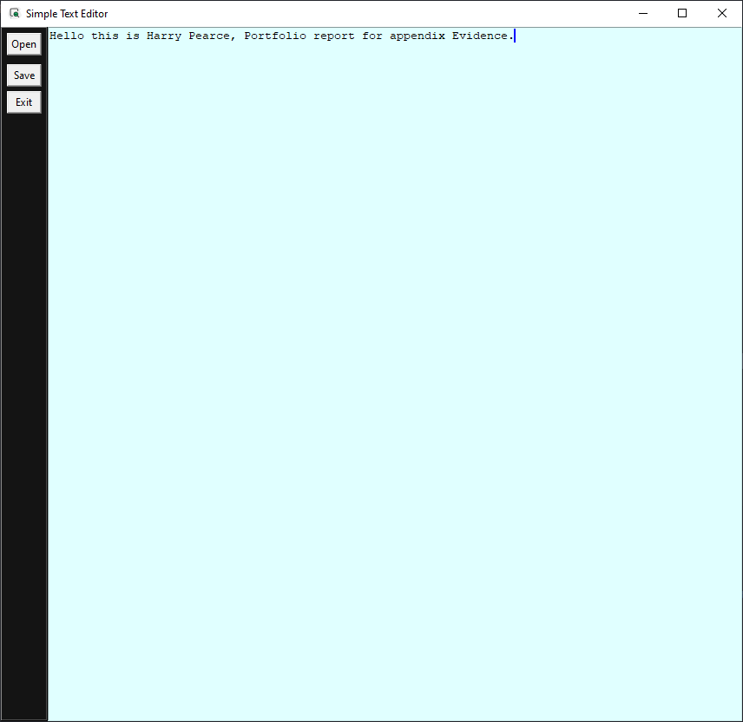

## Appendix 6 – QA of Application design and Installation

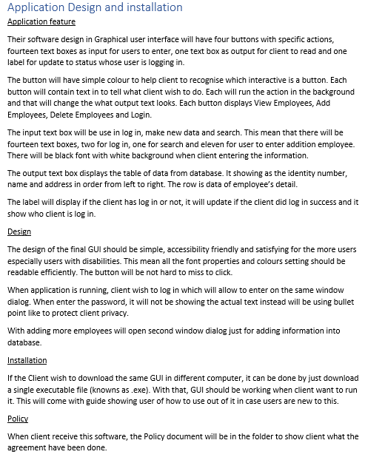

## Appendix 7 – three slide that I make for this seminar slideshow.

