CS2S567 Professional Practice and Employability:
Team Based Software Development Workshop

Portfolio

By
Jessica Fealy, 18024092

Team Number | 2
Team Task | Create a PIM system
Own role(s) and tasks in Team | Role:  Week 1 – 5 Team Organiser  Documentation  Programmer  Tasks:  Writing team portfolio weeks 1 – 5  Writing LESPI  Created flowchart  Researching Tkiner and SQLite  Created basic prototype for phase 1

Contents
Contents 2
Weeks 1 & 2 3
Weeks 3 4
Weeks 4 5
Weeks 5 6
Weeks 6 & 7 7
Weeks 8 8
Personal QA/ISSUE TRACKING Activity Overview Log 9
Appendix 12
Appendix 1 – GUI Plan 12
Appendix 2 – Discord creation 12
Appendix 2 – Team meetings time discussed 13
Appendix 3 – Spoken about what tasks are required to be completed 13
Appendix 4 – Trello board 13
Appendix 5 – Team work assignment 14
Appendix 6 – Week 4 work assignment 14
Appendix 7 – Week 4 Trello board 15
Appendix 8 – Slide show discussion 15
Appendix 9 – Week 4 programminglab 15
Appendix 10 – SQLite Research and SQLite creation 16
Appendix 11 – Flowchart 17
Appendix 12 – My slides 17
Appendix 13 – TKinter research 18
Appendix 14 – Form Creation 19
Appendix 15 – Speaking to Ben 19
Appendix 16 – LESPI 20

Weeks 1 & 2 | Project Setup
Author: Jessica | Team | Own
Activities undertaken | Over the following weeks I acted as team leader, here are my personal logs for the weeks I was team leader. You can find the team portfolio using the link below or submitted with this portfolio.  Overall, I am very happy with how my team work and cooperated over the 5 weeks  https://github.com/BenB33/ProfessionalismTeam2/blob/main/Team%20work/Team%20Portfoilo.odt | Created and annotated a GUI mock-up for how each component will work
Outcome of QA activities |  | Tried to create first simple interface with buttons and user input fields
Activities resulting from QA process |  | I created a discord channel for our team to talk and work together adding all members.  I began adding tasks we needed to complete.  I assigned members for the team work to do.
Personal QA development | Researched how to create a basic interface with limited usability.  Researched how to incorporate a database / CVS file with python  Learning each members abilities and how to assign them to work which will best suit their strengths
Evidence of own activities | Appendix 1 – GUI plan  https://github.com/BenB33/ProfessionalismTeam2/blob/main/Jessica/GUI%20PLAN.tif  Appendix 3 – Trello board  Appendix 4 – Discord creation  Appendix 5 – Teamwork assignments

Weeks 3 | Project Setup
Author: Jessica | Team | Own
Activities undertaken | I wrote this week team portfolio which can be found on the GitHub link found on Week 1, and which I have submitted with this portfolio | For the past 2 weeks I have written the LESPI and started on the quality assurance document.  I have also been working with myprogramminglab.  Ben and I had set up a time to meet to discuss the content required for the quality assurance document.  I have also been researching how to use SQLite with python
Outcome of QA activities |  | The LESPI has been written and the I have gained further understanding of python, TKinter and SQLite
Activities resulting from QA process |  | To further complete the quality assurance and to continue researching Tkinter and SQLite
Personal QA development | Written LESPI talking specifically talking about the computer misuse act and GDRP with Ufix policies on these.  Researched how to create tables and attributes using SQLite and python
Evidence of own activities | LESPI Document – GitHub link  https://github.com/BenB33/ProfessionalismTeam2/blob/main/Jessica/user%20gui.odt  Appendix 16 - LESPI

Weeks 4 | Project Setup
Author: Jessica | Team | Own
Activities undertaken | I wrote this week team portfolio which can be found on the GitHub link found on Week 1 | Assigned team members to work on.  Continued work on myprogramminglab to chapter 4.5
Outcome of QA activities |  | Trello board has been updated
Activities resulting from QA process |  | To continue work on myprogramminglab  To work with Komal in doing the flowchart  Finish my slides for seminar
Personal QA development | Speaking to the team members to help detail the work they have been assigned over the past 4 weeks and what they can talk about and evidence they can show for their work on the seminar
Evidence of own activities | Appendix 6 – Week 4 work assignment  Appendix 7 – Week 4 Trello board  Appendix 8 – Slide show discussion  Appendix 9 – Week 4 programminglab

Weeks 5 | Project Setup
Author: Jessica | Team | Own
Activities undertaken | Ben work from this week his team portfolio can be found using the same link found on week 1, and which I have submitted with this portfolio | As my last week being team leader, I assigned people to do their slides for the seminars and chased them up to ensure they were done in a timely manner. Once all slides are completed, I got Ben to add animations and transitions to the slides.  I done the functionality flowchart, SQLite research, and LESPI slides. Fully voiced over and images.  I have also completed the flowchart needed for user interaction with Komal completing the flowchart for the login
Outcome of QA activities |  | Team members began and completed their slides and as a team we watched through the slides to find any issues
Activities resulting from QA process |  | Flowchart completed  Seminar slides were completed
Personal QA development | Recording and editing audio for powerpoint presentations  Learning how to keep all team members to a schedule and chasing team members up for their slides to be completed  Reviewing slides with team members to discuss depth they have gone into and way they could improve the slides before submission
Evidence of own activities | Appendix 10 - SQLite Research and SQLite creation  Appendix 11 – Flowchart  Appendix 12 – My slides

Weeks 6 & 7 | Project Setup
Author: Jessica | Team | Own
Activities undertaken | Ben work from this week his team portfolio can be found using the same link found on week 1 | Throughout this week I had reviewed and submitted our teams comments for the feedback of the teams who had submitted their work. I also continued research on how to develop forms using tkinker.  And to continue work on myprogrammingklabs
Outcome of QA activities |  | Teams who had submitted their work in this period had their work reviewed and commented upon.  Progress has been made with understanding, namely on how different buttons and text boxes interact
Activities resulting from QA process |  | Further research on how grids can be used to effectively used to make the forms look more appealing  Team leader ben has asked me to begin work on the prototype
Personal QA development | Continued work onto myprogamming labs, many of the first chapters have been completed  Learnt how to use Grid with Tkinter along with other functionality of Tkinter
Evidence of own activities | Appendix 13 – Research

Weeks 8 | Project Setup
Author: Jessica | Team | Own
Activities undertaken | Ben work from this week his team portfolio can be found using the same link found on week 1 | Began working on the prototype for the project. Have completed a rudimentary log in screen, without any data being pulled from the databases.  All buttons, list boxes, and text box has been created with their function calls which haven’t been completed.  No data is yet being pulled from the databases
Outcome of QA activities |  | Need team assistance to create and pull data from database.  Need to continue work on the appearance of the data form  Need to create functionality of for the buttons
Activities resulting from QA process |  | After speaking to team leader Ben about issues I was facing he agreed too look at the prototype and see how he can change the appearance.  He has asked me to focus on the login screen and encryption of passwords and hell focus on the appearance.
Personal QA development | Created the first prototype for the solution  Spoken to team leader about issues facing, and he has given other things to look at while he looks at the problem  I have completed the login page for the prototype with a hardcode username and password for now – this will be changed to a database call
Evidence of own activities | Appendix 14 – First prototype  Appendix 15 – Speaking to Ben

Personal QA/ISSUE TRACKING Activity Overview Log

Issue | Week  date | Activities undertaken | Outcome of QA Activities | Activities resulting from QA Process | Personal QA development
1 | 1 | Created discord for all team members to use to communicate  Appendix 2 | All team members added to the channel | Assigned work for all team members to attempt before next meeting | N/A
2 | 1 | During the first week we discussed and summarised what we believe we had to be doing to create the PIM  Appendix 3 | We had a path where to go with the project | Team members were assigned various tasks based on their skill set | N/A
3 | 1 | Updated Trello board with base tasks that we had thought about that we needed to complete  Appendix 4 | All members were assigned a task on the trello board to work on | In the next meeting we will talk about what each team member was able to complete from their assigned tasks | N/A
4 | 1 | Created mock up of how the GUI is intended to look, this is to help guidance in writing the quality assurance doc  Appendix 1 | Mock up designed where other team mate (Ben) done a visual studio mock up to make sure the design looked how we wanted and was practical | Created a pending process to created the quality assurance document | In the future I would want to do further research into tkinter before attempting to make a mock up to ensure what is practical
5 | 2 | Began work on myprogamminglab | I have got to answered all questions to chapter 3 on myprogramminglab | Allotting time to do further work on myprogramminglab | N/A
6 | 3 | Researched LESPI principles and what items are required to be included on this | Had an idea and list of ideas that need to be written in the LESPI | To write a first draft LESPI for PIM | Doing this task I learnt the features and laws required to be written in an LESPI
7 | 3 | Wrote the LESPI and email to Shaily to get clarity on if it is down the right lines  Appendix 16 | Confirmation from Shaily that LESPI looks good, but to explicity mention Computer misuse Act | To write the final draft of the LESPI | To delete this task to more than 1 team member ( myself) to ensure that more people have input on this
8 | 4 | Updated Trello board to reflect what has been currently done  Appendix 7 | All tasks completed has been updated on the Trello board | To continue with the project and regularly updating the trello board | To remember to update the trello board with a more regular occurrence
9 | 4 | Discusses with teams members of what each should include on there powerpoint slides  Appendix 8 | Each team member has written down what each of them are expected to created for the powerpoint | Teams members are to go and complete their slides | To have this conversation with team members at an earlier time
10 | 4 | Continued work on myprogramminglab  Appendix 9 | Completed up to chapter 4 | To focus on other tasks for this project and other commitments and do myprogramminglab when there is time | N/A
11 | 5 | Researched SQLite, namely how to create tables and entities. And using Python and SQlite created a basic database  Appendix 10 | Can create a very basic database using Python and SQLite | Need to further research how to pull data from a CVS file and add this data to a SQLite database. Need to speak to team members to further help with this | Research how to pull data from a CVS file into a SQLite database
12 | 5 | Completed flowchart showing the logical interactions a user can have with the project  Appendix 11 | Flowchart created | Added this flowchart to the seminar slides
13 | 5 | Begin work on creating my slides for the seminar | Have a rough layout on what I want to talk about | To compete the final look and to voice over my slides | N/A
14 | 5 | Creating slides for the powerpoint, audio, text and pictures  Appendix 12 | My slides with recording have been completed and uploaded to github | Needing to chase up team members to ensure their slides are completed in time | To not read from a script while recording audio for these slides and speak more naturally
15 | 6 | Going though all work which has been submitted by other teams and submitted feedback | All team should’ve received their feedback from us | As a team we have discussed things we have learned from other teams slides and how we can improve ours in the future | Learnt how other teams have created and formatted their slides and have taken ideas. Also learnt what other teams are creating
16 | 7 | Researching how to use form functionality and implementations  Appendix 13 | Learnt how to place buttons and use button clicks to open new forms and pass data between forms. Learnt how text boxes work and how to send text to different forms | Implement these objects onto the prototype | Learnt how to use different tkinter elements and feel more comfortable implementing this into a prototype
17 | 8 | Begin work on prototype, namely the login screen  Appendix 14 | Created the login screen with a hard coded username and password and a very basic main form | Tested the login form to make sure it works as planned. Next phase need to allow database calls to ensure only correct users can access the system. Not very happy with how the screen looks | Happy with the login screen, and satisfied with the current functionality.  Need to learn a better way to the grid system.
18 | 8 | Finding issues using grids and ensure they look presentable  Appendix 15 | Needing to speak to team members to figure out better methods to make this work. | After speaking to Ben, he suggested to use positional placement over grids and has taken over changing the appearance of the form | Learnt about positional placement rather than using grid placements for objects

Appendix

Appendix 1 – GUI Plan

Appendix 2 – Discord creation
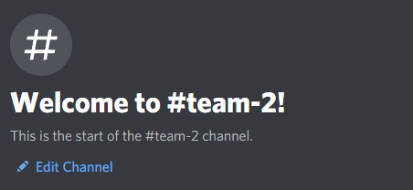

Appendix 2 – Team meetings time discussed
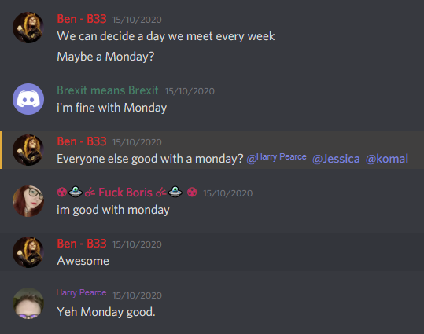

Appendix 3 – Spoken about what tasks are required to be completed
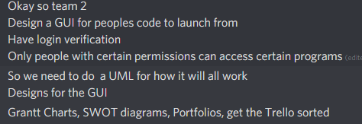

Appendix 4 – Trello board

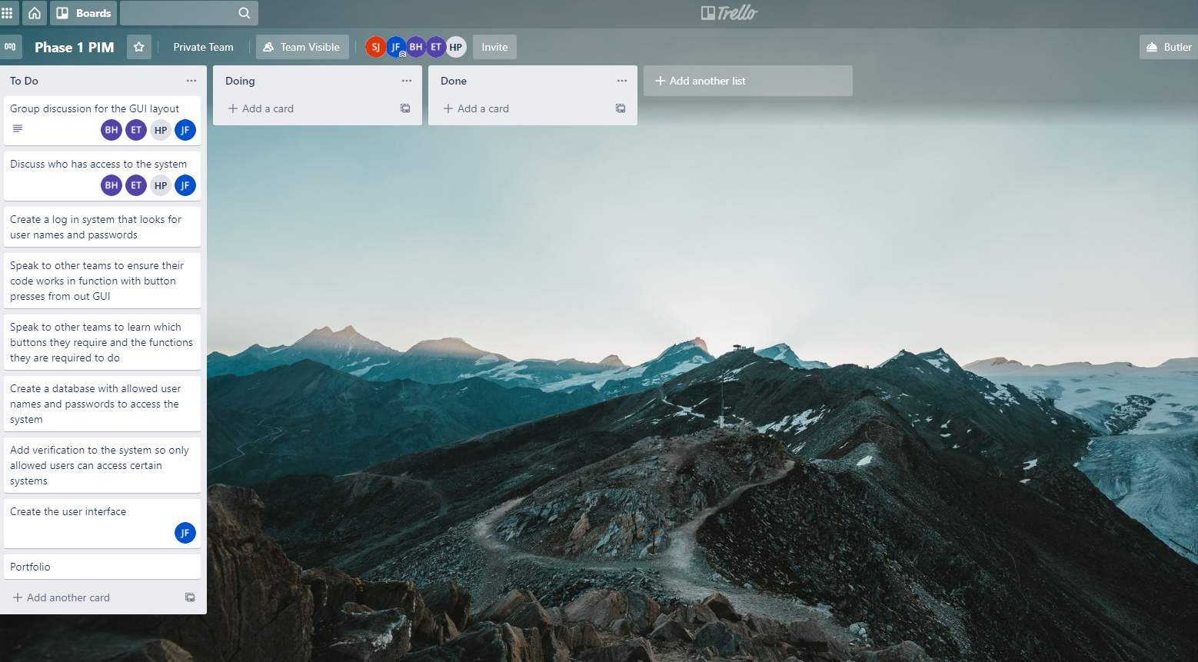

Appendix 5 – Team work assignment
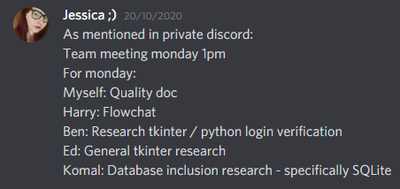

Appendix 6 – Week 4 work assignment

Appendix 7 – Week 4 Trello board
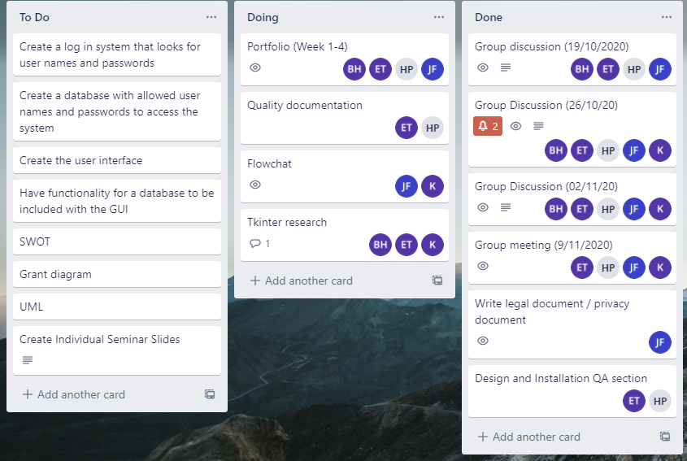

Appendix 8 – Slide show discussion
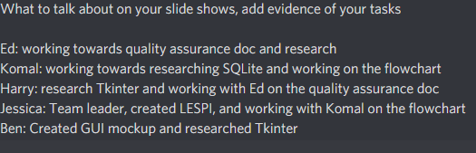

Appendix 9 – Week 4 programminglab
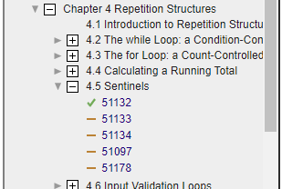

Appendix 10 – SQLite Research and SQLite creation

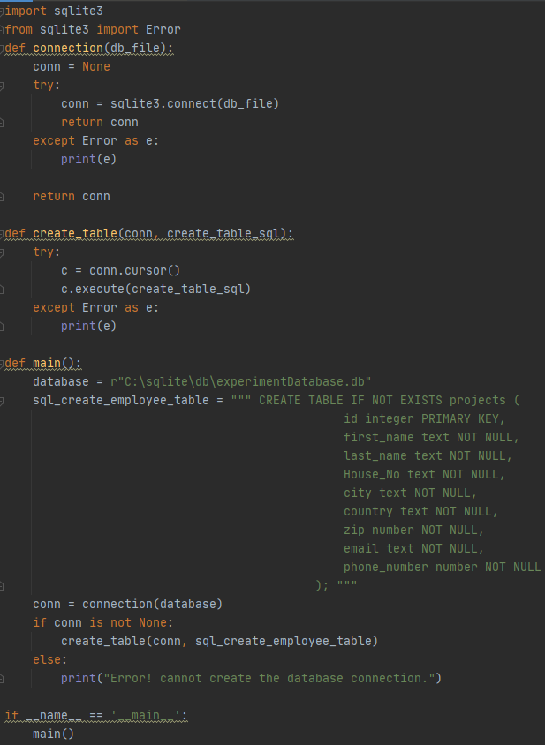
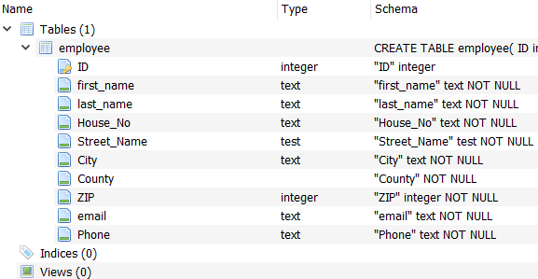

Appendix 11 – Flowchart

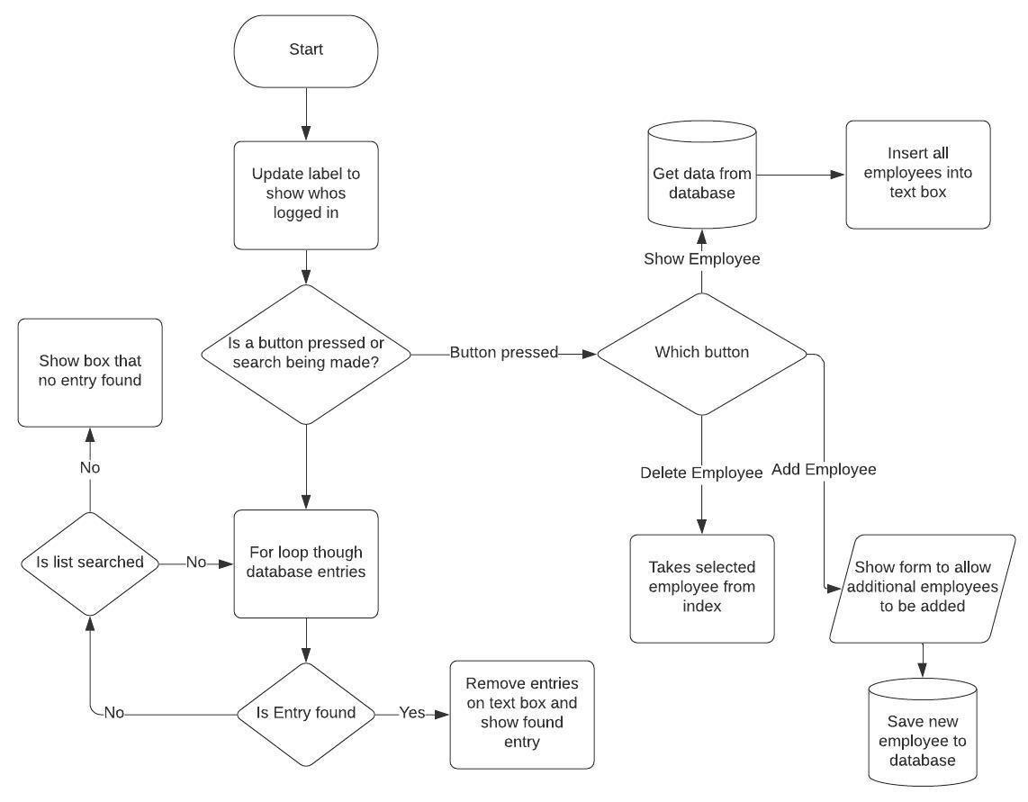

Appendix 12 – My slides
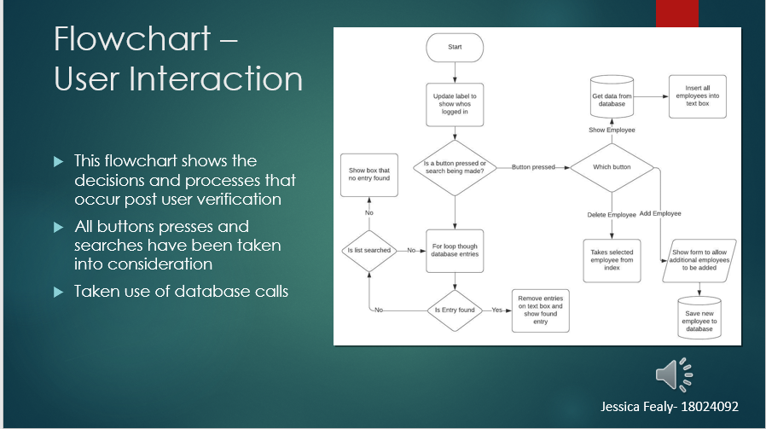
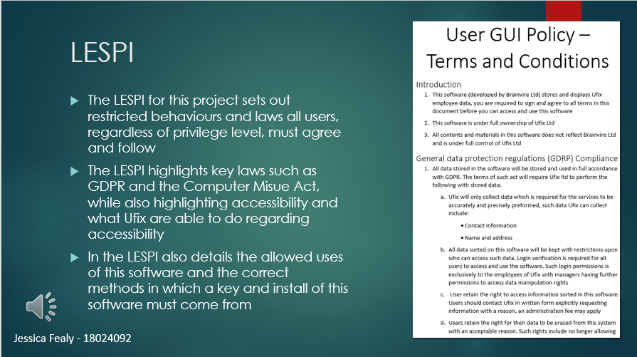
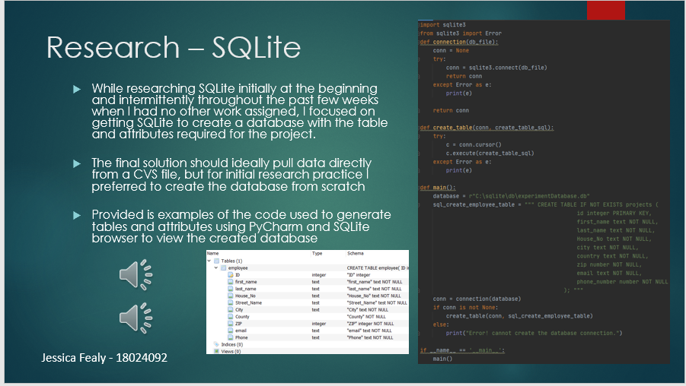

Appendix 13 – TKinter research

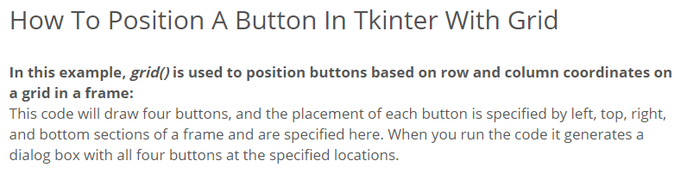

Appendix 14 – Form Creation

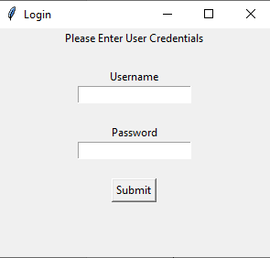
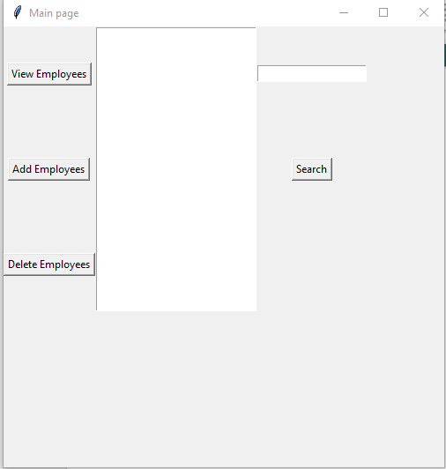

Appendix 15 – Speaking to Ben

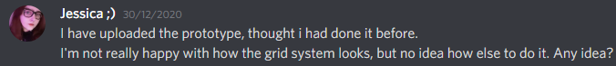
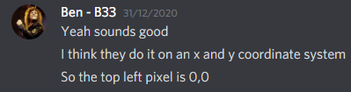

Appendix 16 – LESPI

