CS2S567 Professional Practice and Employability:
Team Based Software Development Workshop

Portfolio

By
Jessica Fealy, 18024092

Team Number | 2
Team Task | Create a PIM system
Own role(s) and tasks in Team | Role:  Week 1 – 5 Team Organiser  Documentation  Programmer  Tasks Phase 1:  Writing team portfolio weeks 1 – 5  Writing LESPI  Created flowchart  Researching Tkiner and SQLite  Created basic prototype for phase 1  Tasks Phase 2:  Supporting developer role  Created scenario-based use cases which will help with testing the program  Researched C++ for seminar  Helped to create and reference vulnerability document – week 18  Created python XOR code, using B as a key  Tasks Phase 3:  User guide  Final Documentation  De facto team coordinator  Seminar

Overview
Over the period of phase 3 I have done several tasks, and effectively communicated with my team members when required. Most of our work was completed by the end of Phase 2, this is due to our phase 3 seminar being the first to be delivered.
Throughout this phase I have learnt how to further communicate with both the team and Shaily when required.

Throughout this project I have taken on multiple tasks, some of which were outside of my comfort zone (notably being a team leader), but I have further learnt how to effectively communicate, delegate, and chase up issues with my team members.

During phase 3 I was responsible for 2 main topic areas, the User guide, and the Final documentation.

Issues and resolutions for Phase 3
During phase 3 only a few issues were encountered. Firstly, being needing assistance from the team, and more specifically help from Ben to complete the User guide. To resolve this I reached out to my team members requesting a team meeting the following day. The preceding team meeting subsequentially allowed me to complete the user guide.

The other notable issue occurred with a confusion of what was required to be completed for this phase. This resulted in me reaching out to Shaily Jain to seek assistance and advice. Through communications via Teams all issues were resolved. I feed this message back to my team to help any of this that required help.
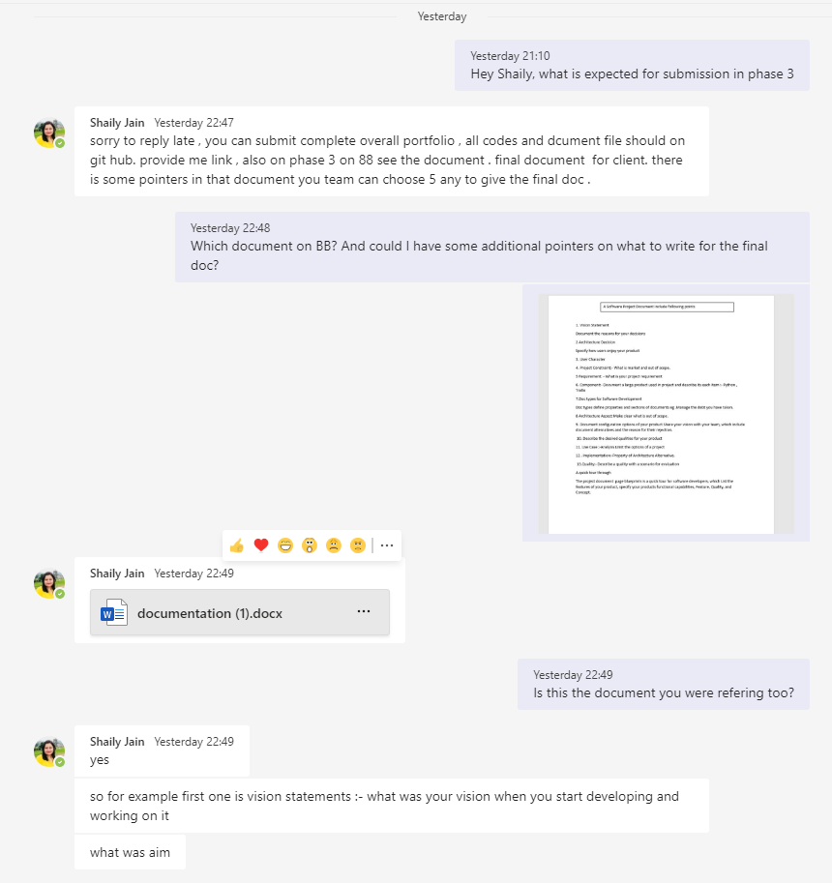
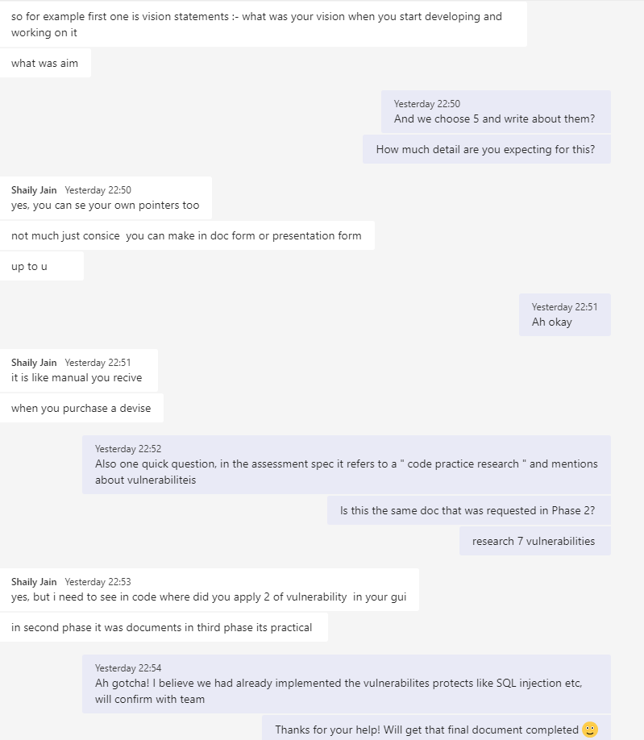

User guide
During this phase it was my responsibility to write the User Guide for my teams PIM system. For this I required to have a team meeting to discuss with team members what should the contents of this guide should contain. I further communicated with Ben about the technical limitations and processes of the systems to further explain this in the user guide. The guide took several weeks to finalise due to external circumstances. Any issues were resolved efficiently with team members. Due to Ben being the most familiar with the finalised PIM system, I required his assistance in acquiring images that were used to further document and detail in the user guide. Once I had completed the User Guide I presented this to my team members for this feedback.

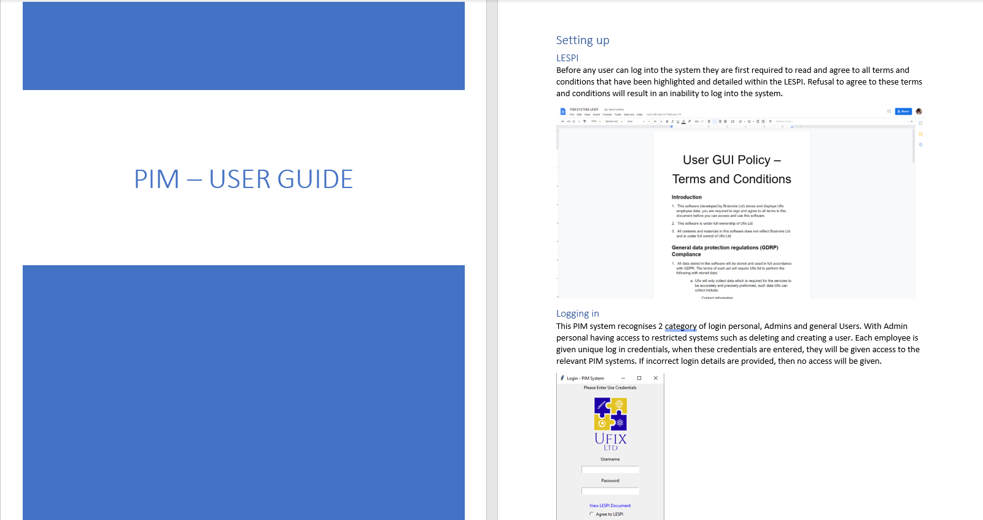
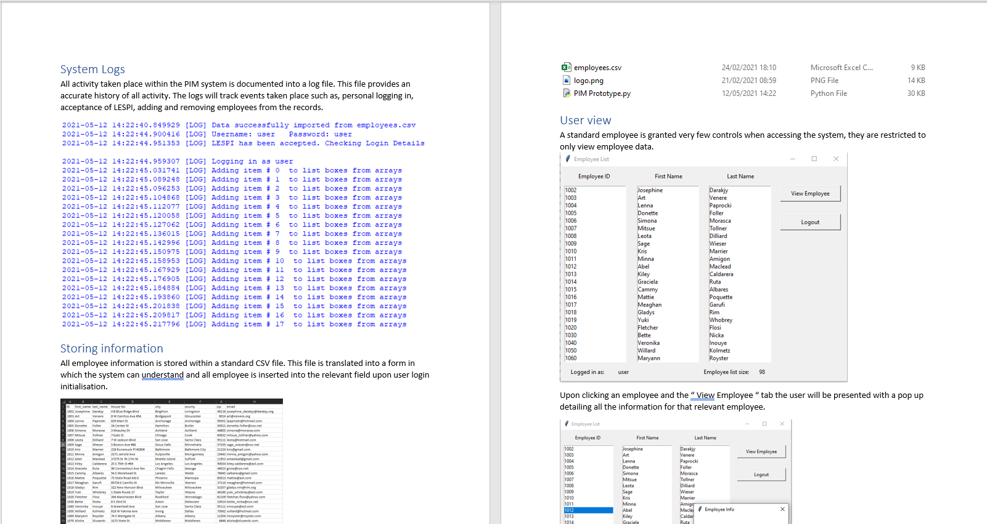
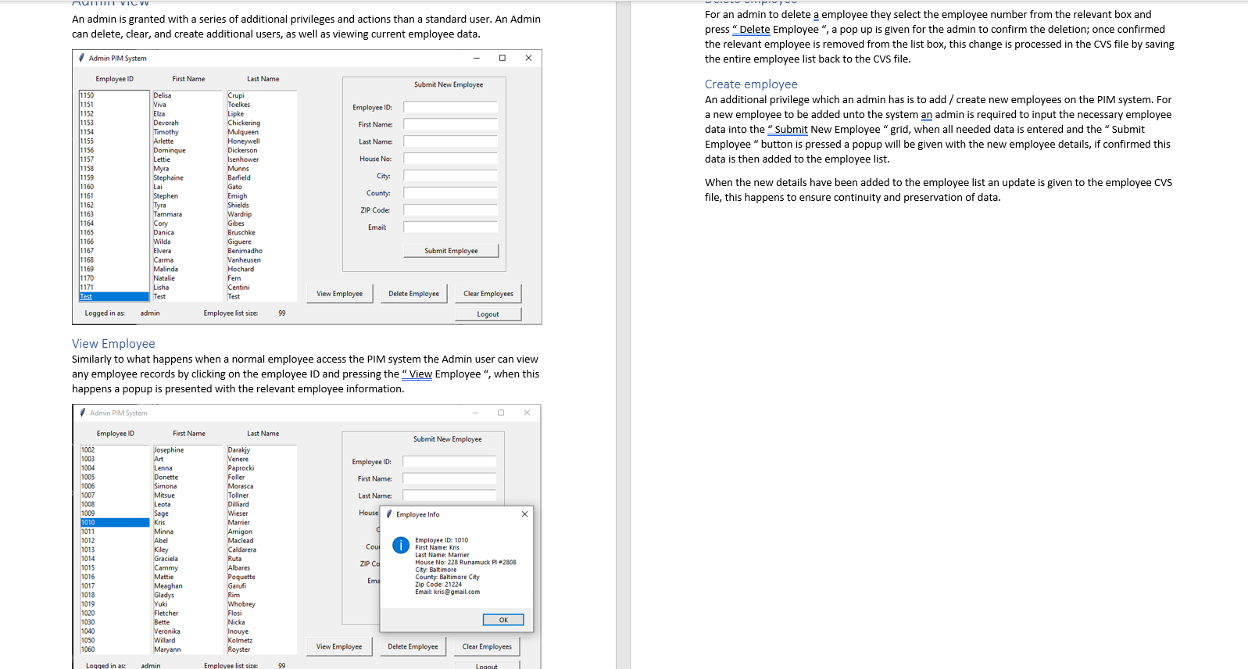

Final Documentation

