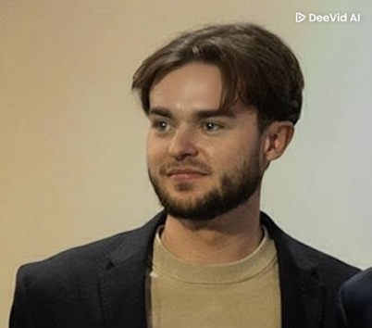
Benjamin BAHUREL
23, chemin du Purgatoire
74000 Annecy
+33 7 81 54 42 74
benjamin.bahurel@gmail.com
28 février 2002

LinkedIn Portfolio Github

EDUCATION
EPFL – 1002 Lausanne

2024-2026: MSc in Robotics (ongoing) – EPFL – (GPA 4.0).
2020-2024: BSc in Microengineering – EPFL – (GPA 4.0)

LYCEE SAINT MICHEL – 74000 Annecy

2019-2020: Final year of high school (Scientific track, European Section - English, with Spanish as a second foreign language)

- Specialization : Mathematics
- Awarded the Scientific Baccalaureate with European option, with High Honors ("Très Bien") – (17,9/20)

WORK / TEACHING EXPERIENCE
EPFL – 1002 Lausanne
2025-now: Cleanroom Operator Fabrication of devices for nanofluidic measures
2024-now: Teaching Assistant Support provided to students through lectures / exercise sessions
07/2023: Machining Engineer Intern. Precision of parts production at ETML, Lausanne
2022-2023: Coaching Organization of integration events, AGEPoly (student association)
MÉDIPÔLE SAVOIE – (Clinical) – 73910 Challes-les-Eaux
Pharmacy Assistant Preparation of medication / equipment for various department Warehouse Operator Manages medication inventory and distribution
August 2020/2021:
July 2020:

INTHEBOX – 74000 Annecy
June 2020: Observational internship Discovery internship on VFX and animation

SKILLS
LibreOffice and Microsoft Office Suite (Word, Excel, PowerPoint)
Python, C, C++, MATLAB, Git, GitHub, PyTorch and Machine Language programming
CAD Softwares – CATIA, SolidWorks, AutoDesk Fusion 360, KLayout, FlexSim
Basic knowledge of HTML, CSS and JSON programming
Hands-on with cleanroom equipment (spin-coater, photolithography, dry/wet etching, metrology)
Proficient in using various social media platforms

LANGUAGES
French: C2 (Native) English: C1 Spanish: B2

OTHERS
License / certificate: - Driver's license (Category B) in 2020
- Boat license in 2024
- PSC1 certificate (First aid training) in 2018
- Level 2 (PA20 / PE40) in scuba-diving

Sports: - Competition, Freeride and Freestyle skiing (FWT Junior participant)
- Tennis (15/3) and Padel
- Scuba-diving, trail, kitesurfing, wakeboarding, climbing

