**Nov 25, 2023**

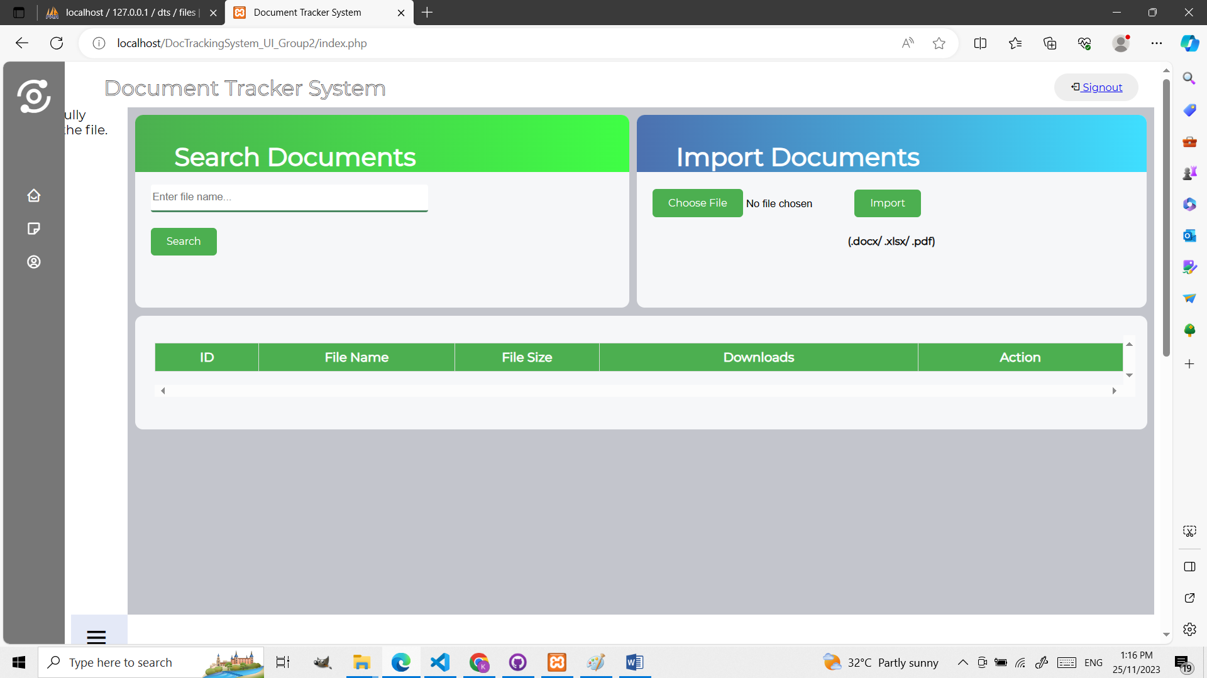

Polishing on the UI was resumed by Ms. Tupaz. Card headers were added to the search ‘Documents Card’ and ‘Import Documents’ card to create a more gratifying look. The color palette that was chosen at this time was yet to be finalized, hence, the empty ‘Document Tracker System’ header and the differing colors of the top cards and buttons. Lastly, Ms. Tupaz made changes to the input field of the ‘Search Documents’ card to fit the current style of the landing page.

**Nov 26, 2023**

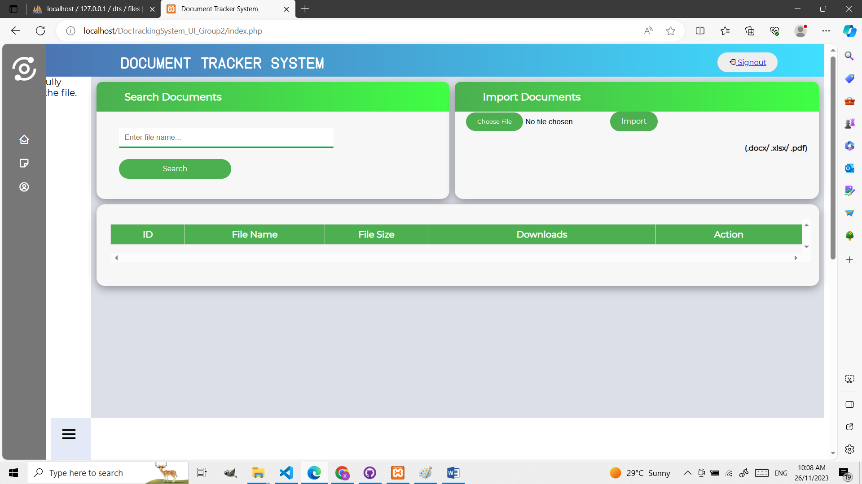

Since there was an issue with the signout button having a hyperlink underline which was quite displeasing to the eye, Ms. Tupaz began working on that. The text inside the card headers were changed as well to something less distracting and box shadows were added to the cards to accentuate. Ms. Tupaz then began working on the misaligned buttons on the ‘Import Documents’ card after the style changes.

**Nov 27, 2023**

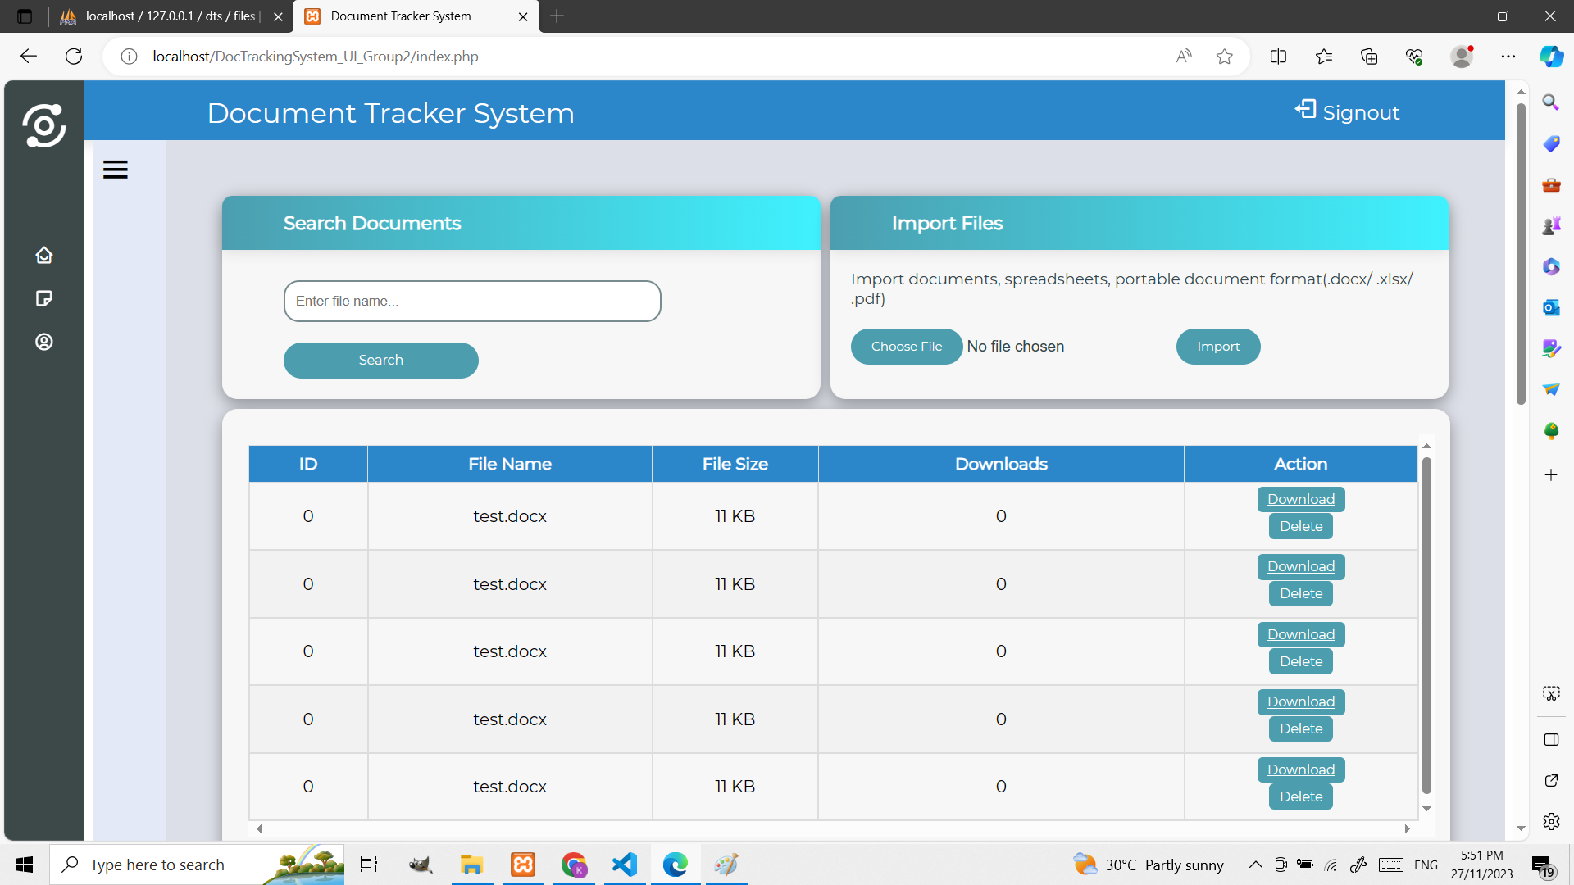

The underline and blue hyperlink color of the signout button was fixed and the color palette for the landing page was also changed from green to blue. Ms. Tupaz made this choice as blue is found to be a more industrial look than green, which fits the general context of the Document Tracker System. The padding of the landing page was also changed and a border was added for the input field, which is now much easier to visually see compared to the previous input field style.

**Nov 29, 2023**

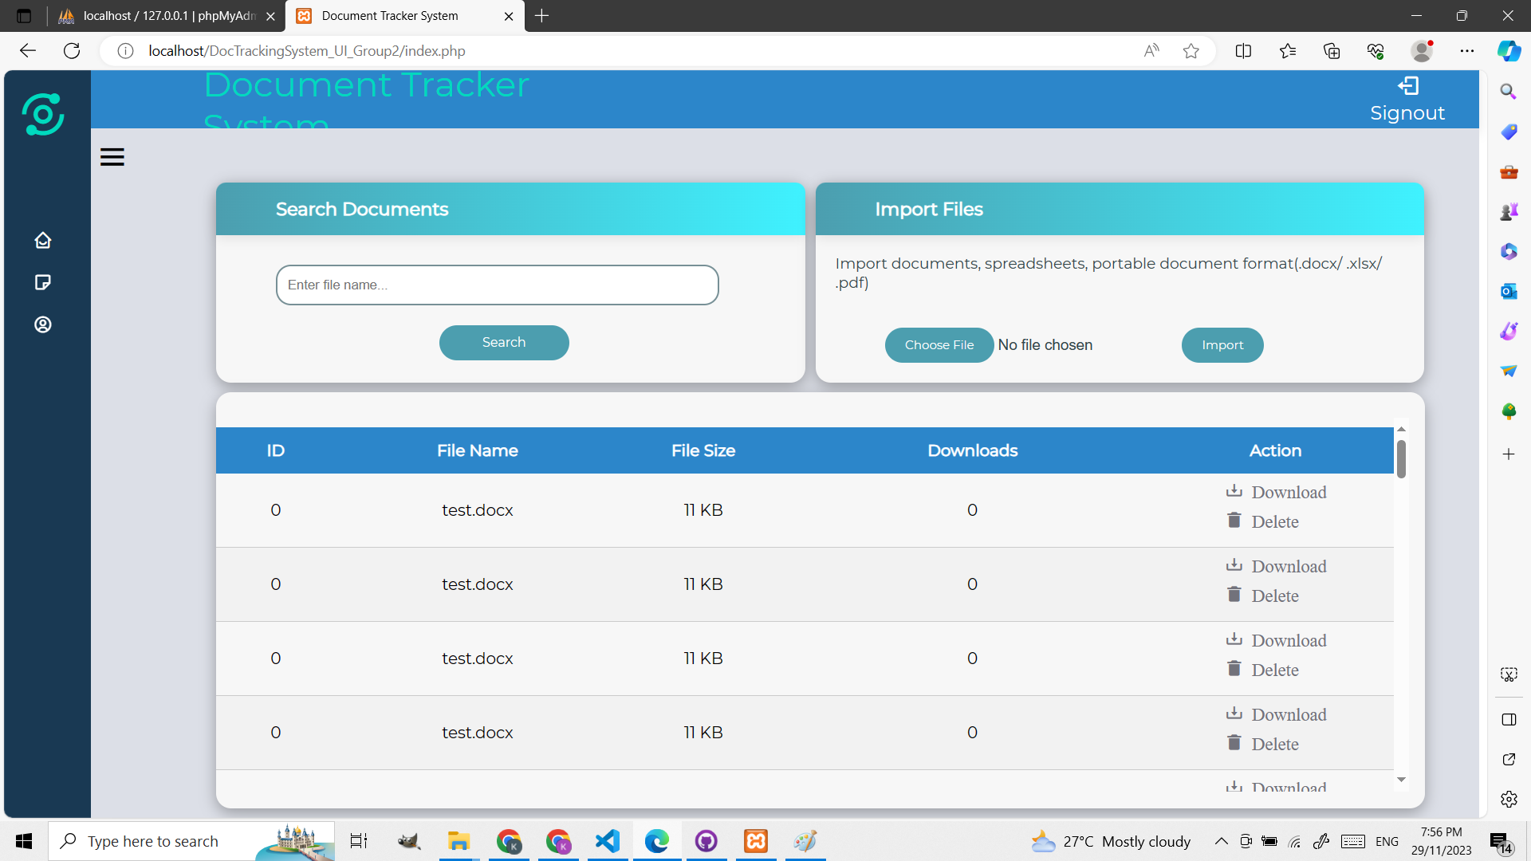

Ms. Tupaz added icons to the action buttons on the table and changed their styles from blue buttons to buttons with transparent background color; since this style made the action buttons less compact, it is much easier to look at compared to the previous colored background of the action button. She also made slight style changes to the table - the table is now ‘fitted’ inside the card and the border was removed. This is to create a more modern look to accentuate the theme of the landing page.