***Ara Department of Computing***

Assignment Cover Sheet

|  |  |
| --- | --- |
| **Student Name:** | Ben Orpwood |
| **Student ID:** | 99218426 |
|  |  |
| **Course code:** | BCIS207 |
| **Assignment:** | 2 |
|  |  |
|  |  |
| **Tutor(s):** | Bernard Otinpong |

|  |  |
| --- | --- |
| Word Count: | 159 |
| Date: | 25/10 |

I ______________________________________ (student/s signature/s) hereby declare that this assignment is all my/our own work, and any sources are referenced and cited.

Contents

Task 1 2

Task 2 2

Task 3 4

Task 4 5

Task 5 5

Task 6 6

Task 8 7

# Task 1

I created a backlog of stories.

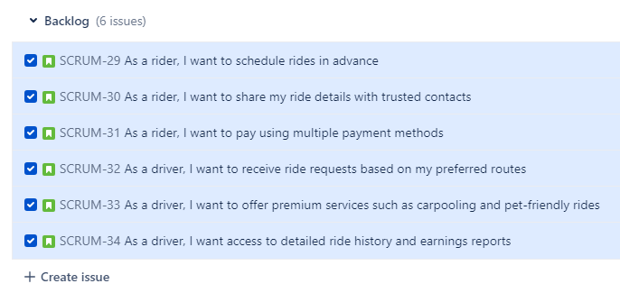

# Task 2

I 6 stories for the epic 3 for a driver 3 for a user

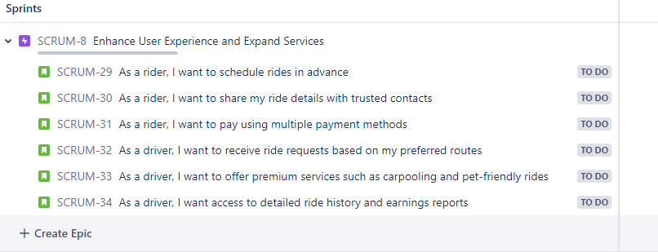

# Task 3

I made 2 child issues for each story

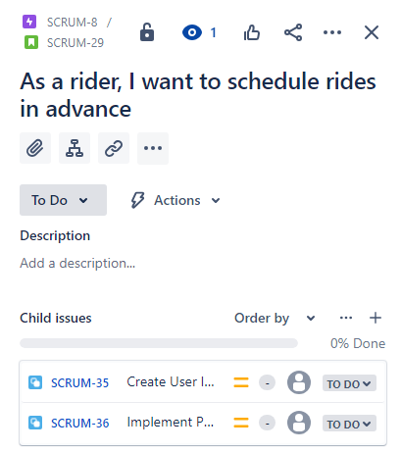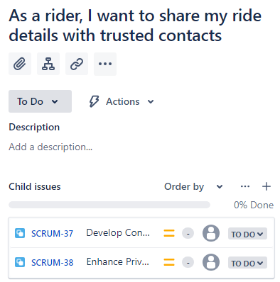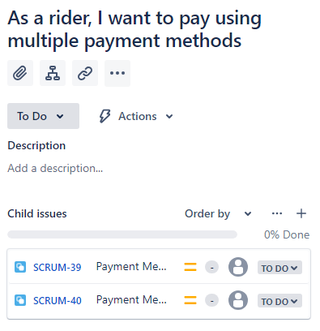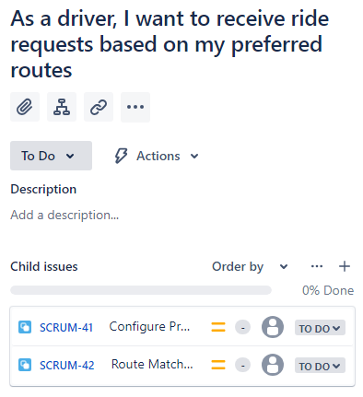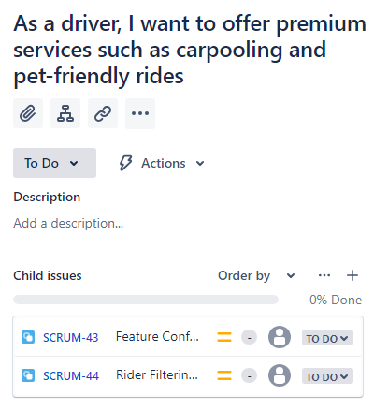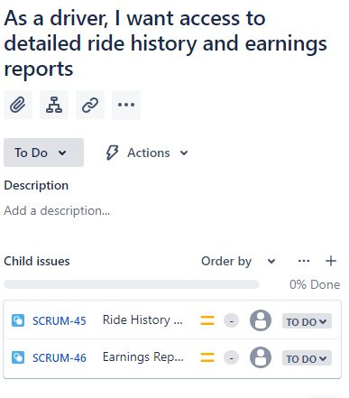

# Task 4

I split the stories up into 3 sprints

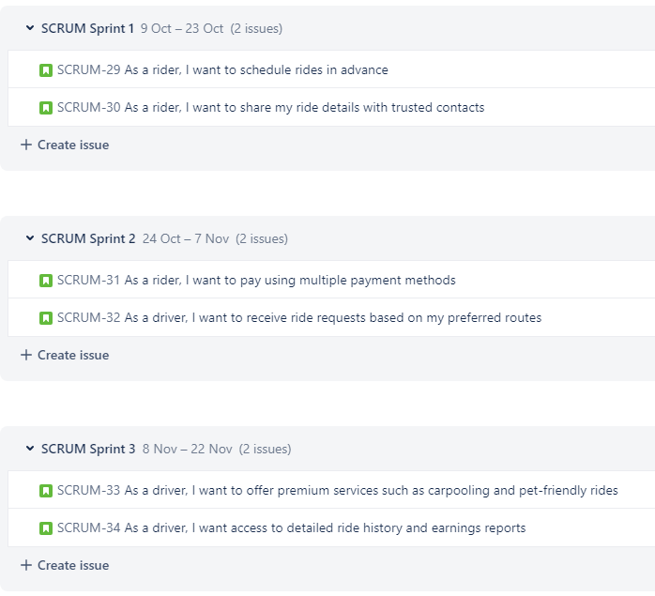

# Task 5

I made a timeline of the sprints

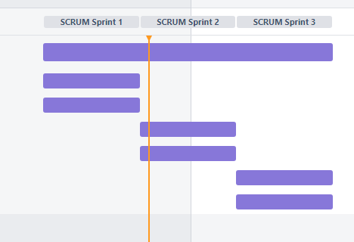

# Task 6

I made a Kanban board.

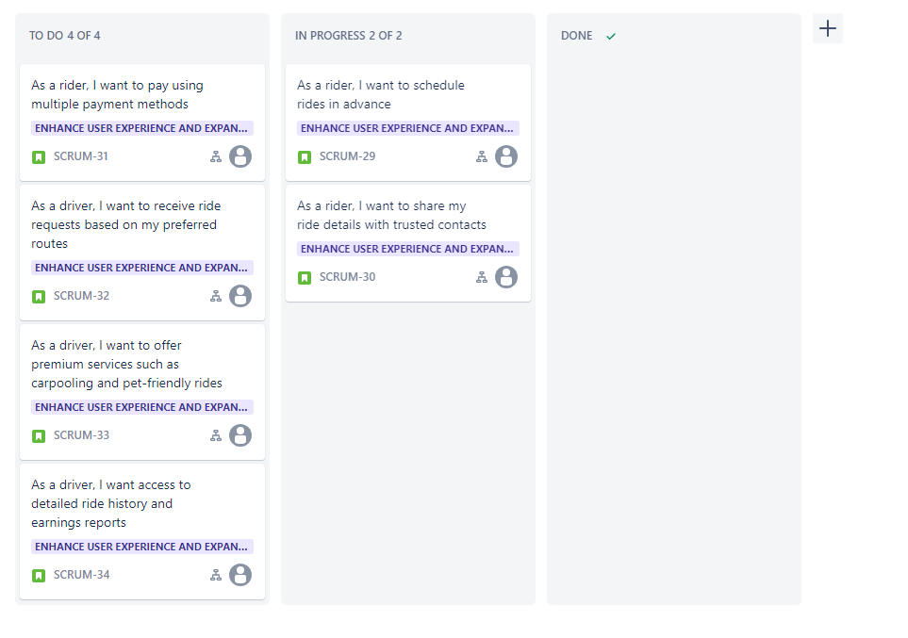

# Task 8

I then skipped task 7 and made a work down chart.

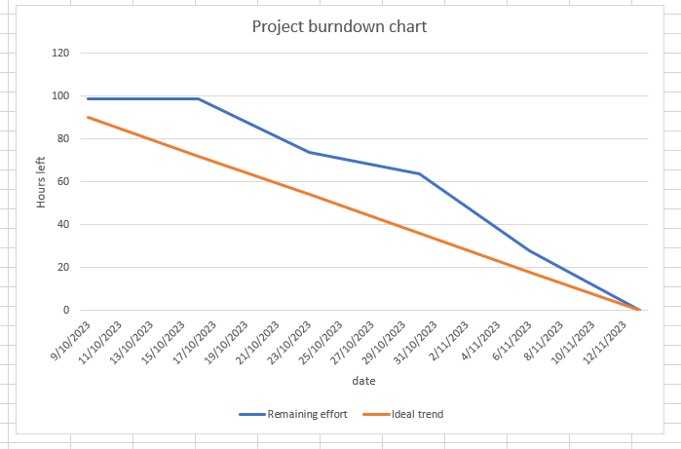

The burn down chart show that the project experienced a slow start and required significant catch-up efforts in Weeks 2 and 4. but, by the end of Week 5, the project was closer to the planned work hours, indicating progress.