# Summary

|  |  |  |  |  |
| --- | --- | --- | --- | --- |
| Syntax Features | Source Code From | | | |
| In-class demos | Referenced PHP tutorials | Homework exercises or personal practice | Assessment |
| 1. PHP tags, escaping html, Instruction separation |  |  |  |  |
| 2. Variables: basic types, globals, scope, predefined variables, constants |  |  |  |  |
| 3. Namespaces, include, require |  |  |  |  |
| 4. Coding Conventions |  |  |  |  |
| 5. Arrays, foreach |  |  |  |  |
| 6. Selection |  |  |  |  |
| 7. Iteration |  |  |  |  |
| 8. Functions |  |  |  |  |
| 9. Strict types, type hinting, |  |  |  |  |
| 10. Classes, properties, constructors and destructors, visibility |  |  |  |  |
| 11. OO “tricks”: inheritance, static, abstract, interfaces |  |  |  |  |
| 12. Error handling, try, catch, throw, finally |  |  |  |  |
| 13. Cookies |  |  |  |  |
| 14. Sessions |  |  |  |  |
| 15. REST |  |  |  |  |
| 16. Passwords |  |  |  |  |
| 17. Regular expressions |  |  |  |  |
| 18. il8n |  |  |  |  |
| 19. String functions |  |  |  |  |
| 20. MySQL Improved Extension |  |  |  |  |

# PHP tags, escaping html, Instruction separation

PHP tags

## Code from in-class demos

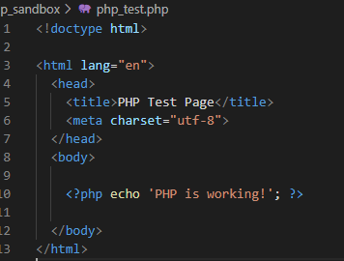

## From referenced PHP tutorials with a unique example

https://www.php.net/manual/en/language.basic-syntax.phptags.php

## Code from homework exercises or personal practice

Short echo tag



PHP script without closing tag at the end

Escaping HTML

Instruction separation

## Code from assessment