# PHP TAGS, ESCAPING HTML, INSTRUCTION SEPARATION

## Code from in-class demos

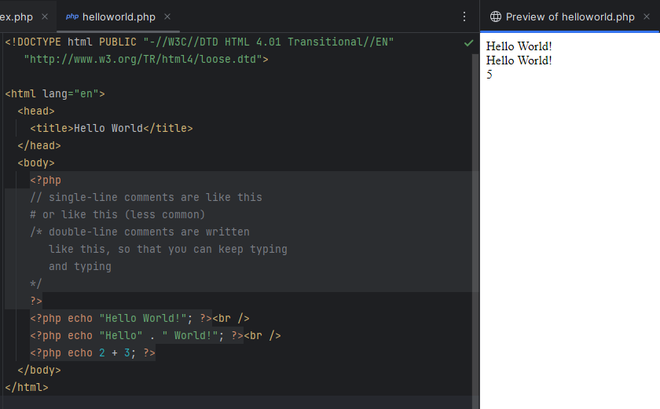

## From referenced PHP tutorials with a unique example

https://www.php.net/manual/en/language.basic-syntax.phptags.php

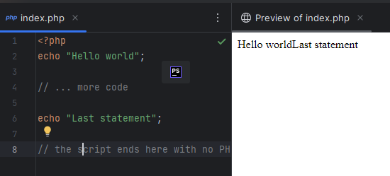

https://www.php.net/manual/en/language.basic-syntax.phpmode.php

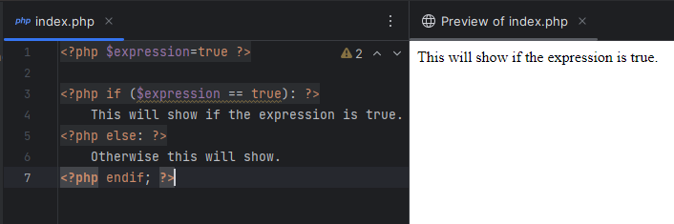

https://www.php.net/manual/en/language.basic-syntax.instruction-separation.php 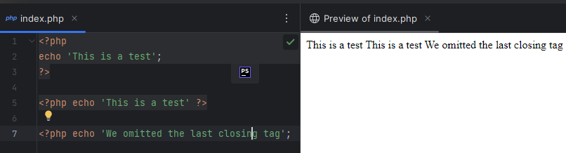

## Code from homework exercises or personal practice

Php with no closing tag

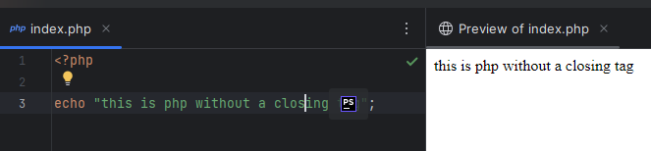

Instruction separation

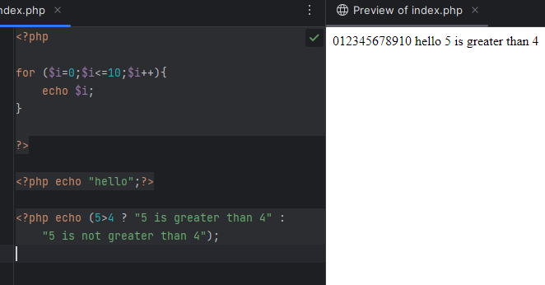

Short php tags

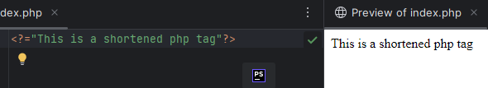

# Variables: basic types, globals, scope, predefined variables, constants.