**Progr Projet 2GIN**

**Game: Color Bouncing Ball**

The principle of the game is that the ball bounces off the walls within the circle and changes color each time it hits a wall. The ball turns into a color that the circle must be turned to in order to avoid losing the game. Players can use the mouse to rotate the circle in any direction to continue collecting points.

You can rotate the game circle by 40 degrees using the left mouse button to turn it to the left or the right mouse button to turn it to the right. The goal of the game is to keep the bouncing ball inside the circle for as long as possible. You earn one point for each collision with the correct color in the circle. The current score is displayed during the game on top of the game area.

As the game progresses, the ball bounces faster and faster within the circle until the ball touches the non-corresponding color and then the game is over. A loser screen appears where you can restart the game.

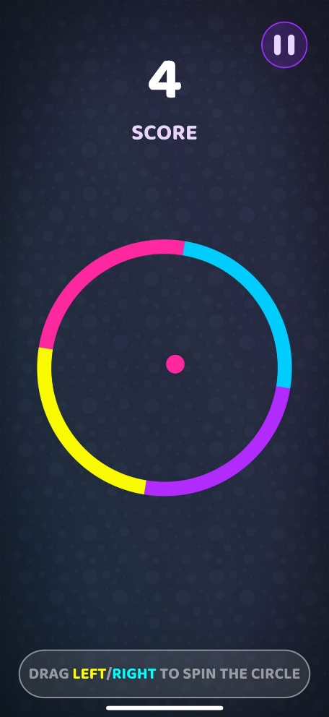

First Ideas:

Ein Bild, das Text, Handschrift, Screenshot, Kreis enthält.

Here is the first sketch I prepared on the first day of the project with a few side notes about the future project.

Different classes:

* **Ball**: Game ball with movement and collision logic.
* **Circle**: Game circle that catches the ball and moves.
* **Game**: Contains game logic and manages game objects.
* **Background**: Base class for drawing a background.
* **GrayBackground**: Inherits from Background, draws a gray background.
* **BlackBackground**: Inherits from Background, draws a black background.
* **MainFrame**: Main window of the application contains the game and timer.
* **LooseFrame**: Window displayed when the game is lost.
* **DrawPanel**: Panel for drawing game objects.
* **Utils**: Utility, includes random number generation.

|  |  |  |
| --- | --- | --- |
| **Planned** | **In Progress** | **Done** |
| **Sprint 1 – 10.05.2024** | | |
| Mainframe | Class: Ball | Create Classes |
| Drawpanel | Class: Circle |  |
| Implement Extends | Class: Game |  |
| **Sprint 2 – 24.05.2024** | | |
| Class: Ball   * Collision | Mainframe   * Add Timer | Mainframe   * Mouse Buttons |
| Implement Extends |  | Drawpanel   * Set the game |
| **Sprint 3 – 07.06.2024** | | |
| Implement Extends | Class: Game   * Game Over | Class: Ball   * Collision * Right Ballcolor |
|  |  | Class: Circle |
|  |  | Mainframe:   * Add Timer |
| **Sprint 4 – 21.06.2024** | | |
|  |  | Class: Game  Scoresystem |
|  |  | Class: Ball  Random xDir, yDir |
|  |  | LoosingFrame:   * GameOver Menu |
|  |  | Implement Extends:   * Class: Background   Class: GrayBackground  Class: BlackBackground |

**Ein Bild, das Text, Screenshot, Diagramm, parallel enthält.
UML:**