**Progr Projet 2GIN**

**Game: Color Bouncing Ball**

Structure:

The principle of the game is that the ball bounces off the walls within the circle and gets a different color each time. The ball turns into a color in which the circle must be turned in order not to lose the game. You can use the mouse to turn the circle in any direction to continue collecting points. You can rotate the Game circle by 30 degress by using the left mouse button to turn it to the left or the right button to turn it to the right. The goal of the game is to keep the bouncing ball in the circle for as long as possible. You get one point for each collision with the correct color in the circle. The current score is also displayed during the game. The ball bounces faster and faster through the circle the longer the game lasts

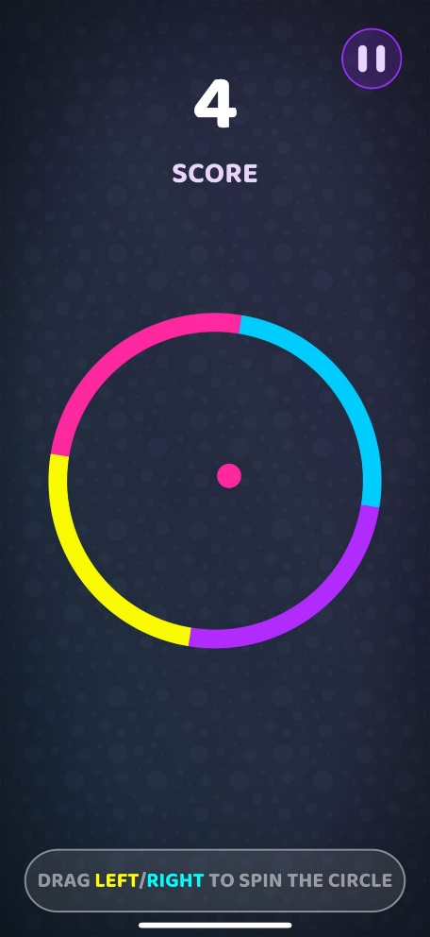

Classes:

* Class Circle
  + Properties of the Circle
    - x, y, color, radius, angle
    - Circle() // Set x and y of the circle
    - moveLeft() // rotate 30 degrees to left
    - moveRight() // rotate 30 degrees to right
    - draw() // draw the game circle
* Class Ball
  + Properties of the Ball
    - x, y, xDir, yDir, radius, color
    - Ball () // set x and y of the Ball
    - isHit() // check if ball hits the circle wall
    - move() // moves the ball after hitting the wall
    - draw() draw the ball
* Class Game
  + Methods:
    - CheckIfLoose()
    - Score System
    - isHit()
* Class MainFrame
* Class DrawPanel