**Progr Projet 2GIN**

**Game: Color Bouncing Ball**

Structure:

The principle of the game is that the ball bounces off the walls within the circle and gets a different color each time. The ball turns into a color in which the circle must be turned in order not to lose the game. You can use the mouse to turn the circle in any direction to continue collecting points. You can rotate the Game circle by 30 degress by using the left mouse button to turn it to the left or the right button to turn it to the right.

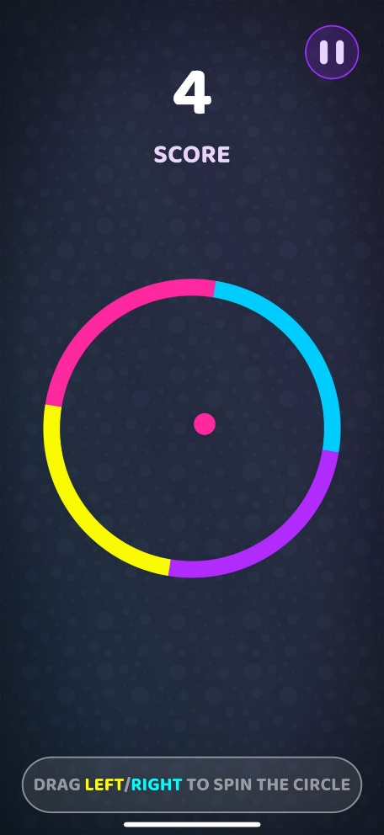

Classes:

* Class Circle
  + Properties of the Circle
    - Color / Direction
    - Rotate
* Class Ball
  + Properties of the Ball
    - X, Y / xDir, yDir
    - Color
    - Radius
* Class Game
  + Methods:
    - CheckIfLoose()
    - Score System
    - isHit()
* Class MainFrame
* Class DrawPanel