Understanding the PalmettoBUG Interface
This page of the documentation is dedicated to all the peculiarities, idiosyncrasie, and graphics-focused details s of the PalmettotBUG GUI.

The Directory Display:
On most pages of the program, except the entry screen, you will find a “directory display” panel. These start out empty / blank, and load when data into loaded into the appropriate part of the program. When loaded they look like this:
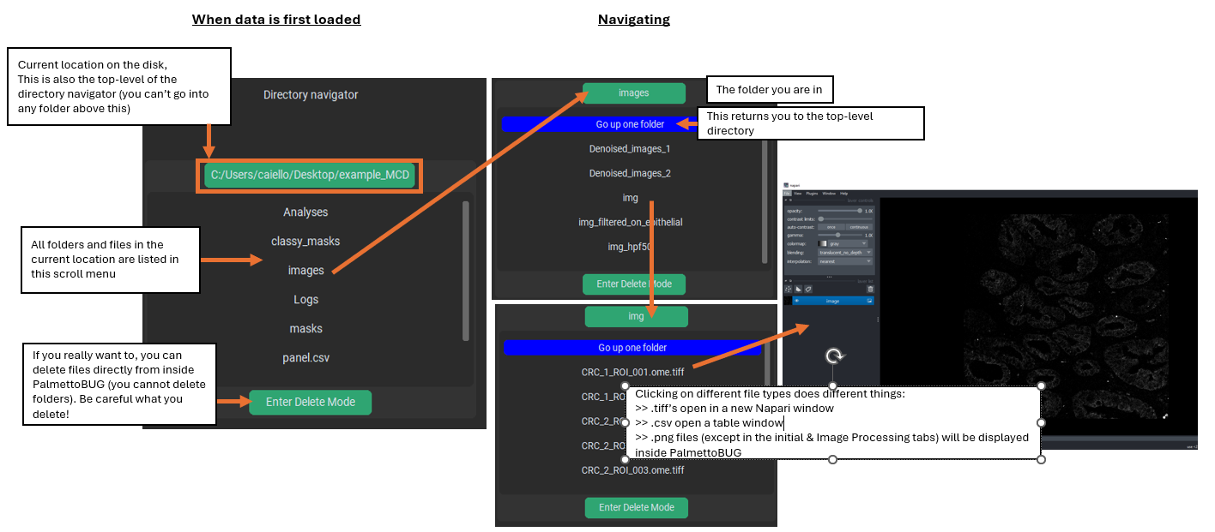
This display serves a simplistic alternative to using your computer’s normal file explorer program to navigate inside the PalmettoBUG project directory. It lists the files and folder inside your project, and lets you see as the folder populate with outputs & allows you to inspect some of them. Anything that can be done in the PalmettoBUG directory display could also be effectively done outside PalmettoBUG, as long as you know where to look, so this is mainly just there as a potential convenience.
Clicking on a folder will open that folder in the directory display. Clicking on a file can open that file, if it is one of a few file types that PalmettoBUG frequently creates: .tiff, .csv, pr .png. Specifically, clicking a .tiff file will open it in a new Napari window, clicking a .csv file will open it as a table inside PalmettoBUG – and specially named .csv’s (like Analysis_panel.csv) are given special treatment – while clicking a .png file (except the first two tabs) will display that .png file inside PalmettoBUG.
You can also toggle the display to be in “delete mode”, where clicking on a file (no deleting folders from inside PalmettoBUG) will simply delete it. Generally speaking, DON’T USE THIS FEATURE – unless you are very confident you know what you are doing, and that you won’t mis-click something important.

Plot Display
On most of the tabs of the program, except the starting tab & the Image Processing tab, there is a plot display widget. This widget starts with a picture of one of the friendly AI-generated PalmettoBUGs. Once you generate a plot in PalmettoBUG, or click on a .png file in directory display, that file will be displayed on the Plot display (and Mr./Mrs. PalmettoBUG will be gone until you reload the program!).
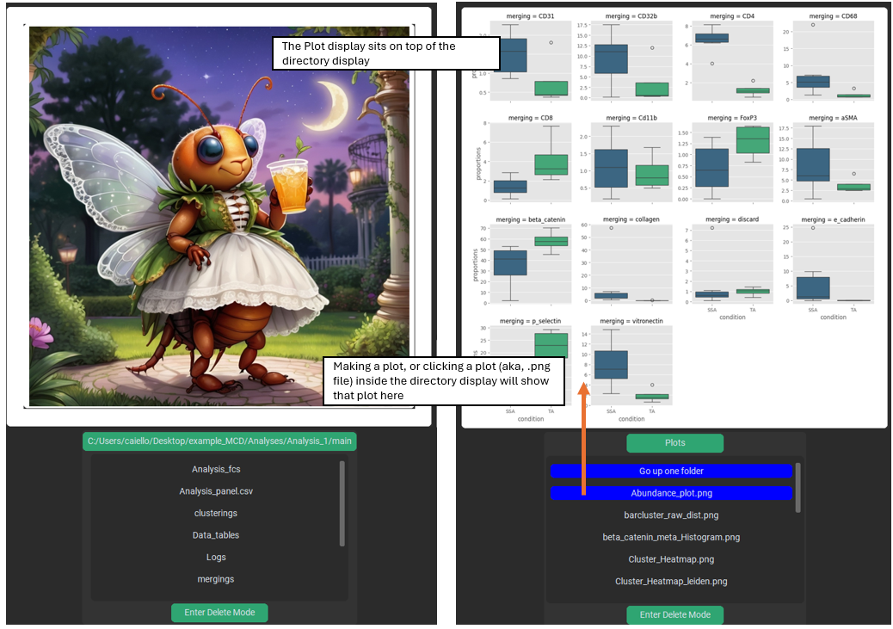
This is a convenient way to see your plots as you generate them. However, note that any plot displayed in PalmettoBUG is forced into the relatively small, square plot display widget, which can distort its appearance and reduces its overall quality – because of this plots are ALWAYS higher quality when viewed from the saved file in your computer’s standard image display software, not in the plot display!

Changing the Appearance PalmettoBUG
The PalmettoBUG interface appearance can be changed in a few ways, from a window launched from the starting tab. You can change the size of the GUI (including the widgets), which can be very helpful if the GUI is too large for your computer screen. You can change the theme of PalmettoBUG, whether to be in light / dark mode or an entirely different color scheme.
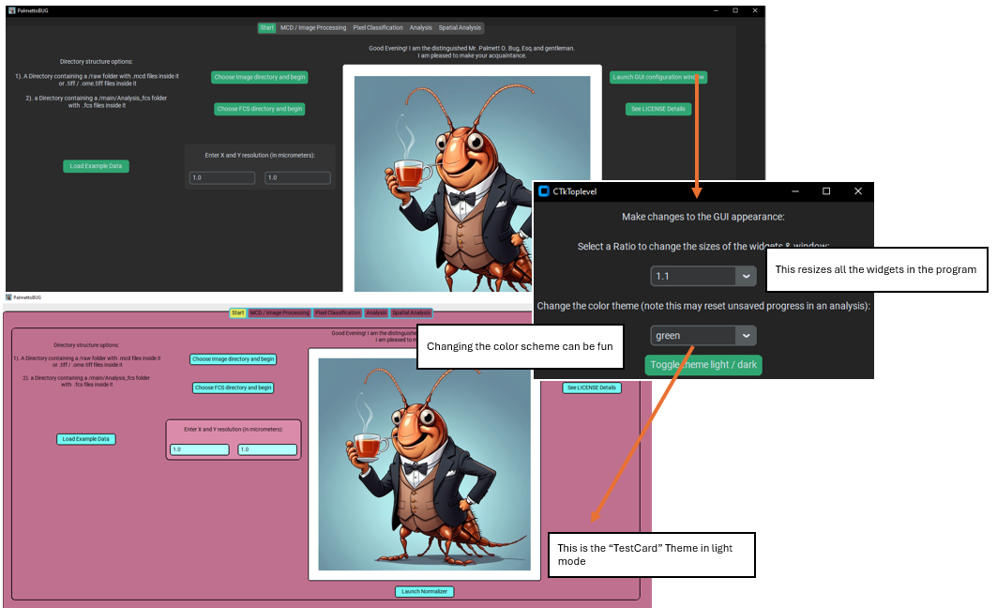
The PalmettoBUG interface is built using the customtkinter package, and a set of themes for this package exists from customtkinter_theme_builder, which were bundled with PalmettoBUg just for fun. This means you can completely change the color scheme for much of the program! However, note that the GUI was written with its default color scheme (“green”) in mind and not the alternative themes – so the useability of the program / clarity of the widgets can suffer in alternate color schemes.
Note! – Changing the GUI color-theme is best done BEFORE loading any data into the program. Part of updating the widgets to the new color scheme means that any progress in the GUI will be lost, and you will need to re-load your project!

Other Noteworthy Peculiarities of PalmettoBUG
There are some conventions / standard behavior in PalmettoBUG that may be different / unexpected from your more usual software. A few examples are listed here, although some of them may change in the future, depending on how problematic they seem to be, or if there is a better system that is easy to implement. For example, I could change the GUI to no longer offer default file / folder names.
1). Overwriting existing files is normal / no warning is given. If you specify the same file path as an existing folder / file at any given step, then PalmettoBUG will happily overwrite anything it needs to. This most frequently comes into play at the many steps where PalmettoBUG asks you for an output folder (common for image processing steps, where a procedure is performed on every image in a folder) or for an output filename (common when generating a plot). Overwriting also characterizes the cell grouping behavior of the Analysis portions of the program. For example, there can only be 1 metaclustering column (same for merging/leiden/CN, etc.) in the data at a given time, so running a 2nd FlowSOM will effectively erase the first metaclustering.
PalmettoBUG’s love of overwriting can become a particular risk for file / folder names because of peculiarity number 2:
2). Default folder / filenames are given at most steps. These are offered as examples of file names, to allow the easiest on-ramp to learning the PalmettoBUG pipeline by giving good examples of what the filenames might be. However, if you forget / choose not to change these defaults at a step you do more than once in the pipeline you will overwrite the output of the first step (see peculiarity #1 above)! This is usually not a massive problem, because as long as you know what you’ve done at each step, you should be able to fairly easily re-create whatever it is that you overwrote (this is particularly simple & fast for most of the plotting functions). It is obviously still irritating having to retrace your steps, but it is also possible to overlook the fact you overwrote the plot / images that you intended to use & end up displaying an incorrect plot or performing a downstream calculation on the wrong set of images!
3). Napari / isoSegDenoise are launched as separate processes. Except when creating training labels for supervised pixel classifiers, Napari windows launched inside the program, as well as the isoSegDenoise sister program, are managed in a separate process from the main PalmettoBUG process. This means that the launched windows do not block your ability to interact, click buttons, perform analysis steps, etc. in the main window. However, this is different for the napari window launched for supervised pixel classification training labels – it is launched in the same process, so PalmettoBUg becomes unavailable (in fact, if you try to access PalmettoBUG there is a chance that you cause a catastrophic error that crashes the entire program!).

