Using a Pixel Classifier
There is no point in creating a pixel classifier, if you don’t then use it! Most of the use cases for a pixel classifier (except segmentation) are in the Pixel Classification tab >> Use Pixel Classifier sub-tab.
Specifically, there are four main ways to use a classifier in this sub-tab: filter images, analyze the classes as a whole, classify cell masks, and extend cell masks.
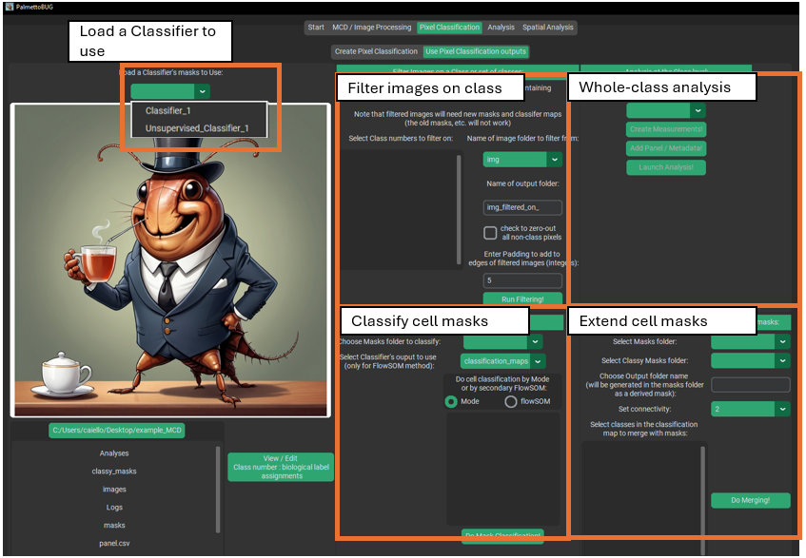
The first and critical step anytime you enter this sub-tab of the program is to select one of the classifiers that you have made in the project. This is done with the upper-left hand side of the program. This is also where you can look to see what classifier is currently loaded in this sub-tab, in case you forget.
When loading a classifier, it is best to use one that has predictions for every image in the dataset and also has a biological_labels.csv, which associates the class numbers in the classifier’s predictions to relevant biological groupings.

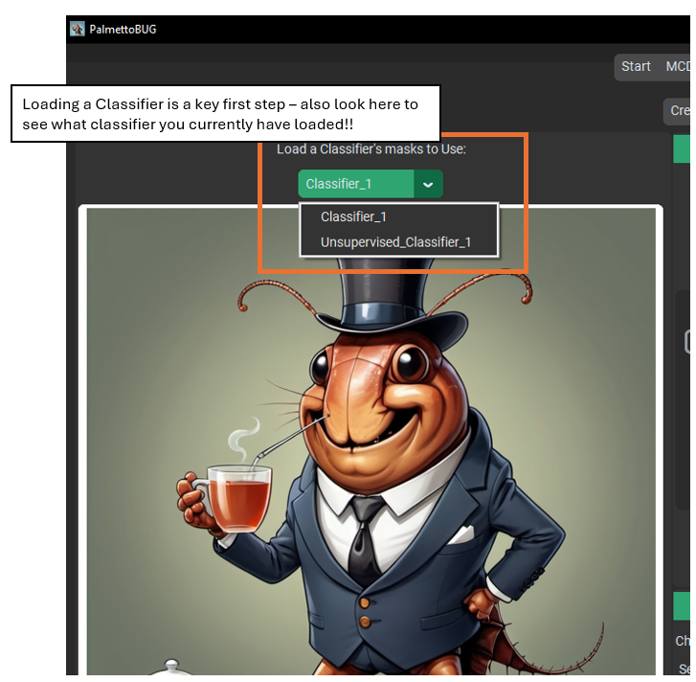
Once you have loaded a classifier, the widgets of this sub-tab will populate with values relevant to the classifier (such as classes).

Filtering on class
Image filtering on a pixel class is a way to try to drop unwanted image regions from your analysis. Specifically, you select class(es) of interest and a folder of images, then each image will be cropped down to the minimum bounding rectangle than captures all the class of interest. Optionally, all the pixels not of the class(es) of interest can be dropped to zero (not common), and the minimum bounding rectangle can be expanded by a fixed number of pixels (padding).
Possible reasons to do this step might be to help focus on only tissue regions of interest, or to reduce the computational load of later steps in the pipeline.
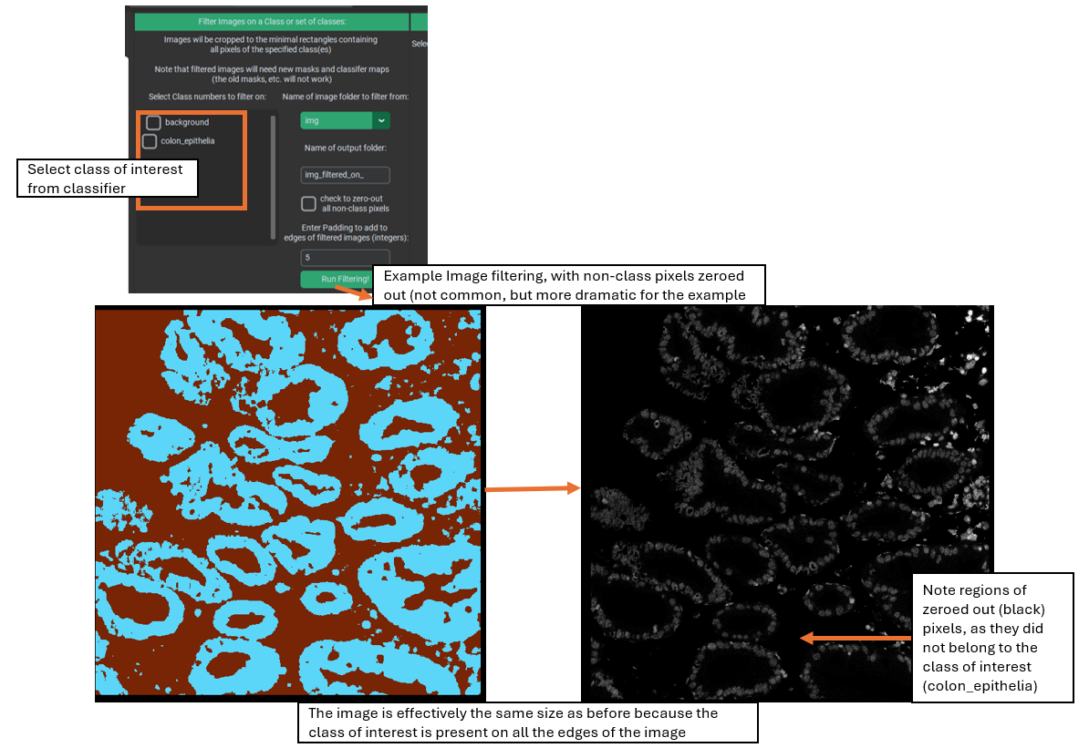
Sometimes, as in the example image above, the class(es) of interest are near or at all the edges of the image. In this case, the filtering / cropping of the image will essentially leave the image unchanged.

Whole-Class Analysis
Pixel classes can also be analyzed as a whole in the “Analysis at the class level” section. The idea here is to treat each pixel class as a single segmentation mask for each image, and then perform a similar analysis as the main pipeline of the program. This can provide information such as how much of the images are a given pixel class, and what the average expression of the markers are within the different classes. This section also allows some basic comparisons and statistics between the conditions in the experiment.
To begin, you must first select whether to use the “classification_maps” folder or the “merged_classification_maps” folder – the distinction between these is whether the background class is included in the analysis (it is not for merged class maps) and whether (for unsupervised classifiers only) to analyze the merged / annotated classes or the original FlowSOM classes.
Then, open the window for creating measurements. Like when creating region measurement in the main single-cell analysis directed pipeline, this step asks you to select images and a statistic to read from the classes, usually mean. After this, you must provide a panel / metadata file (again, just like for the single-cell analysis portion of the program), then finally the analysis itself can be launched.
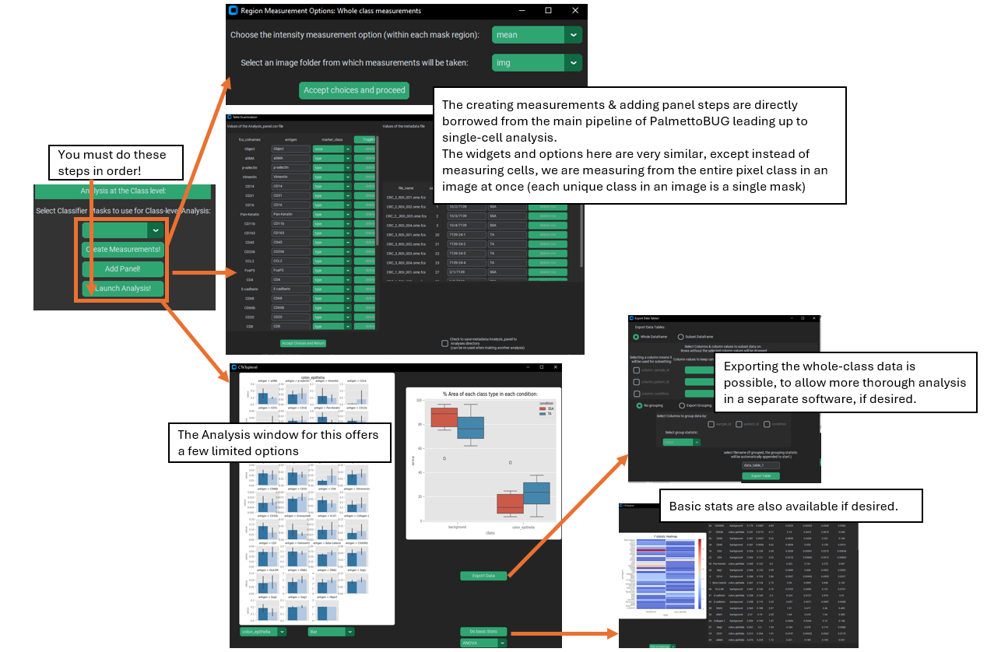
Within the analysis window, PalmettoBUG will display a box plot of the % of each class in each condition of the data, and a barplot of marker expression in one of the classes. This barplot can be changed to show a different class, or to be a violin plot instead. A statistics window can also be launched that either uses an ANOVA or a Kruskal-Wallis test to compare classes between conditions.
Additionally, this window allows you to export the data inside this whole-class analysis to a .csv file, which can be useful if want to examine this data more thoroughly in a separate software with more options for this.

Classifying Cells
Classifying cells may be the most commonly used purpose for a pixel classifier, and it is a necessary intermediate step before extending masks with a classifier. What this does is assign a pixel class derived from the classifier to each cell mask in a folder of cell segmentation masks. This creates a “classy mask” where the unique, identifying values of the original cell masks are replaced with the assigned class numbers for each mask. As this is done, the class assignments are recorded in order and written to a csv (allowing these to be loaded into a single-cell analysis made from the same cell masks).
The goal in classifying cells can be to load those cell groupings into a single-cell analysis, as an alternate way to annotate cell types compared to the cell-level clusterings available in the single-cell module. Additionally, classifying cells can just be a way to prepare for extending cell masks.
There are two ways to classify cell masks: mode and FlowSOM.
Mode is the easier and simpler method: cells are simply assigned to the pixel class that is most common within the mask. To do this, all you need to do is select the folder of masks to classify (the folder of pixel class maps is automatically found in the loaded classifier). Typically, the mode method is used more with supervised classifiers.
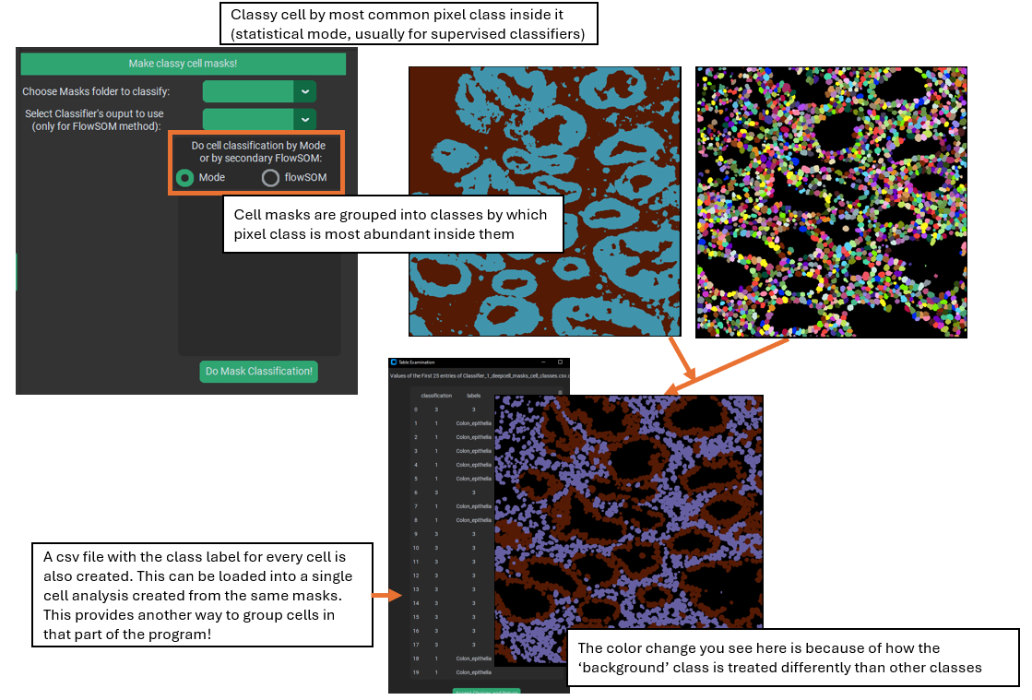

The output of the mask classification will be written to a sub-folder of the /classy_masks folder inside the project, with a name automatically derived from the used mask folder and classifier name.
The more complex method is to use a secondary FlowSOM. This method closely imitates the Angelo lab Pixie / ark-analysis pipeline for identifying cell types, and is typically used more with unsupervised classifiers. What is does is to find the fraction of each pixel class within every cell mask, then clusters the cells utilizing a FlowSOM whose input is the fraction of each pixel class in each cell. This creates an unlabeled clustering of the cells in the images, which requires annotation / merging by the user.
A window for annotation is automatically launched after the secondary FlowSOM completes. It displays a heatmap of the expression of markers in the various cell classes, allows you to launch an image in Napari to examine how the cell classes match with the image channels, and also displays a table for annotating the classes. Like with other annotation steps in PalmettoBUG if you give the same label to two different clusters, they will be merged into one. Note that when doing the annotation, you can either use the same labels as were in the classifier, or you can use custom / free-form labels. If you are intending to extend the cell masks with these labels, you MUST use the same labels as in the classifier! This is required when matching the cell masks to the regions they can be expanded into. However, if you are only interested in grouping the cells into cell types for the sake of single-analysis, you can freely use custom labels.
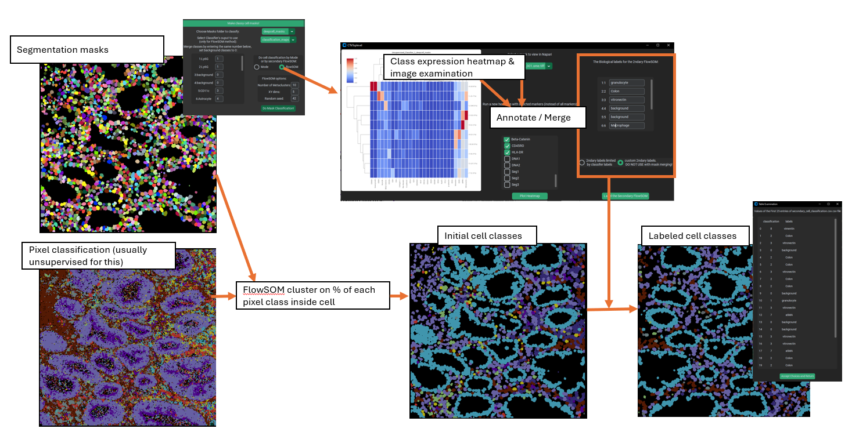
When the secondary FlowSOM is first run, a folder is created in /classy_masks, which will be populated by the outputs of the secondary FlowSOM. Once the annotation is accepted, merged classy masks & a new cell class csv are additionally written to this folder – later, when using this class_mask sub-folder for single-cell analysis or mask extension, the merged files will take precedence over the unannotated files.

Mask Extension
Mask extension is a very useful tool for certain tricky segmentation problems, particularly for irregularly shaped cells, which can be difficult for generalist algorithms to segment.
This method takes a set of pixel classification maps from the loaded classifier, a set of classified cell masks with matching classes, and a set of segmentation masks (these must match the classified cells masks). The user then selects class(es) to extend the cell masks into. PalmettoBUG will then identify the segmentation masks belonging to the class(es) of interest, and extend those cell masks into the surrounding regions that were predicted to be in the matching class.
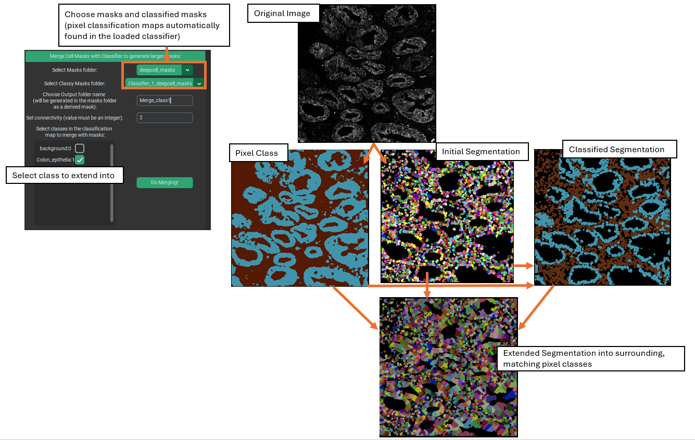
This extension process occurs simultaneously for every cell mask in a given class, using water shedding to connect masks to the continuous regions of that class surrounding the masks. This is accomplished by seeding the water shedding step from each of the centroids of the cell masks of the matching class.
For example, using the image above, a supervised classifier was created to roughly predict the epithelial regions of a colon tissue image, and a generalist algorithm (like DeepCell) was used to segment the region into cells. These cell segmentation masks were then classified into epithelia or background categories using the pixel class predictions. Finally, the cell masks that had been classified as epithelial were extended into the surrounding pixels that had been predicted to belong to the epithelia. Cells classified in the background class were not extended, while the extended epithelial cell masks were only grown into pixels inside the epithelia.
Note that the starting segmentation masks are not allowed to be shrunk by this process – cell masks will neither lose pixels because of mismatched class nor lose any pixels to a neighboring cell during the water shedding.
When created, a name for the new folder of extended masks is needed – this will be written as a sub-folder of /masks, where it can be picked up by the rest of PalmettoBUG for the purposes of region measurements, etc.

