Welcome to PalmettoBUG!
PalmettoBUG is a GUI interface for performing all the steps of analysis for an (imaging) mass cytometry experiment. While explicitly intended for IMC and solution-mode mass cytometry, it theoretically can work with any imaging data that can represented in a .tiff file or any single-cell data that can be represented as an .fcs file. However, note that it’s design was very much directed at high-dimensional, but small/medium scale experiments and not low-dimensional very large experiments. So its performance will likely suffer with very large data / very large individual ROIs.

PalmettoBUG Capabilities in Graphical Form
From the manuscript: ( BioRXiv link here )
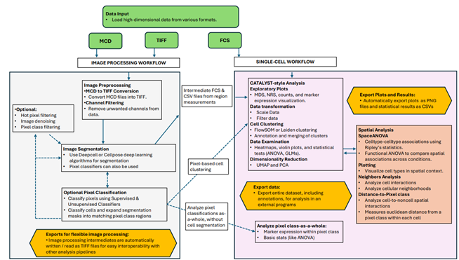

Installation:
To install, first setup a Python 3.9 or 3.10 environment.
I used miniconda to develop and test PalmettoBUG.
Enter your environment and issue the command:
>>> pip install palmettobug
To install PalmettoBUG in your environment. All dependencies should be automatically installed (via the pyproject.toml dependency manifest) by pip.
There are many dependencies for the program, and the example data for PalmettoBUG is quite large so this installation will take some time, and can use a good deal of disc space (> 1-2 Gb). If you run into errors you believe are a result of dependency issues, you can look at the environment files at the PalmettoBUG github repository to see the exact version numbers of the packages in my development environment, or you can open an issue at the same repository.
A Note on the isoSegDenoise sister program
One dependency to make particular note of is isoSegDenoise – a sister program to PalmettoBUG that handles segmentation and denoising of images (separated for licensing reasons, see below). If needed, it can be separately installed by the command:
>>> pip install isoSegDenoise
Note that isoSegDenoise should be installed in the same python environment as PalmettoBUG so that the PalmettoBUG GUI can directly and smoothly launch it when needed.

PowerPoint Documentation & Full Dependencies
Inside the PalmettoBUG package itself or on the GitHub repository, you will find two PowerPoints which can serve an alternate documentation for the PalmettoBUG GUI. These can be particularly powerful because of their animations that lay out how to use the various buttons of the GUI in excruciating detail.
Also on the GitHub / inside the package are a few text documents listing all the dependencies that are installed with PalmettoBUG / isoSegDenoise, at least in my personal miniconda, python3.10 environment on a windows device (using “pip freeze” or “conda list” commands to retrieve).

GPU support
GPU support is only useful for the isosegdenoise sister program, specifically for the DeepCell and Cellpose segmentation / denoising deep neural network models. On a windows 10 system for a NVIDIA GPU (in python 3.10), I was able to successfully install GPU support. Specifically, presuming you have successfully installed the NVIDIA driver for your GPU, you will need to:
1). follow the recommended pip download on the PyTorch website: Start Locally | PyTorch to get GPU support for Cellpose functions.
2). Download the proper tensorflow & cuda packages for deepcell / mesmer (listed are what worked for me):
>>> pip install tensorflow-gpu==2.8.4
>>> conda install cudnn=8.9.2.26
>>> conda install cudatoolkit=11.8.0
>>> conda install zlib-wapi
However, your mileage using these steps may vary in practice – GPU support was not thoroughly tested on a variety of computer systems or setups!
Do note that to get GPU support really means getting it configured for Cellpose (build on PyTorch) and DeepCell/Mesmer (Tensorflow) packages as these are the only parts of the program that use a GPU. So you can also consult these package’s for information about configuring GPU support.

Licensing information:
PalmettoBUG is under the GPL-3 opensource license. Much of the code & dependencies of PalmettoBUG came from GPL-2+ projects across a few different programming languages, necessitating that PalmettoBUG itself be under the same license. The DeepCell model (and possibly some of those from Cellpose) is licensed under a more restrictive non-commercial license that is not compatible with GPL-3, which is why the isoSegDenoise program was separated off from the main package.

