Loading Data in isosegdenoise separately from palmettobug
While the typical use of isosegdenoise is an a sub-program of palmettobug, the isosegdenoise GUI can be launched separately, and load data separately.

Note: even though isosegdenoise can be used separately from palmettobug, it expects the data / directory structures created by palmettobug, and does not perform these steps (such as converting MCDs TIFFs in raw) on its own. Because of this, it is rare to even launch this program separately from palmettobug.
Launch:
In the terminal (usually miniconda prompt in the environment where isosegdenoise is installed), type:
>>> segdenoise
This will launch the program without loading any data automatically.
Loading data:
Once in the opening screen of the program:
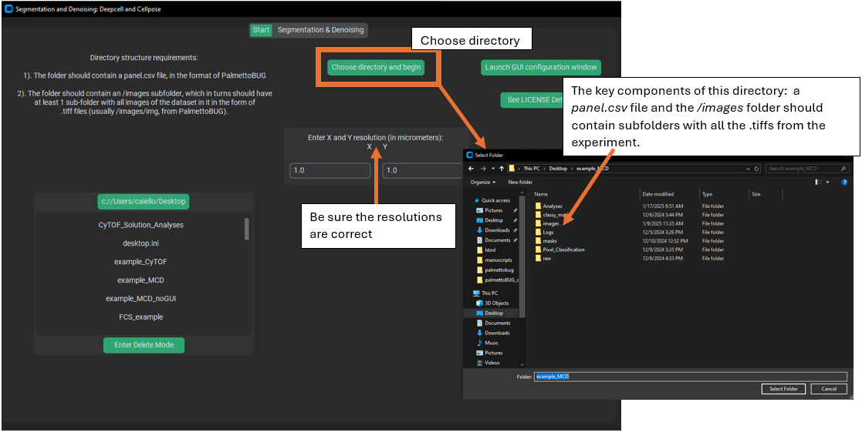

Note that unlike PalmettoBUG, this program only interacts with the images and masks folders (and their subfolders of images), as well as the panel file. The panel file and images (as .tiff files in a subfolder of /images) must be present when loading the directory. Other folders may or may not be present when you load the directory, but these are the minimum needed to do isosegdenoise functions.

Performing Denoising & Segmentation
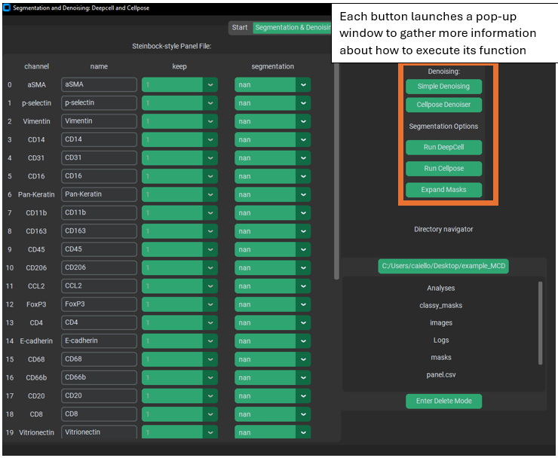
Once the directory is loaded, then make sure the panel file is up to date and reflects your desired choices.

Then use the buttons in the upper right corner to launch pop-up windows in order to do the described functions. These pop-up windows ask for information like, Which folder of images are you denoising? Which folder do you want to write the denoised images to? What parameters for the denoising algorithm? Etc.
If you click on a button and a windows doesn’t show up immediately, it might be that the window opened behind other programs open on your computer. You can click the same button again as a shortcut to bring that window to the front (as a rule, clicking again on a button in this program will not open an additional pop-up window for that function, but will try to bring any existing window for that function to the front).

