Neural Networks for scoliosis quantification

Ben Church – 10006197

Kyle MacNeil – 10057473

December 4, 2016

CISC 874 – Project part D

# Background and Introduction:

Scoliosis is a pathological curvature of the spine that typically manifests during adolescence and progresses throughout growth. The disease is quantified in terms of the Cobb angle, defined as the greatest angle between the endplates of any two vertebrae in the coronal plane. This angle dictates the course of action in managing the patient’s disease. Patients with Cobb angles less than 20° receive repeated follow-ups to monitor the progression of the curvature. Bracing is used to slow progression for angles between 20° and 40°. Finally, surgical vertebral fusing may be used for angles greater than 40° [Frerich2012]. As such, accurate quantification of the disease is important to prescribe, monitor, and assess the treatment to minimize the disease’s pathology and the cost of treatment. X-ray imaging is currently the gold-standard for scoliosis quantification. Since the disease is quantified in terms of one angle, this information can easily be read from one 2D X-ray image of the back. The health risks of repeated exposure to X-ray radiation throughout adolescence, as progression of the disease is monitored, are well documented [Doody2000, and Schmitz-Feuerhake2011]. These risks have motivated research [Chen2011, Cheung2015, Ungi2014, and Zheng2015] into using spatially tracked ultrasound imaging to quantify scoliosis.

[Chen2011] verified both that the Cobb angle could be accurately inferred from vertebral pedicle locations, and that these pedicles could be accurately located with tracked ultrasound. [Ungi2014] verified that the Cobb angle could be estimated using transverse process locations obtained from tracked ultrasound. Their methods both produced results within clinically acceptable limits of the ground-truth, the radiographically measured Cobb angle. Both of these studies measured phantom models, in-vitro. [Chen2011] made use of a healthy shaped model, while [Ungi2014] used a model exhibiting scoliotic curvature, with limited vertebral twist or other confounding geometric deformations. Ultrasound images of real patients contain more speckle and artifacts than do those images taken of phantoms due to inhomogeneities of musculature and ligamentation, for instance. This implies that the landmark data necessary for scoliosis quantification are likely to contain more random noise when collected in a clinical setting.

While [Cheung2015, and Zheng2015] collect in-vivo data to assess their methods of scoliosis quantification, their patients were limited to those having mild to moderate scoliosis, with Cobb angles exclusively less than 45° for [Zheng2015] and less than 30° for [Cheung2015]. Furthermore, they use a special-purpose, wide transducer ultrasound to image the entire width of the spine simultaneously. Such systems are not widespread compared to general purpose tracked ultrasound, and although they facilitate angle measurement, the landmarks they require are not always locatable. In fact, [Cheung2015, and Zheng2015] either discarded data, or used alternative landmarks in cases where the necessary landmarks could not be found. These studies’ subjects’ Cobb angles are too small to reliably assess the effectiveness of their methods on patients with severe scoliosis. Such patients could have Cobb angles greater than their validated ranges, in addition to modes of deformation such as vertebral twist. Greater spinal deformation could compromise these methods if any landmarks are occluded.

Consequently, quantification of scoliosis from ultrasound-accessible landmarks remains a challenge. The inherent difficulty of interpreting ultrasound could produce landmarks that are inconsistently located, corresponding to noise in the ground-truth landmark locations. Trauma causing physical landmark destruction or displacement can also result in incomplete landmark sets. Severe coronal curvature and its accompanying deformations can occlude landmarks or orient surfaces such that they do not appear in ultrasound. Because the ribs are parallel and near to the transverse processes, with similar curvature, they can be mistaken for transverse processes. Such a mistake would result in a point which is displaced from its expected ground-truth by an amount dependant on nearby geometry in the anatomy.

For these reasons, we propose a neural network approach to estimate the Cobb angle from the locations of patients’ transverse processes. We use transverse process locations retrieved from scoliotic patients’ previous CT scans, and from them, programmatically create point sets with varying amounts of noise added. We believe that a neural network is well suited to this problem since it involves estimating the function which maps the interdependent set of transverse process coordinates to their angle of maximum coronal curvature. Such a neural network should be able to accurately estimate the Cobb angle using a set of 3D anatomic landmark points as input. To the best of our knowledge, no work has been done to investigate such a method.

# Methods

Our original data consists of the spatial locations of 124 scoliotic patients’ transverse processes, represented as 3D coordinates. The points were located manually from CT-generated volume models of the patients’ spines, as the accuracy of CT ensures the points correspond closely to the true location of the patients’ anatomic structures. The set sizes vary across patients, as each required only a certain amount of their spine to be scanned for scoliosis assessment. The maximum coronal angle between any two vertebras can be extracted from this data as a ground-truth value for the Cobb angle proxy we wish to estimate. To test our method’s robustness, we preprocess the data by adding random noise, also completing the point sets to make them compatible with a feedforward neural network of constant architecture. Our method’s data flow is shown from the highest overview in Figure 1.

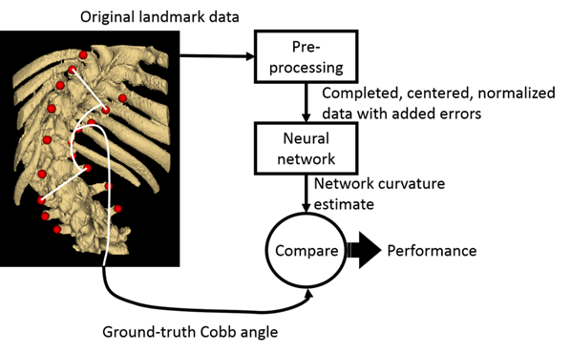

Figure 1: Top-level view of data analysis pipeline

The pre-processing procedure itself consists of centering the landmarks sets, creating a set with points for vertebrae that could be present with any patient, creating a set with simulated ultrasound error, splicing the new sets together, and normalizing the resulting landmark set. This overview of the pre-processing procedure is shown in Figure 2, and described in greater detail below.

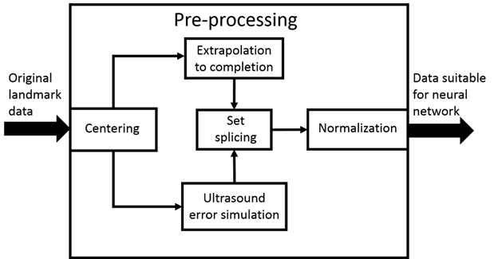

Figure 2: Modules used in pre-processing component of procedure

The centering program is written in ScoliosisNeuralNets/CenterAndNormalizeLandmarks/CenterAndNormalizeLandmarks.py. It simply finds the mean coordinate for each dimension of each patient’s landmarks, and subtracts that value from that coordinate of all landmarks.

Ultrasound error simulation was done with the Slicer module in ./ScoliosisNeuralNets/DegradeTransverseProcesses/DegradeTransverseProcesses.py. Currently, the only error introduced is random noise is each coordinate of each landmark. Figure 3 shows a patient’s landmark points with their CT derived model, before and after having noise introduced.

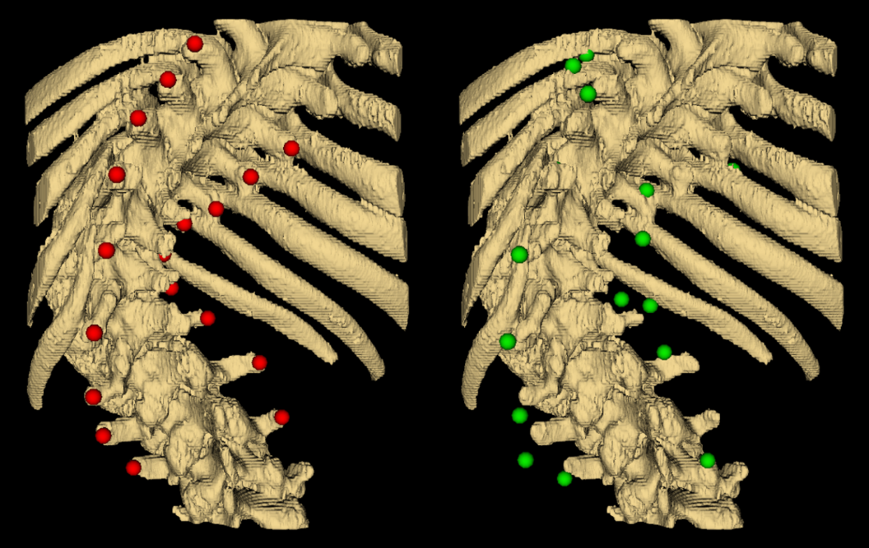

Figure 3: Model of patient’s spine with original landmark points (left).   
Model of patient’s spine with noise added to landmark locations (right)

The partially complete, centered original landmarks must be extrapolated to completion if a neural network with constant architecture is to be used. This is done in the Slicer module in ./ScoliosisNeuralNets/ExtendSpine/ExtendSpine.py. It works by taking the top-most, and bottom-most pair of landmarks, and subsequent point pairs with the same relative position at multiples of the average vector leading from the second outermost landmark points to outermost landmark points, until the set is complete. This ensures that the extrapolation does not affect the curvature encoded in the landmarks, since they add no new angles, and a minimum of features. Figure 4 compares a patient’s original landmark set, before and after extrapolation to completion.

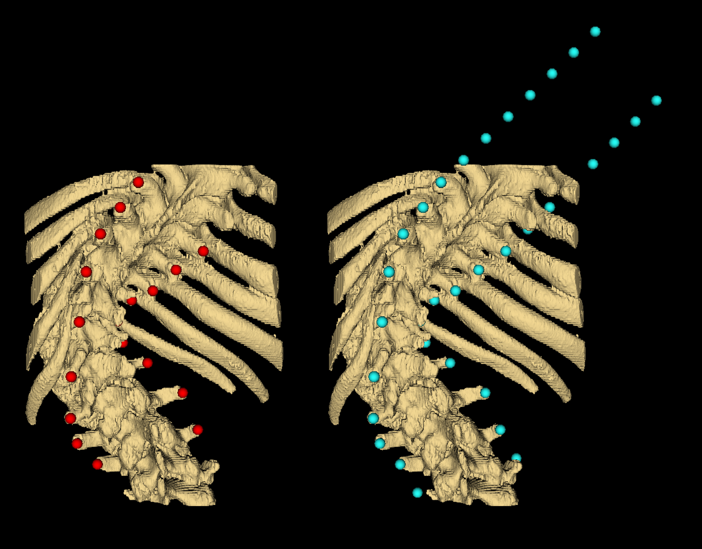

Figure 4: Model of patient’s spine with original landmark points (left). Model of patient’s spine with landmark set extended to include points for landmarks potentially present in any patients original data (right)

The landmarks of the completed set which correspond to points in the set with simulated error are replaced by those with the simulated error. Errors were not introduced into the extrapolated points as they are meant as place holders, not to affect results. This replacement of points, called “Splicing” in Figure 2, is performed in the Slicer module in ./ScoliosisNeuralNets/ExtendSpine/ExtendSpine.py. Such a spliced point set is shown in Figure 5.

Finally, each patient’s landmark points are normalized by the Slicer module in ./ScoliosisNeuralNets/CenterAndNormalizeLandmarks  
/CenterAndNormalizeLandmarks.py. This is simply a matter of finding the maximum absolute coordinate value in any dimension, and dividing all landmark coordinates for that patient, by that value. This is not illustrated because the normalized points differ only in the scale of the geometry, where original coordinates in millimeters are mapped over the range [-1, 1]. This finally results in point sets, all with the same number of points, normalized over a range suitable for a neural network, and embodying the desired error.

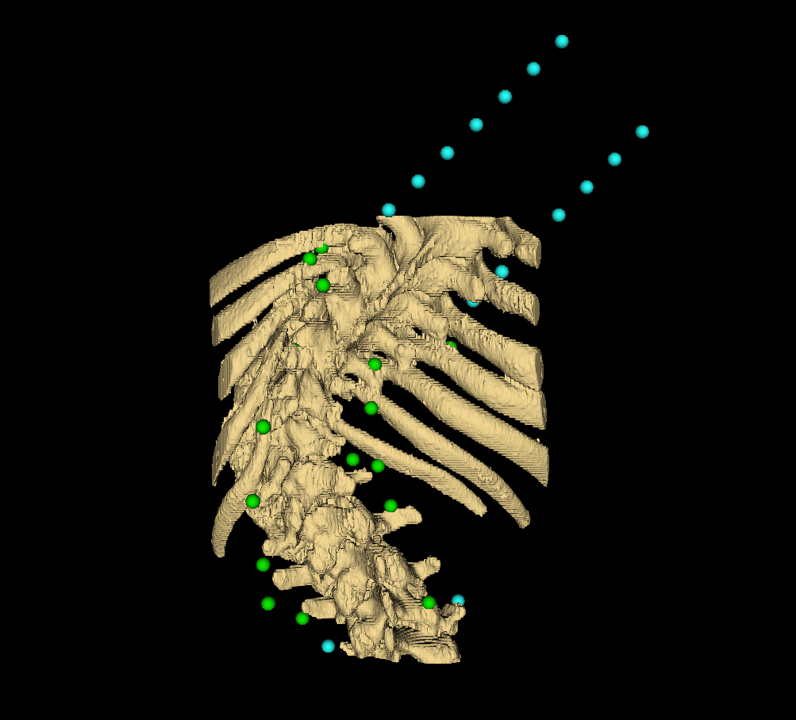

Figure : Original points with noise added spliced into completed set

A feedforward neural network was chosen for the angle estimation component of the pipeline prototype for its function approximation capabilities and the functionality offered by MATLAB for assessment of the prototype. The expanded representation of the neural network in Figure 4 shows its architecture.

Each normalized coordinate of each landmark was passed through an input node. Specifically, 102 values in the range [-1, 1] constituted one input set. 102, being the number of landmarks in a complete set, 34, times the 3 spatial dimensions of each. One output node was needed to obtain an angle estimate. 0.5 was subtracted from the output node’s activation and the result multiplied by 240°, mapping its [0, 1] output to the range [-120°, 120°]. These values were chosen since the most severe curvature in the data set is approximately 113°, thus making good use of the output node’s range. The weight values were trained using MATLAB’s Lavenberg-Marquardt training algorithm with 10 hidden nodes. 15% of the landmark sets were used for MATLAB’s validation, and 15% for testing. With 124 patients’ landmarks, that corresponds to 19 sets for validation and testing, and 86 for training. These are simply MATLAB’s default parameters and were used as a starting point for result generation.

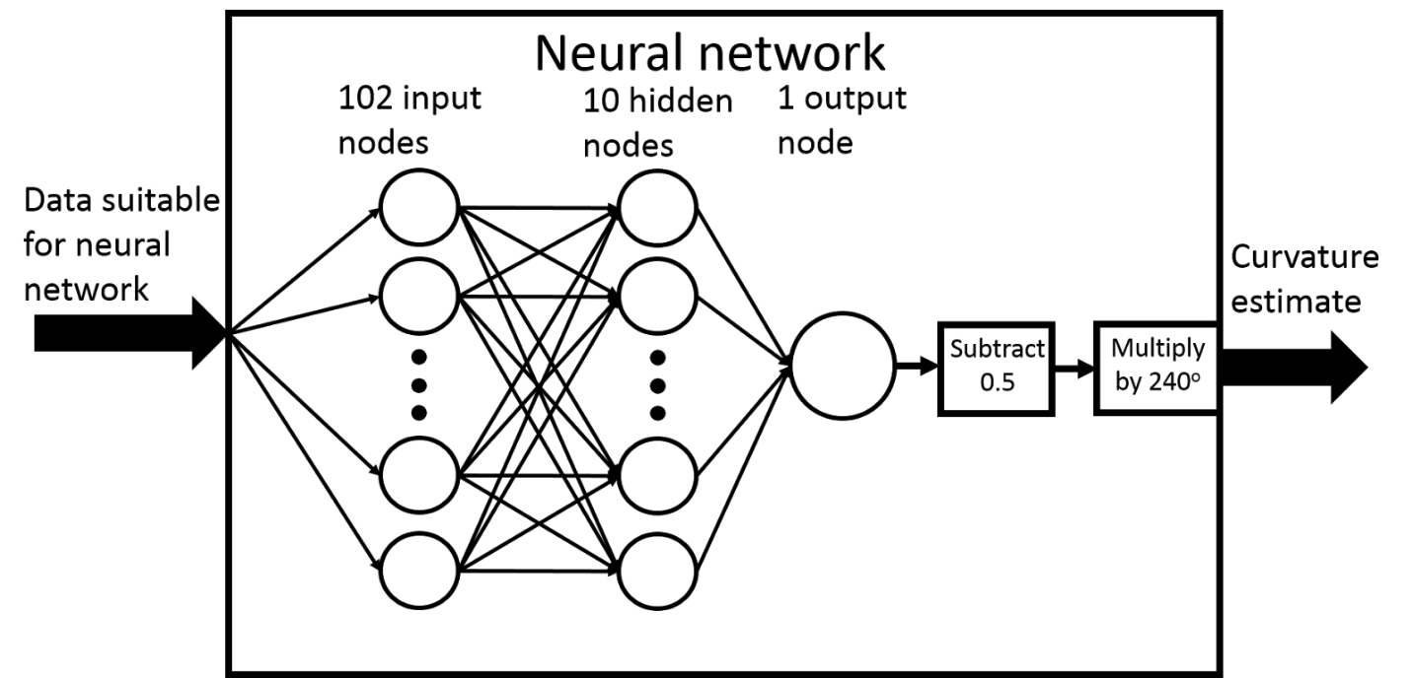

Figure 6: Feedforward neural network architecture

To evaluate the performance of our prototypical method, we generated several data sets, trained the network on them, and observed the training, validation, and in particular, testing mean-squared-errors (MSE). The control set consisted of only the normalized, completed, centered sets. Random noise of increasing standard deviation was added to the original landmark locations to create the remaining sets. The network was trained and retrained multiple times with each data set to collect MSE statistics.

# Results

The result of MATLAB’s Neural Network Function Fitting app was the mean-squared-error of the training, validation, and test sets. The test set errors, being the results of interest, were averaged over 10 training trials for each experimental configuration. 11 experimental configurations were used, one for each additional mm2 in the points’ noise’s standard deviation from 0mm to 10mm. Figure 7 shows the network’s mean-squared-error in its angle estimation, averaged over 10 training trials for each data set.

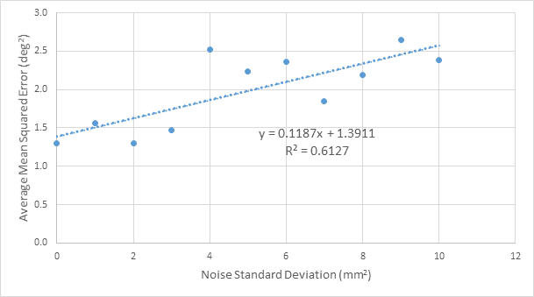

Figure 7: Mean-squared-error in angle output, averaged over 10 training trials, for a range of noise standard deviations

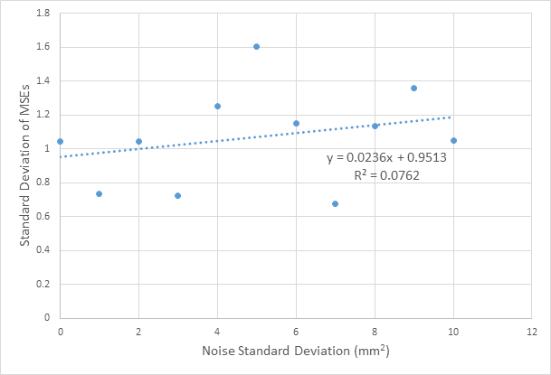

Figure 8: Standard deviation, averaged across 10 training trials, of the testing MSEs, for a range of noise standard deviations

# Discussion

The prototypical method has demonstrated utility in estimating spinal curvatures from noisy anatomic landmark locations. The average angle estimation errors, squared, are still less than the clinically acceptable limit of error in Cobb angle measurement of 5° [Cobb1948], for the full range of noise standard deviations tested. However, our method should not be compared directly to the Cobb method. The Cobb angle itself can only be measured when the vertebral end plates are visible. Authors mentioned in our proposal validated their results against X-ray ground-truth. We do not have access to X-ray data, just the landmark points. Therefore, we cannot remark on the superiority of either method. However, the intention was not to replace existing methods, but to supplement them with a tool for dealing with imperfect or incomplete data. Our method demonstrates robustness against noise so far, and stands soon to be tested against other challenges.

Work to improve the robustness, and extent of validation, of the method is ongoing. A module for estimating missing point locations (interpolation within original landmark sets, not extrapolation to completion) using either a statistical or another neural method, is planned. It must be implemented between the ultrasound error simulation and set splicing, as they are shown in Figure 2. A means of partitioning the patients’ landmark sets into testing and training sets sorted by severity of curvature is also planned. This will provide valuable information regarding the relationship between the method’s performance and severity of the disease. This will be useful information since other work has focused on cases with curvatures typically less than 45°, whereas we have scans from a number of cases worse than this. We do not expect our final neural network to be implemented using MATLAB’s app.

Work has begun on a Visual Studio C++ solution which will implement our network, however existing toolboxes such as PyBrain or TensorFlow will be considered as well. This will provide more freedom to experiment with different network architectures, learning strategies, and functionalities. For instance, we plan to add 17 nodes to the output layer, one for each vertebra in the thoracic and lumbar regions. The first node will still estimate the curvature, but two of the other nodes will indicate which two vertebrae determine the angle of curvature. That seems to be a combined function approximation and classification problem. As such, the level of control over the network required to implement such functionality must be available in whichever platform is used for subsequent development.

# Conclusions

Our method demonstrates progress to the end of ensuring robustness against imperfect data when determining the curvature of scoliotic spines from anatomic landmarks. It has shown tolerance to noisy data, but remains to have missing value imputation by interpolation, or misplaced value detection and correction functionalities implemented and evaluated. The proposed method is sufficiently modular that these extensions can be implemented with minimal reworking of the original method, if any. The modularity will also allow the method to be extended to output more information, namely, the two most relatively tilted vertebrae, defining the curvature to be estimated. An implementation of the neural component of the method, which provides useful information to researchers working to implement the method in a fashion suitable for clinical applications, is ongoing.

# References

[Chen2011] W. Chen, E. H.M Lou, and L. H. Le, “Using ultrasound imaging to identify landmarks in vertebra models to assess spinal deformity”, 33rd Annual International Conference of the IEEE EMBS 2011; 8495-8498.

[Cheung2015] C-W. J. Cheung, G-Q. Zhou, S-Y. Law, K-L. Lai, W-W. Jiang, and Y-P. Zheng, “Freehand three-dimensional ultrasound system for assessment of scoliosis”, Journal of Orthopaedic Translation 2015; 3:123-133.

[Cobb1948] J. Cobb, “Outline for the study of scoliosis”, AAOS Instr Course Lect 1948; 5:261-275.

[Doody2000] M.M. Doody, J. E. Lonstein, M. Stovall, D. G. Hacker, N. Luckyanov, and C. E. Land, ‘Breast Cancer Mortality After Diagnostic Radiography“, Spine 2000; 25(16):2052-2063.

[Frerich2012] J. M. Frerich, K. Hertzler, P. Knott, and S. Mardjetko, “Comparison of Radiographic and Surface Topography Measurements in Adolescents with Idiopathic Scoliosis”,The Open Orthopaedics Journal 2012; 6:261-265.

[Schmitz-Feuerhake2011] I. Schmitz-Feuerhake, and S. Pflugbeil, “‘Lifestyle’ and Cancer Rates in Former East and West Germany: The Possible Contribution of Diagnostic Radiation Exposures”, Radiation Protection Dosimetry 2011; 147(1-2):310-313.

[Ungi2014] T. Ungi, F. King, M. Kempston, Z. Keri, A. Lasso, P. Mousavi, J. Rudan, D. P. Borschneck, and G. Fichtinger, “Spinal Curvature Measurement by Tracked Ultrasound Snapshots”, Ultrasound in Medicine and Biology 2014; 40(2):447-454.

[Zheng2015] R. Zheng, A. C.Y. Chan, W. Chen, D. L. Hill, L. H. Le, D. Hedden, M. Moreau, J. Mahood, S. Southon, and E. Lou, “Intra- and Inter-rater Reliability of Coronal Curvature Measurement for Adolescent Idiopathic Scoliosis Using Ultrasonic Imaging Method - A Pilot Study”, Spine Deformity 2015; 3:151-158.