Spatially tracked ultrasound   
for scoliosis quantification

Ben Church

# Introduction

This survey begins with a brief description of anatomy relevant to the methods of using tracked ultrasound for scoliosis quantification investigated by [Cheung2015, Ungi2014, Zheng2015]. This is intended to make the following content regarding scoliosis and quantification of the disease more accessible to an audience with a general computing experience but lacking the related medical background.

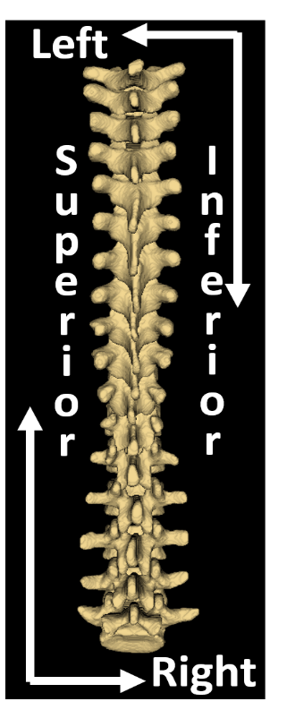

Figure 1: Posterior of spine model in a coronal plane with axes labelled (left). Left view of spine model in a parasagittal plane with axes labelled (right). The third plane, the axial plane, is not shown.

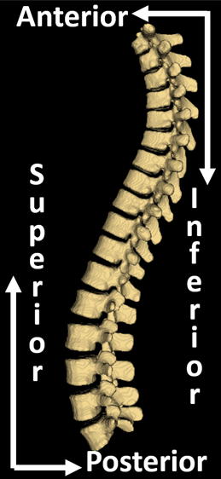

## Spinal anatomy

Figure 1 shows two of the three anatomic planes, the coronal, and the sagittal planes, with anatomic direction axes labelled. The axial plane is omitted because two planes are sufficient to define the third and its axes.

Figure 2 shows a model vertebra with labels on the anatomic structures used in methods described and discussed the subsequent section. It also shows the vertebral endplate, while not visible in ultrasound, it is of interest for the standard method of scoliosis quantification.

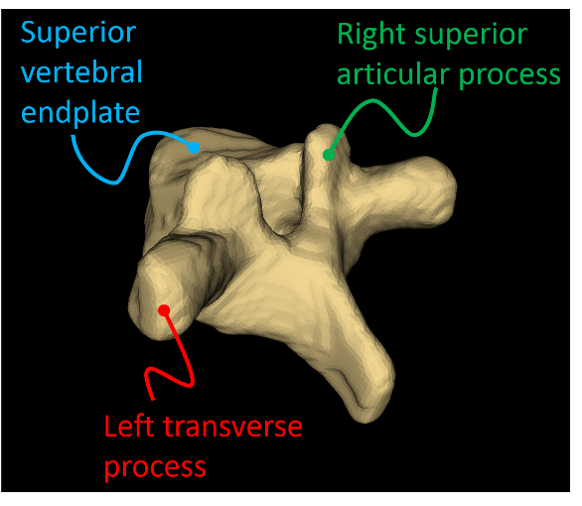

Figure 2: CT derived model of a single vertebra with relevant anatomy labelled.

## Scoliosis

Scoliosis is a pathological curvature of the spine which typically manifests in adolescence and develops during growth. The disease can be quantified in terms of the Cobb angle, that is, the maximum angle between the endplates of any two vertebrae, projected onto the coronal plane, as shown in Figure 1. Angles of additional, non-maximum curves in the spine are also often of interest. Anatomic planes and directions are illustrated in Figure 3. The Cobb angle is of interest to clinicians because it provides an objective indication of how severe the scoliosis is. As such, it is used to decide which treatment plan to proceed with.

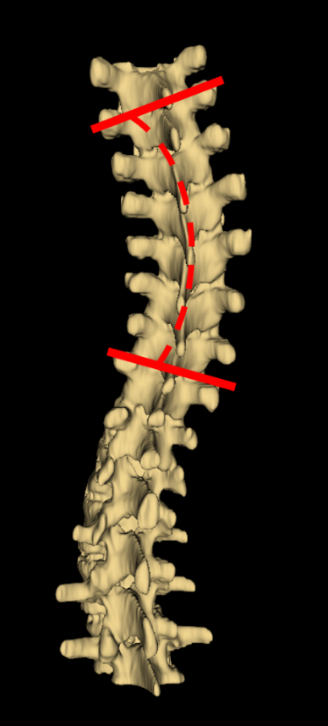

Figure 3: CT derived model with Cobb angle illustrated.

Cases with Cobb angles less than 20o are typically monitored so the deformation does not progress to the point of causing other health problems. Patients with Cobb angles between 20o and 40o often have braces prescribed to support the spine and slow further deformation. Cobb angles greater than 40o may require surgical vertebral fusing to halt deformation.

When possible, bracing is a preferable treatment to surgery. Surgical vertebral fusing results in permanent mobility loss and entails greater risks and financial costs than bracing. Therefore, with the curvature progressing during growth, regular assessment of the disease is important to ensure treatment risks and costs are minimized.

The current gold-standard method for assessment of scoliosis is to measure the Cobb angle directly from an X-ray of the patient’s back. Cumulative exposure to the ionizing radiation of X-ray imaging for scoliosis monitoring has been shown to increase cancer risks by [Doody2000]. This has motivated research into other methods for assessment of the disease, such as MRI [Diefenbach2013], surface topography [Frerich2012, Goldberg2001, and tracked ultrasound [Cheung2015, Ungi2014, Zheng2015].

Surface topography consists of projecting a particular shadow onto the patient’s back. When cast onto a flat surface, these shadows form some regular pattern, like many parallel lines. An image of the patient’s back with shadows is captured and analyzed with software. The geometry of the patient’s torso can be computed from the shadows contours. The asymmetry of the spine is used in the estimation of the Cobb angle. [Goldberg2001] reported moderate correlation (R2 = 0.66) between their surface topography method’s angle and the radiographic Cobb angle, and a false positive rate of 37.7%. [Frerich2012] reported intra and inter-observer variance of 5.14o and 6.54o in their topographic method. Their method underestimated curvature components by an average of 8.12o, except thoracic kyphosis, which was overestimated by an average of 7.26o.

MRI is an effective alternative to X-ray imaging as it produces a clear image of the spine, similar to X-ray, from which the Cobb angle can be measured directly. However, MRI is more expensive and less accessible than other methods like ultrasound and surface topographic methods. MRI is also incompatible with metal implants often used in scoliosis surgery [Diefenbach2013].

## Tracked ultrasound

Spatially tracked ultrasound presents an attractive imaging modality for scoliosis quantification. Unlike X-ray, it has no known health risks. This also means that fewer safety regulations are required for its use, translating into less financial cost and greater accessibility. [Cheung2015, Ungi2014, Zheng2015] investigated the applicability of their respective tracked ultrasound methods for scoliosis quantification. These papers are the focus of this survey. Their methods and results are described below, in their respective sections.

Using spatially tracked ultrasound for scoliosis assessment generally consists of locating landmarks in 3D space and projecting them onto the coronal plane. A proxy to the Cobb angle is then extracted from the landmark data. The proxy measurement is required because vertebral endplates, which define the Cobb angle, cannot be located with ultrasound. Bone, having a higher acoustic impedance than other tissue, reflects most of the ultrasound. Therefore, bone surfaces approximately normal to the direction of propagation of the ultrasound appear as bright regions in the images with acoustic shadows under them. On the other hand, surfaces not normal to this direction reflect the ultrasound away from the probe, resulting in a dark region in the image. These features of ultrasound bone images are illustrated in Figure 4.

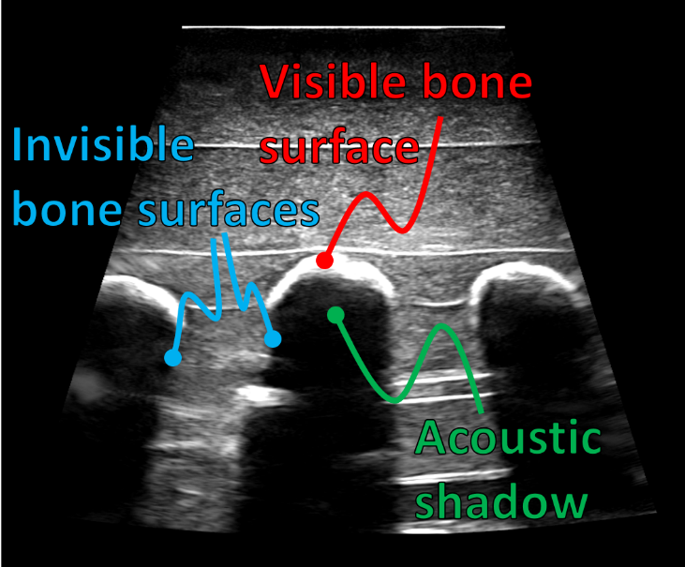

Figure 4: Sagittal spine ultrasound image with bone surfaces, both visible and invisible, and acoustic shadows, illustrated. Visible surfaces are of the transverse processes.

# Summary

Hopefully the background provided will be sufficient to support an appreciation of the state of the art, upon reading the following summary. Three papers intended to be representative of the topic field were chosen. This section contains a summary of each work’s purpose, methods, and results. This summary is intended to supply the required material for the following discussion of the current state of the topic field.

## [Ungi2014] – Sagittal tracked ultrasound snapshots

### Purpose

Motivated by the health risks of using X-ray for scoliosis monitoring, and the unreliability or other limitations of other methods as described in the Introduction section, [Ungi2014] sought to develop a method for using spatially tracked ultrasound to quantify the disease. They acknowledge that work like [Chen2012] has been used to estimate Cobb angles using tracked ultrasound to located laminae. However, [Chen2012]’s method requires a special, wide transducer capable of imaging the width of the spine simultaneously. Their method overcomes the need for this hardware.

### Methods

[Ungi2014]’s procedure for scoliosis quantification involves locating the transverse processes (TPs) from tracked ultrasound snapshots captured in a sagittal orientation. Figure 4 shows one such ultrasound image. Operators scanned phantom models of 3D printed scoliotic spines and captured a snapshot when they believed the center of the TP was visible. The snapshots consist of a position and orientation in space from the tracking information, and the ultrasound image itself. Therefore, they could be loaded into [3DSlicer]’s virtual environment, as shown in Figure 5. Operators then placed points at the peaks of each TP. The angles in the coronal plane of the lines connecting the transverse processes of a given vertebra are then used as a proxy the endplate angles. The angle between the two most relatively tilted lines is the proxy to the Cobb angle. They evaluated their procedure in terms of the inter-operator variability. They compared the inter-operator variability of their procedure’s output to that Cobb angle measurements performed on X-rays of the phantom models.

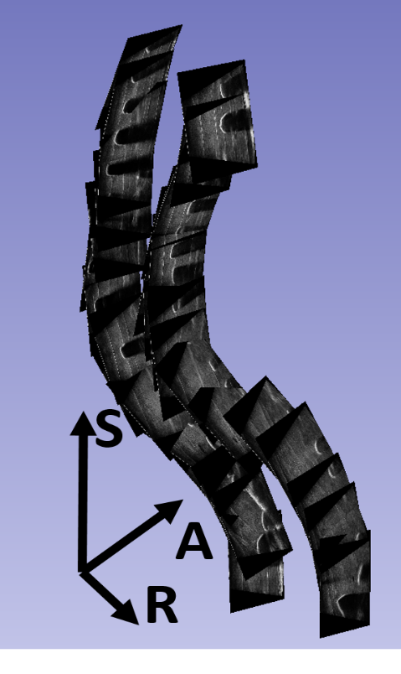

Figure 5: Tracked sagittal ultrasound snapshots of a scoliotic spine, like those used by [Ungi2014]. Axes added for clarity.

### Results

[Ungi2014] reports a good correlation between their angle measurements and X-ray Cobb angle measurements, with   
R = 0.998 for their adult model, and R = 0.977 for their pediatric model. Their method produces angles with no more than 3.1o error. This is within the clinically acceptable error limit of 5o suggested by [**********]. They report a statistical significance of p < 0.05 for the statistics describing the difference between the X-ray and ultrasound approaches.

## [Zheng2015] – Axial Ultrasound Scan Volume Projection

### Purpose

[Zheng2015] states the usual motivation for using ultrasound for scoliosis quantification, the health risks of repetitive X-raying. They then list a several of studies using ultrasound to design braces for patients, and a number validating the use of ultrasound for scoliosis quantification in phantom models. [Zheng2015] offers a pilot study determining the accuracy and reliability of a spatially tracked ultrasound procedure.

### Methods

26 adolescents with major curve angles ranging from 10o to 45o, who had not received surgical treatment for their scoliosis, were selected for the study. They had out-of-brace X-rays imaging, and had ultrasound scans within an hour. Their ultrasound system uses a spatially tracked, wide transducer used to image the left and right sides of the spine simultaneously. The series of ultrasound images captured in an axial orientation were projected onto an image in the coronal plane. To measure the curvature from these coronal images, they used the center of laminae (COL) method developed by [Chen2012].

Raters each marked both laminae at each vertebral level using a custom designed software environment to interact with the tracked image sequences. To ensure consistent measurement, all three raters agreed on the level of the 12th thoracic vertebra, usually identifiable by being connected to the last pair of ribs, and numbered all other layers accordingly. To place landmarks, the raters were able to select a level in the scan, and the axial image captured at that level was shown with the coronal image, allowing the raters to fine tune their landmark locations. The software automatically drew lines on the coronal image, each connecting a pair of laminae for a given vertebral level. The software then displayed their proxy Cobb measurement as the angle between the two most relatively tilted lines.

Measurements were performed by three raters so that inter and intra-operator statistics could be obtained. Each rater measured the angles of curvature with both ultrasound and X-ray methods twice, with at least a week between trials. The proxy measurements resulting from their approach were compared to curves where at least two of the three operators identified that curve in X-ray. The patients’ primary and secondary curves yielded 49 curves for comparison ranging from 12o to 45o.

### Results

The mean absolute difference between ultrasound measurements for each of the raters were 3.1o, 3.4o, and 1.9o, with standard deviations of 2.4o, 2.0o, and 1.9o. They note that although these are larger than those of the raters’ X-ray measurements (1.5o + 1.6o, 1.3o + 1.2o, and 1.2o + 1.3o), they are lower than the commonly accepted intra-rater variability for X-ray measurement of 4.9o [Morrissy1990]. They report high a reliability of their ultrasound method as the intra-class correlation coefficient values were above 0.8 for each rater.

The mean absolute differences between raters were 2.3o + 2.3o, 3.4o + 2.6o, and 2.8o + 2.1o for each pair of raters’ ultrasound measurements. Again, they were lower for X-ray measurements at 1.2o + 1.3o,   
1.5o + 1.1o, and 1.4o + 1.0o. With intra-class correlation coefficients ranging from 0.8 to 0.9 for the ultrasound method, they maintain that their method is reliable.

The number of curves identified using the ultrasound method varied from rater to rater, sometimes curves were missed. The number of curves identified with ultrasound were 41, 44, and 40. The mean absolute differences between the raters’ ultrasound and X-ray measurements were 3.3o + 2.3o, 3.8o + 2.7o, and 3.3o + 2.3o. Moderate correlation between ultrasound and X-ray measurements were observed, with R values ranging from 0.78 to 0.84.

## [Cheung2015] – Axial tracked ultrasound snapshots

### Purpose

[Cheung2015] describes the risks associated with cumulative X-ray exposure, as well as the limitations associated with other quantification modalities. They seek to demonstrate the utility of their system for scoliosis quantification on live patients, where *in vivo* studies were lacking. They also claim that their approach overcomes difficulties encountered by other work, including [Ungi2014], in which the scan was performed with the probe in a sagittal orientation.

### Methods

[Cheung2015]’s system consists of a wide ultrasound probe to scan a standing patient scanning the spine with the ultrasound probe in an axial orientation. The axial orientation of the probe allows the left and right landmarks of the vertebrae to be viewed in a single image. Their setup differs from that of [Zheng2015] in that patients are supported by a frame designed to improve their standing stability. The series of ultrasound images, with their position data, are used to create a 3D model of the spine in their custom software. The procedures differ in which landmarks are used. The first procedure uses just the TP locations, except when they couldn’t be located due to with ultrasound. In that case, they used the superior articular process (SAP) locations as substitutes. The second approach uses both the TP, and SAP locations for each vertebra.

Custom software was used to display the scans’ images in anatomic space. This provided the interface for operators to place points at the landmark locations. In addition to the landmarks for curvature measurement, operators marked spinous processes as well. A model of the patient’s spine was then produced by projecting the landmarks onto the coronal plane, and drawing lines connecting landmarks of a given vertebra. A visualization of such a model would look like Figure 6. In Figure 6, landmarks were placed on a CT derived surface model of a scoliotic spine at the landmarks used by [Cheung2015]. Finally, their curvature measurement came from the two most relatively tilted lines in the model. These are not the lines shown in Figure 6, but lines connecting the vertebrae’s TPs, or SAPs where they were locatable.

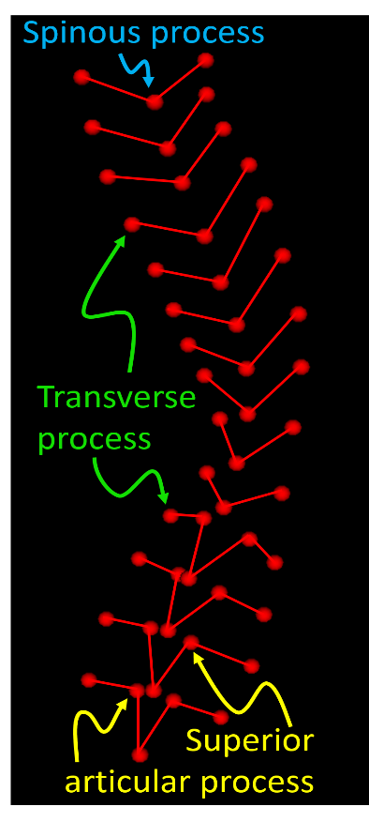

Figure 6: Coronal projection of points placed on a CT derived model at landmarks used by [Cheung2015].

[Cheung2015] evaluated their measurement approaches by comparing the curvatures resulting from the operators ultrasound scans to curvatures measured from X-ray by the same operators. They examined the accuracy of their procedures in terms of the correlations between their outputs and the X-ray measurements. Inter and intra-operator variability for both the ultrasound and X-ray measurements were also investigated.

### Results

37 curvatures were measured from 28 patients using the Cobb method with X-ray images. The ranges of curvatures resulting from the Cobb, TP only, and TP plus SAP approaches were 1.9o to 29.9o, 0.8o to 25.9o, and 0.48o to 20.7o, respectively. The correlation coefficients for the relationship between [Chueng2015]’s two curvature measurements and the Cobb angle measured from X-rays were R2 = 0.68, and R2 = 0.86, for the TP only, and TP plus SAP approaches, respectively. Their TP plus SAP approach underestimated the curvature by an average of 2.5o, with results distributed normally about this average. The intra and inter-class correlation coefficients were 0.93 and 0.89, respectively for the TP plus SAP approach. They were 0.57 (p = 0.0045) and 0.75 for the TP only approach. The omitted p-values of all statistics here are reported to be p < 0.001.

One patient’s data had to be discarded from the TP approach’s results because they were unable to locate all of the patient’s TPs.

# Discussion

The summary section provides a chronology of some of the developments in the field of scoliosis quantification using tracked ultrasound.

[Ungi2014] represents here a number of studies, including [Chen2012], performed on phantom models of scoliotic spines. One of the often mentioned limitations of using phantom models for this particular application is that *in vivo* images tend to be lower quality. [Ungi2014] mentions this, saying that *in vitro* images exhibit higher contrast. However, [Ungi2014] states that the main limitation using phantoms, is that they are static, unlike living patients. The shape of the spine, including its curvature, change with time of day and posture. Posture can be an issue if different imaging modalities require different postures. Posture presents a special challenge for scoliotic patients, as they experience decreased standing stability [Nault2002], exacerbating the possibility of changes in spine shape.

The limitations of phantom models make them unsuitable for end-stage validation of methods to be used in a clinical setting. However, the earlier work done on these models laid foundations for the next logical step: *in vivo* studies. [Zheng2015] recognized the need for such *in vivo* studies, and performed their reliability study.

# References

[3DSlicer] <https://www.slicer.org/>

[Chen2012] W. Chen, L. H. Le, and E. H. M. Lou, “Ultrasound imaging of Spinal Vertebrae to Study Scoliosis”, Open Journal of Acoustics 2012; 2:95-103.

**[Cheung2015] C.-W. J. Cheung, G.-Q. Zhou, S.-Y. Law, K.-L. Lai, W.-W. Jiang, and Y.-P. Zheng, “Freehand three-dimensional ultrasound system for assessment of scoliosis”, Journal of Orthopaedic Translation 2015; 3:123-133.**

[Diefenbach2013] C. Diefenbach, B. S. Lonner, J. D. Auerbach, N. Bharucha, and L. E. Dean, “Is Radiation-Free Diagnostic Monitoring of Adolescent Idiopathic Scoliosis Feasible Using Upright Positional Magnetic Resonance Imaging?”, Spine 2013; 38(7):576- 580.

[Doody2000] M. M. Doody, J. E. Lonstein, M. Stovall, D. G. Hacker, N. Luckyanov, and C. E. Land, “Breast Cancer Mortality After Diagnostic Radiography”, Spine 2000;   
 25(16):2052-2063.

[Frerich2012] J. M. Frerich, K. Hertzler, P. Knott, and S. Mardjetko, “Comparisson of Radiographic and Surface Topography Measurement in Adolescents with Idiopathic Scoliosis”, The Open Orthopaedics Journal 2012; 6:261-265.

[Goldberg2001] C. J. Goldberg, M. Kaliszer, D. P. Moore, E. E. Fogarty, and F. E. Dowling, “Surface Topography, Cobb Angles, and Cosmetic Changes in Scoliosis”, Spine 2001;  
 26(4):E55-E63.

[Morrissy1990] R. T. Morrissy, G. S. Goldsmith, E. C. Hall, D. Khel, and G. H. Cowie, “Measurement of the Cobb angle on radiographs of patients who have scoliosis. Evaluation of intrinsic error”, J Bone Joint Surg Am. 1990; 72:320-327.

[Nault2002] M. L. Nault, P. Allard, S. Hinse, R. Le Blanc, O. Caron, H. Labelle, and H. Sadeghi, “Relations between standing stability and body posture parameters in adolescent idiopathic scoliosis”, Spine 2002; 27:1911-1917.

**[Ungi2014] T. Ungi, F. King, M. Kempston, Z. Keri, A. Lasso, P. Mousavi, J. Rudan, D. P. Borschneck, and G. Fichtinger, “Spinal Curvature Measurement by Tracked Ultrasound Snapshots”, Ultrasound in Medicine and Biology 2014; 40(2):447-454.**

**[Zheng2015] R. Zheng, A. C. Y. Chan, W. Chen, D. L. Hill, L. H. Le, D. Hedden, M. Moreau, J. Mahood, S. Southon, E. Lou, “Intra- and Inter-rater Reliability of Coronal Curvature Measurement for Adolescent Idiopathic Scoliosis Using Ultrasonic Imaging Method - A Pilot Study”, Spine Deformity 2015; 3:151-158.**