Visualization of scoliotic spine using  
ultrasound-accessible skeletal landmarks

Ben Church1, Andras Lasso1, Christopher Schlenger2,   
Daniel P. Borschneck3, Parvin Mousavi4, Gabor Fichtinger1,3, Tamas Ungi1,3

1. Laboratory for Percutaneous Surgery, School of Computing, Queen’s University, Kingston, ON, Canada
2. Premier Chiropractic, Stockton, CA, USA
3. Department of Surgery, Queen’s University, Kingston, ON, Canada
4. Medical Informatics Laboratory, School of Computing, Queen’s University, Kingston, ON, Canada

**ABSTRACT**

**PURPOSE:** Ultrasound imaging is an attractive alternative to X-ray for scoliosis diagnosis and monitoring due to its safety and inexpensiveness. The transverse processes as skeletal landmarks are accessible by means of ultrasound and are sufficient for quantifying scoliosis, but do not provide an intuitively comprehendible visualization of the spine. **METHODS:** We created a method for visualization of the scoliotic spine using a 3D transform field, resulting from thin-spline interpolation of a landmark-based registration between the transverse processes that we localized in both the patient’s ultrasound and an average healthy spine model. Additional anchor points were computationally generated to control the thin-spline interpolation, in order to gain a transform field that accurately represents the deformation of the patient’s spine. The transform field is applied to the average spine model, resulting in a 3D surface model depicting the patient’s spine. We applied ground truth CT from pediatric scoliosis patients in which we reconstructed the bone surface and localized the transverse processes. We warped the average spine model and analyzed the match between the patient’s bone surface and the warped spine. **RESULTS:** Visual inspection revealed accurate rendering of the scoliotic spine. Notable misalignments occurred mainly in the anterior-posterior direction at the first and last vertebra, which is immaterial for scoliosis quantification. The average Hausdorff distance computed for 4 patients was 2.4 mm. **CONCLUSIONS:** We achieved qualitatively accurate and intuitive visualization to depict the 3D deformation of the patient’s spine when compared to ground truth CT.

**Keywords:** Spine, scoliosis, ultrasound, visualization

# INTRODUCTION

Scoliosis is a pathological, coronal curvature of the spine, typically greater than 10o. This quantification of the disease is in terms of the Cobb angle, the maximum angle between the endplates of any two vertebrae. Scoliosis typically manifests during adolescence and develops with growth until skeletal maturity. If left untreated, this curvature can become sufficiently severe that back pain or respiratory problems develop. Once scoliosis is detected, continued monitoring and quantification is required to ensure that its progression is met with the appropriate treatment. Continued observation is required for Cobb angles less than 20o. Bracing can be used to slow the progression of the disease for Cobb angles between 20o and 40o. Any curvature in excess of 40o is often treated with surgical vertebral fusing.

X-ray imaging is still considered the gold standard for scoliosis quantification and visualization. The health risks associated with repetitive exposure to ionizing radiation during adolescence have motivated research [Cheung 2015a, Cheung 2015b, Ungi 2014, Wang 2015, Wang 2016, Zheng 2015] into the use of spatially tracked ultrasound as an alternative imaging modality. [Purnama2010] demonstrated that the vertebral transverse processes can be located with tracked ultrasound. [Ungi2014] showed that this method of transverse process location is suitable for quantifying the curvature of a scoliotic spine.

Despite these methods’ utility in quantifying the severity of scoliosis, they do not provide clinicians or patients with a comprehensible visualization of the spine. For example, Figure 1 shows the result of placing a sequence of parasagittal, tracked ultrasound images in virtual anatomic space. [Ungi2014] showed that the transverse process locations extracted from these images are sufficient for scoliosis quantification, although their method does not provide a readily comprehensible visualization of the spine.   
  
The visualization used for landmark identification and subsequent curvature quantification by [Zheng2015] is shown in Figure 2. As [Zheng2015] showed, this image is sufficient for scoliosis quantification, and to some extent, visualization in the coronal plane. However, as a single, consolidated, 2D image, it cannot depict 3D deformation.

Figure 2: Posterior view of spine reconstructed from tracked ultrasound image sequence. Taken from [Zheng2015].

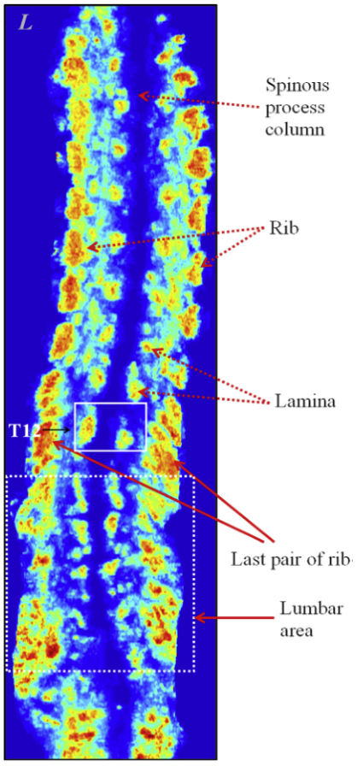

Figure 1: Sequence of tracked ultrasound snapshots shown in virtual anatomic space. Taken from [Ungi2014].

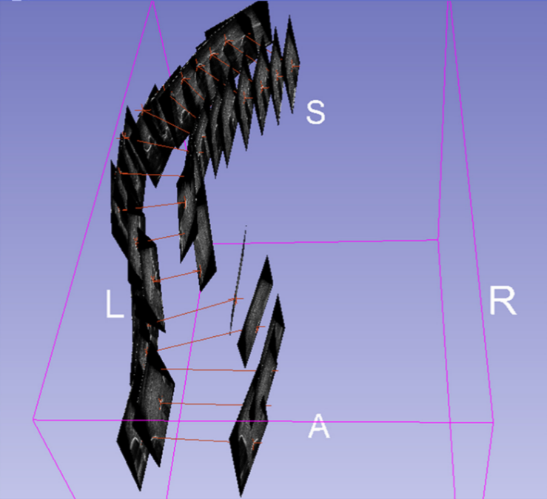

It is because of the lack of a method using ultrasound to produce comprehensible visualizations of spinal anatomy, scoliotic or otherwise, that we propose a method to produce such visualizations. The method uses the transverse process locations (those used by [Ungi2014] for quantification), and a 3D model of a spine with normal anatomy. The result is a 3D volume models suitable for visual inspection of the scoliotic spine, to aid the physician in visual assessment of the extent and nature of the scoliosis.

# NEW OR BREAKTHROUGH WORK

We have developed a method to create 3D visualization of the scoliotic spine, based on the locations of transverse processes as skeletal landmarks, by computationally warping an average healthy spine model to match the landmarks. We have shown that the method produces an excellent qualitative visual representation of the spine that is appropriate for inspection of the extent and nature of the curvature. Besides scoliosis evaluation, applications of this method may include automatic structure labelling, or the initial alignment for registration in surgical navigation.

# METHODS

Landmark-based registration requires two sets of points, one to be registered to the other. In our case, the first set of points consists of the transverse processes from an average healthy spine, while the second set of points are the transverse processes localized in the patient’s ultrasound images. In each point set, the transverse processes align along two nearly parallel curves. The sparsity and peculiar distribution of the points make it extremely challenging to warp an average spine model to the patient’s skeletal landmarks in an anatomically accurate fashion. We propose to remedy this by computationally adding matching anchor points in both point sets, in a manner that preserves the deformation field. The anchor points are added at offsets normal to the curvature of the spines, in the anterior direction. To compute this normal direction consistently, vector cross products of right-left, and superior-inferior vectors are used to compute an anterior-posterior vector. This method defines piece-wise volumes, rather than the original curves. Since each piece of the volume corresponds to one vertebra, the registration algorithm imposes most of the deformation   
inter-vertebrally, rather than continuously along the curves. We account for the scale in length between the average spine and the patient’s spine by scaling the magnitude of the offset distance by the ratio of the length of the patient’s spine to the length of the average spine. To add the anchor point anterior to point P(i,j), where i denotes the vertebra (the superior-most being at i = 0), and where j denotes right versus left (j = 0 for left, j = 1 for right), the right-left vector was computed as:

(1)

where angled brackets denote vectors. Superior-inferior vectors are computed as the average of two possible vectors:

(2)

At the superior and inferior extremities of the spine, where only one vertebra existed below or above the one to which an anchor point is being added, only the existing vector is used in equation (2). Finally, to determine the location of the anchor point, the anterior-posterior vector is computed as the cross product of the vectors from equations (1) and (2), normalized by dividing it by its length, and scaled by a vertebral scaling factor times the ratio of the length of the patient’s spine to that of the average spine:

(3)

where the * denotes an anchor point being added, VSF is a vertebral scaling factor used relate the size of the current vertebra’s local anatomy to the corresponding anatomy of the model, • denotes scalar multiplication, ASF is an anatomic scaling factor representing the scale of the current vertebra, × denotes a vector cross product, and |V| denotes the length of vector V.

The VSF for vertebra i on side j is computed as:

(4)

where the *model* subscript denotes that the superior-inferior vector is associated with the corresponding vertebra on the healthy model. Therefore, the VSFs for the healthy models are identity. This ratio factor reflects the length of the current spine anatomy, relative to that of the model. This causes a scaling of the spine model when it is deformed to the patient’s anatomy.

The ASF is calculated as:

(5)

This factor is meant to convey the length scale of the vertebra in the magnitude of the anchor point distance. This results in the anchor points for longer vertebrae being placed further from their original points. This provides the registration algorithm with information that will scale the model, vertebra-wise, to match the scale of those particular vertebra in the patient.

Figure 3 shows a piece of the average spine with the transverse process points, the anchor points, and the vectors locating an anchor point. The registration is as a thin-plate spline transformation between the two sets of points [Bookstein 1989], as implemented in the Visualization Toolkit ([www.vtk.org](http://www.vtk.org)). The thin-plate spline transformation maps each transverse process and anchor point of the average spine to its corresponding point in the patient’s spine with a smooth interpolation. This yields a continuous 3D transform field that we apply to the average spine model, thereby warping it to match the patient’s spine.



Figure : A piece of the average spine model with transverse process points, anchor points, and illustrations of the vectors used to locate one anchor point. The superior-inferior vector is the result of an average and therefore does not point to P(9,0). Vectors are added for illustration and therefore are not necessarily exact. Right-sided anchor points are occluded by the model.

To validate this method, we apply ground truth CT data sets from pediatric scoliosis patients. We reconstructed their spine surface from CT and we marked their transverse processes that are clearly visible in the CT images. Using the transverse processes as input, we computed the anchor points, computed the deformation field from thin-plate spline registration and warped the average spine model. In addition to qualitative visual inspection, we evaluated the outcome of registration quantitatively by computing the average and maximum Hausdorff distances.

# RESULTS AND DISCUSSION

The method was tested in CT data from four pediatric scoliosis patients. Results for two patients are shown in Figures 2 and 3. Typically, the top and bottom vertebral level a patient’s ultrasound scan is variable. To account for this, the average spine model (leftmost image in   
Figures 2 and 3) is truncated to match the vertebral levels in the patient’s spine. The images demonstrate that the method achieves the intended purpose of producing intuitive 3D visual representation of scoliotic spine as a potentially useful aid to clinicians. Visual inspection revealed accurate rendering of the scoliotic spine relative to the ground truth CT. Notable misalignments occurred mainly in the anterior-posterior direction at the first and last vertebra, where the registration lacked the extra anchor points. However, these regions are immaterial for scoliosis quantification. There is also notable error in the anterior-posterior direction, which is also immaterial in computing the Cobb angle. Still, this error could be reduced by computing the VSF scale factor for each vertebra, which we will undertake in future work.

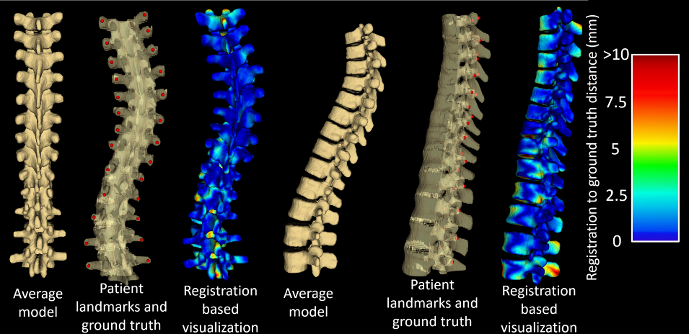Figure 2: Results for Patient #1. The left three images are, from left to right: the average spine model, transverse process landmarks on patient’s ground truth CT, and average spine warped to the landmarks with a heat map showing the distance to the ground truth CT, viewed from the posterior direction. The right three images are the same viewed from the left.

Quantitative registration evaluation metrics are shown in Table 1. Hausdorff distances were chosen over the Dice similarity coefficient as registration metrics because the Dice similarity coefficient is not suitable for shapes containing thin structures, like the spine. Still, the maximum Hausdorff distances tended to be misleadingly large because of the spinous processes, with no landmarks to constrain their deformation to that seen in the patients. In particular, patient #2’s ground truth lacked the end of the inferior-most vertebra, present in the average model. This resulted in an abnormally large maximum Hausdorff distance, still without compromising the visualization. Such misalignment is unsurprising, and as we noted earlier, is of no clinical significance in assessing the scoliosis. Again, the accuracy of the registration distant from the posterior vertebral faces is likely to be sensitive to the particular value used for the vertebral scaling factor, the VSF. As a possible refinement to the method, we will investigate the effects of calculating this value for individual vertebrae based on the distances between the local landmark points. The factor representing the ratio of the lengths of the spines could be refined similarly; by scaling each offset in proportion to local inter-vertebral distances, rather than for the entire spines, further improvements to these results may be achieved.

|  |  |  |  |
| --- | --- | --- | --- |
|  | | **Registration Metric** | |
| **Avg. Hausdorff Distance (mm)** | **Max. Hausdorff Distance (mm)** |
| **Patient #** | **1** | 2.1 | 13.2 |
| **2** | 2.9 | 28.7 |
| **3** | 2.3 | 18.8 |
| **4** | 2.5 | 19.1 |

Table 1: Registration evaluation metrics

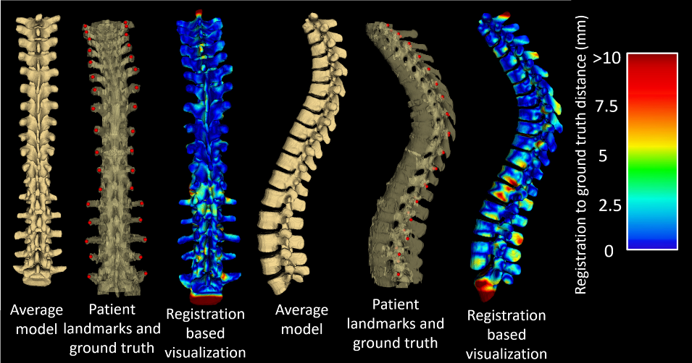

Figure 3: Results for Patient #2. The left three images are, from left to right: the average spine model, transverse process landmarks on patient’s ground truth CT, and average spine warped to the landmarks with a heat map showing the distance to the ground truth CT, viewed from the posterior direction. The right three images are the same viewed from the left.

We stress that for both diagnostic and therapeutic purposes, the spinal curvature is computed from the transverse process landmarks [Ungi 2014]. The purpose of the work presented in this paper is aiding the physician in the visual perception of the curvature that is virtually impossible to see or feel from the sparse skeletal landmarks alone.

It is of note that this method is not strictly limited to scoliosis visualization with the transverse processes or ultrasound imaging. Scoliosis is a clinically significant and challenging application to test our approach, where the associated deformation constitutes difficult anatomy for model registration from sparse anatomical landmarks. Our method was designed on the basis of the symmetry and relative locations of the ultrasound-accessible landmarks, in this case, the transverse processes. However, other landmarks could be retrieved from any imaging modality and the method adapted to suit their geometric properties.

# CONCLUSIONS

The modified landmark-based registration method presented in this paper is capable of producing three-dimensional visualization of the scoliotic spine using just two ultrasound-accessible landmarks per vertebra as input. Most of the registration’s misalignment occurs anterior and posterior to the vertebral faces, in the vertebral bodies and spinous processes, respectively. This misalignment is the result of being distant from the landmarks used for scoliosis quantification and as input to our method, and as such, is of no clinical significance in the visual assessment of the extent and nature of the scoliosis; it does not affect the visual perception of the spinal curvature.