Visualization of scoliotic spine using  
ultrasound-accessible skeletal landmarks

Ben Church1, Andras Lasso1, Christopher Schlenger2,   
Dan Borschneck3, Parvin Mousavi4, Gabor Fichtinger1, Tamas Ungi1

1. Laboratory for Percutaneous Surgery, School of Computing, Queen’s University, Kingston, ON, Canada
2. Premier Chiropractic, Stockton, CA, USA
3. Department of Surgery, Queen’s University, Kingston, ON, Canada
4. Medical Informatics Laboratory, School of Computing, Queen’s University, Kingston, ON, Canada

**ABSTRACT**

**PURPOSE:** Ultrasound imaging is an attractive alternative to X-ray for scoliosis diagnosis and monitoring due to its safety and inexpensiveness. The transverse processes as skeletal landmarks are accessible by means of ultrasound and are sufficient for quantifying scoliosis, but do not provide an intuitively comprehendible visualization of the spine. **METHODS:** We created a method for visualization of the scoliotic spine using a 3D transform field, resulting from thin-spline interpolation of a landmark-based registration between the transverse processes that we localized in both the patient’s ultrasound and an average healthy spine model. Additional anchor points were computationally generated to control the thin-spline interpolation, in order to gain a transform field that accurately represents the deformation of the patient’s spine. The transform field is applied to the average spine model, resulting in a 3D surface model depicting the patient’s spine. We applied ground truth CT from pediatric scoliosis patients in which we reconstructed the bone surface and localized the transverse processes. We warped the average spine model and analyzed the match between the patient’s bone surface and the warped spine. **RESULTS:** Visual inspection revealed accurate rendering of the scoliotic spine. Notable misalignments occurred mainly in the anterior-posterior direction at the first and last vertebra, which is immaterial for scoliosis quantification. The average Hausdorff distance computed for 4 patients was 2.4 mm. **CONCLUSIONS:** We achieved qualitatively accurate and intuitive visualization to depict the 3D deformation of the patient’s spine when compared to ground truth CT.

**Keywords:** Spine, scoliosis, ultrasound, visualization

# BACKGROUND AND PURPOSE

Scoliosis is a pathological curvature of the spine, which typically develops during adolescence. If left untreated, scoliosis can progress to the point that back pain or respiratory problems develop. Management of the disease requires monitoring the deformation’s progression. Scoliosis is quantified by the Cobb angle, the maximum angle between the endplates of any two vertebrae. Continued observation is typically required for patients exhibiting a Cobb angle of less than 20°. Bracing can be used to prevent further progression of the disease for a Cobb angle between 20° and 40°. Any curvature in excess of 40° is often treated with surgical vertebral fusing [Frerich 2012]. X-ray is considered the gold-standard for scoliosis quantification and visualization. The risks of repetitive exposure to ionizing radiation during adolescence have motivated investigation into the use of tracked ultrasound as an alternative imaging modality   
[Cheung 2015]. The transverse processes can be localized in ultrasound [Berton 2016] and they are sufficient to compute the curvature of the spine in three dimensions [Ungi 2014]. Ultrasound, however, can only visualize parts of the posterior surface of the spine, which, despite being sufficient to determine the curvature, does not provide the physician with a comprehensible visualization of the patient’s spine. In this paper, we present a method to warp an average healthy spine to match sparse skeletal landmarks localized in the patient’s ultrasound, thereby allowing three-dimensional visual inspection of the scoliotic spine, to aid the physician in visual assessment of the extent and nature of scoliosis. In clinical practice, the curvature also needs to be presented to the patient and his/her parents, for whom it is virtually impossible to appreciate the shape of the scoliotic spine from the sparse skeletal landmarks alone.

# NEW OR BREAKTHROUGH WORK

We have developed a method to create 3D visualization of the scoliotic spine, based on the locations of transverse processes as skeletal landmarks, by computationally warping an average healthy spine model to match the landmarks. We have shown that the method produces an excellent qualitative visual representation of the spine that is appropriate for inspection of the extent and nature of the curvature. Besides scoliosis evaluation, applications of this method may include automatic structure labelling, or the initial alignment for registration in surgical navigation.

# METHODS

Landmark-based registration requires two sets of points, one to be registered to the other. In our case, the first set of points consists of the transverse processes from an average healthy spine, while the second set of points are the transverse processes localized in the patient’s ultrasound images. In each point set, the transverse processes align along two nearly parallel curves. The sparsity and peculiar distribution of the points make it extremely challenging to warp an average spine model to the patient’s skeletal landmarks in an anatomically accurate fashion. We propose to remedy this by computationally adding matching anchor points in both point sets, in a manner that preserves the deformation field. The anchor points are added at offsets normal to the curvature of the spines, in the anterior direction. To compute this normal direction consistently, vector cross products of right-left, and superior-inferior vectors are used to compute an anterior-posterior vector. This method defines piece-wise volumes, rather than the original curves. Since each piece of the volume corresponds to one vertebra, the registration algorithm imposes most of the deformation   
inter-vertebrally, rather than continuously along the curves. We account for the scale in length between the average spine and the patient’s spine by scaling the magnitude of the offset distance by the ratio of the length of the patient’s spine to the length of the average spine. To add the anchor point anterior to point P(i,j), where i denotes the vertebra (the superior-most being at i = 0), and where j denotes right versus left (j = 0 for left, j = 1 for right), the right-left vector was computed as:

(1)

where angled brackets denote vectors. Superior-inferior vectors are computed as the average of two possible vectors:

(2)

At the superior and inferior extremities of the spine, where only one vertebra existed below or above the one to which an anchor point is being added, only the existing vector is used in equation (2). Finally, to determine the location of the anchor point, the anterior-posterior vector is computed as the cross product of the vectors from equations (1) and (2), normalized by dividing it by its length, and scaled by a vertebral scaling factor times the ratio of the length of the patient’s spine to that of the average spine:



Figure : A piece of the average spine model with transverse process points, anchor points, and illustrations of the vectors used to locate one anchor point. The superior-inferior vector is the result of an average and therefore does not point to P(9,0). Vectors are added for illustration and therefore are not necessarily exact. Right-sided anchor points are occluded by the model.

(3)

where the * denotes an anchor point being added, VSF is a vertebral scaling factor used to constrain registration deformation in the anterior-posterior direction, • denotes scalar multiplication, LP is the length of the patient’s spine, LA is the length of the average spine model, × denotes a vector cross product, and |V| denotes the length of vector V. A VSF of 30 mm was empirically chosen to represent typical inter-landmark spacing.

Figure 1 shows a piece of the average spine with the transverse process points, the anchor points, and the vectors locating an anchor point. The registration is as a thin-plate spline transformation between the two sets of points [Bookstein 1989], as implemented in the Visualization Toolkit ([www.vtk.org](http://www.vtk.org)). The thin-plate spline transformation maps each transverse process and anchor point of the average spine to its corresponding point in the patient’s spine with a smooth interpolation. This yields a continuous 3D transform field that we apply to the average spine model, thereby warping it to match the patient’s spine.

To validate this method, we apply ground truth CT data sets from pediatric scoliosis patients. We reconstructed their spine surface from CT and we marked their transverse processes that are clearly visible in the CT images. Using the transverse processes as input, we computed the anchor points, computed the deformation field from thin-plate spline registration and warped the average spine model. In addition to qualitative visual inspection, we evaluated the outcome of registration quantitatively by computing the average and maximum Hausdorff distances.

# RESULTS AND DISCUSSION

The method was tested in CT data from four pediatric scoliosis patients. Results for two patients are shown in Figures 2 and 3. Typically, the top and bottom vertebral level a patient’s ultrasound scan is variable. To account for this, the average spine model (leftmost image in   
Figures 2 and 3) is truncated to match the vertebral levels in the patient’s spine. The images demonstrate that the method achieves the intended purpose of producing intuitive 3D visual representation of scoliotic spine as a potentially useful aid to clinicians. Visual inspection revealed accurate rendering of the scoliotic spine relative to the ground truth CT. Notable misalignments occurred mainly in the anterior-posterior direction at the first and last vertebra, where the registration lacked the extra anchor points. However, these regions are immaterial for scoliosis quantification. There is also notable error in the anterior-posterior direction, which is also immaterial in computing the Cobb angle. Still, this error could be reduced by computing the VSF scale factor for each vertebra, which we will undertake in future work.

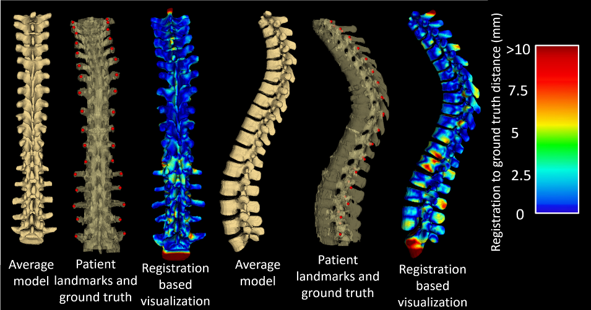

Figure 3: Results for Patient #2. The left three images are, from left to right: the average spine model, transverse process landmarks on patient’s ground truth CT, and average spine warped to the landmarks with a heat map showing the distance to the ground truth CT, viewed from the posterior direction. The right three images are the same viewed from the left.

Figure : Results for Patient #1. The left three images are, from left to right: the average spine model, transverse process landmarks on patient’s ground truth CT, and average spine warped to the landmarks with a heat map showing the distance to the ground truth CT, viewed from the posterior direction. The right three images are the same viewed from the left.

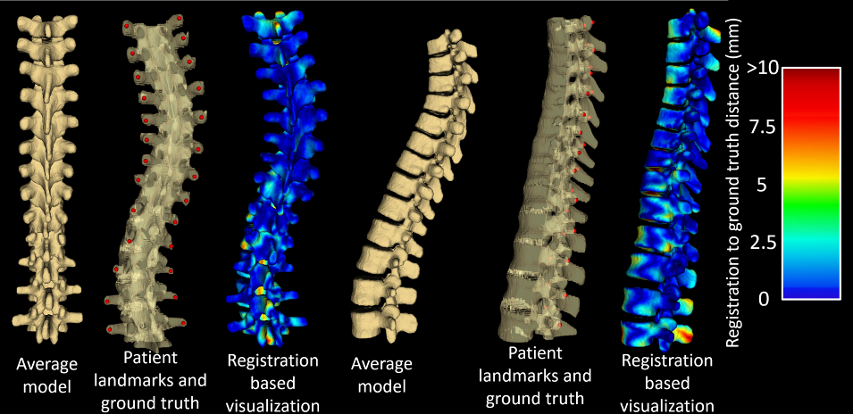

Quantitative registration evaluation metrics are shown in Table 1. Hausdorff distances were chosen over the Dice similarity coefficient as registration metrics because the Dice similarity coefficient is not suitable for shapes containing thin structures, like the spine. Still, the maximum Hausdorff distances tended to be misleadingly large because of the spinous processes, with no landmarks to constrain their deformation to that seen in the patients. In particular, patient #2’s ground truth lacked the end of the inferior-most vertebra, present in the average model. This resulted in an abnormally large maximum Hausdorff distance, still without compromising the visualization. Such misalignment is unsurprising, and as we noted earlier, is of no clinical significance in assessing the scoliosis. Again, the accuracy of the registration distant from the posterior vertebral faces is likely to be sensitive to the particular value used for the vertebral scaling factor, the VSF. As a possible refinement to the method, we will investigate the effects of calculating this value for individual vertebrae based on the distances between the local landmark points. The factor representing the ratio of the lengths of the spines could be refined similarly; by scaling each offset in proportion to local inter-vertebral distances, rather than for the entire spines, further improvements to these results may be achieved.

|  |  |  |  |
| --- | --- | --- | --- |
|  | | **Registration Metric** | |
| **Avg. Hausdorff Distance (mm)** | **Max. Hausdorff Distance (mm)** |
| **Patient #** | **1** | 2.1 | 13.2 |
| **2** | 2.9 | 28.7 |
| **3** | 2.3 | 18.8 |
| **4** | 2.5 | 19.1 |

Table 1: Registration evaluation metrics

We stress that for both diagnostic and therapeutic purposes, the spinal curvature is computed from the transverse process landmarks [Ungi 2014]. The purpose of the work presented in this paper is aiding the physician in the visual perception of the curvature that is virtually impossible to see or feel from the sparse skeletal landmarks alone.

It is of note that this method is not strictly limited to scoliosis visualization with the transverse processes or ultrasound imaging. Scoliosis is a clinically significant and challenging application to test our approach, where the associated deformation constitutes difficult anatomy for model registration from sparse anatomical landmarks. Our method was designed on the basis of the symmetry and relative locations of the ultrasound-accessible landmarks, in this case, the transverse processes. However, other landmarks could be retrieved from any imaging modality and the method adapted to suit their geometric properties.

# CONCLUSIONS

The modified landmark-based registration method presented in this paper is capable of producing three-dimensional visualization of the scoliotic spine using just two ultrasound-accessible landmarks per vertebra as input. Most of the registration’s misalignment occurs anterior and posterior to the vertebral faces, in the vertebral bodies and spinous processes, respectively. This misalignment is the result of being distant from the landmarks used for scoliosis quantification and as input to our method, and as such, is of no clinical significance in the visual assessment of the extent and nature of the scoliosis; it does not affect the visual perception of the spinal curvature.

# REFERENCES

Berton, F., Cheriet, F., Miron, M., and Laporte, C., “Segmentation of the spinous process and its acoustic shadow in vertebral ultrasound images,” Computers in Biology and Medicine 72, 201-211 (2016).

Bookstein, F., “Principal Warps: Thin-Plate Splines and the Decomposition of Deformations,” IEEE Transactions on Pattern Analysis and Machine Intelligence 11, 567-585 (1989).

Cheung CW, Zhou GQ, Law SY, Mak TM, Lai KL, Zheng YP. “Ultrasound Volume Projection Imaging for Assessment of Scoliosis”. IEEE Trans Med Imaging. 2015 Aug;34(8):1760-8.

Frerich, J., Hertzler, K., Knott, P., and Mardjetko, S., “Comparison of Radiographic and Surface Topography Measurements in Adolescents with Idiopathic Scoliosis,” The Open Orthopaedics Journal 16, 261-265 (2012).

Ungi T, King F, Kempston M, Keri Z, Lasso A, Mousavi P, Rudan J, Borschneck DP, Fichtinger G. “Spinal curvature measurement by tracked ultrasound snapshots”. Ultrasound Med Biol. 2014 Feb;40(2):447-54.