## Anatomy and pathology

The spine is a large anatomic structure crucially important for bodily structure. Figure 1 illustrates the anatomy of two adjacent vertebrae, the bones which make up the spine. Vertebrae have a relatively complex shape which presents both challenges and opportunities in medical interventions. Figure 1 provides an unrealistically clear depiction of vertebrae; vertebrae *in vivo* are covered with sinew and many procedures are performed percutaneously, respectively impeding and precluding the possibility of direct visualization of the anatomy by the operator.

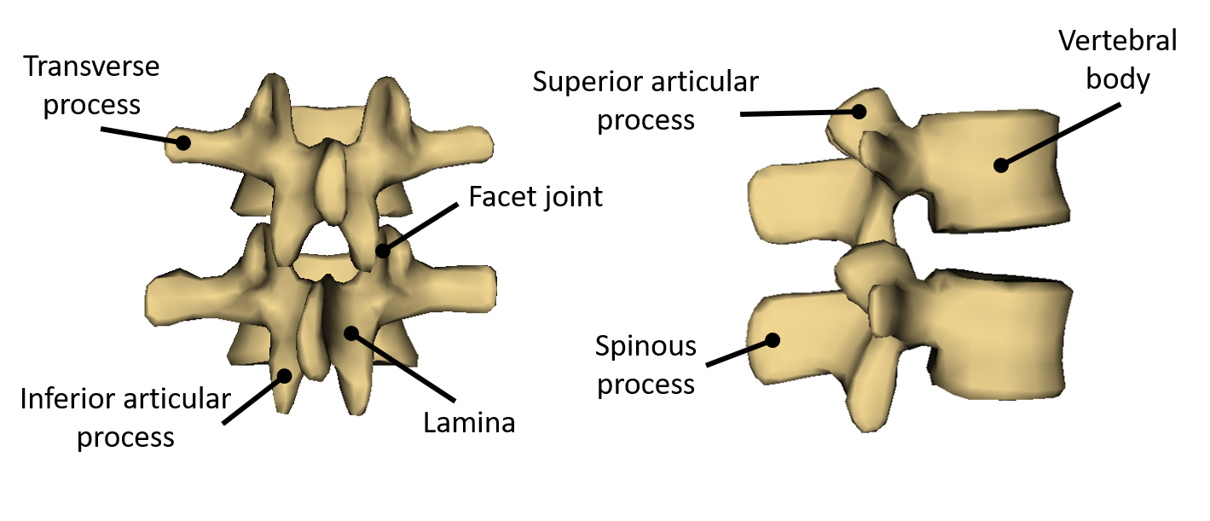

Figure 1: Posterior and right side views of a second and third lumbar vertebrae

The spine is susceptible to a number of costly and potentially debilitating diseases which can impair greater functionality through the importance of the spine.

Back pain is a prevalent health issue in the developed world, with up to 80% of adults experiencing it {sometime} [Rubin2007]. It is a leading cause for missed work and doctor visits.

## Relevant procedures

### Spinal injection

When back pain is not responsive to oral medication, the next step is often a diagnostic injection of anesthetic into the facet joint of the painful area. The small diameter of the facet joint as a target for injection, coupled with its proximity to sensitive nerves of the spine, necessitate the use of visualization of interventional navigation. Fluoroscopy or CT are currently the standards of care for facet joint injection because they provide detailed visualizations of the patient’s anatomy and needle placement. Fluoroscopy and CT require the use of ionizing radiation, and so must be performed at the specialized radiological facilities for health and safety standards. Despite these standards, fluoroscopy and CT still expose patients and practitioners to harmful ionizing radiation. The financial cost of these imaging methods and their proper operation, the radiation exposure resulting from their use, and the volume of injection procedures which they are used for, combine to impose a substantial cost of the health care system. This cost, however, may be largely unnecessary if a radiation-free imaging modality were used.

Ultrasound-based navigation for spinal interventions receives much attention in research as such a radiation-free imaging modality. Furthermore, it is gaining clinical acceptance. For example, committees commissioned by the American Society of Regional Anesthesia and Pain Medicine (ASRA) and jointly by the ASRA and the European Society of Regional Anesthesia and Pain Therapy both report positive recommendations for training and practice with ultrasound guided regional anesthesia (UGRA) [Sites2009, Neal2016].

## Ongoing US research

The simplest method for ultrasound injection guidance involves holding the probe so that the image plane contains the path of the needle [Hurdle2016].

### Inter-modality registration

More sophisticated methods involve the registration of prior CT or MRI scans to intraoperative, spatially tracked ultrasound. Inter-modality image registration-based visualization produces models suitable for assessment and injection guidance, however many patients will not have had prior CTs and performing CTs for this purpose reintroduces the problem of harmful radiation. MRI is not an ideal solution either due to its limited availability and high cost.

### Atlas registration

For the purpose of registration-based visualization, a deformable statistical atlas model can be used instead of a CT or MRI segmentation. The atlas model is essentially an average or expected spine shape. It is generated by performing principal component analysis (PCA) on numerous training sample spine shapes, often CT segmentations. The PCA instantiates the model as two, sometimes three, sets of vectors, usually representing the principal modes of variation in shape, pose, and sometimes

Methods have also been proposed which require only ultrasound as an imaging modality, wherein a statistical atlas models of vertebrae are registered to patient ultrasound. Atlas registration methods have shown some promise both *in vitro* and *in vivo*, but to our knowledge, have not been validated against abnormal anatomy. Abnormal spinal anatomy, such as scoliosis, may prove challenging for statistical atlas generation. Modes of variation which are relatively common in scoliotic patients, such as vertebral wedging, increases both the complexity of the model in the number of parameters required to represent the shape, and the number and distribution of samples required to learn the modes of variability. Statistical atlas models improve with the number of samples presented to them. [Shape + pose both affected]

### Biomechanical model augmented registration

Simply maximizing the similarity between the patient’s ultrasound and the atlas vertebrae or prior CT will not always produce realistic patient models. Since registration methods often treat vertebrae as separate bodies, similarity optimization by itself can return unrealistic (and incorrect) representations of patient anatomy, such as intersecting vertebrae or adjacent vertebrae at impossible angles. To address this difficulty, registration may be implemented with a biomechanical model of the spine to ensure realistic orientation of the vertebrae. By treating adjacent vertebrae of the atlas as connected with springs with their equilibria at the unregistered shape, an energy term can be calculated for any transformation of the spine, penalizing large deformations between adjacent vertebrae. The registration method then seeks to minimize this energy while maximizing the similarity.

## Proposed contribution