|  |
| --- |
| **Lay Summary Description of Project** *maximum 200 words*  (Describe objectives and methodology in plain language. If funded, this description will be used to describe your project in Foundation communications.) |

It is estimated that between 2 to 4% of adolescent children will have scoliosis that requires medical attention. Screening tools were found to be either cost ineffective or inaccurate in identifying those patients with significant scoliosis. Yet, the lack of screening has led to a misappropriate utilization of hospital and clinical resources. A more robust screening tool for scoliosis is necessary which does not involve ionizing radiation, like X-ray imaging. It also needs to be portable and inexpensive to allow screening of the entire adolescent population. Once the diagnosis is established, the spinal curvatures also need monitoring to detect progression early and start the appropriate therapy. Monitoring is currently done using X-ray. Although it is proven that regular X-ray imaging may double the risk of cancer in these children. An ultrasound-based spinal curvature method would not only decrease the cost of screening and monitoring, but would also decrease the risk of cancer of scoliosis patients to the normal population level. Although ultrasound has earlier been found inaccurate in spinal curvature measurement, we propose that ultrasound combined with 3-dimensional position tracking for spinal curvature measurement. We will use tracked ultrasound in a single-centre evaluation study to assess this new technology in spinal curvature measurement.

# Application Contents

1. **Statement of objectives and specific aims of the project in the form of hypothesis (1 page maximum)**

Our objective is to find a safe and accessible way of spine monitoring for children who live with spinal deformities. Currently X-ray imaging is the only way to accurately measure spine curvatures. But regular X-ray imaging increases the risk of cancer, and it is only feasible in special facilities, which burdens the families of patients and the healthcare system, and limits the frequency of follow-up examinations. The ideal spinal curvature measurement tool would be available at each pediatric orthopedic surgery clinic, allowing accurate measurements by the physician who is in charge of patient follow-up. But the measurement method should not use X-ray or other forms of ionizing radiation, and should be affordable.

We propose an ultrasound imaging system, combined with recent techniques for optical position tracking and computerized image analysis. This new system will likely fulfill all requirements of an ideal spinal curvature measurement tool, allowing better care for children with spinal deformities. Our proposed system will be lightweight and portable, allowing physicians to carry it to clinics where there is no permanent spine imaging system installed. It will also be safe, as ultrasound imaging has no known adverse effects to health. The estimated cost of the final system will be under $15,000. We will not only publish our results, but ensure that the developed software is publicly available and easily reusable to facilitate further research in spine imaging and fast dissemination in research and industry.

A system prototype will be evaluated at Queen’s University and affiliated hospitals. The local patient population is sufficiently large and diverse to be a representative sample of the entire population. Our main objective is to investigate if tracked ultrasound is a reliable and repeatable method in spinal curvature measurement. We also need to find evidence that therapeutic decisions based on the proposed system would not lead to delayed treatment of patients with progressing disease. For this, the current clinical practice of X-ray imaging provides gold standard in our evaluation study. Therefore, we propose a comparative study between ultrasound-based and X-ray spinal curvature monitoring. Patients of our local hospitals who volunteer to participate in our study will undergo ultrasound-based spine examination during their scheduled follow-up visits. An estimated study population of 100 patients will provide sufficient scientific evidence on the effectiveness of our proposed spinal curvature measurement system.

If our study confirms that the proposed method is reliable and accurate, the measurement of spinal curvatures will become significantly more affordable and accessible. This will have beneficial impact on approximately 2-4% of the entire adolescent population who live with pathological spinal curvature greater than 11º, requiring regular monitoring. The frequent examinations facilitated by the proposed system may lead to early decisions in diagnosis, which potentially reduces the number of cases where surgical treatment becomes necessary.

1. **Background, rationale and present state of knowledge (6 pages maximum). List of reference for this section (2 pages maximum).**

The most frequent form of spinal deformities is adolescent idiopathic scoliosis. Studies conducted in different countries found its prevalence between 1% and 5%, therefore, it is considered a common disease in children [Suh 2011, Nery 2010, Wong 2005]. Recent epidemiologic studies are lacking in Canada, the last being performed in Quebec [Robitaille 1984], which shows prevalence similar to other countries. The etiology of this disease has not yet been fully discovered, however, genetic factors influence both the incidence and the severity of scoliosis [Ward 2010]. It is most commonly diagnosed in early adolescence (9-12) and progresses until the spine reaches full development, around the age of 18-20 years.

Symptoms of adolescent idiopathic scoliosis include lateral curvature of the spine in straight standing position, kyphosis, and permanent vertebral rotation around the axis of the spine. The severity of scoliosis is characterized by the angle of curvature between vertebrae above and below the curvature (Cobb angle). Therapeutic protocols are based on Cobb angle: i) curvatures less than 20 degrees require X-ray monitoring every 3-6 months, depending on the rate of progression; ii) scoliosis between 20-40 degrees is treated with bracing; and iii) scoliosis over 40 degrees, or if chest deformation causes breathing difficulties, is treated surgically, permanently fusing the vertebrae in a straight position. Scoliosis monitoring continues after surgical treatment as well using regular spine imaging. About 10% of adolescent scoliosis cases progress to a state when they require therapy.

Although screening children in the early adolescent age for scoliosis would be necessary for optimal treatment and optimal use of clinical resources, currently affordable screening methods are inaccurate [Aartun 2014]. Therefore, patients may be diagnosed when scoliosis progressed in an advanced stage.

Once diagnosis is confirmed, it is important to frequently monitor all cases to make sure progression is detected early and appropriate therapy is started. However, frequent X-ray imaging in children can lead to increased risk of cancer. Girls who undergo regular spine X-ray, have a nearly twofold risk of breast cancer as adults [Hoffman 1989; Doody 2000]. Another study found that repeated X-ray exams in childhood significantly contribute to leukemia and prostate cancer [Schmitz-Feuerhake 2011]. Further studies may be needed to establish accurate estimates of the risks of X-ray, but a safe scoliosis monitoring method would improve the health of this young patient population.

Radiation-free scoliosis monitoring methods have been investigated in the past, but none of them have been successful in replacing X-ray in the clinical practice. The optimal method needs to be: free of ionizing radiation, accessible to the patient population, and accurate for therapeutic decision making.

Magnetic resonance imaging (MRI) is a safe and accurate alternative to X-ray because it does not have ionizing radiation and provides excellent images of the spine. Open MRI machines permit scanning from a standing patient position, making these images suitable for scoliosis angle measurement. Unfortunately, MRI is less accessible than X-ray due to its high cost and the patient has to stand motionless for several minutes while the scanner captures the entire spinal column, which further limits its use for routine monitoring in an adolescent population [Diefenbach 2013].

Inspection will yield visual signs of scoliosis on the back of the patient. If these signs could be quantified, there would be no need for special medical imaging devices for scoliosis measurement. Visual signs of spinal curvatures have been measured using computerized topographic scans of the skin surface using laser scanners and stereo camera technology [Goldberg 2001]. However, surface scans are not informative enough to support therapeutic decisions. [Frerich 2012] reported Cobb angle errors up to 9° in surface topographically measured curves compared to X-ray measurements.

Ultrasound does not have a large enough field of view to directly visualize spinal curvatures. There have been attempts to use indirect ways of measuring spinal curvatures with ultrasound. A correlation between vertebral rotation and scoliosis angles in untreated patients was discovered [Suzuki 1989] but this correlation is unreliable and, completely lost in patients receiving therapy [Li 2010].

One of the recently emerging imaging modalities is tracked ultrasound: a combination of conventional ultrasound and position tracking technology. With tracked ultrasound we can create a 3D reconstruction from 2D ultrasound images. Position tracking of the ultrasound transducer allows us to join small cross-sections and display the whole spine region in 3D. Experimental results have confirmed that landmarks on these reconstructed image volumes could be used to monitor spine curvature angles [Purnama 2010; Chen 2011]. Tracked ultrasound appears to be the only alternative to X-ray that fulfills all three requirements: safety, accessibility and accuracy.

A new method for scoliosis measurement has been developed previously, and tested on phantom models [Ungi 2014]. Tracked ultrasound (TUS) has been successfully used in medical imaging and image-guided interventions. In particular, it has been tested in spinal injection navigation [Ungi 2012] and vertebra localization for spine surgery [Ungi 2013]. The goal of this project is to evaluate this new system in clinical use. The proposed system takes advantage of the TUS technology. Tracking of the ultrasound position in space makes it possible to reconstruct 2-dimensional ultrasound images in a larger 3-dimensional image volume that covers the entire spinal column. The reconstructed image is visualized similarly to CT or MRI volumetric images. Since the 3-dimensional ultrasound volumes do not distort the geometry of underlying anatomical structures, they are suitable for spinal curvature measurement.

**References**

[Aartun 2014] Aartun E, Degerfalk A, Kentsdotter L, Hestbaek L. Screening of the spine in adolescents: inter- and intra-rater reliability and measurement error of commonly used clinical tests. BMC Musculoskelet Disord. 2014 Feb 10;15:37.

[Diefenbach 2013] Diefenbach C, Lonner BS, Auerbach JD, Bharucha N, Dean LE. Is radiation-free diagnostic monitoring of adolescent idiopathic scoliosis feasible using upright positional magnetic resonance imaging? Spine (Phila Pa 1976). 2013 Apr 1;38(7):576-80.

[Doody 2000] Doody MM, Lonstein JE, Stovall M, Hacker DG, Luckyanov N, Land CE. Breast cancer mortality after diagnostic radiography: findings from the U.S. Scoliosis Cohort Study. Spine (Phila Pa 1976). 2000 Aug 15;25(16):2052-63.

[Frerich 2012] Frerich JM, Hertzler K, Knott P, Mardjetko S. Comparison of radiographic and surface topography measurements in adolescents with idiopathic scoliosis. Open Orthop J. 2012;6:261-5.

[Goldberg 2001] Goldberg CJ, Kaliszer M, Moore DP, Fogarty EE, Dowling FE. Surface topography, Cobb angles, and cosmetic change in scoliosis. Spine (Phila Pa 1976). 2001 Feb 15;26(4):E55-63.

[Hoffman 1989] Hoffman DA, Lonstein JE, Morin MM, Visscher W, Harris BS 3rd, Boice JD Jr. Breast cancer in women with scoliosis exposed to multiple diagnostic x rays. J Natl Cancer Inst. 1989 Sep 6;81(17):1307-12.

[Li 2010] Li M, Cheng J, Ying M, Ng B, Zheng YP, Lam TP, Wong WY, Wong MS. Application of 3-D ultrasound in assisting the fitting procedure of spinal orthosis to patients with adolescent idiopathic scoliosis. Stud Health Technol Inform. 2010;158:34-7.

[Nery 2010] Nery LS, Halpern R, Nery PC, Nehme KP, Stein AT. Prevalence of scoliosis among school students in a town in southern Brazil. Sao Paulo Med J. 2010;128(2):69-73.

[Purnama 2010] Purnama KE, Wilkinson MH, Veldhuizen AG, van Ooijen PM, Lubbers J, Burgerhof JG, Sardjono TA, Verkerke GJ. A framework for human spine imaging using a freehand 3D ultrasound system. Technol Health Care. 2010;18(1):1-17.

[Robitaille 1984] Robitaille Y, Villavicencio-Pereda C, Gurr J. Adolescent idiopathic scoliosis: epidemiology and treatment outcome in a large cohort of children six years after screening. Int J Epidemiol. 1984 Sep;13(3):319-23.

[Suh 2011] Suh SW, Modi HN, Yang JH, Hong JY. Idiopathic scoliosis in Korean schoolchildren: a prospective screening study of over 1 million children. Eur Spine J. 2011 Jul;20(7):1087-94.

[Suzuki 1989] Suzuki S, Yamamuro T, Shikata J, Shimizu K, Iida H. Ultrasound measurement of vertebral rotation in idiopathic scoliosis. J Bone Joint Surg Br. 1989 Mar;71(2):252-5.

[Ungi 2012] Ungi T, Abolmaesumi P, Jalal R, Welch M, Ayukawa I, Nagpal S, Lasso A, Jaeger M, Borschneck DP, Fichtinger G, Mousavi P. Spinal needle navigation by tracked ultrasound snapshots. IEEE Trans Biomed Eng. 2012 Oct;59(10):2766-72.

[Ungi 2013] Ungi T, Moult E, Schwab JH, Fichtinger G. Tracked ultrasound snapshots in percutaneous pedicle screw placement navigation: a feasibility study. Clin Orthop Relat Res. 2013 Dec;471(12):4047-55.

[Ungi 2014] Ungi T, King F, Kempston M, Keri Z, Lasso A, Mousavi P, Rudan J, Borschneck DP, Fichtinger G. Spinal curvature measurement by tracked ultrasound snapshots. Ultrasound Med Biol. 2014 Feb;40(2):447-54.

[Ward 2010] Ward K, Ogilvie JW, Singleton MV, Chettier R, Engler G, Nelson LM. Validation of DNA-based prognostic testing to predict spinal curve progression in adolescent idiopathic scoliosis. Spine (Phila Pa 1976). 2010 Dec 1;35(25):E1455-64.

[Wong 2005] Wong HK, Hui JH, Rajan U, Chia HP. Idiopathic scoliosis in Singapore schoolchildren: a prevalence study 15 years into the screening program. Spine (Phila Pa 1976). 2005 May 15;30(10):1188-96.

1. **Project design, methodology and analysis (8 pages maximum). List of references for this section (1 page maximum).**

**TRACKED ULTRASOUND SYSTEM**

The tracked ultrasound (TUS) system integrates two main components: a conventional ultrasound scanner, and a position tracker attached to the ultrasound scanner to track ultrasound images. Position tracking allows reconstruction of the 2-dimensional ultrasound images into 3-dimensional volumes. These reconstructed image volumes are stored and visualized as other conventional volumetric images, like CT or MRI. They are large enough to cover the spinal column. Therefore spinal curvatures can be seen in these volumes.

In our first published prototype, position tracking was achieved using electromagnetic technology [Ungi 2014]. But electromagnetic tracking is not the optimal technology for clinical studies. Electromagnetic position sensors have wired connection to the computer, they have limited operating range, and the tracking is not accurate when there are metal objects in the tracking field. Therefore, our clinical prototype is built on optical tracking. The optical tracker uses stereo camera to identify characteristic visual markers. These markers are black-and-white patterns that can be printed on any flat surface. Therefore, tracked markers can be low cost, lightweight, and disposable. Optical markers are permanently attached to the ultrasound scanner for image tracking, and disposable markers are available for tracking the patient position and accidental patient movements (Figure 1).

None of the planned hardware components have known risks to health. Neither ultrasound, nor optical tracking have ionizing radiation or any other known harmful effects on patients or physicians.

Low cost and portability is achieved by using the latest innovation in both ultrasound and tracking technology. A portable ultrasound transducer with USB connection (SeeMore USB Ultrasound, Interson Corp. Pleasanton, CA, USA) is integrated with a lightweight position tracker camera (MicronTracker, Claron Technology Inc, Toronto, ON, Canada). Both are connected to a tablet computer. The total cost of ultrasound and tracker hardware with tablet computer is under $15k. The estimated weight of all equipment combined is under 6 kg, and the equipment can be packed in a handbag. This will allow orthopaedic surgeons to carry the equipment to clinics where X-ray imaging is not available. If our clinical study proves that TUS-based scoliosis measurement is reliable, they will be able to complete scoliosis monitoring and make therapeutic decisions in a single visit, and at any location. This is in contrast to the current standard in scoliosis measurement with X-ray machine that can only be installed in special rooms for radiation safety, costs significantly more, and is not portable.



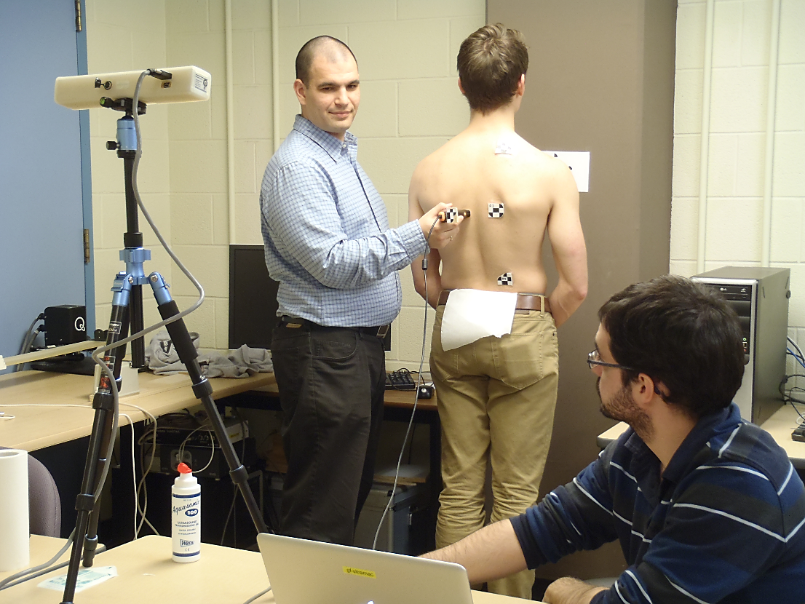

**Figure 1**. Upper image shows schematic design of the portable, tracked ultrasound-based (TUS) scoliosis monitoring system. Lower image shows the experimental prototype of the system.

All algorithms and application software developed for scoliosis measurement by our team are already available freely as open-source software components [Ungi 2014]. In the current project we will build on this software foundation, keep the developed applications freely available. The current software tools are suitable for proof of concept tests and collection of experimental data for measurement accuracy analysis, but they are not organized in an intuitive user interface. Therefore, the current system requires technical staff to operate. In the framework of the proposed project, we will develop a simple user interface that allows easy dissemination to clinicians.

The software of our system is built on the most popular medical image analysis application platform, 3D Slicer ([www.slicer.org](http://www.slicer.org)). Our scoliosis measurement module can be downloaded from the 3D Slicer extension manager (a.k.a. Slicer App Store). This infrastructure is the optimal platform to make our results available for a wide range of potential users and researchers. Furthermore, the hardware connection part of our system is implemented using the PLUS software kit ([www.plustoolkit.org](http://www.plustoolkit.org)), which allows quick connection to any ultrasound and position tracking hardware. This facilitates reproduction of our methods by researchers who have different models of ultrasound and tracker hardware.

**STUDY DESIGN**

We will evaluate scoliosis measurement with tracked ultrasound (TUS) in clinical use. The first phase of the project consists of iterative prototype testing, feedback, and system modifications for improving usability. These activities are organized in 2-week cycles to ensure that all usability issues are addressed by the end of phase one. In the second phase of the project we will collect clinical data to estimate the value of the TUS-based system in scoliosis screening and monitoring.

**Phase 1. Technical evaluation**

Specific aims of this work phase are:

1. Establish a clinically feasible workflow for scoliosis measurement with TUS.
2. Assess the reproducibility of scoliosis measurement by the TUS system.
3. Assess the accuracy of scoliosis measurement by the TUS system.

Patients will be invited to participate in our study who are diagnosed with adolescent idiopathic scoliosis and monitored at the Orthopedic Surgery Clinic of Hotel Dieu Hospital in Kingston, ON. These patients undergo X-ray imaging for spinal curvature measurement on a regular basis. Patients who participate in our study will also undergo TUS scan during their scheduled visits to the clinic.

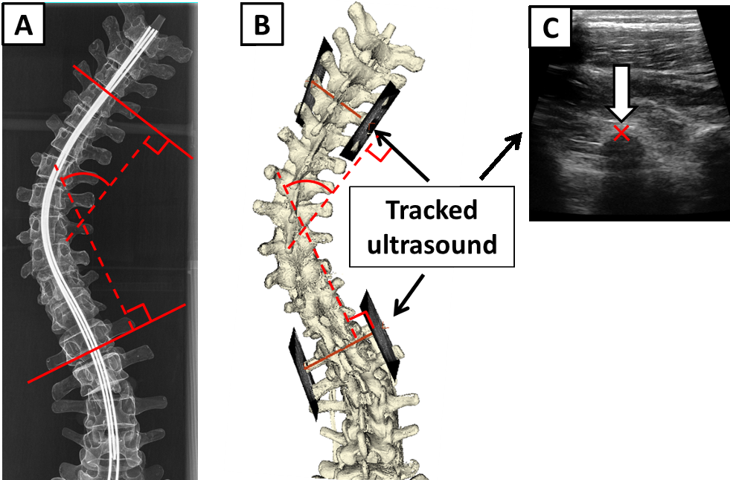

**Figure 2.** Radiographic Cobb-angle (defined by red dashed lines on picture A). Ultrasound-derived Cobb-angle (B), using four vertebral landmarks defined on ultrasound snapshots (C).

Measurement accuracy will be validated by using both X-ray and TUS imaging with multimodality radiological skin markers. These markers will be visible in the X-ray image by inserting small metal markers in them, and they will also be visible by the position tracking camera by optical markers on their surface. Marker positions will be recorded during ultrasound scanning using the same position tracker that tracks the ultrasound transducer.

The tracker camera concurrently tracks skin markers and the ultrasound probe. This will be used during validation to check if the skin markers maintain their relative positions between ultrasound scanning and X-ray imaging. If there is a significant difference between the relative positions, then the measurement needs to be considered unreliable due to posture change between ultrasound and X-ray imaging.

The main function of the multimodality markers, however, is to allow spatial registration between the X-ray and TUS images. X-ray will serve as ground-truth when we evaluate the curvature measurement with TUS.

Spinal curvature measurement in X-ray and TUS is illustrated in Figure 2. The X-ray image shows a projection of the entire spinal column. While single ultrasound images need to be reconstructed in a larger 3-dimensional volume to enable spinal curvature measurement.

Patient TUS scan sessions are planned once per week during phase 1. The Systems Engineer will be present at each clinical scan session to observe workflow and identify system usability issues that can be improved.

**Phase 2. Clinical evaluation**

Specific aims of this work phase are

1. Acquire pilot clinical data on TUS-based measurement results for sample size estimation for clinical evaluation.
2. Single-center clinical evaluation of TUS-based scoliosis measurement in management of patients with adolescent idiopathic scoliosis.

The pilot evaluation study will be completed at the Queen’s University and affiliated hospitals. Results of the pilot study will provide estimation of descriptive statistical parameters. These parameters are necessary for the planning of clinical evaluation for the TUS-based prototype system. Sample size will be estimated for our main research hypothesis, that therapeutic decision made based on TUS spinal curvature measurement are not significantly different from decisions made based on X-ray imaging.

Sample size estimation for the pilot clinical evaluation study is based on previous phantom experiments [Ungi 2014] that compared the X-ray and ultrasound-based measurement method. These measurements were performed on synthetic spine phantoms embedded in ultrasound-compatible gel. Phantoms present ideal measurement conditions compared to patients. They don’t change posture between X-ray and TUS imaging, and the operator may take as much time as they need to find anatomical landmarks using TUS. As opposed to phantoms, patients have small posture differences in each measurement session that presents as error in the comparison of X-ray and TUS-based curvature angles. The time to perform TUS-based measurements is also limited in adolescent patients, as they may become tired after one minute of standing in the same posture. For these reasons the experimental results from the phantom study cannot be directly used to plan a clinical evaluation study, although they reveal important features of the TUS system.

Phantom experiments revealed that the difference between radiographic and ultrasound-based spinal curvature measurement is normally distributed (p=0.47, D’Agostino-Pearson test for normal distribution, N=34), with a standard deviation (SD) of 1.54°. Clinicians require spinal curvature measurement accuracy within a 5° acceptable range, as this is the average variance in radiographic measurements in the same patient and the same X-ray image [Malfair 2010, Sardjono 2013]. Our goal is that at least 99% of our measurements fall within the acceptable range, therefore, the mean needs to be determined within a E=0.38° margin of error (E=5–3*SD). Using the formula for sample size estimation N=(Z*SD/E)2, with a critical value Z=1.96 for 95% confidence interval, we calculate that at least N=64 samples will be needed for the clinical evaluation. But due to the limitations of the phantom study, the number of patients invited in the clinical evaluation study is estimated to be approximately 100. After the first 64 patients are enrolled in the study, and their X-ray and TUS spinal curvature measurements are available, we will review the results to determine statistical parameters of the data, and plan the final number of participants in the clinical evaluation study.

The clinical evaluation study requires follow-up of the participant population until sufficient number of therapeutic decisions are made for statistical comparison between decisions based on TUS and X-ray imaging. Orthopedic surgeons experienced in adolescent idiopathic scoliosis management will be asked to make virtual therapeutic decisions. Surgeons will be blinded to the identity of the patient, and they will make their decisions based on TUS or X-ray imaging, and a short anamnesis.

Our results will be shared with the clinician and researcher communities in multiple platforms. Results of the clinical evaluation study will be presented at scientific conferences. Technical details of the final TUS system will not only be published in biomedical engineering conferences and journals. Both system assembly instructions and software source code will be available online free of charge to allow incremental research and development on our results. When the first results of this single-centre study are available, we will facilitate a multi-centre study to get sufficient evidence on the value of TUS in clinical scoliosis measurement to make recommendations on how to incorporate it in the patient management protocols nationally and internationally.

**REFERENCES**

[Ungi 2014] Ungi T, King F, Kempston M, Keri Z, Lasso A, Mousavi P, Rudan J, Borschneck DP, Fichtinger G. Spinal curvature measurement by tracked ultrasound snapshots. Ultrasound Med Biol. 2014 Feb;40(2):447-54.