Introduction

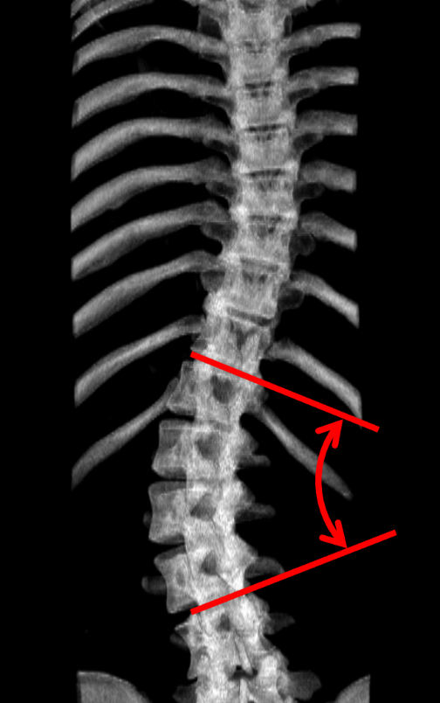
Scoliosis
Figure 1: DRR illustrating the Cobb angle, a measure of scoliotic deformity
Scoliosis is a disease of the spine characterized by lateral curvature and associated with 3D deformation. Adolescent idiopathic scoliosis is the most common variety of the disease, affecting 1-5% of the population [1]. It is usually diagnosed during early adolescence, and the curvature progresses until growth ceases. The gold-standard of assessment for diagnosis and treatment planning is measurement of the Cobb angle from a radiograph of the torso in the coronal plane. The Cobb angle is defined as the maximum angle between the endplates of any two vertebrae, measured in the coronal plane, as illustrated in Figure 1. The progressive nature of the disease requires regular assessment to ensure that patients receive less invasive treatments when possible. Bracing has been shown to be effective at slowing or halting the curvature progression in mild to moderate cases, or Cobb angles between 20° and 40° [2]. Surgical vertebral fusing may be necessary to stabilize spines with Cobb angles exceeding this range. Symptoms of the disease are largely the result of deformation of the torso; these symptoms may include psychological effects arising from cosmetic aberration, back pain, and impaired balance or respiratory function if the deformation is allowed to progress.

Visualization for therapy
Visualization of scoliosis is important for ensuring optimal care through proper assessment. X-ray imaging remains the gold-standard for assessment and monitoring because it produces a full posterior view of the spine, suitable for scoliosis quantification via the Cobb angle. Although planar assessment of the spine is useful for measuring curvatures, it is limited in the information it provides regarding 3D aspects of deformation. To assess vertebral rotation, or anterior-posterior deformation of the spine such as lordosis, patients may be referred for additional imaging [3]. In a hospital setting, the additional imaging may come from another X-ray, this time in the lateral plane, or more sophisticated methods like MRI or CT.
The importance of visualization is not limited to the decision whether to prescribe a brace or perform surgery. Practitioners providing conservative treatment in the form of physical therapy or chiropractic care may wish to tailor the treatment to the patient-specific conditions [4]. For example, the Schroth method [5], involves directing the patient to perform ‘rotational breathing’ which opposes the torsion imposed on the torso by scoliotic deformation to improve respiratory function and posture [6]. The Dobosiewicz method augments asymmetric breathing exercise with proprioceptive and exteroceptive facilitation at the apical vertebra [7]. The directionality of asymmetric breathing or manual therapy depends on the direction of the scoliotic curvature in 3D, not simply the magnitude of the Cobb angle. Visualization in these settings is especially challenging since even X-ray may be unavailable, and surface-based assessment methods like the Scoliometer and optical techniques provide limited information about internal structure.
The risks associated with repeated exposure to ionizing radiation during adolescence have caused some controversy regarding the use of radiographic method for scoliosis monitoring. Monitoring protocols may provide some reduction in radiation exposure. Radiographic assessment may be performed less frequently in mild or slowly progressing cases, and MRI may be employed for 3D assessment instead of CT. Nonetheless, ionizing radiation still conveys increased cancer risks [8], and is not available in physiotherapeutic or chiropractic settings. Nor is MRI a potential replacement for radiographic assessment because of its cost and availability. Hospital-based assessment and monitoring, and therapeutic settings both stand to benefit an accessible system capable of providing a 3D visualization of scoliosis, without using ionizing radiation. Other instruments and imaging modalities have their respective uses and limitations, but we believe tracked ultrasound to be the best available solution for the requirements.

Objective
The objective of this thesis is to develop a method for 3D visualization of the spine suitable for scoliosis assessment. The method must use tracked ultrasound data to ensure availability and complete radiation safety. The method should require a minimum of operator interaction.

Contributions
The main contributions of this thesis are:
- A method for generating patient-specific spinal visualizations using a thin-plate spline transform to realistically deform a healthy-shaped model to patient ultrasound data.
- A technique was designed for this visualization method, which supplements natural landmarks with anchor points, ensuring that the registration has sufficient 3D constraint.
- Validation of the visualization method for depicting scoliotic deformities.
- A method for automatically generating the landmarks used by the visualization method from an ultrasound scan. This was done to minimize operator interaction in manual landmark identification.
Contributions regarding the visualization method are addressed in Chapter 3. Chapter 4 is about the automatic landmark generation. These chapters are presented in the order in which their subject material was developed, reflecting the natural logical progression. This organization was chosen over presenting the material in the order in which it is employed for data processing, as in a technical report. Their relation, through the workflow that is the sum of Chapters 3 and 4, is shown in Figure 2.
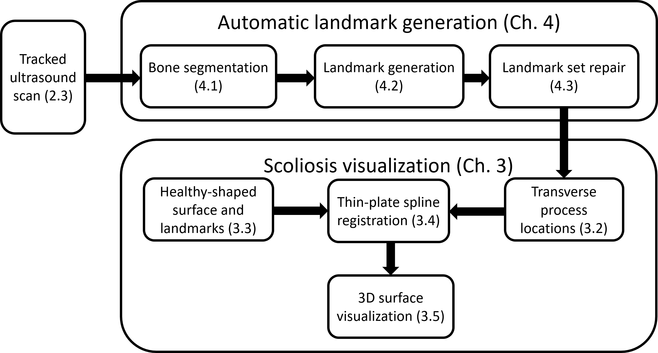
Figure 2: Chapters’, and their sub-sections', combined sequence for visualization from ultrasound data

