Scoliotic spine visualization using   
ultrasound-accessible anatomic landmarks

Ben Church1, Andras Lasso1, Christopher Schlenger2,   
Dan Borschneck3, Parvin Mousavi4, Gabor Fichtinger1, Tamas Ungi1

1. Laboratory for Percutaneous Surgery, School of Computing, Queen’s University, Kingston, ON, Canada
2. Premier Chiropractic, Stockton, CA, USA
3. Department of Surgery, Queen’s University, Kingston, ON, Canada
4. Medical Informatics Laboratory, School of Computing, Queen’s University, Kingston, ON, Canada

**ABSTRACT**

**PURPOSE:** Ultrasound imaging is an attractive alternative to X-ray for scoliosis diagnosis and monitoring due to its safety and inexpensiveness. The transverse processes provide landmarks which are accessible by means of ultrasound, and are sufficient for quantifying scoliosis, but, own their own, do not provide an intuitively comprehensible visualization of the spine. **METHODS:** We created 3D surface models of individual patients’ scoliotic spines using the transverse processes locations, and an average shaped, healthy spine model registered to them. The method consists of manually locating the transverse processes, and programmatically adding anchor points to the sets of transverse process points to ensure accurate registration of the average spine model to them. **RESULTS:** The registration resulted in 3D transformation fields, interpolated as a thin-plate spline between points, which were then applied over the surface of the average spine model, yielding 3D surface models of the patients’ spines. Hausdorff distances, Dice similarity coefficients, and model-to-model distance maps were computed to evaluate the quality of the registration based models compared to ground truth, CT-derived patient spine models. Misalignment occurs mainly at upper and lower-most vertebrae, and in the anterior-posterior directions, which is immaterial in scoliosis quantification. **CONCLUSIONS:** This method is shown to be capable of producing qualitatively accurate models which depict the 3D deformation of the patients’ spines when compared to ground truth CT scans.

**Keywords:** Spine**,** scoliosis, modelling, ultrasound, landmark, visualization

# BACKGROUND AND PURPOSE

Scoliosis is a pathological curvature of the spine which typically manifests and develops during adolescence and growth. If left untreated, scoliosis can progress to the point that back pain or respiratory problems develop. Management of the disease requires that the progression of its resulting deformation be monitored. Scoliosis is quantified in terms of the Cobb angle, the maximum angle between the endplates of any two vertebrae. Continued observation and measurement is typically indicated for patients exhibiting a Cobb angle of less than 20°. Bracing can be used to prevent further progression of the disease for a Cobb angle between 20° and 40°. Any curvature in excess of 40° is often treated with surgical vertebral fusing [Frerich 2012].

Accurate knowledge of spinal deformation is therefore crucial in ensuring that patients receive the appropriate treatment. X-ray is considered the gold-standard for scoliosis quantification and visualization. The risks of repetitive exposure to ionizing radiation during adolescence have motivated investigation into the use of ultrasound as an alternative [Berton 2016]. Ultrasound imaging, in addition to conveying 3D deformation information when tracking is used, is less expensive than X-ray, partly because its inherent safety has meant fewer regulations are needed for its use. Should ultrasound technology for scoliosis quantification become sufficiently mature, its safety and inexpensiveness make it an attractive tool not only for scoliosis progression monitoring, but also for screening in schools, and for chiropractic treatment monitoring.

Despite experimental results with tracked ultrasound as an imaging modality for scoliosis monitoring, bone surfaces can be difficult to locate in ultrasound. Ultrasound can only visualize parts of the posterior surface of the spine, which, despite being sufficient to determine the Cobb angle, does not provide a practitioner with a comprehensible visualization of the patient’s spine. To produce spine models from the ultrasound images, previous CT images of the same patient, or standard spine shape models, have been spatially registered to anatomic landmarks obtained by ultrasound [Gill 2012]. We have previously shown that a few anatomic landmarks visible in ultrasound images are sufficient for accurate registration of CT-derived models of vertebrae [Ungi 2013], but this requires significant time and an experienced sonographer, and most patients do not have a CT scan of their whole spine.

An accurately registered model can therefore be used to approximate a patient’s anatomy for a number of purposes. Gill et al. [Gill 2012] registered lumbar spine surfaces extracted from ultrasound to existing CT scans of the corresponding cadavers and patient-based phantoms. They used an iterative closest point (ICP), rigid registration to achieve initial alignment between the CT model and landmark point set, and then registered each vertebra as a rigid body to account for inter-imaging changes in posture or anatomy. In the work presented here, we investigated if an average healthy spine model could be registered to ultrasound-accessible landmarks of scoliotic spines in the absence of patient-specific CT. Such a registration method would allow visualization of the full spine based on a few patient-specific landmarks.

# NEW OR BREAKTHROUGH WORK

We have developed a method to create 3D models of patients’ scoliotic spines based on the locations of the transverse processes, and a standard-anatomic, average, healthy spine model. We have shown that this registration method produces a qualitative visual representation of the spine that is sufficiently accurate for a number of clinical applications. Such applications might include automatic structure labelling for ultrasound guided navigation, providing the initial alignment for surgical navigation quality registration, or providing visually comprehensible interpretations corresponding to expected quantitative improvements from scoliosis treatments.

# METHODS

Landmark based registration requires two sets of points, one to be registered to the other. The first set of points consisted of the transverse processes from an average, healthy spine model. The second point set was the transverse processes from the actual patient’s anatomy. The landmark point sets, such as those depicted in Figure 1, effectively consist of two nearly parallel curves, one along the left transverse processes, and the other along the right. Despite the visibility of these points in ultrasound, the information contained therein is sparse, and therefore cannot reliably encode the 3D deformation present in scoliotic spines, making it challenging to produce accurate models from them. In a healthy spine, the transverse processes of two adjacent vertebrae define a trapezoid as its vertices, while the deformation of a scoliotic spine warps this trapezoid into a general quadrilateral. This is illustrated in Figure 1.

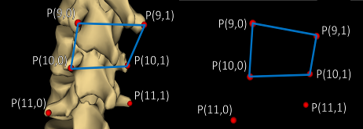

Figure 1: (Left) Model of average spine with transverse processes marked and the trapezoid defined by those of the 11th and 12th thoracic vertebrae, (P(9,0) – P(9,1)) and (P(10,0) – P(10,1)), respectively. (Right)Transverse process points from patient #1’s same vertebrae with the resulting quadrilateral.

We remedied the difficulty of representing 3D deformation with two curves by adding anchor points to the patient’s and the average model’s point sets, one anchor point for each transverse process point. To convey a maximum of 3D information, the anchor points were added to the existing points at offsets normal to the curvature of the spines, in the anterior direction. This method effectively defined volumes, rather than curves, analogous to extruding the quadrilaterals of Figure 1 approximately normal to their surfaces. By constructing such a volume for each vertebra, the registration algorithm imposed most of its deformation inter-vertebrally, rather than continuously along the curves. Finally, by scaling the magnitude of the offset distance by the ratio of the length of the patient’s spine to that of the average model, variability in the length scales of the spines was also conveyed to the registration method. To compute consistent directions normal to the curves, vector cross products of right-left, and superior-inferior vectors were used to compute an anterior-posterior vector.

To add the anchor point anterior to point P(i,j), where i denotes the vertebra (the superior-most being at i = 0), and where j denotes whether it is the left or right point (j = 0 for the left, j = 1 for the right), the right-left vector was computed as:

$〈RL(i,j)〉=〈P(i,j)〉-〈P(i,j+1 \left(mod 2\right))〉$ (1)

where the angled brackets denote vectors.

The superior-inferior vectors were computed as the average of two possible vectors:

$〈SI\left(i,j\right)〉=\left[\left[〈P\left(i+1,j\right)〉-〈P\left(i,j\right)〉\right]+\left[〈P\left(i,j\right)〉-〈P\left(i-1,j\right)〉\right]\right]÷2$ (2)

At the superior and inferior extremities of the spine models, where only one vertebra existed below or above the one to which an anchor point was currently being added, respectively, only the existing vector was used in equation (2).

Finally, to determine the location of the anchor point, anterior-posterior vector was computed as the cross product of the vectors from equations (1) and (2) was computed, normalized by dividing it by its length, scaled by a vertebral scaling factor times the ratio of the length of the patient’s spine to that of the average spine model:

$〈P^{*}\left(i,j\right)〉=〈P\left(i,j\right)〉+〈AP\left(i,j\right)〉=〈P\left(i,j\right)〉+\left[VSF∙\left(L_{P}/L_{A}\right)\right]∙\left[〈RL\left(i,j\right)〉×〈SI\left(i,j\right)〉\right]/\left|〈RL\left(i,j\right)〉×〈SI\left(i,j\right)〉\right|$ (3)

where the * denotes an anchor point being added, VSF is the vertebral scaling factor used to constrain registration deformation in the anterior-posterior direction, • denotes scalar multiplication, LP is the length of the patient’s spine, LA is the length of the average spine model, × denotes the vector cross product operation, and |V| denotes the length of vector V. A VSF of 30mm was chosen empirically and applied identically to all patients. As such, this magnitude is representative of typical intra and inter-vertebral transverse process spacing. The lengths of the spines were computed as the sum of the distances between each transverse process and its inferior neighbor, averaged across the left and right sides. This supplemented the vertebral scaling factor with information about the difference in the length scale of the patient’s spine and the average model. Figure 2 shows a CT-derived surface model of a patient’s spine, with the transverse process points, the supplemental anchor points, and the vectors used to locate one anchor point.

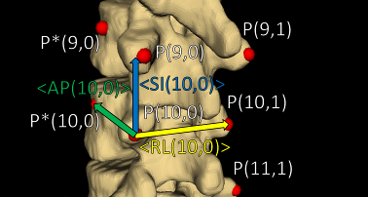

Figure 2: A segment of the undeformed average spine model with transverse process points, added anchor points, and ilustrations of the vectors used to locate one of the anchor points.   
Right-sided anchor points are occluded by the model. Note that the superior-inferior vector is the result of an average and therefore does not point to P(9,0). Vectors are added for illustrration and are not necessarily exact in direction or magnitude.

Our registration was implemented as a thin-plate spline transformation between the two sets of points   
[Bookstein 1989]. Details of the implementation are available open-source in the Visualization Toolkit ([www.vtk.org](http://www.vtk.org)). The thin-plate spline implementation meant that transformations, which mapped each transverse processes and anchor point of the average model to its corresponding point in the patient’s set, were smoothly interpolated. This allowed the entire surface of the average spine model to be deformed onto the patient’s landmark points.

Since bone surfaces are difficult to locate accurately in ultrasound, CT-derived surface models of the patients’ spines were used as a ground truth against which to compare the registration based models. The transverse processes can be located precisely in CT, whereas the inaccuracy introduced in ultrasound would make it impossible to distinguish registration error from measurement error. To evaluate the outcome of the registration quantitatively, the average and maximum Hausdorff distances, and the Dice similarity coefficients were computed for the registration models versus ground truth. These metrics, plus the registration based models compared visually to ground truth, are presented and discussed in the RESULTS AND DISCUSSION section, below.

# RESULTS AND DISCUSSION

Table 1: Registration evaluation metrics

|  |  |  |  |  |
| --- | --- | --- | --- | --- |
|  | | **Registration Metric** | | |
| **Avg. Hausdorff Distance (mm)** | **Max. Hausdorff Distance (mm)** | **Dice Similarity Coefficient** |
| **Patient #** | **1** | 2.1 | 13.2 | 0.695 |
| **2** | 2.9 | 28.7 | 0.673 |
| **3** | 2.3 | 18.8 | 0.682 |
| **4** | 2.5 | 19.1 | 0.643 |

Quantitative registration evaluation metrics are shown for each patient in Table 1. These results are potentially misleading, as they correspond to the entirety of the spine, including the vertebral bodies, where no anatomic landmarks were placed. Figures 3 and 4 show the actual registration outcomes for two patients, and demonstrate that, in fact, most of the misalignment is in the vertebral bodies and spinous processes, or generally, in structures anterior and posterior to the transverse process landmarks. This misalignment is of minor importance for the visualization of scoliosis, which is deformation in the right-left directions. It is unsurprising that misalignment occurs in locations far from landmark points, especially at the outer-most vertebrae, where the transformation field had fewer landmarks constraining it. Moreover, scoliosis is well depicted by the posterior vertebral faces, which are well aligned.

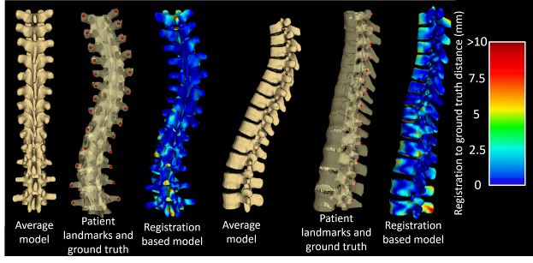

Figure 3: The left three images are, from left to right: the average, un-deformed spine model, patient #1’s transverse process points on the ground truth, CT-derived surface model, and the average model after transformation onto patient #1’s   
landmarks with a heat map showing the distance between the registration and the ground truth models, view from the   
posterior direction. The right three images are the same as the left three, viewed from the left.

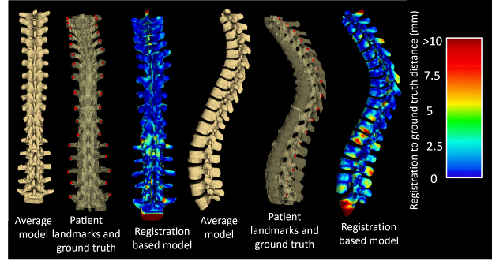

Figure 4: The same depictions of Figure 3, for patient #2.

The accuracy of the rest of the registration (particularly in the anterior-posterior direction) is likely sensitive to the particular value used for the vertebral scaling factor, the VSF, used to determine the magnitude of the offset of the anchor points. As a possible refinement to out method, we will investigate the effects of calculating this value for individual vertebrae based on the distances between the local landmark points. The factor representing the ratio of the lengths of the spines could be refined similarly; by computing the ratio of the inter-vertebral transverse process distances of the patient’s spine to those of the average spine model, at each vertebral level rather than for the entire spines, further improvements to our results may be achieved.

The results depicted in Figures 3 and 4 demonstrate that our method achieves the intended purpose of producing intuitively comprehensible, visual representation of scoliotic spines as qualitative aids to clinicians. These models serve this purpose on the basis of the registration accuracy of the posterior vertebral anatomy. Furthermore, this method is not limited to scoliosis visualization using transverse processes, or ultrasound imaging. Any spine can be visualized in this way, however scoliosis served as a particularly good trial since its associated deformation makes for the most difficult anatomy upon which to register models. Our aim is to use ultrasound for the reasons outlined in the PURPOSE AND BACKGROUND section. This meant our method was designed on the basis of the symmetry and relative locations of the ultrasound-accessible landmarks, the transverse processes. However, other landmarks could be retrieved from any imaging modality, and the method adapted to suit their geometric properties.

# CONCLUSIONS

The landmark based model registration method presented in this paper is capable of producing models displaying the 3D deformation of patients’ spines using just two ultrasound-accessible landmarks per vertebra as input. Most of the misalignment between the models is in the vertebral bodies, where no landmarks were placed. Misalignment in the vertebral bodies is of secondary importance to the vertebra’s posterior faces, since most features of clinical interest are on these posterior faces.

# REFERENCES

Berton, F., Cheriet, F., Miron, M., and Laporte, C., “Segmentation of the spinous process and its acoustic shadow in vertebral ultrasound images,” Computers in Biology and Medicine 72, 201-211 (2016).

Bookstein, F., “Principal Warps: Thin-Plate Splines and the Decomposition of Deformations,” IEEE Transactions on Pattern Analysis and Machine Intelligence 11, 567-585 (1989).

Frerich, J., Hertzler, K., Knott, P., and Mardjetko, S., “Comparison of Radiographic and Surface Topography Measurements in Adolescents with Idiopathic Scoliosis,” The Open Orthopaedics Journal 16, 261-265 (2012).

Gill, S., Abolmaesumi, P., Fichtinger, G., Boisvert, J., Pichora, D., Borshneck, D., and Mousavi, P., “Biomechanically constrained groupwise ultrasound to CT registration of the lumbar spine,” Medical Image Analysis 16, 662-674 (2012).

Ungi, T., Moult, E., Schwab, J.H., and Fichtinger, G., “Tracked ultrasound snapshots in percutaneous pedicle screw placement navigation: a feasibility study,” Clin Orthop Relat Res. 417(12), 4047-4055 (2013).