Scoliotic spine visualization using   
ultrasound-accessible anatomic landmarks

Ben Church1, Andras Lasso1, Christopher Schlenger2,   
Dan Borschneck3, Parvin Mousavi4, Gabor Fichtinger1, Tamas Ungi1

1. Laboratory for Percutaneous Surgery, School of Computing, Queen’s University, Kingston, ON, Canada
2. Premier Chiropractic, Stockton, CA, USA
3. Department of Surgery, Queen’s University, Kingston, ON, Canada
4. Medical Informatics Laboratory, School of Computing, Queen’s University, Kingston, ON, Canada

**ABSTRACT**

**PURPOSE:** Ultrasound imaging is an attractive alternative to X-ray for scoliosis diagnosis and monitoring due to its safety and inexpensiveness. The transverse processes provide landmarks which are accessible by means of ultrasound, and are sufficient for quantifying scoliosis, but, own their own, do not provide an intuitively comprehensible visualization of the spine. **METHODS:** We created 3D visualizations of pediatric patients’ scoliotic spines using 3D transform fields resulting from thin-spline interpolations of the landmark-based registrations between the transverse processes from the patients’ anatomies and the corresponding points from an average-shaped, healthy spine model. Anchor points were added to both the patients’ and models’ landmarks prior to registration such that the resulting transform fields accurately represented the deformation of the patients’ spines. The transform fields were then applied over the surface of the average-shaped spine model, resulting in 3D surface models visualizations of the patients’ spines. CT scans of the patients’ spines were used as a ground truth against which to compare our registration-derived visualizations, since the CT-derived models accurately depict the patients’ transverse process locations and spinal shapes. **RESULTS:** Hausdorff distances, Dice similarity coefficients, and model-to-model distance maps were computed to evaluate the quality of the registration-derived visualizations compared to ground truth models. Misalignment occurs mainly at upper and lower-most vertebrae, and in the anterior-posterior directions, which is immaterial in scoliosis quantification. **CONCLUSIONS:** This method is shown to be capable of producing qualitatively accurate visualizations which depict the 3D deformation of the patients’ spines when compared to ground truth CT scans.

**Keywords:** Spine**,** scoliosis, modelling, ultrasound, landmark, visualization

# BACKGROUND AND PURPOSE

Scoliosis is a pathological curvature of the spine which typically develops during adolescence. If left untreated, scoliosis can progress to the point that back pain or respiratory problems develop. Management of the disease requires monitoring the deformation’s progression. Scoliosis is quantified in terms of the Cobb angle, the maximum angle between the endplates of any two vertebrae. Continued observation is typically indicated for patients exhibiting a Cobb angle of less than 20°. Bracing can be used to prevent further progression of the disease for a Cobb angle between 20° and 40°. Any curvature in excess of 40° is often treated with surgical vertebral fusing [Frerich 2012].

X-ray is considered the gold-standard for scoliosis quantification and visualization. The risks of repetitive exposure to ionizing radiation during adolescence have motivated investigation into the use of ultrasound as an alternative [Berton 2016]. Ultrasound imaging is also less expensive than X-ray, partly because its inherent safety has meant fewer regulations are needed for its use. Should ultrasound technology for scoliosis quantification become sufficiently mature, its safety and inexpensiveness make it an attractive tool not only for scoliosis progression monitoring, but also for screening in schools, and for chiropractic treatment monitoring.

Despite experimental results with tracked ultrasound as an imaging modality for scoliosis monitoring, bone surfaces can be difficult to locate in ultrasound. Ultrasound can only visualize parts of the posterior surface of the spine, which, despite being sufficient to determine the Cobb angle, does not provide a practitioner with a comprehensible visualization of the patient’s spine. We have previously shown that a few anatomic landmarks visible in ultrasound images are sufficient for accurate registration of CT-derived models of vertebrae [Ungi 2013]. A similar registration method would allow visualization of the full spine based on a few patient-specific landmarks.

# NEW OR BREAKTHROUGH WORK

We have developed a method to create 3D visualizations of patients’ scoliotic spines based on the locations of their transverse processes, and a standard-anatomic, average-shaped, healthy spine model. We have shown that the method produces a qualitative visual representation of the spine that is sufficiently accurate for a number of clinical applications. Such applications might include automatic structure labelling for ultrasound guided navigation, providing the initial alignment for surgical navigation quality registration, or providing visually comprehensible representations corresponding to expected quantitative improvements from scoliosis treatments.

# METHODS

Landmark-based registration requires two sets of points, one to be registered to the other. The first set of points for this method consisted of the transverse processes from an average, healthy spine model. The second point sets were the transverse processes from the actual patients’ anatomies. These landmark point sets effectively consist of two nearly parallel curves. Despite the visibility of these points in ultrasound, the information contained therein is sparse, and therefore cannot reliably encode the 3D deformation present in scoliotic spines. This made it challenging to deform the average spine model to the patients’ landmarks in an anatomically accurate fashion.

We remedied the difficulty of representing 3D deformation with two curves by adding anchor points to the patients’ and average model’s point sets, one anchor point for each transverse process point. To convey a maximum of 3D information, the anchor points were added at offsets normal to the curvature of the spines, in the anterior direction. To compute this normal direction consistently, vector cross products of right-left, and superior-inferior vectors were used to compute an anterior-posterior vector. This method effectively defined piece-wise volumes, rather than curves. Since each piece of the volume corresponded to one vertebra, the registration algorithm imposed most of its deformation inter-vertebrally, rather than continuously along the curves. Finally, by scaling the magnitude of the offset distance by the ratio of the length of the patient’s spine to that of the average model, variability in the length scales of the spines was also accounted for.

To add the anchor point anterior to point P(i,j), where i denotes the vertebra (the superior-most being at i = 0), and where j denotes right versus left (j = 0 for left, j = 1 for right), the right-left vector was computed as:

$〈RL(i,j)〉=〈P(i,j)〉-〈P(i,j+1 \left(mod 2\right))〉$ (1)

where angled brackets denote vectors. Superior-inferior vectors were computed as the average of two possible vectors:

$〈SI\left(i,j\right)〉=\left[\left[〈P\left(i+1,j\right)〉-〈P\left(i,j\right)〉\right]+\left[〈P\left(i,j\right)〉-〈P\left(i-1,j\right)〉\right]\right]÷2$ (2)

At the superior and inferior extremities of the spine models, where only one vertebra existed below or above the one to which an anchor point was currently being added, respectively, only the existing vector was used in equation (2). Finally, to determine the location of the anchor point, the anterior-posterior vector was computed as the cross product of the vectors from equations (1) and (2) was computed, normalized by dividing it by its length, and scaled by a vertebral scaling factor times the ratio of the length of the patient’s spine to that of the average spine model:

$〈P^{*}\left(i,j\right)〉=〈P\left(i,j\right)〉+〈AP\left(i,j\right)〉=〈P\left(i,j\right)〉+\left[VSF∙\left(L_{P}/L_{A}\right)\right]∙\left[〈RL\left(i,j\right)〉×〈SI\left(i,j\right)〉\right]/\left|〈RL\left(i,j\right)〉×〈SI\left(i,j\right)〉\right|$ (3)

where the * denotes an anchor point being added, VSF is a vertebral scaling factor used to constrain registration deformation in the anterior-posterior direction, • denotes scalar multiplication, LP is the length of the patient’s spine, LA is the length of the average spine model, × denotes a vector cross product, and |V| denotes the length of vector V. A VSF of 30mm was chosen empirically and applied identically to all patients. As such, this magnitude is representative of typical inter-landmark spacing.

Figure 1 shows the average-shaped spine model, with the transverse process points, the anchor points, and the vectors used to locate one anchor point. The registration was implemented as a thin-plate spline transformation between the two sets of points [Bookstein 1989]. Details of the implementation are available open-source in the Visualization Toolkit ([www.vtk.org](http://www.vtk.org)). The thin-plate spline implementation meant that transformations, which mapped each transverse process and anchor point of the average model to its corresponding point in the patients’ sets, were smoothly interpolated, yielding a 3D transform field. This transform field was applied to the average model, generating 3D surface visualizations of the patients’ spines.

Figure : A segment of the average spine model with transverse process points, anchor points, and illustrations of the vectors used to locate one anchor point.   
The superior-inferior vector is the result of an average and therefore does not point to P(9,0). Vectors are added for illustration and therefore are not necessarily exact.   
Right-sided anchor points are occluded by the model.

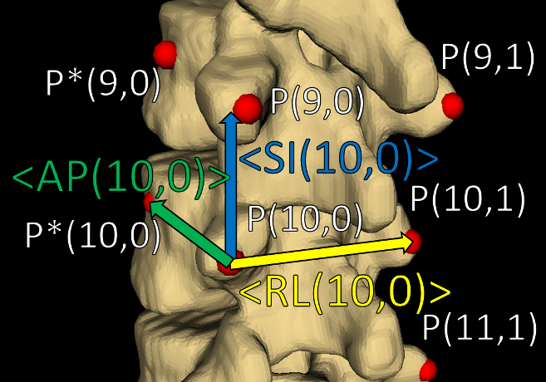

Since bone surfaces are difficult to locate in ultrasound, CT-derived surface models of the patients’ spines were used as a ground truth against which to compare the registration-based visualizations. The patients’ real anatomies can be visualized precisely from CT, whereas the inaccuracy introduced in ultrasound would make it impossible to distinguish registration error from measurement error. To evaluate the outcome of the registration quantitatively, the average and maximum Hausdorff distances, and the Dice similarity coefficients were computed for the registration-based visualizations versus ground truth.

# RESULTS AND DISCUSSION

Table : Registration evaluation metrics

|  |  |  |  |  |
| --- | --- | --- | --- | --- |
|  | | **Registration Metric** | | |
| **Avg. Hausdorff Distance (mm)** | **Max. Hausdorff Distance (mm)** | **Dice Similarity Coefficient** |
| **Patient #** | **1** | 2.1 | 13.2 | 0.695 |
| **2** | 2.9 | 28.7 | 0.673 |
| **3** | 2.3 | 18.8 | 0.682 |
| **4** | 2.5 | 19.1 | 0.643 |

Quantitative registration evaluation metrics are shown for in Table 1. These results are potentially misleading, as they are from the entire spine, including the vertebral bodies, where no anatomic landmarks were placed.

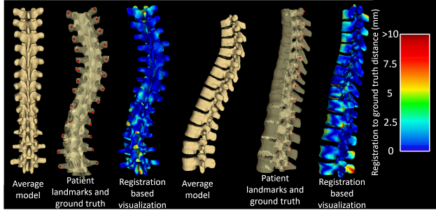

Figure : Results for Patient #1. The left three images are, from left to right: the average spine model, transverse process landmarks on CT-derived ground truth, and the registration-based visualization with a heat map showing the distance between it and ground truth, viewed from the posterior direction. The right three images are the same as the left three, viewed from the left.

Figures 2 and 3 show the actual visualizations generated for two patients, demonstrating that most of the misalignment is in the vertebral bodies and spinous processes, that is, in structures   
anterior and posterior to the landmarks This misalignment is of minor importance for scoliosis visualization, which requires only right-left deformation.   
It is unsurprising that misalignment occurs in locations far from landmark points, especially at the outer-most vertebrae, where the transform field had fewer landmarks to constrain it. Moreover, this misalignment is of minor importance for scoliosis visualization, which is well depicted by the posterior vertebral faces.

Figure : Results for Patient #2. The left three images are, from left to right: the average spine model, transverse process landmarks on CT-derived ground truth, and the registration-based visualization with a heat map showing the distance between it and ground truth, viewed from the posterior direction. The right three images are the same as the left three, viewed from the left.

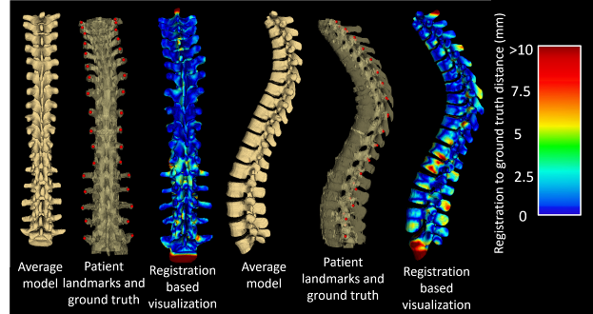

The accuracy of the rest of the registration (particularly in the anterior-posterior direction) is likely sensitive to the particular value used for the vertebral scaling factor, the VSF. As a possible refinement to the method, we will investigate the effects of calculating this value for individual vertebrae based on the distances between the local landmark points. The factor representing the ratio of the lengths of the spines could be refined similarly; by scaling each offset in proportion to local inter-vertebral distances, rather than for the entire spines, further improvements to these results may be achieved.

The results depicted in Figures 2 and 3 demonstrate that the method achieves the intended purpose of producing intuitive, 3D visual representations of scoliotic spines as qualitative aids to clinicians. This purpose is served on the basis of the registration accuracy of the posterior vertebral anatomy. Furthermore, this method is not limited to scoliosis visualization, transverse processes, or ultrasound imaging. Any spine can be visualized in this way, however scoliosis served as a good trial since its associated deformation constitutes difficult anatomy upon which to register models. Our aim is to use ultrasound for the reasons outlined earlier. This meant the method was designed on the basis of symmetry and relative locations of the ultrasound-accessible landmarks, the transverse processes. However, other landmarks could be retrieved from any imaging modality, and the method adapted to suit their geometric properties.

# CONCLUSIONS

The landmark-based registration method presented in this paper is capable of producing visualizations displaying the 3D deformation of patients’ spines using just two ultrasound-accessible landmarks per vertebra as input. Most of the registration’s misalignment occurs anterior and posterior to the vertebral faces, in the vertebral bodies and spinous processes, respectively. This misalignment is the result of being distant from the landmarks used for scoliosis quantification and as input to our method, and as such, is of little clinical significance.

# REFERENCES

Berton, F., Cheriet, F., Miron, M., and Laporte, C., “Segmentation of the spinous process and its acoustic shadow in vertebral ultrasound images,” Computers in Biology and Medicine 72, 201-211 (2016).

Bookstein, F., “Principal Warps: Thin-Plate Splines and the Decomposition of Deformations,” IEEE Transactions on Pattern Analysis and Machine Intelligence 11, 567-585 (1989).

Frerich, J., Hertzler, K., Knott, P., and Mardjetko, S., “Comparison of Radiographic and Surface Topography Measurements in Adolescents with Idiopathic Scoliosis,” The Open Orthopaedics Journal 16, 261-265 (2012).

Ungi, T., Moult, E., Schwab, J.H., and Fichtinger, G., “Tracked ultrasound snapshots in percutaneous pedicle screw placement navigation: a feasibility study,” Clin Orthop Relat Res. 417(12), 4047-4055 (2013).