1. Introduction: Lumbar spine injections are widely used to deliver pain relief to patients suffering from facet joint pain, and for epidural anesthesia during labor. The target injection site’s size, depth, and proximity to the spinal cord and nerves make these procedures challenging, often requiring multiple insertion attempts and causing nerve damage. The difficulty and risks associated with such injections have caused fluoroscopy and CT to emerge as the standard imaging modalities for guiding these procedures. However, fluoroscopy and CT imaging result in repetitive exposure of practitioners to ionizing radiation. The health and safety standards made necessary by the risks associated with these imaging techniques increase their cost, and decrease their availability.

Title

Ben Church¹ and Others¹

¹ Insert corresponding Author Affiliation address here. Affiliations should be in single column format. Include Department name, University Name, City/Town name, Post/Zip code, Country name
¹ Laboratory for Percutaneous Surgery, School of Computing, Queen's University, Kingston, Canada
E-mail: ben.church@queensu.ca

This document gives you guidelines on preparing manuscripts for submission to Healthcare Technology Letters, and also provides the rough format of finished articles in order to estimate the length of your Letter. We would expect most Letters to be up to eight columns in length but they should not exceed twelve columns. Manuscripts can also be submitted in LaTex (please see the LaTex template). The article title should be initial capital, and then lowercase, in font size 14; please avoid using the words ‘new’ or ‘novel’ in the title. Include all authors in a single list, font size 10. The style for the names is: full first name, middle name(s) as initials (with full stops) and family name, each author’s name separated with a comma, precede the final name with ‘and’ (see the example above). Chinese-style names should be typed as the author wishes his/her name to appear in print, all in font size 12. The Abstract should not exceed 200 words. It must not include any References. Expand any acronyms used in the Abstract, as well as the first instance of any acronym used in the main text and in font size 9.
The safety, low cost, and accessibility of ultrasound imaging has attracted research investigating it as an alternative imaging modality for guiding these procedures. Loizides et al. [Loizides2011] presented a method for locating lumbar injection sites using ultrasound. Ungi et al. [Ungi2012b] extended basic ultrasound by adding spatial tracking to the ultrasound and needle, allowing images to be captured, and the needle positioned without the need to manage the probe simultaneously. Despite these methods allowing for the location of injection sites without ionizing radiation, they have not gained widespread use, partly due to the difficulty of interpreting ultrasound images. Addressing this difficulty, more recent work by Nagpal et al. [Nagpal2015] and Zettinig et al [Zettinig2016], investigated generating 3D surface visualizations of patient spines by registering CT-derived surface models to patients’ tracked ultrasound scans. However, the need for a CT scan of the patient to register makes these methods unsuitable for reducing radiation exposure.
Behnami et al [Behnami2016] and Seitel et al. [Seitel2016] generated similar visualizations, but by registering statistical atlas spine models to patient ultrasound, eliminating the need for prior CT scans, and ionizing radiation with them. Statistical atlas registration is feasible in cases where the geometry of the spine is normal, as the availability of previous CT scans of such spines provides enough data to generate the atlas. This is not the case in states of disease causing abnormal geometry, such as scoliosis. The wide variety of shapes possible in diseased spines makes the collection of sufficient data to generate an atlas challenging. [Anon2017] proposed a method for generating surface visualizations of spines by deforming a generic, healthy-shaped spine model to patient anatomy, based on only the patient’s transverse process locations. [Anon2017] produced qualitatively informative visualizations, testing their method on four patients, however the visualization accuracy was not validated for interventional navigation.
Generating spinal visualizations from skeletal landmarks locations collected with tracked ultrasound presents its own challenges, especially in cases of disease. Wang et al. [Wang2015] and Zheng et al. [Zheng2015] both acknowledged the difficulty of locating all of the necessary landmarks to produce their models for scoliosis curvature quantification. The authors suggest several factors which could result in missing landmarks including poor probe contact caused by bony humps, patients with high BMIs, and vertebral rotation accompanying the scoliosis.
The remainder of this work presents a method developed to complete a partial set of a patient’s spinal landmarks. The resulting landmark sets can be used for visualization generation as [Anon2017] did.

2. Methods: The proposed method takes a set of 3D points as input, assumed to correspond to a partially complete set of skeletal landmarks along the vertebrae of a patient’s spine. Figure 1 shows an example of an input data set, and the complete landmark set output by the program, overlaid on a CT segmentation originally used to locate the input landmarks.
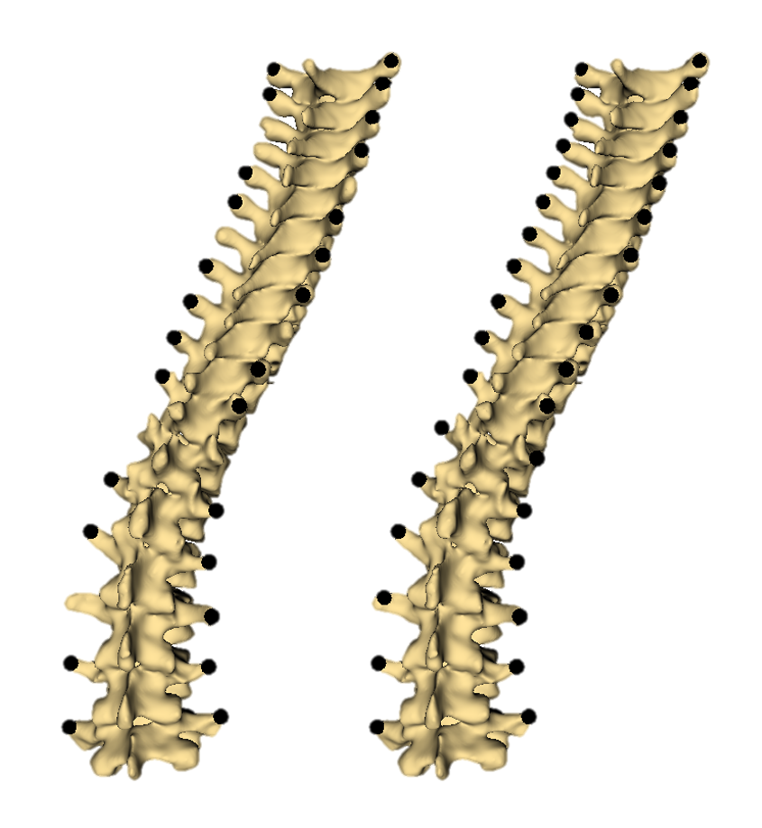
Fig. 1 Left: Example of input data used by method, roughly a quarter of landmarks omitted; Right: Sample output, landmarks omissions estimated and imputed; Landmarks are shown on CT segmentation used for input data generation.

A flowchart illustrating the process used by the Slicer module to repair the partially complete landmark set is shown in Figure 2. The process essentially consists of categorizing the points as belonging to the right or left side of the spine, fitting curves to each side, and using point spacing along these curves to estimate where and how many points to add. The user ultimately decides how many points are added, and repeats the processes as necessary to repair each side. The process is described in greater detail in the following paragraphs.
The transverse process landmarks can be thought of as points on either a right or left-side curve along the superior-inferior direction, by virtue of the vertebrae’s right-left symmetry. Therefore, the first step of the proposed method is to categorize each landmark as belonging to either the right or left. This was done by sorting the landmarks from highest to lowest, and running k-means classification on a sliding window of landmarks. Each iteration of the k-means classification resulted in one vote per landmark, either right or left. A point was categorized as right or left-sided based on which side it received more votes for. Once the right and left sides were recognized, they could be treated separately.
Polynomials are then fitted to each side’s landmark locations, with the vertical coordinate as the independent variable. To identify intervals along these polynomials which were likely to have a missing landmark, polynomials were fit to the spacing of the landmarks along the other polynomials, again, with the vertical direction as the independent variable. The module currently checks the length of an interval against those of the adjacent intervals, and against overall interval statistics, although other conditions could be used to check for omissions.

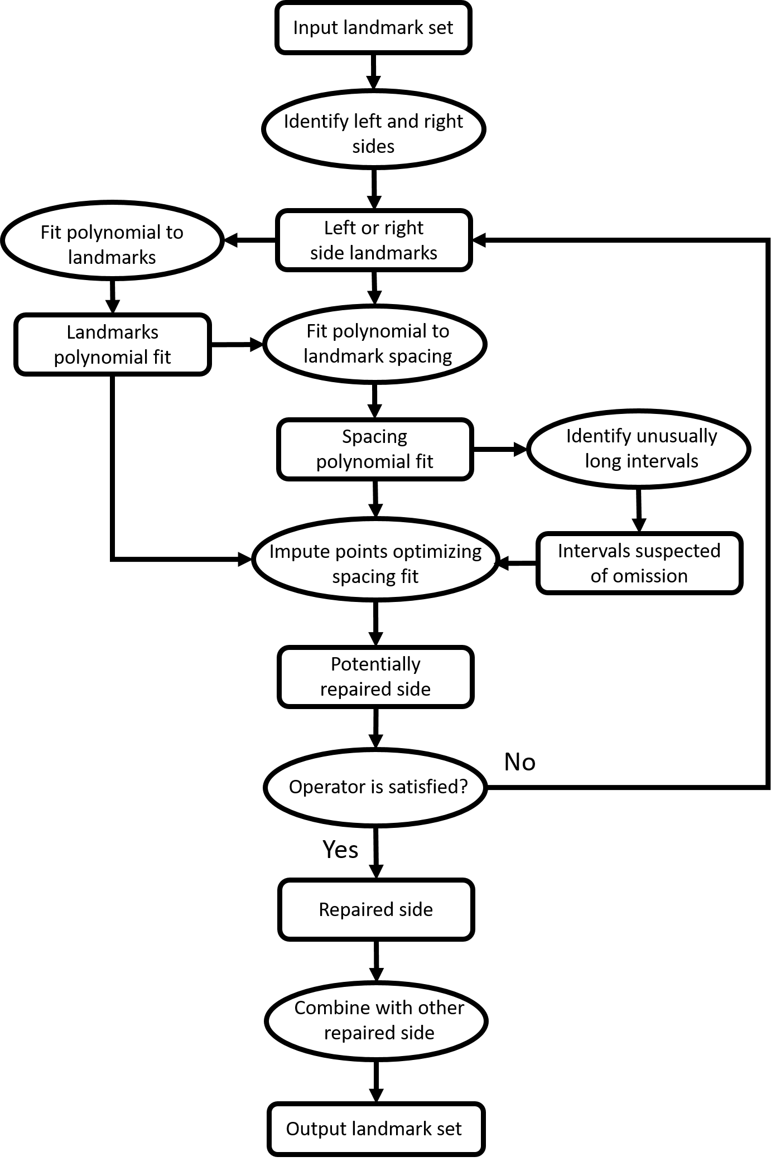
Fig. 2 Flowchart illustrating the procedure used by the Slicer module to repair an incomplete spinal landmark set

3. Results:

4. Discussion:

5. Conclusion: The Conclusion must be clearly marked as shown. When referring to other Sections in the Letter, please use the Section heading, or describe the relevant Section as the ‘following’ or ‘preceding’ Section in relation to the current Section in the text.

6. Acknowledgments: This work was supported by *insert acknowledgment here* (grant ABCD-1234X).

7. Declaration of interests:
All conflicts of interest must be declared in this section in accordance with the IET’s Conflict of Interest Policy which can be found in the Author Guide at http://digital-library.theiet.org/journals/htl/author-guide. The manuscript will not be sent for peer review without this declaration and each author must complete a Conflict of Interest Disclosure form available in the Author Guide. If there are no conflicts of interest to report, please state ‘None declared.’

8. References:
[Loizides2011] Loizides, A., Peer, S., Plaikner, M., Spiss, V., Galiano, K., Obernauer, J., and Gruber, H.: ‘Ultrasound-guided injections in the lumbar spine’, Medical Ultrasonography, 2011, 13, (1), pp. 54-58
[Ungi2012b] Ungi, T., Abolmaesumi, P., Jalal, R., Welch, M., Ayukawa, I, Nagpal, S., Lasso, A., Jaeger, M., Borschneck, D. P., and Fichtinger, G.: ‘Spinal Needle Navigation by Tracked Ultrasound Snapshots’, IEEE Transactions on Biomedical Engineering, 2012, 59, pp. 2766-2772 (doi: 10.1109/TBME.2012.2209881)
[Nagpal2015] Nagpal, S., Abolmaesumi, P., Rasoulian, A., Hacihaliloglu, I., Ungi, T., Osborn, J., Lessoway, V. A., Rudan, J., Jaeger, M., Rohling, R. N., Borschneck, D. P., and Mousavi, P.: ‘A multi-vertebrae CT to US registration of the lumbar spine in clinical data’, Int J CARS., 2015, 10, pp. 1371-1381 (doi: 10.1007/s11548-015-1247-5)
[Zettinig2016] Zettinig, O., Fuerst, B., Kojcev, R., Esposito, M., Salehi, M., Wein, W., Rackerseder, J., Sinibaldi, E., Frisch, B., and Navab, N.: ‘Toward Real-time 3D Ultrasound Registration-based Visual Servoing for Interventional Navigation’, IEEE International Conference on Robotics and Automation, Stockholm, Sweden, 2016, pp. 945-950.
[Behnami2016] Behnami, D., Seitel, A., Rasoulian, A., Anas, E. M. A., Lessoway, V. Osborne, J., Rohling, R., and Abolmaesumi, P.: ‘Joint registration of ultrasound, CT and a shape+pose statistical model of the lumbar spine for guiding anesthesia’, Int J CARS., 2016, 11, pp. 937-947 (doi: 10.1007/s11548-016-1369-4)
[Seitel2016] Seitel, A., Sojoudi, S., Osborne, J., Rasoulian, A., Nouranian, S., Lesoway, V., Rohling, R., and Abolmaesumi, P. ‘Ultrasound-Guided Spine Anesthesia: Feasibility Study of a Guidance System’, Ultrasound in Med. & Biol., 2016, 42, (12), pp. 3043-3049 (doi: 10.1016/j.ultrasmedbio.2016.07.008)
[Wang2015] Wang, Q., Li, M., Edmond, L., and Wong, M. S., ‘Reliability and Validity Study of Clinical Ultrasound Imaging on Lateral Curvature of Adolescent Idiopathic Scoliosis’, PLoS ONE, 2015, 10, (8), (doi:10.1371/journal.prone.0135264)
[Zheng2015] Zheng, R., Chan, A., Chen, W., Hill, D., Le, L., Hedden, D., Moreau, M., Mahood, J., Southon, S., and Lou, E.: ‘Intra- and Inter-rater Reliability of Coronal Curvature Measurement for Adolescent Idiopathic Scoliosis Using Ultrasonic Imaging Method-A Pilot Study’, Spine Deformity, 2015, 3, pp. 151-158 (doi: 10.1016/j.jspd.2014.08.008)
[1] Kraus, J. D. : ‘The square-corner reflector’, European Microwave Conf., Rome, Italy, 2011, pp. 19–24
[2] Wait, J.R.: ‘On the theory of an antenna with an infinite corner reflector’, Can. J. Phys., 2009, 32, (6), pp. 365–371 (doi: 10.1016/j.sigpro.2010.09.022)
[3] Olver, A.D., and Sterr, U.O. : ‘Study of corner reflector antenna using FDTD’. Proc. Int. Conf. on Antennas and Propagation, Edinburgh, UK, April 1997, Vol. 1, pp. 334–337
[4] Taflove, A.: ‘Computational electrodynamics’ (Artech House, Norwood, MA, 1995)
[5] Wait, J.R.: ‘Theory of an antenna with square-corner reflector’, Can. J. Phys., 1954, 23, (4), pp. 215–222 (doi: 10.1016/j.sigpro.2010.09.022)
[6]. Kraus, J. D.: ‘The square-corner reflector’, http://www.theiet.org, accessed 22nd November 2010
---------------------------------------------------------------------------------------
The maximum length of a manuscript allowed is 12 columns (6 pages).
This document is intended as a guide for format and length; your manuscript will be copyedited and formatted further at proof stage.

