1. Introduction: Please include Section headings; each new Section should have a heading in the style shown. An Introduction and Conclusion are necessary. The main text should be set in two-column format, with a column width of 8.7 cm and a central space of 1.06 cm. Use Times New Roman, font size 9, with line spacing of 1.0, and please number all pages.

Submissions template for Healthcare Technology Letters

John Smith^{1,3}, Arthur D. Author², Li-Rong Dai² and Sarah M. J. Author²

¹ Insert corresponding Author Affiliation address here. Affiliations should be in single column format. Include Department name, University Name, City/Town name, Post/Zip code, Country name
² Department of Physics, University of Physics, Town, Post/Zipcode, Country
³Author may have more than one Affiliation.
E-mail: a.author@email.com (Only include one corresponding author email address)

This document gives you guidelines on preparing manuscripts for submission to Healthcare Technology Letters, and also provides the rough format of finished articles in order to estimate the length of your Letter. We would expect most Letters to be up to eight columns in length but they should not exceed twelve columns. Manuscripts can also be submitted in LaTex (please see the LaTex template). The article title should be initial capital, and then lowercase, in font size 14; please avoid using the words ‘new’ or ‘novel’ in the title. Include all authors in a single list, font size 10. The style for the names is: full first name, middle name(s) as initials (with full stops) and family name, each author’s name separated with a comma, precede the final name with ‘and’ (see the example above). Chinese-style names should be typed as the author wishes his/her name to appear in print, all in font size 12. The Abstract should not exceed 200 words. It must not include any References. Expand any acronyms used in the Abstract, as well as the first instance of any acronym used in the main text and in font size 9.
Expand acronyms as follows: ‘electromagnetic interference (EMI)’ – the expansion should not be capitalised, unless the word would normally be capitalised, i.e. ‘fibre Bragg grating (FBG)’, and the acronym should be in brackets. All future uses of the acronym are not expanded and are not put in brackets – e.g. ‘EMI’. References should be cited in this format: [1] set in square brackets, such as [1, 2] or [3–5] – please ensure all References are included in the References Section at the end. All References must be cited in the main text (in numerical order). All Figures and Tables must also be cited (in numerical order). Citation of Figures should be as follows: Fig. 1, Fig. 2, Figs. 3a and b, Fig. 4 (if any sub- Figure is cited, then all other sub-Figures must be cited). Citation of Tables should be as follows: Table 1, Table 2. Include your Figures and Tables in the main text near the relevant citation.

2. Information on equations: All numbered equations such as (1), below, are referred to in the main text using the bracketed number only – for example, ‘I in (1) signifies the area’. Numbered equations or substantial mathematics should be set on a separate line from the text, as follows:

D_{H} = [2π I(90,φ)] / [ ∫₀ ^{2π} I(90,φ)dφ] (1)

Equation editors can be used, as long as they are in English. All variables must be defined, e.g. ‘the apex angles φ’. If an equation is too long to fit on a single line, then split it over two lines as follows:

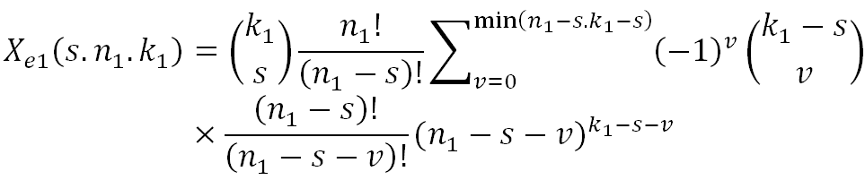
(2)

3. Information on Figures and Tables: Information relating to Figure format is shown in Fig. 1 (see also Figs. 2 and 3).

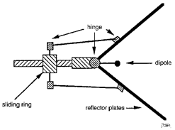

Fig. 1 All text in Figures should be lowercase, unless the word would normally be capitalised (i.e. ‘LED’, or ‘Butler matrix’)

Please ensure that Figures are clearly labelled and are of good quality. All Figures must be clear when the manuscript is viewed at 100%. All Figures are relettered, so inclusion of unlettered originals (at the end of the manuscript or as separate files) is welcomed. Note: if possible, please try to avoid setting line-drawings and photographs in the same Figure since photographs require different processing in order to maintain quality. Figures can be placed in a single column (Fig. 1) or spread across two columns, as shown in Fig. 2. Sub captions discussing each Figure are necessary for all Figures that contain more than one image.

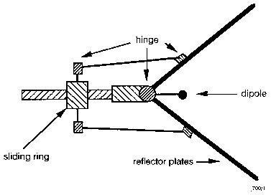
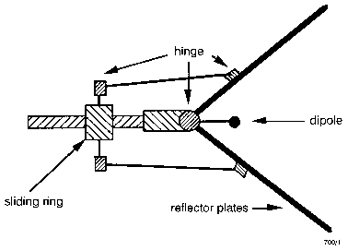
Fig. 2 Insert Figure captions below Figures: each sub-Figure should have a separate caption.
a Label axes in the format: angle, deg (what axis shows, comma, units)
b All Figures should be clear to understand in black and white

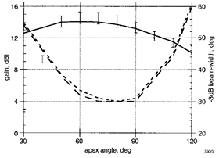

Fig. 3 Zero should always be written ‘0’ (Fig. 3a), do not include decimal places after zero (i.e. not ‘0.0’) (Fig. 3b). Set all legends in boxes within the Figure.

Information relating to Table format is shown in Table 1. Please ensure all Tables are cited in numerical order. Tables can be spread across two columns.

Table 1: Table captions go above the relevant Table, and are not italicised. If all values in a column use the same units, include this in the column heading in brackets rather than after each value

Name | Proportion (%) | Frequency (GHz) | Area  (mm²)
One | 45 | 64 | 12.3
Two | 55 | 18 | 3.4

4. Conclusion: The Conclusion must be clearly marked as shown. When referring to other Sections in the Letter, please use the Section heading, or describe the relevant Section as the ‘following’ or ‘preceding’ Section in relation to the current Section in the text.

5. Acknowledgments: This work was supported by *insert acknowledgment here* (grant ABCD-1234X).

6. Declaration of interests:
All conflicts of interest must be declared in this section in accordance with the IET’s Conflict of Interest Policy which can be found in the Author Guide at http://digital-library.theiet.org/journals/htl/author-guide. The manuscript will not be sent for peer review without this declaration and each author must complete a Conflict of Interest Disclosure form available in the Author Guide. If there are no conflicts of interest to report, please state ‘None declared.’

7. Information on References: A numerical Reference System is used in Healthcare Technology Letters. Please give as much information as possible – all authors, title, publication/book/conference name, date, venue, volume and issue (if relevant), page numbers, DOI etc. and all References must be cited in the main text in numerical order. Note that References to submitted works cannot be included unless they have been accepted for publication. In the case of PhD theses, please provide as much information as possible, especially the relevant university. For Conferences the venue must be given.
[1] Kraus, J. D. : ‘The square-corner reflector’, European Microwave Conf., Rome, Italy, 2011, pp. 19–24
[2] Wait, J.R.: ‘On the theory of an antenna with an infinite corner reflector’, Can. J. Phys., 2009, 32, (6), pp. 365–371 (doi: 10.1016/j.sigpro.2010.09.022)
[3] Olver, A.D., and Sterr, U.O. : ‘Study of corner reflector antenna using FDTD’. Proc. Int. Conf. on Antennas and Propagation, Edinburgh, UK, April 1997, Vol. 1, pp. 334–337
[4] Taflove, A.: ‘Computational electrodynamics’ (Artech House, Norwood, MA, 1995)
[5] Wait, J.R.: ‘Theory of an antenna with square-corner reflector’, Can. J. Phys., 1954, 23, (4), pp. 215–222 (doi: 10.1016/j.sigpro.2010.09.022)
[6]. Kraus, J. D.: ‘The square-corner reflector’, http://www.theiet.org, accessed 22nd November 2010
---------------------------------------------------------------------------------------
The maximum length of a manuscript allowed is 12 columns (6 pages).
This document is intended as a guide for format and length; your manuscript will be copyedited and formatted further at proof stage.

