**Scoliosis visualization using transverse process landmarks**

Ben Church1, Andras Lasso1, Christopher Schlenger2,   
Daniel P. Borschneck3, Parvin Mousavi4, Gabor Fichtinger1,3, Tamas Ungi1,3

1. Laboratory for Percutaneous Surgery, School of Computing,  
    Queen’s University, Kingston, ON, Canada
2. Premier Chiropractic, Stockton, CA, USA
3. Department of Surgery, Queen’s University, Kingston, ON, Canada
4. Medical Informatics Laboratory, School of Computing,   
   Queen’s University, Kingston, ON, Canada

**Introduction** Scoliosis is a lateral curvature of the spine which typically develops until skeletal maturity. Patient’s must have the disease monitored regularly to ensure they receive less invasive treatments, if need be. The disease is normally quantified in terms of the Cobb angle. The greatest angle between the end plates of any two vertebrae, normally measured from X-ray. The health risks of repeatedly X-raying patients throughout growth has motivated research [1] into using spatially tracked ultrasound as another means of quantifying the disease. Current quantification methods, although capable of assessing the scoliotic curvature, do not produce intuitively comprehensible visualizations of the spine such that practitioners or patients might understand the disease’s pathology through its overall form, or how it might change with treatment. We propose a method for producing such spinal visualization by deforming a healthy shaped spine model to patient anatomy.

**Methods** Transverse process locations were marked on an average shaped spine model, and on patient spine models derived from prior CT scans. Supplemental anchor points were added to both point sets, normal to the anterior curvature of the spine. This ensured that the subsequent registration of the model’s point set to the patients’ would encode the vertebral scale and orientation transformations in an anatomically realistic way. Thin-plate spline registration was used to produce deformation fields, which were then applied over the continuity of the average spine model, warping it to the patients’ anatomies. The prior CT scan models were then compared to the warped models, as their accuracy makes them a natural ground-truth.

Figure 1 - Top row: Patient ground truth (left), visualization from deformed model with error map (right). Bottom: Undeformed model.

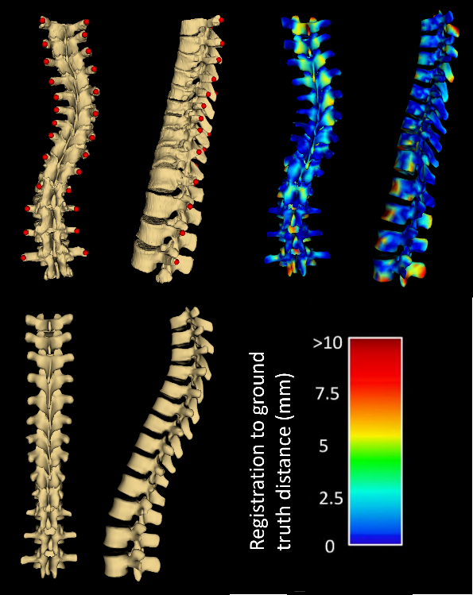

**Results** Figure 1 shows the visualization resulting from one registration, compared to the patient’s ground truth with transverse process locations.

**Conclusions** Visualization error occurs mainly at the ends of the spine, and anterior and posterior to vertebral faces, where there are fewer landmarks to constrain the deformation field. Nonetheless, the proposed method can be used to visualize scoliotic spines using their transverse process locations

**References** [1] Ungi et al. Ultrasound in Medicine and Biology 2014; 40(2):447-54.