**Scoliosis visualization using transverse process landmarks**

Ben Church, Andras Lasso, Christopher Schlenger,   
Daniel P. Borschneck, Parvin Mousavi, Gabor Fichtinger, Tamas Ungi

**Introduction** Scoliosis is a lateral curvature of the spine which typically develops until skeletal maturity. Patient’s must have the disease monitored regularly to ensure they receive less invasive treatments, if need be. The health risks associated with monitoring the disease using X-ray have motivated research [1] into using spatially tracked ultrasound instead. Current quantification methods, although capable of assessing scoliotic curvature, do not produce intuitively comprehensible visualizations of the spine such that practitioners or patients might understand the disease’s pathology through its overall form. We propose a method for producing such spinal visualization by deforming a healthy shaped spine model to patient anatomy.

**Methods** Transverse process locations were marked on an average shaped spine model, and on CT-derived patient spine models. Each landmark was supplemented with an anchor point, created at an offset determined from local landmark geometry. A vector, pointing to the landmark being supplemented from its neighbor below, was averaged with a vector pointing to the landmark above. This vector was crossed with the vector from the landmark to its symmetric neighbor. Anchor points placed in the direction of this cross product ensured that the subsequent landmark registration would encode the vertebral scale and orientation transformations in an anatomically realistic way. Thin-plate spline registration was used to produce deformation fields, which were then applied over the continuity of the average spine model, warping it to the patients’ anatomies. The prior CT scan models were then compared to the warped models, as their accuracy makes them a natural ground-truth.

Figure 1 - Top row: Patient ground truth (left), visualization from deformed model with error map (right). Bottom: Undeformed model

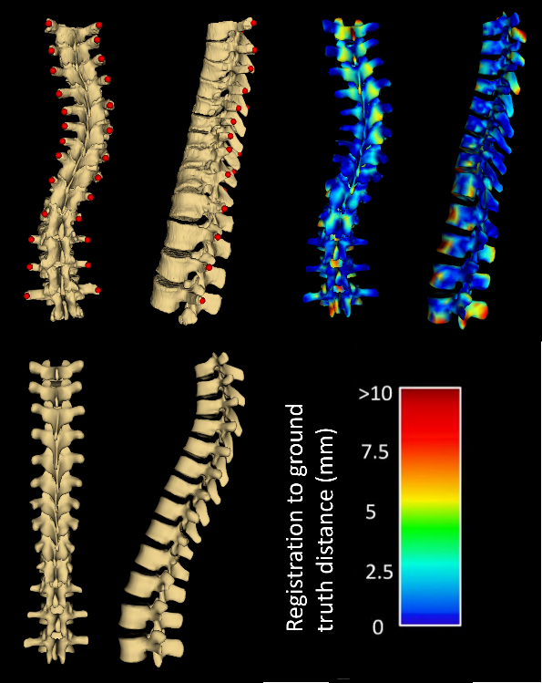

|  |  |  |
| --- | --- | --- |
| **Patient** | **Avg. Hausdorff (mm)** | **Max. Hausdorff (mm)** |
| 1 | 2.8 | 20.0 |
| 2 | 2.3 | 24.0 |
| 3 | 2.4 | 17.7 |
| 4 | 2.9 | 18.1 |
| 5 | 3.3 | 23.8 |

**Results** Figure 1 shows the visualization resulting from one registration, compared to the patient’s ground truth with transverse process locations. Four other registrations were performed. All the patients’ visualization to ground-truth Hausdorff distances are shown in Table 1. Large maximum Hausdorff distances relative to average ones are typically the result of protruding structures, far from landmarks to constrain them, such as the spinous processes, which are irrelevant to quantifying scoliotic curvatures.

Table 1: Average and maximum Hausdorff distances for each patient’s registered model

**Conclusions** Visualization error occurs mainly at the ends of the spine, and anterior and posterior to vertebral faces, where fewer landmarks constrain the deformation field. Nonetheless, the proposed method can be used to visualize scoliotic spines using their transverse process locations.

**References** [1] Ungi et al. Ultrasound in Medicine and Biology 2014; 40(2):447-54.