**Scoliosis visualization using transverse process landmarks**

Ben Church1, Andras Lasso1, Christopher Schlenger2,   
Daniel P. Borschneck3, Parvin Mousavi4, Gabor Fichtinger1,3, Tamas Ungi1,3

1. Laboratory for Percutaneous Surgery, School of Computing, Queen’s University, Kingston, ON, Canada
2. Premier Chiropractic, Stockton, CA, USA
3. Department of Surgery, Queen’s University, Kingston, ON, Canada
4. Medical Informatics Laboratory, School of Computing, Queen’s University, Kingston, ON, Canada

**Introduction** Scoliosis is a lateral curvature of the spine, typically diagnosed in adolescence and monitored by periodic X-ray imaging until skeletal maturity. Ultrasound has been investigated as a radiation-free imaging modality for spinal curvature measurement [1, 2]. The spinal curvature is computed from sparse skeletal landmarks, such as transverse processes (TrP), localised in ultrasound. This information, however, does not allow for intuitive visualization of the spine which practitioners or patients might easily comprehend.

**Methods** We propose a method for producing spinal visualizations by deforming an average model to the patient's anatomy based on TrP landmarks as they are localized in tracked ultrasound. Each landmark was supplemented with an anchor point, at an offset determined from local landmark geometry. A vector, pointing to the landmark being supplemented from its neighbor below, was averaged with a vector pointing to the landmark above. This vector was cross-produced with the vector from the landmark to its symmetric neighbor. Anchor points placed in the direction of this cross product ensured that the subsequent landmark registration encode vertebral orientation transformations in an anatomically realistic way. The offset size was determined from anatomic scale. Thin-plate spline registration yielded deformation fields, which, applied over the continuity of the average spine, warped it to the patient’s anatomy. To validate our method, we marked the TrP on five (n=5) CT scoliosis patient scans. We computed the deformation field according to our method, applied it to the average spine model, and compared it to the surfaces obtained from CT.

**Results** Figure 1 shows the visualization resulting from a typical registration: The patient's CT with TrP landmarks, registered model, and the registered model with color code indicating the surface distances. Larger registration errors occur at the dorsal processes of the highest and lowest vertebrae, due to lack of constraints. Moderate registration errors occur at protruding structures in the AP plane, where landmarks provide less constraint for registration. In all cases, larger and moderate errors are constrained to the AP plane, irrelevant to scoliosis assessment. The average of all patients’ average and maximum Hausdorff distances were 2.7mm and 20.7mm, respectively. The average is favorably low. The maxima occur only in the dorsal process of the highest and lowest vertebrae, not affecting scoliosis assessment.

Figure 1 - Top row: Patient #5 ground truth (left), resulting visualization (right). Bottom: Visualization with color code showing error

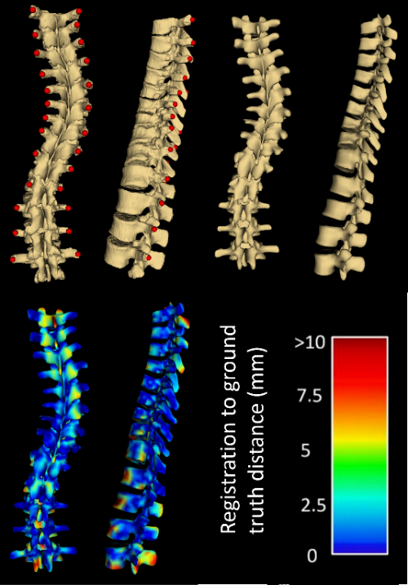

**Conclusions** Larger registration error occurs mainly at the highest and lowest vertebrae, due to a lack of constraints. Fortunately, the error is constrained to the dorsal processes and vertebral bodies, which are irrelevant to the assessment of scoliosis; our method produces visualization that is both perceptually and quantitatively accurate for assessing scoliosis.

**References** [1] Ungi et al. Ultrasound in Medicine and Biology 2014; 40(2):447-54. [2] Chueng et al. Journal of Orthopaedic Translation 2015; 3:123-33.