**Scoliosis Quantification Accuracy Using Feedforward   
Neural Network with Noisy Landmark Data**

Ben Church

Laboratory or Percutaneous Surgery, School of Computing,  
 Queen’s University, Kingston, Canada

**Introduction** Scoliosis is a pathological curvature of the spine which typically develops throughout growth. Regular monitoring of the disease ensures that patients receive less invasive treatments when possible. The gold-standard method for quantifying the disease is the Cobb angle measurement, performed on X-ray images. The Cobb angle is the largest angle between the end plates of any two vertebrae projected onto the coronal plane. The health risks of such cumulative ionizing radiation exposure has motivated research [1] into spatially tracked ultrasound as an alternative approach to quantifying the disease. [1] used the transverse processes as anatomic landmarks from which to extract a curvature on scoliotic phantom models. Changes in relative locations of these landmarks, due to breathing for example, in live patients, could cause error in these landmarks’ locations [2]. To produce an estimate of a scoliotic spine’s curvature from noisy landmark locations, we used a feedforward neural network from MATLAB’s Neural Fitting app on data with various amounts of noise added.

**Methods** 124 scoliotic patients’ transverse processes were located from prior CT scans. CTs were used to ensure the initial accuracy of the landmark locations. The angle between the two most mutually tilted vertebrae is extracted from this landmark set. Landmark sets were generated with random noise of varying standard deviation in each coordinate of each landmark point. 86 patients were used for training a neural network with a single hidden layer of 10 nodes. 19 were then used for each of the validation and testing phases. The network was trained 10 times with the Levenburg-Marquardt algorithm, and the training, and testing mean-squarred-errors (MSEs) were recorded. This was repeated for 10 landmark sets with coordinated noise standard deviations varying from 1mm, to 10mm.

**Results** The average angle estimation errors shown in Figure 1 indicate that although the network was able to learn enough to reduce the training set error, its accuracy on either set is incomparable to existing manual quantification methods. The small training set size, relative to the number of network weights to be trained, and the numerous modes of deformation to be learned, may be an important factor limiting this quantification approach.

Figure 1: Testing and training average errors from neural network versus input data noise.

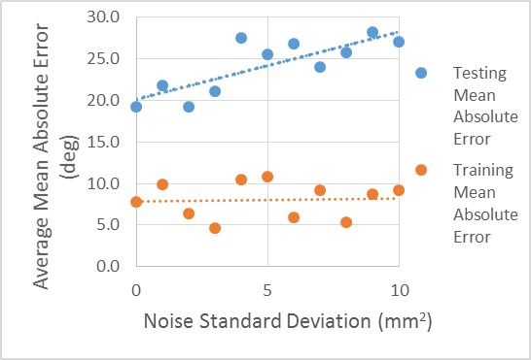

**Conclusions** A feedforward neural network proved ineffective at quantifying scoliosis relative to manual, tracked ultrasound-based, methods. More data to train the network should be investigated as a means to improve such a network’s performance.

**References** [1] Ungi et al. Ultrasound in Medicine and Biology 2014; 40(2):447-54. [2] Chueng et al. Journal of Orthopaedic Translation 2015; 3:123-33.