**Scoliosis visualization using transverse process landmarks**

Ben Church, Andras Lasso, Christopher Schlenger,   
Daniel P. Borschneck, Parvin Mousavi, Gabor Fichtinger, Tamas Ungi

**Introduction** Scoliosis is a lateral curvature of the spine, typically diagnosed in adolescence and monitored by periodic X-ray imaging until skeletal maturity. Ultrasound has been investigated as a radiation-free imaging modality for skeletal curvature measurement [1, 2]. The spinal curvature is computed from sparse skeletal landmarks, such as transverse processes (TrP), localised in ultrasound. This information, however, does not allow for intuitive visualization of the spine which practitioners or patients might easily comprehend.

Figure 1 - Top row: Patient #5 ground truth (left), visualization from deformed model with error map (right). Bottom: Average model

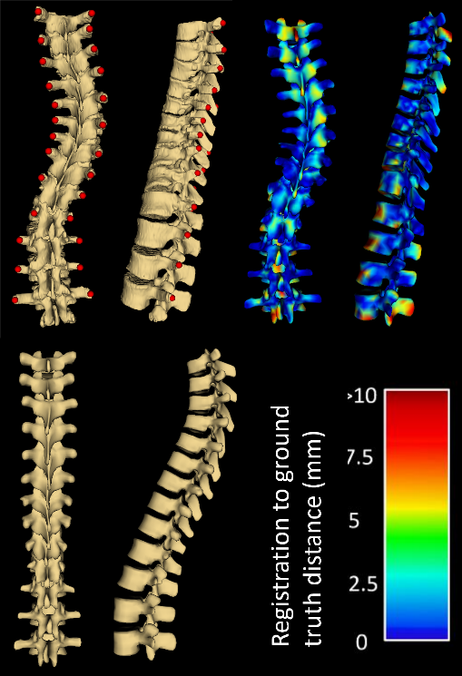

|  |  |  |
| --- | --- | --- |
| **Patient** | **Avg.** | **Max.** |
| 1 | 2.8 | 20.0 |
| 2 | 2.3 | 24.0 |
| 3 | 2.4 | 17.7 |
| 4 | 2.9 | 18.1 |
| 5 | 3.3 | 23.8 |

**Methods** We propose a method for producing spinal visualization by deforming an average model to the patient's anatomy based on TrP landmarks as they are localized in tracked ultrasound. Each landmark was supplemented with an anchor point, at an offset determined from local landmark geometry. A vector, pointing to the landmark being supplemented from its neighbor below, was averaged with a vector pointing to the landmark above. This vector was cross-produced with the vector from the landmark to its symmetric neighbor. Anchor points placed in the direction of this cross product ensured that the subsequent landmark registration encode the vertebral scale and orientation transformations in an anatomically realistic way. Thin-plate spline registration yielded the deformation fields, which were applied over the continuity of the average spine, warping it to the patient’s anatomy. To validate our method, we marked the TrP on five (n=5) CT scans from scoliosis patients. We computed the deformation field according to our method and applied it to the average spine model and compared it to the surfaces obtained from the patient's CT.

**Results** Figure 1 shows the visualization resulting from a typical registration: The patient's CT with TrP landmarks, average spine, and the average spine deformed to the patient with color code indicating the surface distances. Larger registration errors occur at the dorsal processes of the highest and lowest vertebrae, due to lack of constraints. Moderate registration errors occur at protruding structures in the AP plane, where landmarks provide the weakest constraint for the registration. In all cases, larger and moderate errors are constrained to the AP plane, irrelevant to the assessment of scoliosis. Table 1 shows the all Hausdorff distances (n=5). The average is favorably low. The average maximum is about 20mm, occurring only in the dorsal process of the highest and lowest vertebrae, not affecting scoliosis assessment.

Table 1: Average and maximum Hausdorff distances (mm) for registered models

**Conclusions** Larger registration error occurs mainly at the highest and lowest vertebrae, due to lack of constraints. Fortunately, the error is constrained to the dorsal processes, which is irrelevant to the assessment of scoliosis; our method produces visualization that is both perceptually and quantitatively accurate for assessing scoliosis.

**References** [1] Ungi et al. Ultrasound in Medicine and Biology 2014; 40(2):447-54. [2] Chueng et al. Journal of Orthopaedic Translation 2015; 3:123-33.