Title

Ben Church1, Andras Lasso1, Christopher Schlenger2,   
Daniel P. Borschneck3, Parvin Mousavi4, Gabor Fichtinger1,3, Tamas Ungi1,3

1. Laboratory for Percutaneous Surgery, School of Computing,  
    Queen’s University, Kingston, ON, Canada
2. Premier Chiropractic, Stockton, CA, USA
3. Department of Surgery, Queen’s University, Kingston, ON, Canada
4. Medical Informatics Laboratory, School of Computing,   
   Queen’s University, Kingston, ON, Canada

**ABSTRACT**

# Introduction

Idiopathic scoliosis is a pathological curvature of the spine occurring in 1-2% of adolescents [Goldman2012]. Since adolescent idiopathic scoliosis progresses with growth until skeletal maturity, it is important to assess the disease at regular intervals. Regular assessment helps ensure that the 10-20% of patients requiring intervention receive less invasive treatments, such as bracing instead of surgical vertebral fusing, while they are still feasible. The gold-standard method for assessing the disease is still using X-ray imaging. An X-ray of the patient’s back in the coronal plane is taken and the Cobb angle is measured, where the Cobb angle is the greatest angle between the endplates of any two vertebrae, projected onto the coronal plane. The Cobb angle is illustrated on the left-most image of Figure 1.

The health risks resulting from using X-ray for regular assessment of adolescent idiopathic scoliosis have motivated research into using spatially tracked ultrasound as an alternative method. Wang et al. [Wang2015] and Cheung et al. [Cheung2015] examine several methods which use wide-transducer, spatially tracked ultrasound probes to scan patients’ spines in an axial orientation. The series of axial images are used to render a coronal representation of the spine, which could be examined at various depths of the remaining anterior-posterior dimension. Operators then located various skeletal landmarks identifiable from ultrasound. Estimated of the spines’ curvatures are extracted from the landmarks’ locations, and the angles of the curvatures were compared to the Cobb angle for validation of the particular method. Ungi et al. [Ungi2014] scanned scoliotic phantom models with the tracked ultrasound probe in a sagittal orientation to locate the transverse processes. When the operator was confident the transverse process was centered in the ultrasound image, a snapshot with position information was captured. Multiple snapshots could be taken of a given transverse process as necessary to confidently locate all of the landmarks within a range of interest. With the snapshots represented in a 3D environment, operators located the transverse processes, placing points at them from which an angle of curvature was extracted and compared to the Cobb angle.

These methods may be useful for quantitative, radiation-free, assessment of scoliosis, but they do not provide a macroscopic visualization of the patient’s spinal pathology in the way X-ray imaging, or better still, CT, do. X-ray and CT, despite their health risks, provide clinicians with an overall impression of their patient’s scoliosis, as shown in Figure 1. In [Anon2017], authors developed a method for producing such informative, macroscopic visualizations of spinal anatomy using radiation-free, ultrasound-accessible skeletal landmarks, namely, the transverse processes. The visualizations produced by their method, while not a substitute for standardized, quantitative measures such as angle of curvature, they may accompany these measures to give clinicians, patients, and their parents a visual understanding of the nature of the disease. Such a method might also be used to illustrate approximately how a spine’s curvature is expected to change before and after, or in the absence of, a treatment. An example of the results of their method is shown in Figure 2, with the inputs which produced it.

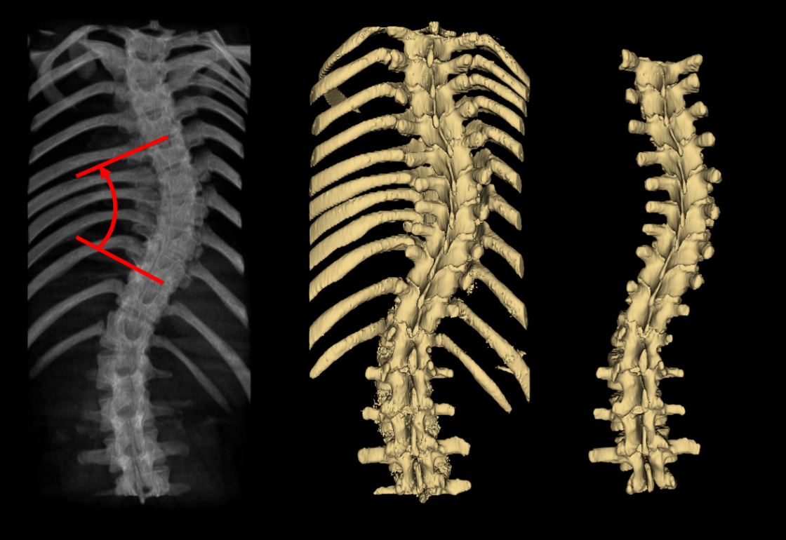

Figure 1: Comparison of X-ray and CT visualizations of scoliosis. Left: Simulated X-ray (digitally rendered radiograph) with Cobb angle illustrated; Center: Surface model of lumbar and thoracic anatomy obtained by applying a threshold to a CT scan; Right: Surface model of lumbar and thoracic spine manually segmented from a CT scan.

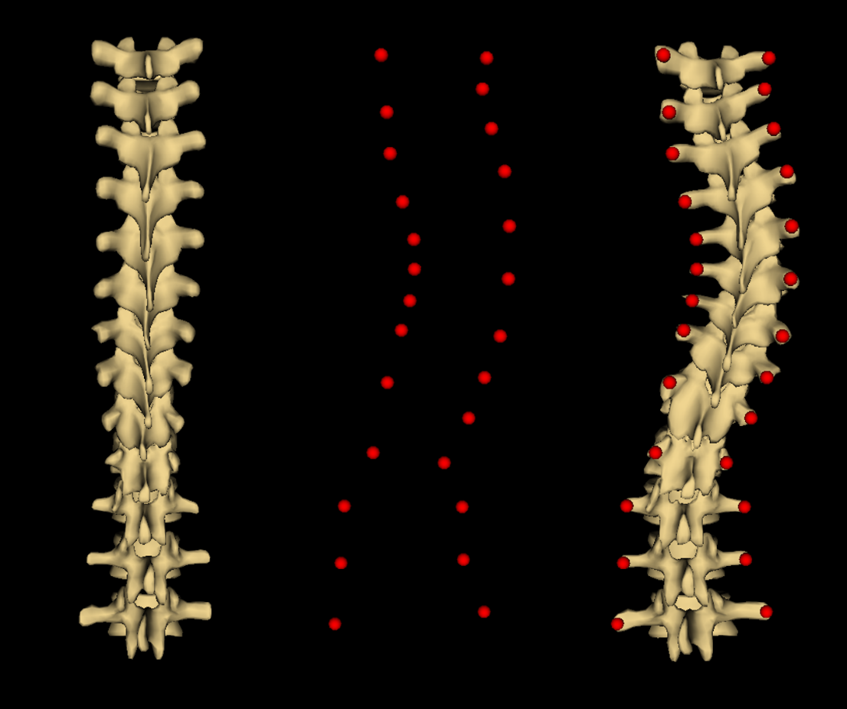

Figure 2: Input and resulting output from method proposed in [Anon2017]. Left: Healthy-shaped spine model; Center: Patient's transverse process locations; Right: Visualization resulting from warping healthy-shaped model to transverse process locations.

The method presented in [Anon2017], despite producing geometric visualizations of scoliotic spinal anatomy, was only tested on four patients. Furthermore, the landmark locations used in [Anon2017] were taken exclusively from CT-segmentations. Validation of this method requires additional results, and testing on transverse process landmarks located from tracked ultrasound scans, as they are the intended source of input for the method. The robustness of the method with respect to under-sampled or noisy transverse process locations may reflect on the utility of the method in cases of imperfect input data.

This paper addresses the need for validation of the method presented in [Anon2017]. In addition to generating visualizations of 13 scoliotic patients’ spines from CT-derived landmarks, we produce visualizations from tracked   
ultrasound-derived transverse process locations of an adult and child phantom models. The 13 patients’ visualizations were generated from transverse process landmark sets with various degrees of landmark under sampling, and with various amounts of normally distributed noise added to the landmarks’ locations.

# Methods

To validate the method presented in [Anon2017], we generated a variety of visualizations as they describe. To do this, the transverse processes of 13 patients were manually located from CT segmentations. From these complete transverse process location sets, additional landmark sets were generated with one third, one half, and two thirds of the vertebrae’s landmarks deleted. From each of the four sets containing different fractions of the total vertebrae, landmark sets were generated containing various amounts of random noise in the points’ coordinates. Sets were generated with noise having a standard deviation of 1mm2 to 10mm2 added to each coordinate of each transverse process location. The quality of the model registrations, constituting the visualizations, were assessed by comparing them to the CT segmentations from which the points were originally located. The accuracy of CT makes these segmentations a natural choice for a ground-truth against which to compare results. Average and maximum Hausdorff distances were computed for these registrations, and are plotted against landmark location noise in Figures 3 and 4, respectively.

# Results

Figure : Average Hausdorff distances, averaged over all patients' registrations, versus standard deviation of noise added to landmark locations, for each under sampling fraction.

Figure : Maximum Hausdorff distances, averaged over all patients' registrations, versus standard deviation of noise added to landmark locations, for each under sampling fraction.

Figures 3 and 4 show the average and maximum Hausdorff distances for the CT-derived-landmark based registrations. Each data point is the average over all registrations from that noise-under sampling combination.

# Discussion

Both the average and maximum Hausdorff distances suggest that the method from [Anon2017] exhibits graceful degradation with respect to both noise and under sampling. The small magnitude of the increase in Hausdorff distances with noise and under sampling relative to the Hausdorff distance magnitudes suggests some of the error results from sources intrinsic to the method. A substantial contribution to this error is likely a result of the proportions of the undeformed, healthy-shaped model. Figure 5 compares patient #1’s ground-truth to both the registered and unregistered models. Notably, the vertebral bodies of the registration are shorter in the anterior direction than those of the patient, particularly in the lower thoracic and lumbar regions. The error in this direction is depicted in an anterior view in Figure 6. However, the method from [Anon2017] scales the model to the patient’s anatomy in the registration process. This can be seen in the shrinking of the vertebral bodies from the undeformed model, to the registered one. However, the vertebral bodies of the undeformed model are already smaller than those of the patient, whereas the spine is typically longer, the patients being adolescents and the model being adult in scale. The result is that the vertebral bodies are shrunk in order to scale the model’s posterior anatomy containing the landmarks. A more accurately proportioned registration input model would be a simple remedy to this problem.

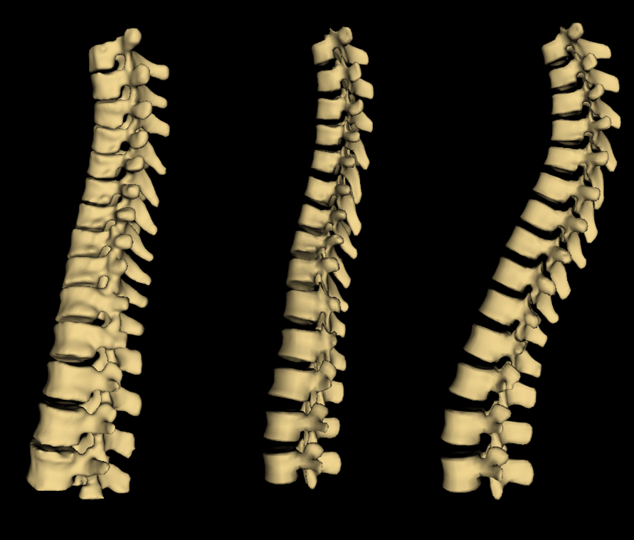

Figure : Left: Patient #1 ground-truth CT segmentation; Center: Model registered to patient #1; Right: Model before registration to patient #1.

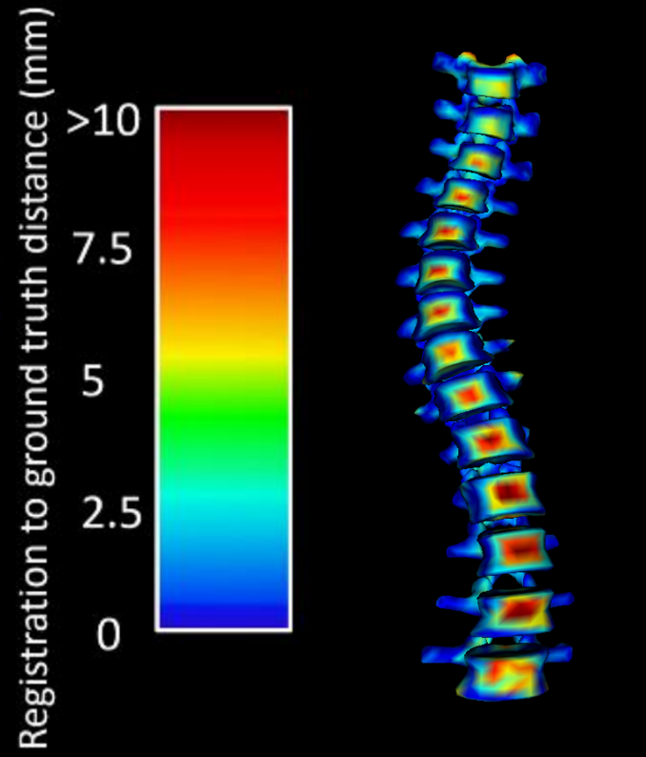

Figure : Anterior view of a color map projected onto patient #1's registration, showing the distance between ground-truth and the registration.

# Conclusions

# References

[Goldman2012] Goldman L, Schafer AI (2012) Goldman Cecil’s Medicine. Elsevier/Saunders, Philadelphia, p. 605.  
[Wang2015] Wang Q, Li M, Lou EHM, Wong MS (2015) Reliability and Validity Study of Clinical Ultrasound Imaging on Lateral Curvature of Adolescent Idiopathic Scoliosis. PLOS ONE 10(8):1-16.

[Cheung2015] Cheung CW, Zhou GQ, Law SY, Mak TM, Lai KL, Zheng YP (2015) Ultrasound Volume Projection Imaging for Assessment of Scoliosis. IEEE Trans Med Imaging 34(8):1760-8.

[Ungi2014] Ungi T, King F, Kempston M, Keri Z, Lasso A, Mousavi P, Rudan J, Borschneck DP, Fichtinger G (2014) Spinal curvature measurement by tracked ultrasound snapshots. Ultrasound in Medicine and Biology 40(2):447-54.

[Anon2017] Anonymous