Routing Optimiser
How it works — a plain-English guide
A one-line summary: it decides how to split card payments across several payment routes to get the most approvals while staying under our risk limit.

1. What is this tool for?
- We send card payments through several payment routes — call them "doors" (each is a gateway / MID).
- Some doors approve more payments; some cause more chargebacks (risk).
- Visa limits how much risk we're allowed — the "VAMP cap". Go over it and we get penalised.
- This tool chooses what share of payments to send through each door: as many approvals as possible, while staying under the risk limit.
- It makes that choice separately for lots of small buckets called cells.
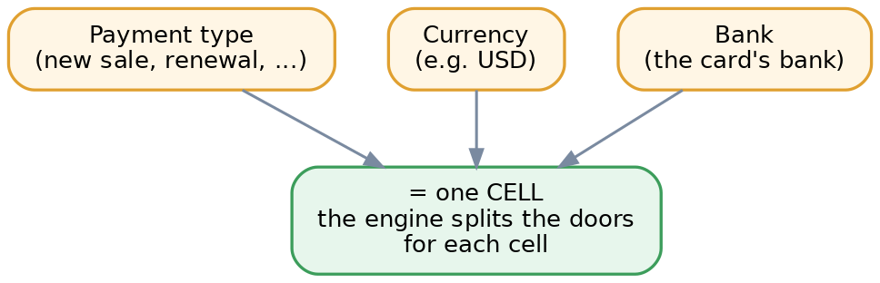
A "cell" = one payment type x currency x bank. The tool sets the door-split for each cell.

2. The big picture
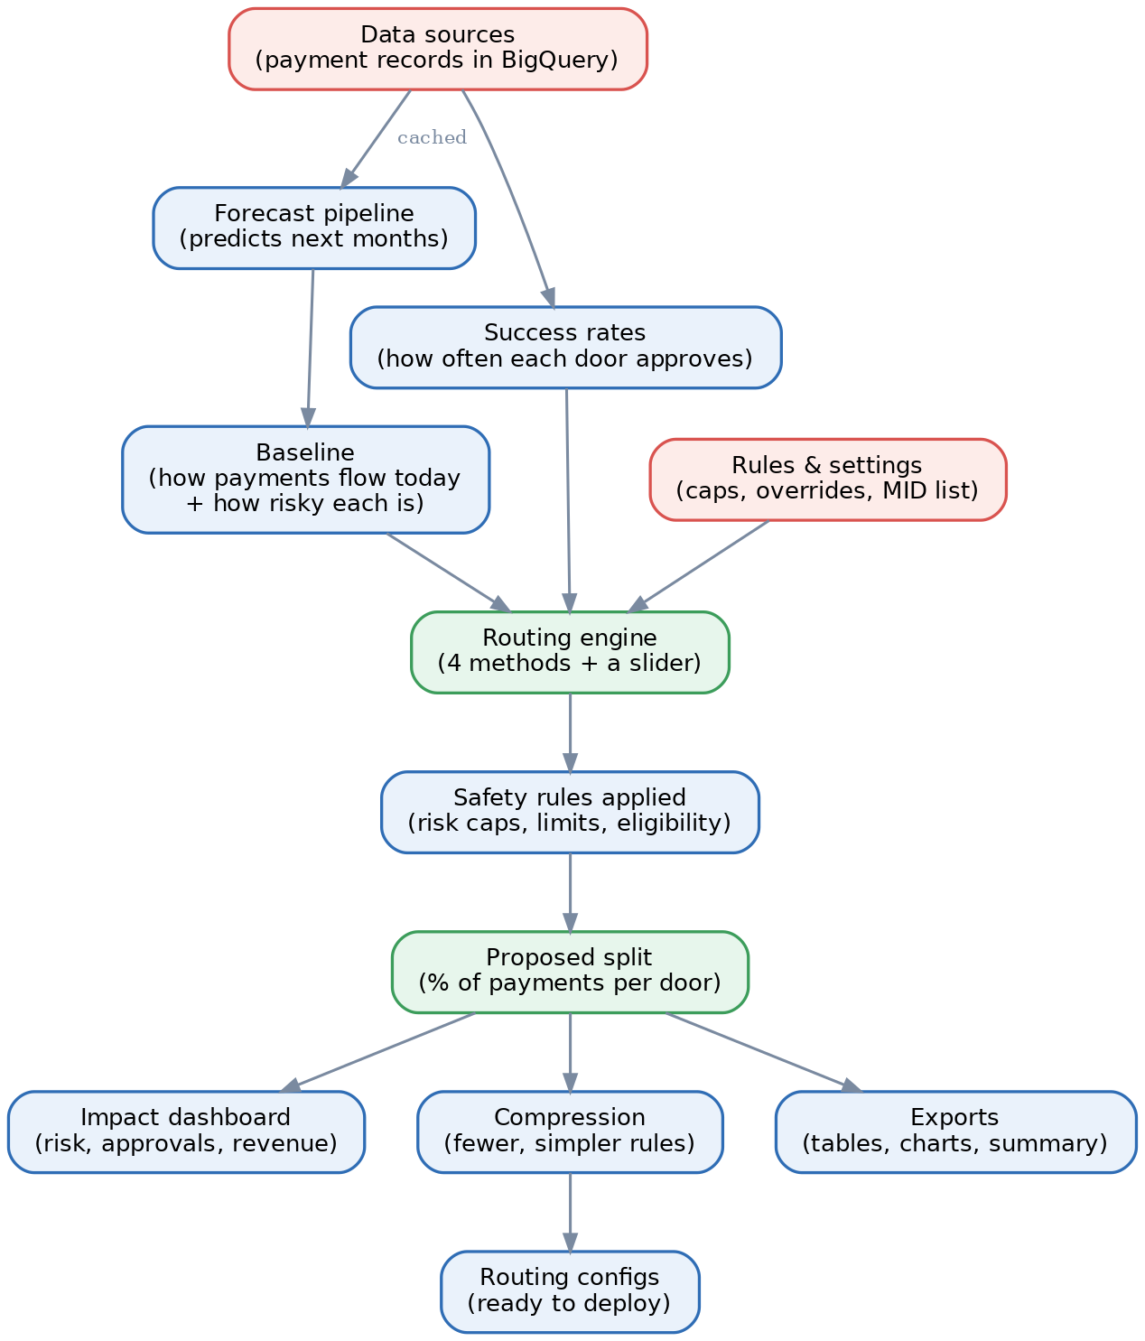
From raw payment data all the way to deploy-ready routing settings.
- It reads real payment history plus a forecast of the coming months.
- It works out each door's approval rate and how risky it is.
- The engine proposes a new split; safety rules automatically trim anything that breaks a limit.
- You get dashboards (risk, approvals, revenue) and can turn the split into ready-to-deploy configs.

4. The four engines (methods you can pick)
- Genetic (the default): tries loads of different splits, keeps and mixes the best over many rounds — best at obeying every rule at once.
- Softmax: sends more traffic to the better doors, but always keeps some spread.
- Thompson (bandit): mostly uses the door that's probably best, but keeps testing newer ones in case one's a hidden winner.
- Portfolio: spreads across doors like savings across piggy banks; avoids the unpredictable ones.
- They all read the same inputs and give the same kind of output, so you can switch between them freely.

5. The one slider you control
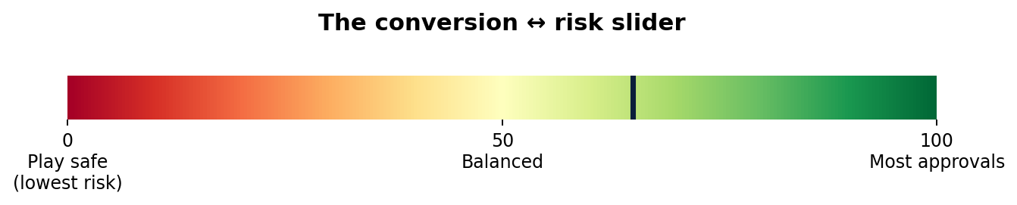
- A single slider runs from "play safe" (0) to "most approvals" (100).
- 100 = chase approvals; 0 = lowest risk; the middle = a balance.
- You just slide it to the trade-off you want.

6. How it picks a split
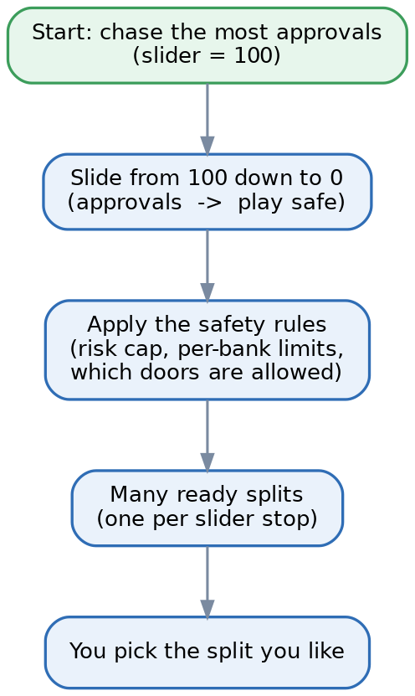
- It starts at 100 (most approvals).
- It slides down toward 0, gradually favouring safety.
- At each stop it applies the safety rules (risk cap, per-bank limits, which doors are allowed).
- That produces a menu of ready splits — you pick the one you like.

7. Two zoom levels (a little more detail)
- The decision is made on bigger buckets (Bank level) — more data means steadier choices.
- The real risk and the settings we actually deploy live at a finer level (the BIN — the first digits of a card number, which tells you the card's bank).
- So the tool zooms IN to measure risk and build the deploy settings, then zooms OUT for the dashboards.

8. Seeing the results
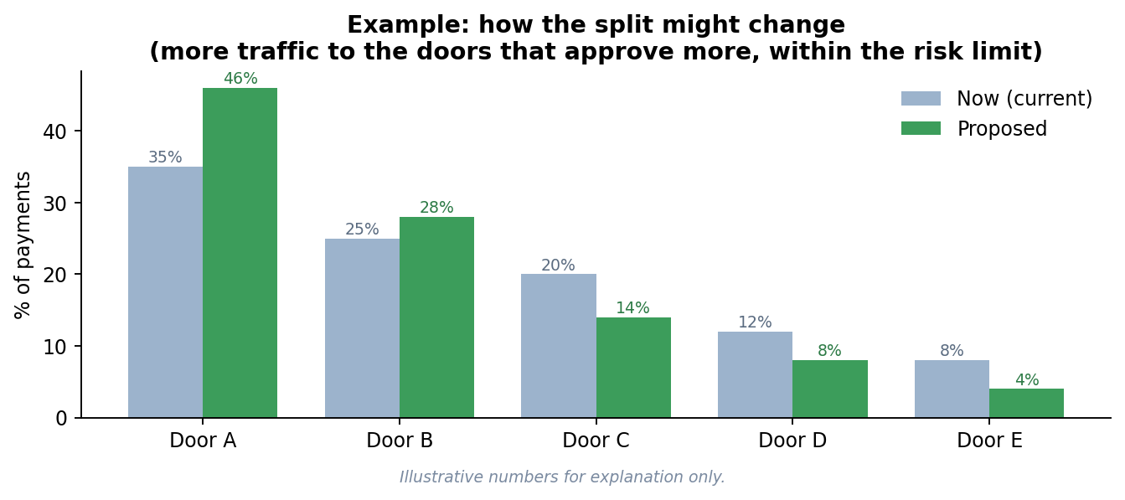
- The dashboards compare "now" vs "proposed": approvals, risk and revenue.
- Typically, more traffic shifts to the stronger doors — without breaking the risk cap.
- (The numbers in this example are made up, just to show the idea.)

9. Using the app (4 tabs)
- 1. Baseline & Validate — set up today's picture (or check a past decision).
- 2. Routing engine — pick a method and the slider, then compute the options.
- 3. Split, outputs & impact — see the results, risk, revenue and the detail behind them.
- 4. Generate configs — shrink to fewer, simpler rules and export deploy-ready files.

