This program works as a simple password manager that generates, encrypts and stores passwords for specific websites. The user runs the app by going to the directory inside of a terminal and typing:  
  
python3 pwMan.py <website>  
  
The password manage will then start.

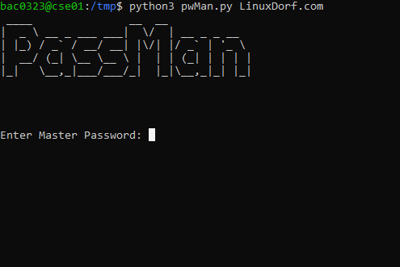

If the user has already run the app then the master password needs to be the same that was used when it was first created. If not, then whatever password is entered will now be the master password.

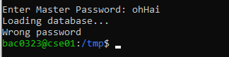

If you cant remember the password you must remove the password file by typing   
  
rm passwords

The next time you run the app and enter a password it will create the file and store the password as the master password. The app will also randomly generate a password and store that in the file for the website used in the command. All of this information is encrypted before stored in the file.

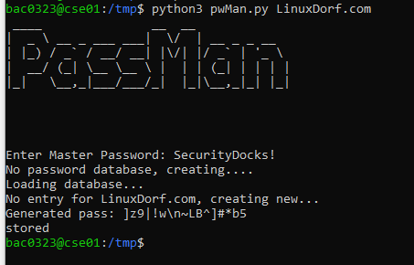

If the same command and website are used with the same master password, the program will find the passwords file, decrypt and check the master password. If that is not correct it will display and exit, if it is correct the program will check the file for the website name. If the website is there it will display the password, if it is not there it will generate, display, encrypt and store the password in the file before exiting.

