SIMULATION ENVIRONMENT

HIGH LEVEL DESIGN STUDY
Document Number: 2000-0002
Revision: 1.0
Date: 2026-03-15

Revision History
Revision | Reason for Change | Author | Date
1.0 | Initial comprehensive HLD for the simulation environment | GitHub Copilot | 2026-03-15

1 Introduction

1.1 Purpose
The purpose of this document is to define the High Level Design (HLD) of the TDS simulation environment implemented in the Simulation/ workspace components and supporting infrastructure.
- This document describes:
- The end-to-end architecture and boundaries
- Component responsibilities and interactions
- Discovery, control, and data paths
- Security model and deployment model
- Scalability, reliability, and operational considerations
- Current implementation state and future design trajectory

1.2 Scope
- In scope:
- Runtime components in Simulation/ (gate, station_computer, cs, pctrbo, pa, ticketdistributor)
- Registry/discovery infrastructure (cmd/server, cmd/client_proxy)
- Multi-VM and Kubernetes deployment patterns reflected in repository docs/scripts
- Primary transaction and settlement pathways for OY and PCTR card types
- Out of scope:
- Low-level code implementation details
- Detailed database table-by-table design beyond architecture-level boundaries
- UI-level behavior outside architecture-critical interfaces

1.3 Background
The simulation environment models a transport payment system with multiple bounded services and trust zones. It validates two card ecosystems: OY cards handled by CS and PCTR cards handled by PA and PCTRBO.

1.4 Design Drivers
- Service discovery without hard-coded downstream addresses
- Support for single-machine and multi-VM operation
- Isolation of cryptographic responsibilities for sensitive PCTR data
- Ability to scale service instances horizontally
- Clear control over eventual consistency and batching behavior
- Operational testability and reproducibility for demos and research

2 Context and HLD View

2.1 System Context
- Entry edge: Gate devices receiving taps
- Mid-tier dispatch: Station Computer instances
- Domain back-office services: CS, PCTRBO, PA
- Discovery/control plane: TDS server and client proxy
- Persistence plane: PostgreSQL databases per business service

2.2 High Level Architecture Diagram (Logical)
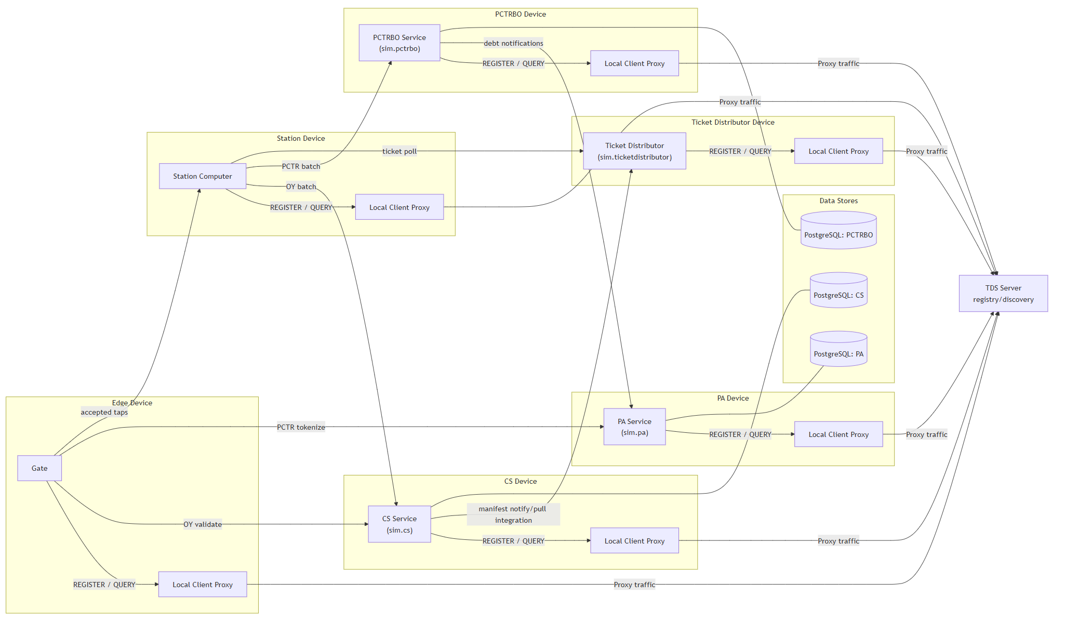logic continued)

2.3 Deployment Topology Variants
- Single-host local demo
- Multi-VM deployment
- Kubernetes deployment variant

3. Component Architecture Overview

3.1 TDS Server — Central Discovery Authority
- Maintains task-to-endpoint registry
- Handles registration, heartbeat, and query resolution
- Ensures liveness through timeout cleanup

3.2 Client Proxy — Local Discovery Gateway
- Provides local REGISTER/QUERY interface
- Forwards to TDS or P2P depending on mode

3.3 Gate — Transaction Entry Point
- Receives taps and performs allow/deny decisions
- Routes OY to CS and encrypts PCTR for PA

3.4 Station Computer — Buffering and Batch Dispatcher
- Buffers accepted taps
- Sends batch uploads to CS and PCTRBO

3.5 CS — OY Validation and Journey Engine
- Validates OY taps
- Constructs journeys and maintains OY state

3.6 PCTRBO — Back-office Tokenized Journey Processor
- Ingests tokenized batches
- Generates debt outcomes and reports to PA

3.7 PA — PCTR Cryptographic and Account Authority
- Decrypts/encrypts PCTR payloads
- Manages token-to-card mappings

3.8 Ticket Distributor — Manifest Distribution Layer
- Pulls manifests from CS
- Serves station polling consumers

4. System Flows and Interactions

4.1 Discovery & Registration
- Services register via proxy → TDS
- Heartbeats maintain liveness
- TDS removes stale entries

4.2 OY Processing Flow
- Gate validates with CS
- Valid taps forwarded to station
- Station uploads batches to CS

4.3 PCTR Processing Flow
- Gate encrypts using PA public key
- Calls PA for tokenization
- Station sends tokenized batches to PCTRBO

4.4 Ticket Distribution Flow
- CS produces manifests
- Ticket Distributor distributes to stations

5 Security and Trust Model

5.1 Trust Zones
- Edge zone
- Business logic zone
- Discovery/control zone
- Data zone

10 Risks and Mitigations
Risk | Impact | Mitigation
TDS central dependency | Discovery interruption | Run with health checks, fast restart, optional cache
Proxy local single point | Host-local isolation | Process supervision, watchdog restart
Misconfigured addresses | Cross-VM failures | Startup validation and deployment-time checks
End of document.

