M2 Supporting Evidence — Sample Verification and Code Review
Group 16 — Project 22
Verification performed by: Shakeeba Hamdam
Work completed: 22–23 October 2026

supporting evidence
This review checks the 12-project sample in Data/final_data_file_sample.csv and independently reruns one one-sided Wilcoxon rank-sum test using the sample’s end-velocity values. The purpose is to check the sample’s basic data quality and determine whether the result matches the group’s previously saved bounded-run output.

Check | Result
Total projects | 12
Microservice projects | 6
Non-microservice projects | 6
Duplicate project IDs | 0
Missing start-velocity values | 0
Missing end-velocity values | 0

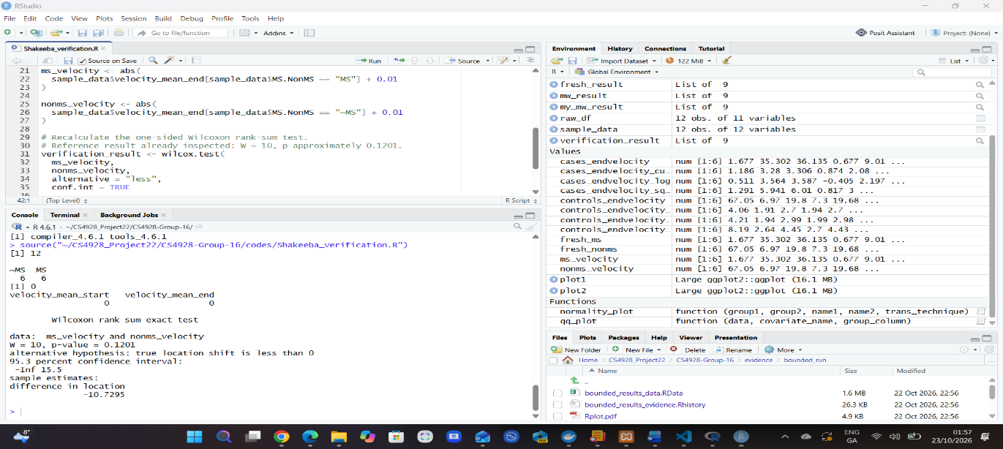
Figure 1: Verification script execution. Ran codes/Shakeeba_verification.R against the sample CSV. The output confirmed 12 projects, six in each group, no duplicate project IDs, and no missing start- or end-velocity values. The one-sided Wilcoxon test produced W = 10 and p = 0.1201, matching the group’s saved bounded-run result.

The end-velocity values were separated into microservice and non-microservice groups. Following the inspected analysis code, 0.01 was added to each value before taking its absolute value. A one-sided Wilcoxon rank-sum test was then run with alternative = "less" and conf.int = TRUE. The test produced W = 10 and p = 0.1201, matching the group’s previously saved bounded-run result. At the 0.05 significance level, this test does not provide sufficient evidence that the microservice group has lower values. This does not establish that the groups are equivalent.

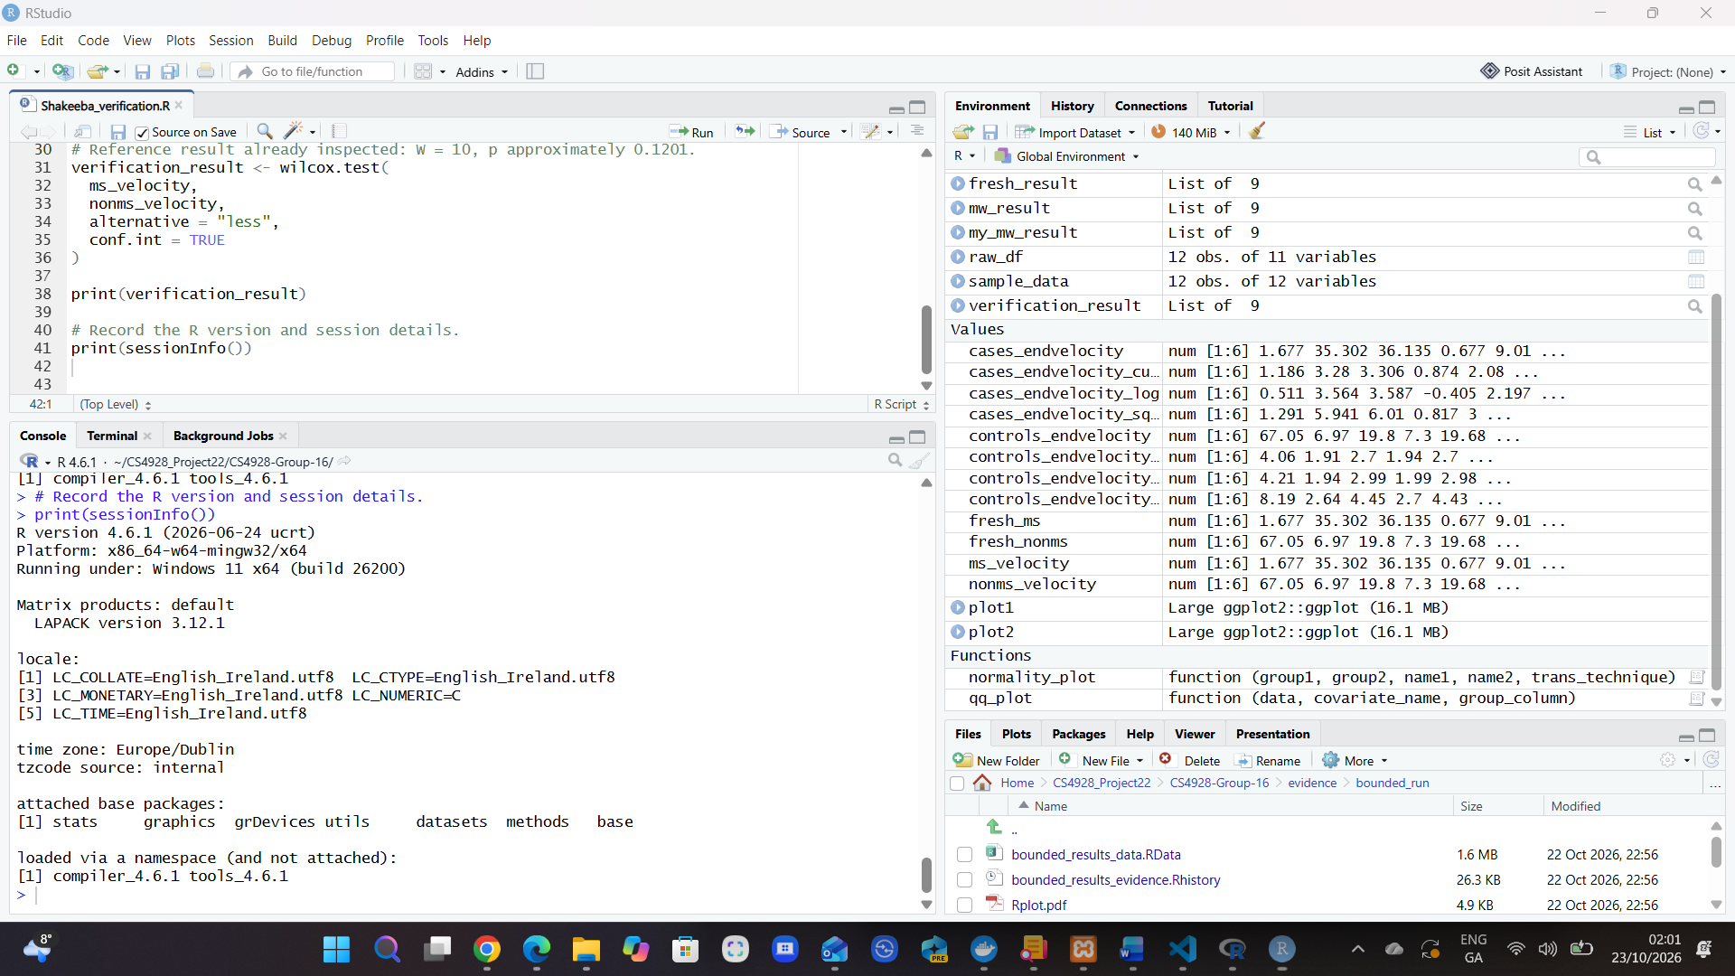
Figure 2: Verification environment. The output of print(sessionInfo()) records R 4.6.1 running on Windows 11, with the Europe/Dublin time zone.

Verification environment. The output of print(sessionInfo()) records the environment used for verification: R 4.6.1 running on Windows 11, with the Europe/Dublin time zone. These details help others repeat the analysis and investigate any differences in results.

Scope and limitations: This verification covers one unadjusted end-velocity comparison using a bounded sample of 12 projects: six microservice and six non-microservice projects. The result was independently recalculated from the sample CSV and matched the group’s saved output. It does not reproduce the full original study, the complete Table 8 analysis, or the matched-cohort analysis. The method used to select the 12 projects remains unverified, so representativeness cannot be established.
Code review findings
The original analysis code was inspected for potential issues. The full original analysis script was not run as part of this review, so the issue below was identified by reading the code rather than by observing an error during execution.
Sample-size issue: The inspected code requests a random sample of 30 values from each group without replacement. However, the checked dataset contains only six projects in each group. That sampling instruction cannot be used unchanged with this 12-project dataset. The group should confirm which dataset and sample size this part of the code was intended to use.

Set the R working directory to the repository root, the folder containing Data, codes and evidence. Run the following command in the R console:
source("codes/Shakeeba_verification.R")
The script reads the sample CSV, prints the sample checks, recalculates the Wilcoxon test and records the R session information.
- Input: Data/final_data_file_sample.csv
- Verification script: codes/Shakeeba_verification.R
- Saved output: evidence/Shakeeba_verification_output.txt
- This review document, containing the annotated screenshots
- GitHub commit link: [Pending upload]

