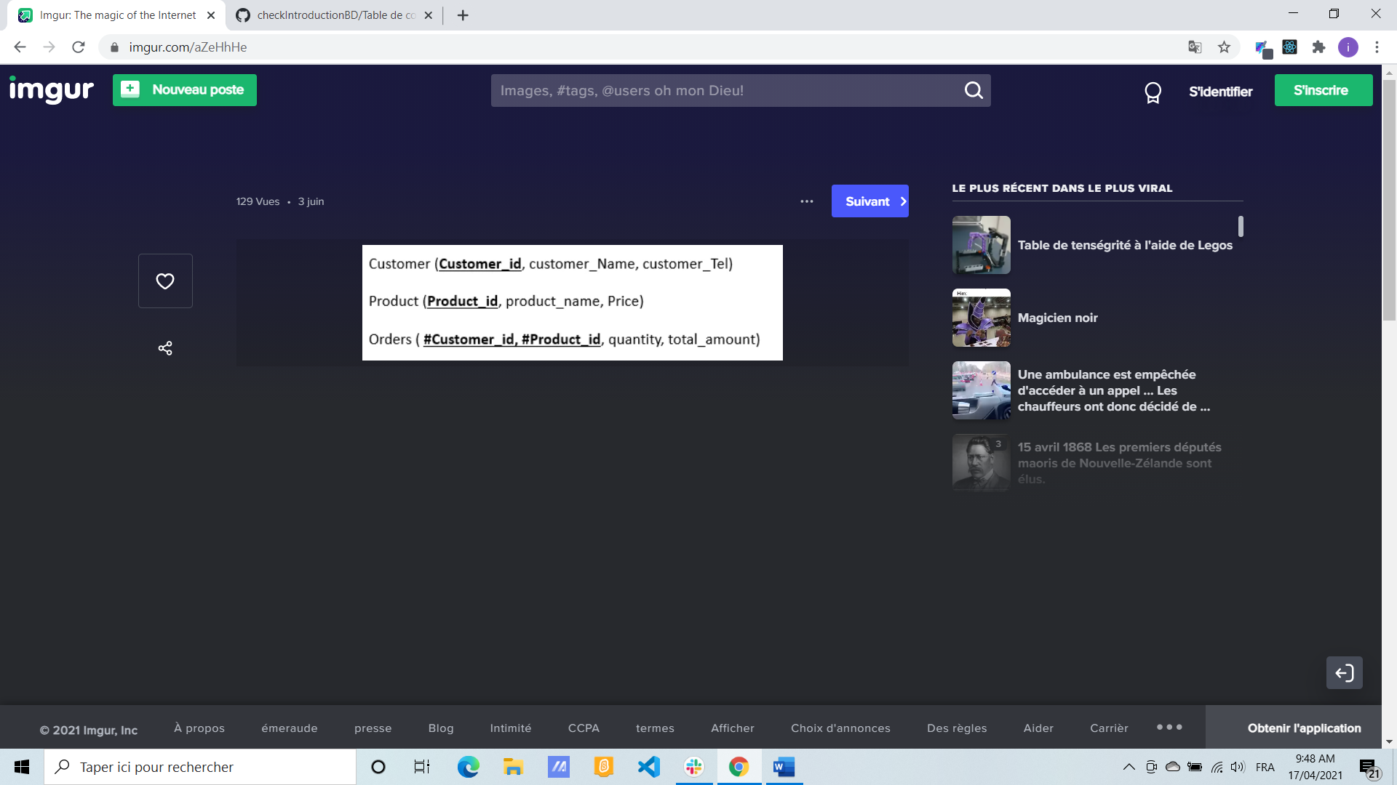

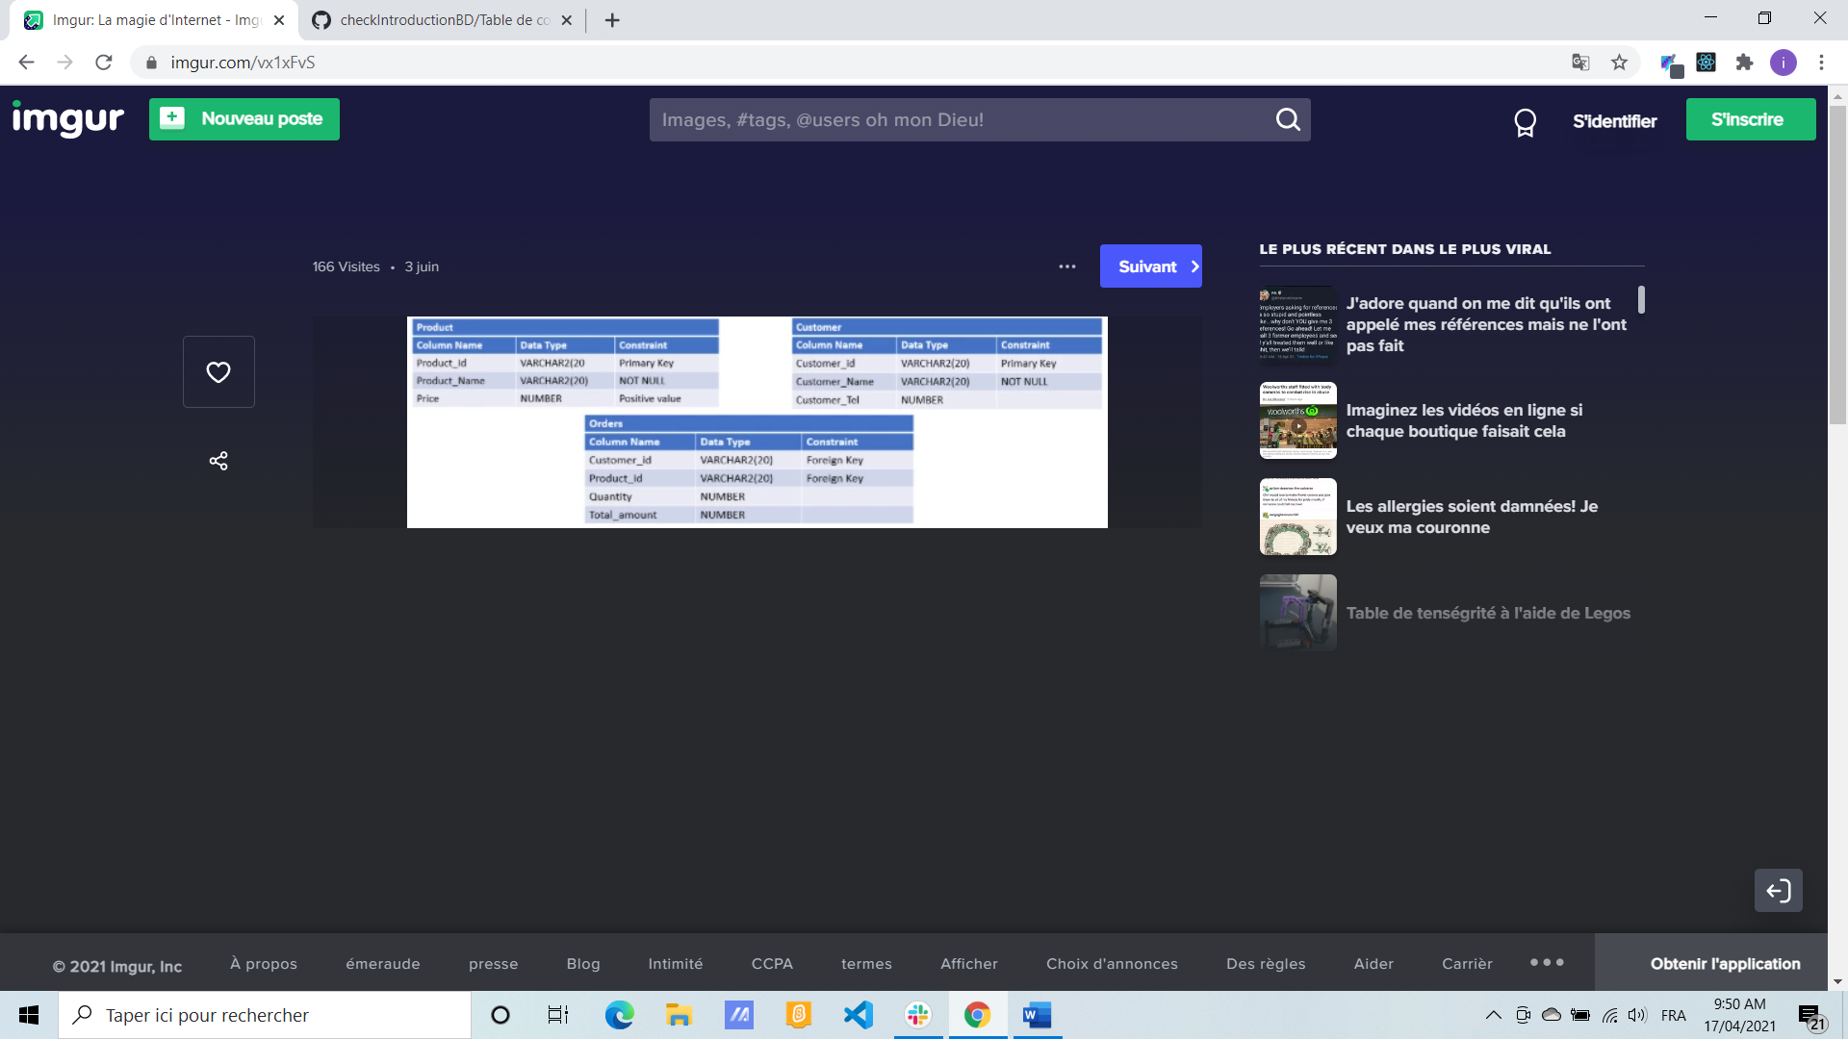

CREATE TABLE Customer (

Customer_id VARCHAR2(20) CONSTRAINT pk PRIMARY KEY,

Customer_name VARCHAR2(20) CONSTRAINT nn NOT NULL,

Customer_Tel Number

);

CREATE TABLE Product (

Product_id VARCHAR2(20) CONSTRAINT pk PRIMARY KEY,

Product_name VARCHAR2(20) CONSTRAINT nn NOT NULL,

Price Number CONSTRAINT pp >0,

);

CREATE TABLE Orders (

Customer_id VARCHAR2(20) CONSTRAINT pk PRIMARY KEY,

Product_id VARCHAR2(20) CONSTRAINT pk PRIMARY KEY,

Quantity Number

Total_amount Number

CONSTRAINT fkc FOREIGN KEY (Customer_id) REFERENCES Customer (Customer_id)

CONSTRAINT fkp FOREIGN KEY (Product_id) REFERENCES Product (Product_id)

);