

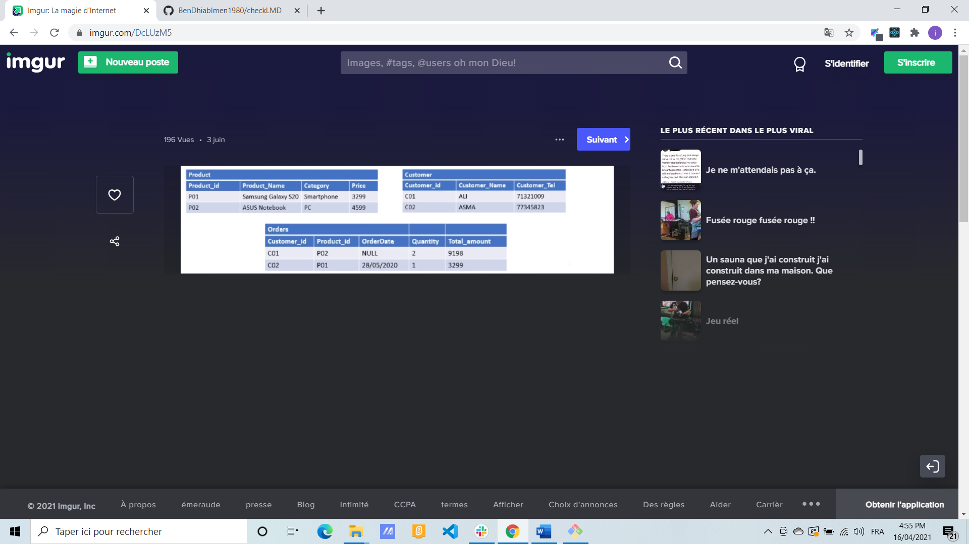

Insert into Customer(customer_id, customer_name, customer_tel)

values(‘c01’, ’Ali’, 71321009) ;

Insert into Customer(customer_id, customer_name, customer_tel)

values(‘c02’, ’Asma’, 77321009) ;

Insert into Product(product_id, product _name, Category, Price)

values(‘P01’, Sumsung GalaxyS20’, Smartphone, 3299) ;

Insert into Product(product_id, product _name, Category, Price)

values(‘P02’, Asus’, PC, 4599) ;

Insert into Orders(customer_id , product_id, order_Date, Quantity, Total_amount) values(‘c01’, ‘P02’, , 2,9198) ;

Insert into Orders(customer_id , product_id, order_Date, Quantity, Total_amount) values(‘c02’, ‘P01’,28/05/2020 , 1, 3299) ;