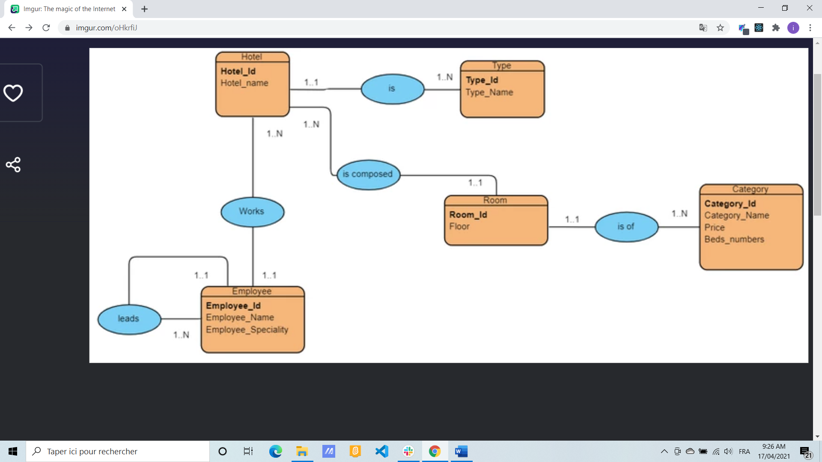

Hotel(**Hotel_id,** hotel_name,**# type_id**)

Type(**type_id,** type_name)

Room(**Room_id**,**# Hotel_id**)

Employee(**Employee l_id,** Employee _name, Employee _speciality ,**# Hotel_id,** ,**# Director_id**)

Category(**Category l_id,** Category _name, Price ,beds_nubers,**# Room_id**)