**Hypertrophic Scar Formation Following Burns and Trauma: New Approaches to Treatment Aarabi et al 2007**

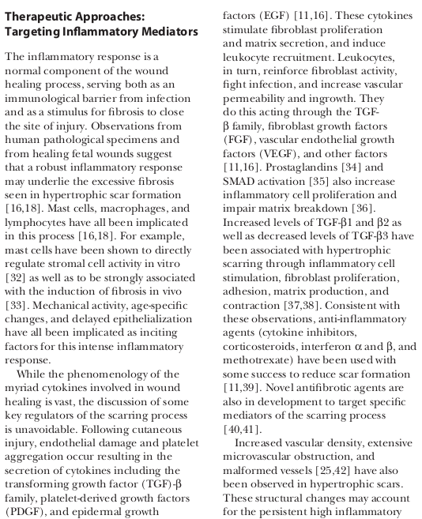

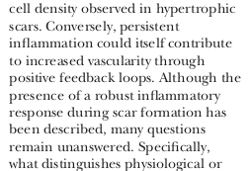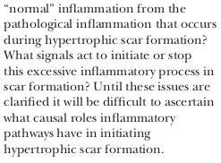

**Notes on: Extracellular Matrix Reorganization During Wound Healing and Its Impact on Abnormal Scarring**

Abnormal ECM reconstruction during wound healing contributes to the formation of hypertrophic and keloid scars. Whereas adult wounds heal with scarring, the developing foetus has the ability to heal wounds in a scarless fashion by regenerating skin and restoring the normal ECM architecture, strength, and function. Recent studies show that the lack of inflammation in fetal wounds contributes to this perfect healing.

**TGFB**

The majority of cells involved in wound healing express TGF-b1, which strongly promotes the chemotaxis of fibroblasts to the site of injury and plays a critical role in fibroblast proliferation and ECM production.91 This growth factor induces the expression of SMA and promotes the synthesis and maturity of collagen I. Although TGF-b1 induces the expression of MMP-2, -9, and -13 in fibroblasts, it actually reduces collagen degradation by inhibiting the expression of MMP-1 and increasing the production of TIMP-1. There are three isoforms of TGF-a—TGF-b1 and TGF-b2 have the profibrotic properties whereas TGF-b3 is antifibrotic. TGF-b1 signalling activates SMAD2 and SMAD3, which use SMAD4 for translocation to the nucleus, whereas TGF-b3 stimulates Smad7. Adjusting the balance of the TGF-b isoform ratio has attracted considerable attention by researchers attempting to correct scar development. Normal adult healing involving scars:

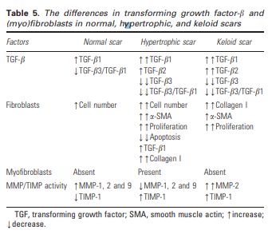

Inhibition of inflammation -> less collagen formation

US 7,312,198

**PROTEIN COMPOSITIONS FOR PROMOTING WOUND HEALING AND SKN REGENERATION**

However, most growth factors are short lived (rapidly degraded by proteases present in the wound fluid) and often counteract each other's effects or may be difficult to establish an optimal dose. For example, transforming growth factor-C. and transforming growth factor-B have stimulatory and inhibitory effects on keratinocyte proliferation, respectively Werner S. and Grose, R. (2003) Regulation of wound healing by growth factors and cytokines. Physiol. Rev. 10, 835-870.

proliferation of cells in the dermis and epidermis in non-chronic wounds by sequential use of AT+PALP or TFPALP or AT-PALP-TF or AT-PALP-TF-AGP com positions and then the PALP+TF+AGP or AT+PALP+TF+ AGP compositions.

Intradermal application of the

4-protein composition enhanced formation of new layers in the epidermis both in the mouse and human skin. Topical administration of various compositions containing 2, 3 or 4 proteins promoted regeneration of both human epidermis and dermis after damaging the skin by exposing to hot water.

**Paper is focused on protein compositions and the effects on proliferation, but we won’t be focusing on that stuff so a bit useless.**

**COMPOSITIONS AND METHODS FOR STIMULATING WOUND HEALING AND FIBROBLAST PROLIFERATION**

Furthermore, this stimulation of fibroblast proliferation does not result in a corresponding Stimulation of collagen Synthesis. Thus, wound healing compositions can be formulated that improve wound healing without increasing Scar formation.

The serum/growth factors may augment the PALP effects by activating the fibroblast cells from a Stationary phase in a cell cycle, referred to as G cycle, to a proliferative phase, referred to as G1 cycle. PALP products may also include any other agent that can induce cells into the proliferative phase.

Postburn sepsis amplifies the selective vasconstrictive impact of thermal injury on hepatic arterial blood flow, yielding a pronounced ischemia/ reperfusion injury, associated with a critical reduction of hepatic oxygen delivery and consumption. A postburn septic challenge induces portal hypertension, which may account for previous

**Scar-free healing: from embryonic mechanisms to adult therapeutic intervention**

Thus, embryonic wounds that heal without a scar have low levels of TGF1 and TGF2, low levels of platelet-derived growth factor and high levels of TGF3. We have experimentally manipulated healing adult wounds in mice, rats and pigs to mimic the scar-free embryonic profile, e.g. neutralizing PDGF, neutralizing TGF1 and TGF2 or adding exogenous TGF3. These experiments result in scar-free wound healing in the adult. We also demonstrate that both repair with scarring and regeneration can occur within the same animal, including man, and indeed within the same tissue, thereby suggesting that they share similar mechanisms and regulators. Consequently, by subtly altering the ratio of growth factors present during adult wound healing, we can induce adult wounds to heal perfectly with no scars, with accelerated healing and with no adverse effects, e.g. on wound strength or wound infection rates.

Many other differences between embryonic scar-free healing wounds and adult scar-forming wounds have been shown, e.g. increased levels of hyaluronic acid, more primitive fibroblasts, or absence of a fibrin clot in embryonic wounds

Interestingly, panneutralization of all three TGF isoforms (TGF1, TGF2 and TGF3) does not improve scarring, suggesting that neutralization of TGF3 may be detrimental

TGFB

present at high levels in developing skin and in embryonic wounds that heal with no scar

present at low levels in adult skin and wounds that scar

induced late in adult wound healing when levels of TGF1 start to fall

neutralization of TGF3 in adult wounds makes the scar worse

addition of TGF3 to adult wounds reduces or eliminates scarring

genetic deletion of TGF3 causes scarring following embryonic wounding (litter mate / embryos heal with no scar)

MAINI

**A morphoelastic model for dermal wound closure**

Wound contraction is responsible for up to 80 % of dermal healing (McGrath and Simon 1983).

The main process by which this occurs is fibroblasts pulling the wound edges inwards. Additionally, growth of new tissue within the surrounding healthy dermis, also regulated by fibroblasts, may contribute to healing. The hole that remains is initially filled with extracellular matrix and over a longer period of time is remodelled into scar tissue.

Typical solutions of the model revealed three distinct phases of healing. Initially, the wound retracts and the radius plateaus due to no growth or contraction (up to 2 days). The wound radius then decreases over approximately 14 days as a result of contraction and mechanosensitive growth. Finally, contraction and mechanosensitive growth slow down. Over a much longer time period (approximately 100 days), the dermal tissue remodels, returning to its homeostatic resting stress. We show that there is only one steady state for the stress, corresponding to T=T∗ , with one associated nonnegative steady state growth profile. The system takes approximately 120–150 days to remodel, depending on the choice of model parameters.

Inflammation and contraction

These cells can be induced by TGF-b1 to express a-SMA, and they readily contract collagen gels in vitro

Although the modulation toward the protomyofibroblast is at present not well explored, the switch from the protomyofibroblast to the differentiated myofibroblast has been related to the production by inflammatory cells**,** and possibly by fibroblastic cells, of transforming growth factor‐β1 (TGF‐β1), the most accepted stimulator of myofibroblastic differentiation

Particularly, in hypertrophic scars that develop after burn, myofibroblastic cells expressing a-SMA are numerous and are involved in contracture formation (Figure 2). A possibility is the inhibition of the apoptosis of these cells that characterizes the terminal phases of wound healing.15 This is difficult to prove in clinical situations and, unfortunately, at present there are no reliable models of hypertrophic scarring in experimental animals. Moreover, even if the observation that myofibroblasts undergo

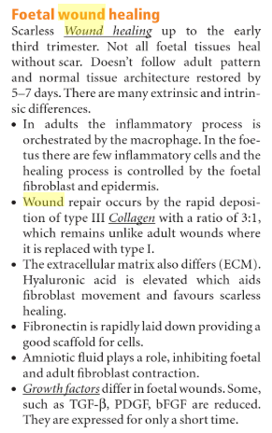

Inflammation ->

platelet-derived growth factor (PDGF) and transforming growth factor-beta 1 (TGF-β1), to initiate fibroblasts and mesenchymal cells migration from surrounding the wound tissue which will be required for the formation of new extracellular matrix and dermal tissue during the proliferative phase of wound healing. These cells can be induced by TGF-b1 to express a-SMA, and they readily contract collagen gels in vitro