  - Ben Dieck
  - Dr. Gary Block
  - IST 652 – Scripting for Data Analysis
  - HW 1 – Report: Donors Dataset
  - Syracuse University
  - 12 November, 2023

Primary Analysis of the Donor Dataset

The Donor Dataset: Obscured Without a Codebook
The Donor Dataset was provided through the course, IST 652, for coding and analysis. It is a csv file, Donors_Data.csv, with 3120 observations of 24 variables comprised of a mixture of continuous, float, values, and discretized data that provides categorical information for the dataset. There are no missing values within the dataset, and the information, when read into a pandas data frame, my_df, allows us to perform operations on it. So little to no cleaning is required using this method. A subset of the original dataset, donations_df, was used to conduct the analysis which allowed the querying to use simplified syntax.
One of the primary components that was lacking in this analysis was a codebook that quantified what the variables within the dataset were. They weren’t particularly complex to intuit, but without a codebook that specifies what we are reading about the analysis is all conjecture. This does not impact our purposes as this is merely an example of processes.
Data exploration was very limited in scope as the dataset itself is simple and straightforward. The list of variables was analyzed to see what stood out as obvious business questions:
Original Columns:
['Row Id', 'Row Id.', 'zipconvert_2', 'zipconvert_3', 'zipconvert_4', 'zipconvert_5', 'homeowner dummy', 'NUMCHLD', 'INCOME', 'gender dummy', 'WEALTH', 'HV', 'Icmed', 'Icavg', 'IC15', 'NUMPROM', 'RAMNTALL', 'MAXRAMNT', 'LASTGIFT', 'totalmonths', 'TIMELAG', 'AVGGIFT', 'TARGET_B', 'TARGET_D']

The describe() function was utilized to examine the range of a few of these variables to determine plausibility of approach, before finalizing logical business questions.

Change in Donor Giving: Last to Recent
Analysis centered on donor giving behaviors as they would represent one of the most real points of interest for users of this dataset. Primarily on how donor giving behaviors are changing. This dataset has something of a pseudo-timeseries to utilize, which we took advantage of in deeper questioning, but primarily we focus on the difference between the average donation and whatever the last donation was. Because the last donation is the most real indicator of how the charity would be doing, as a health check, as well as being able
to project what the next donation was.
We generated two questions:
What is the average shift between a donors last donation, and their average donation?
Using this information we were able to zero in on richer information.
How is a donor’s giving behavior affected by their wealth category compared to how long since they have last donated?
These two questions are of interest to marketing personnel and strategic decision makers within the charity as they reveal current giving health of the organizations donor base, as well as indicators as to where controls and interventions should be applied to improve giving behavior towards favorable trends.

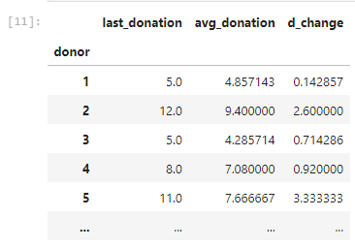
Getting with the Program
Scripting read in the Donors_Data.csv dataset and converted it to a usable pandas data frame. After sub setting the columns that we wanted, we used vector operations to subtract the avg_donation from the last_donation to measure the change in the donation’s value (d_change). Coincidentally, the majority of the changes were positive so we pleasantly did not have to deal with a ton of negative values.
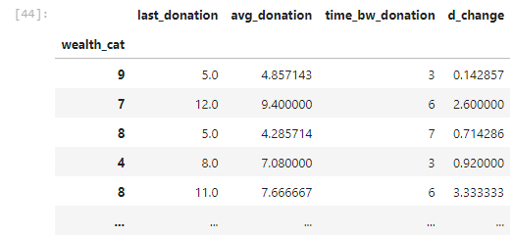
The newly created subset was used to create a plot using matplotlib to conduct some simple analysis on what the giving trend was within the organization, and to pave the way for the final analysis. The subset was reconstructed in order to be more useful to the final analysis, adding the wealth_cat (WEALTH) column and the time_bw_donation column (LAG) which is assumed to be the amount of weeks (perhaps months) between donations. The index of the data frame was changed to the wealth_cat column, and then the whole data frame was pivoted to assemble the report in a useful format for the continued analysis. The final lines of code print out a .csv of the new donor lag time report for use by an analyst.

Positive Trends in Donor Outputs

One of the key outputs generated by the program was a histogram of current giving behavior as opposed to the average behavior for the same donor. It shows a positive trend for the entire organization by giving a comparison between the last donor, to the average donation given by any given donor.
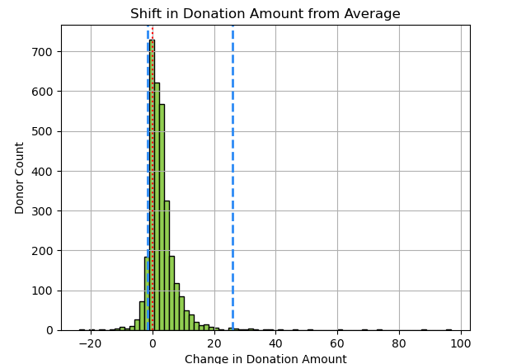
The x axis reflects the change from the donation average in dollars, while the y axis is the count of a donor for a given amount. The ‘0’ crossover point is highlighted as well as the 95% HDI of the set. Almost the entirety of the HDI resides on the positive side of 0, indicating a strong trend towards an increase in giving from a donor’s average donation with the increase usually being $5 dollars or less. This is a better indicator of behavior as we can see that there are outliers within the set of some donors increasing their donations by almost $90, or $100.
The last output is the pivoted data frame that cross references average change in donation by wealth category against lag time in donation. It provides a report that is very difficult to read, and does not brief well to strategic leaders.
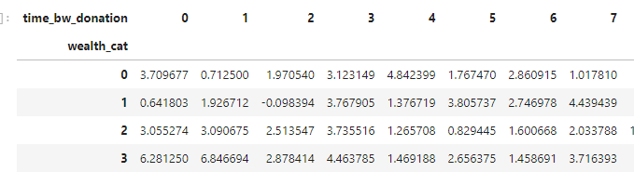 However, it provides a potent tool for an analyst when exported to a csv and read into some of the visualizations that are possible in Excel. We assume in this case that 5 lag, for example, might mean 5 weeks.
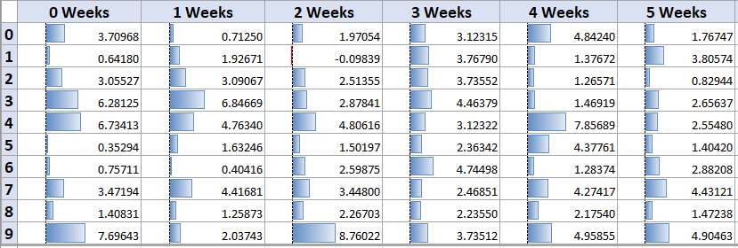
The first five week window shows very few incidents of an average decrease in giving, with categories 0, 1, 5, and 6 generally not increasing their donation. Categories 3 and 4 however seem to steadily increase their donation within this period, which means that this might be a prime period to engage them for sustained / greater involvement in the charity.
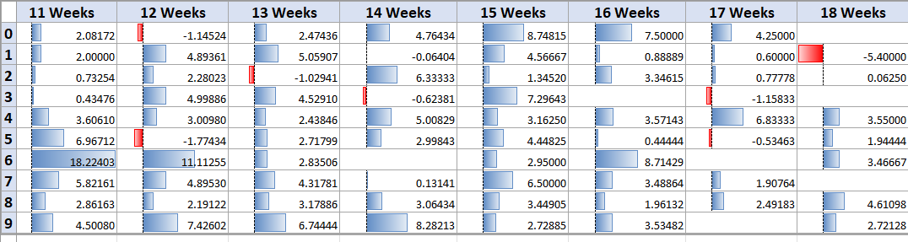
At 11 Weeks of lag the behavior completely changes, with the majority of the cases of decreasing donations starting to be seen. This provides us a suggested population, within the donor base, that might require greater targeted marketing efforts that involve showing them the importance of their donations, and the attainability of the programs goals. But we can also see that this is the period that category 6 are most likely to have sizable increases to their giving behavior. This might suggest an infrequent, but larger donation for that particular group behavior.
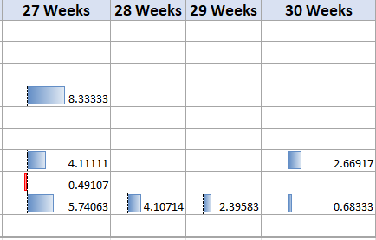

Between 27 and 28 weeks, this decrease in donation becomes a terminal end to donations for many subscribers.

So What: Future Growth
Initial analysis reveals that there is a generally positive trend in donor behavior which should generate good reason for optimism. Donors across all wealth categories, despite not donating for some time, tend to increase their donations to the organization rather than decreasing it. There are numerous factors that might impact this phenomenon including seasonality, political climate, and the state of the national economy, so it is difficult to isolate a variable within this dataset to provide predictive analysis with. However, where we were successful is potentially finding targeted marketing groups and strategies that might need to be taken in order to optimize the situation that currently exists. Without understanding more about the dataset, everything within the analysis, however, is conjecture.

