Shot Chart Takeaways

Ben Ellingworth

3/29/2022

## Shot Charts

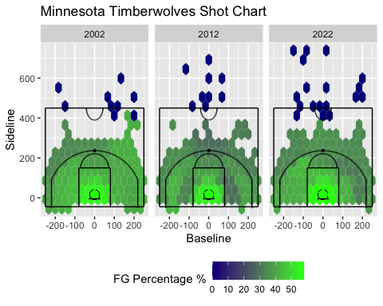

## Key Takeaways

* Need one more 3pt shooter.
* Stay away from the top of the key/deep mid-range shots.
* Balanced Scoring Wins Games
* Keep Attacking
* Attack the right side of the court

## Extra Reading

## Need one more 3pt shooter.

* With the game evolving and playing styles changing, it is essential to have guys who can space the floor. With the success rate we are having getting to the rim, adding one or two more >35% 3PT shooters will help open lanes for our team to continue to getting to the rim as well as fit the pace of play needed in today’s NBA game. As we look at the different shot charts between 2012 and 2022, we are a much better all around shooting team from inside the arc, but can see little improvement from the three point line. We are not lacking from behind the arc, but I believe adding one more player who has a high 3PT percentage can help us take the final step we need to contending.

## Stay away from the top of the key/deep mid-range shots.

* The 2022 shot chart shows we are shooting some of our worst percentages from the top of the key and left-side mid-range jump shots. The worst shot in basketball is the long two and eliminating these shots by either stepping out to the 3pt line or attacking to get closer to the rim will be beneficial. As a team, we are shooting better from the left corner 3pt line than slightly inside the arc at that area. By stepping out as well, we are gaining one extra point from each shot for attempting the three. Lastly, both inside and outside the arc from the top of the key are some of our worst shooting percentages. Staying away from contested shots in these areas may help the offense become more efficient and overall shoot better.

## Balanced Scoring Wins Games

* I mentioned early adding one more 3PT specialist would help, but also adding veterans who can score on all 3 levels would be beneficial as well. Part of what made that 2002 team very good was having a good mixture of players who could do whatever they were asked. As we see from the shot charts, they were very well balanced at all spots on the floor. They didn’t have one glaring weakness that teams could exploit as the year went on. When one option was taken, they were able to find ways to produce. This year we have taken a step in the right direction, but getting a player or two who aren’t great at just one aspect of the game, but are very competent in all aspects, I believe would help benefit the team. Our shot chart shows we have some gaps to fill. We could use someone who is great from the left side of the court. Having the perfect mixture of specialists and all-around players is essential to trying to contend for a title.

## Keep Attacking

* The strength of the Timberwolves this year is their age and athleticism. We are more athletic than most teams we play and shoot very well from 2PT. It was expected that our best FG percentage would be near the hoop, but we still need to emphasize attacking the rim and not settling. Especially for players like Anthony Edwards, he is at his best when he’s going downhill and getting to the rim. Even getting a foot or two inside the lane has shown to be very successful this year. It doesn’t have to be a layup or a dunk. The 2022 chart shows how effective we can be as a team if we can attack and get in the lane. Unlike deep mid-range shots, we are shooting a much better percentage barely inside the lane so we should not look to abandon these shots. A layup every possession is unrealistic but incorporating more free throw line and elbow shots in our offense could help make us more efficient.

## Attack the right side of the court

* As a team overall, we are shooting a much better percentage from the right side of the court than from the left. The shot chart shows just how big of difference there is between sides. With this data we can slightly tweak the way we play to try and benefit our offense. Adding a couple sets to get shooters open on the right side of the court, or just instilling in the players minds to attack the right side as the shot clock runs down, can have a huge impact. Obviously, these players shouldn’t be changing the entire way they play and stray away from open looks from the left side, but incorporating small tweaks to situations can help pay dividends in the long run.