**CS 557 Winter 2018**

**Final Project:** Terrain with Water

**Benjamin Fields**

[fieldsbe@oregonstate.edu](mailto:fieldsbe@oregonstate.edu)

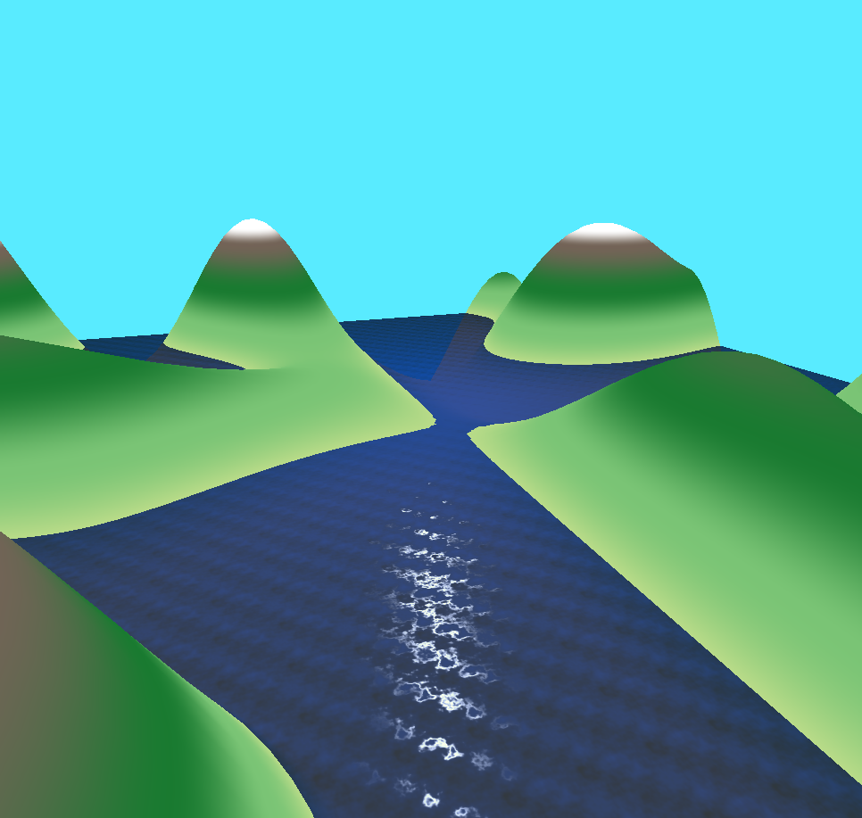

**Figure 1:** Image capture showing the terrain scene with water.

**Description:**

This project is using the glman program to view a terrain scene with animated water. The scene is created by two base Quads. One Quad is used for the terrain and the second is used for the water. The terrain shader uses a vertex shader to create the hills and the fragment shader is used to assign the colors based on elevation. The displacement of the y position is generated by taking the X and Z position and plugging them into the following equation:

GetHeight (float x, float z) = 0.3*(z*sin(0.1*x) +x*cos(0.1*z))

The colors are assigned based on the y position and a collection of colors and edges. Using the edges, we can interpolate between intervals to get a smooth transition between colors. This uses the smooth step and mix functions from GLSL.

For the water a vertex shader is used to pass the eye, light and normal information to the fragment shader, but does not actually change the location of the vertices. The fragment shader is used to create a water effect with animation and lighting. This is done by using the Timer with noise, bump mapping techniques and the standard ambient diffuse specular lighting model. The noise is used to read in a noise value to perturb the standard normal off the previous orientation of straight up. This noise texture when combined with the Timer variable allows us to see an animated water effect over time as each time a new noise value is being read. By continuously changing the normal the surface appears to be wavy and animated. This information is then used in the ADS model with a high specular lighting value to achieve the effect of a shiny water surface.

Link to Video:

<https://media.oregonstate.edu/media/t/0_lz8bzvb9>