**CS 557 Winter 2018**

Project 2: Noisy Elliptical Dots

Benjamin Fields

[fieldsbe@oregonstate.edu](mailto:fieldsbe@oregonstate.edu)

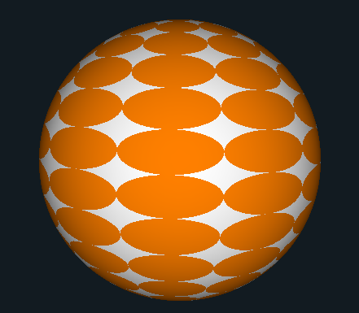 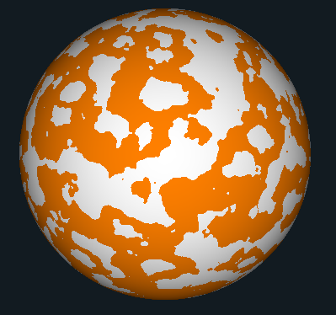

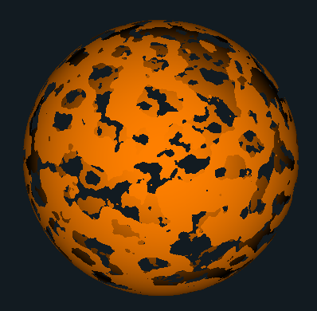 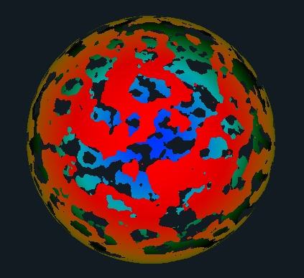

**Figure 1:** Screenshots from the program. Video can be found at the following link:

https://media.oregonstate.edu/media/t/0_olkwcz0p