**CS 557 Winter 2018**

**Project 3:** Displacement Mapping, Bump Mapping, and Lighting

**Benjamin Fields**

[fieldsbe@oregonstate.edu](mailto:fieldsbe@oregonstate.edu)

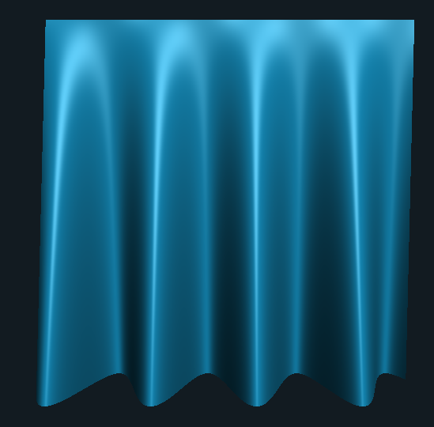 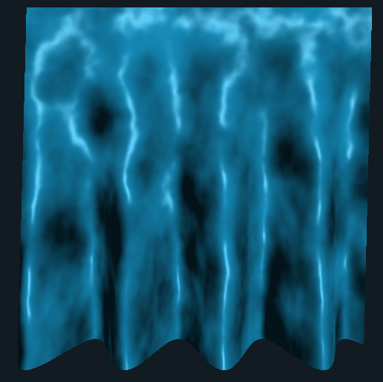

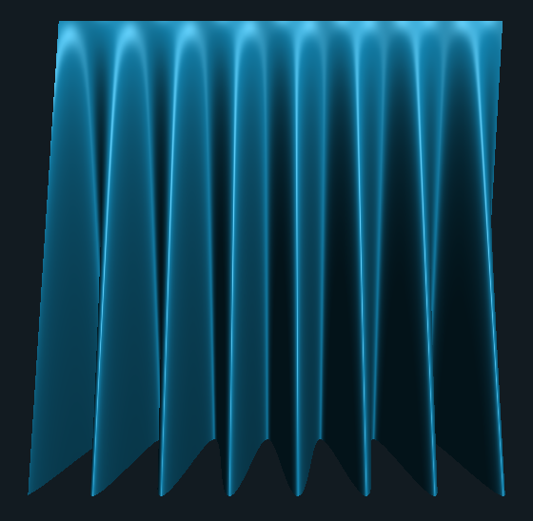 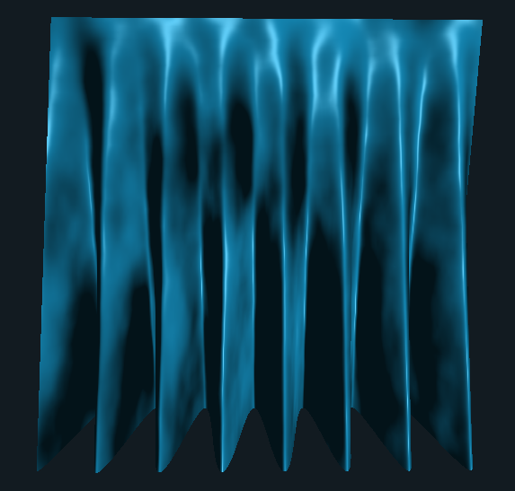

**Figure 1:** Screenshots from the program. Top two images represent standard lighting on the left and Bump mapping applied on the right. Bottom two same but with different pleat parameters. Video can be found at the following link: <https://media.oregonstate.edu/media/t/0_8xpl0bea>

**Description**: This program used a standard quad as the base object that gets passed through a vertex and fragment shader. The vertex shader calculates the displacement in Z according to the x and y position and uses the mathematical definition to calculate the normal. This normal is then passed to the fragment shader where an Ambient Diffuse Specular lighting model is applied. The normal is also rotated according to two noise values for the bump mapping effect.