**CS 557 Winter 2018 Giraffe Poster**

**Benjamin Fields**

**Procedural Varnished Wood Grain**

[fieldsbe@oregonstate.edu](mailto:fieldsbe@oregonstate.edu)

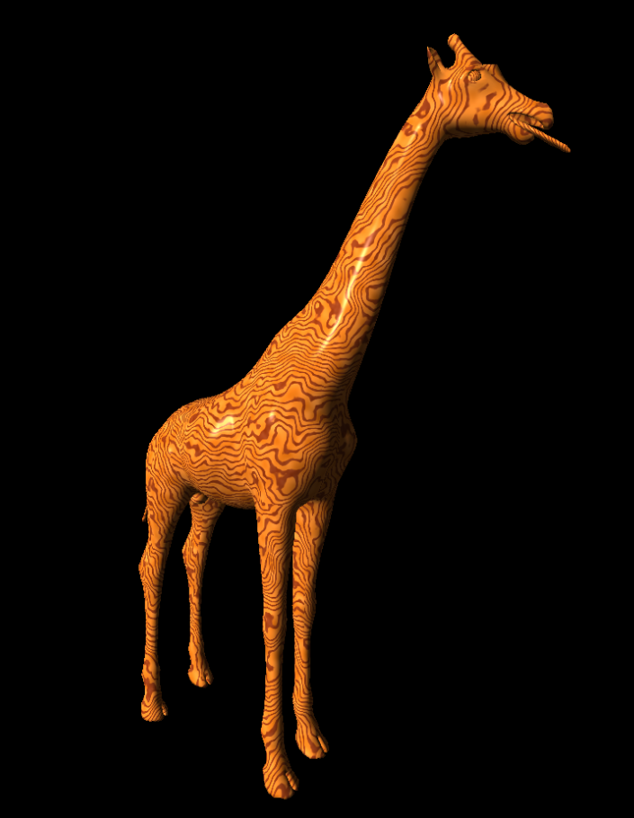

**Description:** This effect was created by defining a virtual log in line with the y-axis that lives within the scene that has a light and dark wood grain pattern based on the distance from the center. The distance from each point to the center is measured to determine the color of wood grain at a given location. Noise is used to alter the distance from the center to achieve a non-uniform structure. Noise is also used to create wood tonal differences throughout the wood grain to more closely model variation in wood tone. Finally, a standard Ambient Diffuse Specular lighting model is used to achieve the varnished finish and scene lighting.

**Video Can be found at the following link:**

[**https://media.oregonstate.edu/media/t/0_0mq8dtb6**](https://media.oregonstate.edu/media/t/0_0mq8dtb6)