**CS 557 Winter 2018**

**Project 6:** Geometry Shaders for Quantizing 3D Geometry: The Lego™ Project

**Benjamin Fields**

[fieldsbe@oregonstate.edu](mailto:fieldsbe@oregonstate.edu)

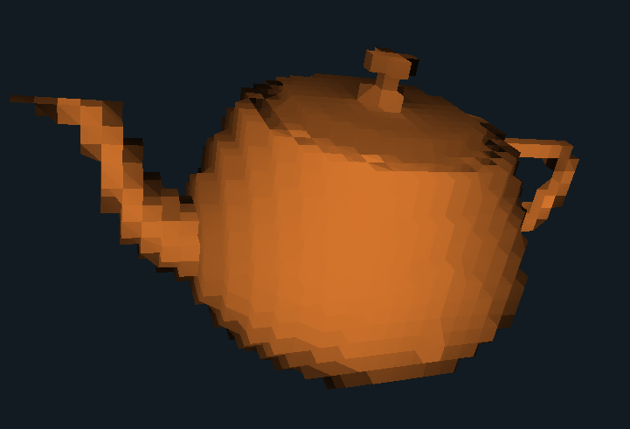

**Figure 1:** Image taken from the shader program showing the effect of quantizing the object.

Link to Video:

<https://media.oregonstate.edu/media/t/0_tre6sgcl>